Java Full stack Layered Architecture

What is a layered architecture?

Is the most preferred architecture for building applications.

In which we divide the application into multiple layers.

An application can be in

Monolithic architecture (or)

2-tier architecture (or)

3-tier architecture (or)

n-tier or multi tier architecture

What are the services offered by a application software?

Presentation / UI / Front End

Business / Domain / Middle tier

Data / Back End

---------------------

monolithic:

a single application provides all the 3 services:

if you see EXCEL, it provides UI / front end also

it provides data storage service also

it provides business services like calculation, validation, formatting, etc

ex: MS Access

2-tier architecture

Server database

Client UI

Where is the business layer??????

It can be a part of server or client or both

If a server provides business service also, then it is called as “Fat server”

If a client provides business service also, then it is called as “Fat client”

3-tier architecture

--------------------------

Clear separation of

Application

Business

Data

Layers in three different deliverable products

n-tier architecture

--------------------------

1. UI
2. Functionality
3. Business
4. Application
5. Data

UI proxy Business dao Data

Layered Architecture:

UI layer

Module 2 is UI layer HTML5, CSS3, Javascript ES6, Angular

Business Layer

Spring Core, Spring AOP, Spring MVC, Spring REST

Data Layer

Spring data JPA

MySQL / PostgreSQL

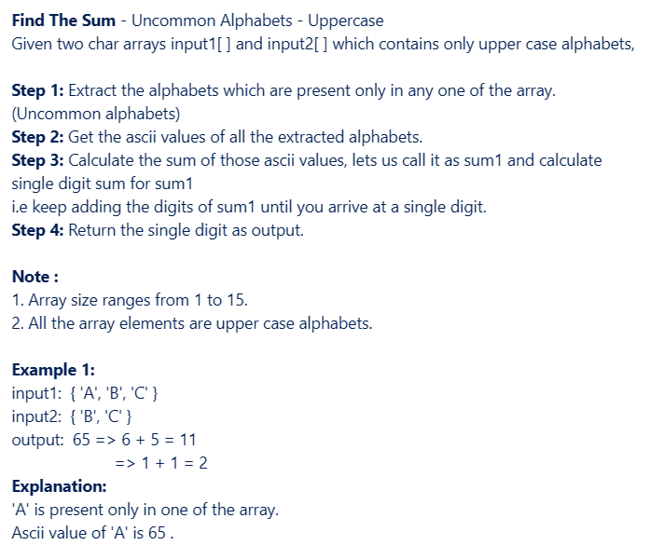

      ArrayList<Character> uncommon=new ArrayList<>();

for(char c1 : input1)

{

//check if c is present in input2 array

boolean flag=false;

for(char c2 : input2)

{

if(c1==c2)

{

flag=true;

break;

}

}

if(!flag)

uncommon.add(c1);

}

for(char c1 : input2)

{

//check if c is present in input1 array

boolean flag=false;

for(char c2 : input1)

{

if(c1==c2)

{

flag=true;

break;

}

}

if(!flag)

uncommon.add(c1);

}

// System.out.println(uncommon);

int sum=0;

for(Character c : uncommon)

{

int ascii=c;

// System.out.println(ascii);

sum+=ascii;

}

while(sum>9)

{

String str=sum+"";

int total=0;

for(char c : str.toCharArray())

{

int digit=c-48;

total+=digit;

}

sum=total;

}

return sum;