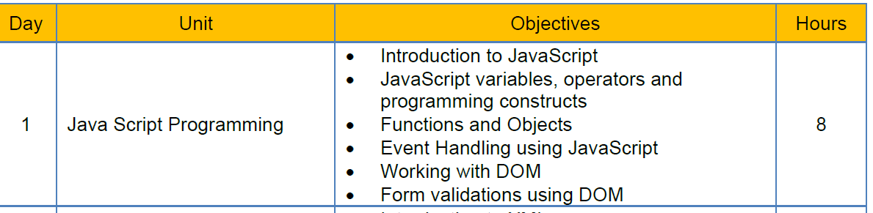

<https://github.com/jagasia/ng>

Javascript:

In our capstone project, the front end is Seen through a browser.

Because our project is a web application.

What is the role of javascript?

Validations

Calculations

Computations

In HTML, I am able to create TEXTBOX, DROPDOWN LIST, RADIO, CHECK BOX, BUTTON, etc

Then why we need javascript?

The above things done in HTML are static aspects of a web page.

What are dynamic aspects of a web page?

When I select a country in dropdownlist, corresponding states must be displayed.

When I click a button, the user name and password are checked and result is displayed.

When I type data in a textbox, the data is validated and only correct data is allowed.

When I type confirm password, it is compared with password and if it is matching or not is verified.

In response to an user interaction, some validation / calculation / computation happens.

Advantages of javascript:

Runs in client. So server does not need additional infrastructure. Browser itself can run javascript code.

Disadvantages of javascript:

Javascript runs in clients machine. So client may fear that it is harmful.

int i=20; float f=2.2f;

var i=20; var f=2.2;

if(i<20)

for(var i=0;i<20;i++)

{}

while(i>100)

{}

console.log(“”);

console.log(new Date());

System.out.println(new Date());

window.alert(“hello world”);

Javascript data types:

Activity:

Javascript data types:

Primitives:

| **Type** | **typeof return value** | **Object wrapper** |
| --- | --- | --- |
| [Null](https://developer.mozilla.org/en-US/docs/Web/JavaScript/Data_structures#null_type) | "object" | N/A |
| [Undefined](https://developer.mozilla.org/en-US/docs/Web/JavaScript/Data_structures#undefined_type) | "undefined" | N/A |
| [Boolean](https://developer.mozilla.org/en-US/docs/Web/JavaScript/Data_structures#boolean_type) | "boolean" | [Boolean](https://developer.mozilla.org/en-US/docs/Web/JavaScript/Reference/Global_Objects/Boolean) |
| [Number](https://developer.mozilla.org/en-US/docs/Web/JavaScript/Data_structures#number_type) | "number" | [Number](https://developer.mozilla.org/en-US/docs/Web/JavaScript/Reference/Global_Objects/Number) |
| [BigInt](https://developer.mozilla.org/en-US/docs/Web/JavaScript/Data_structures#bigint_type) | "bigint" | [BigInt](https://developer.mozilla.org/en-US/docs/Web/JavaScript/Reference/Global_Objects/BigInt) |
| [String](https://developer.mozilla.org/en-US/docs/Web/JavaScript/Data_structures#string_type) | "string" | [String](https://developer.mozilla.org/en-US/docs/Web/JavaScript/Reference/Global_Objects/String) |
| [Symbol](https://developer.mozilla.org/en-US/docs/Web/JavaScript/Data_structures#symbol_type) | "symbol" | [Symbol](https://developer.mozilla.org/en-US/docs/Web/JavaScript/Reference/Global_Objects/Symbol) |

var x; // x is undefined

var x=20; // x is number type

var y=20;

if(x===y) //means, x and y are same

== is used for equals or not

=== is used for same or not same type and same value

In javascript, semicolon is not compulsory, when there is a line separator.

Var x=20 Var y=30

Javascript Operators and Programming constructs:

Activity:

Identify the operators used in javascript

Activity:

Programming constructs like  
 if - else

Switch

While

Do while

For loop

For each

        var arr=[12,40,18,7,9,8,11,15];

        for(var x of arr)

        {

            console.log(x);

        }

        var arr=[12,40,18,7,9,8,11,15];

        for(var x in arr) //in is for index

        {

            console.log(x);

        }

var arr=[1,2,3,4,5,56,8,9];

Operators in javascript:

* Arithmetic Operators
* Assignment Operators
* Comparison Operators
* String Operators
* Logical Operators
* Bitwise Operators
* Ternary Operators
* Type Operators

Arithmetic Operators:

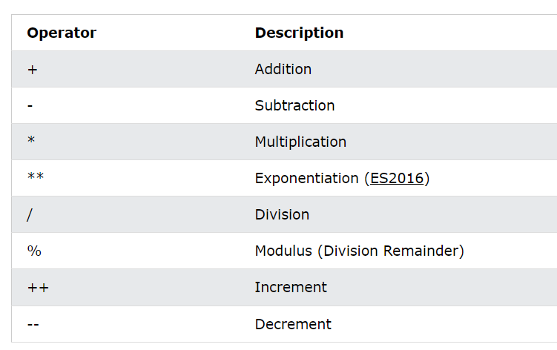

Assignement operators:

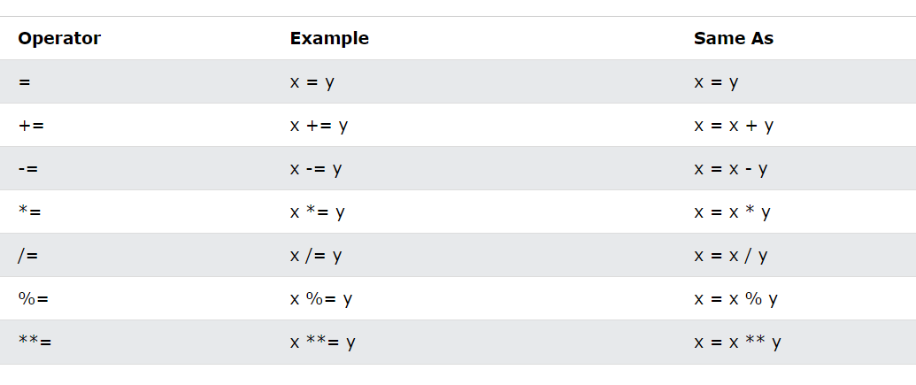

NULLIS COALESCE ASSIGNMENT

(x)??=fn1();

JavaScript Comparison Operators

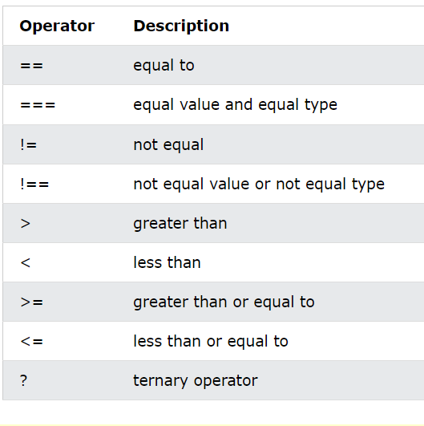

console.log((x>y)?20:10);