Watchfacelibrary使用手册

1. 需要使用watchfacelibrary.aar和serialTransprot.aar两个库。
2. 发送流程是由一个intentService控制，发送完成或者遇错后会自动退出并通过localbroadcast通知外部
3. 创建需要传输的文件和传输

目标表盘文件通常是一个zip文件，调用方式如下任取一种

context：context

待定参数：视方法不通参数不同，具体如下

BluetoothAddress：需要传输的设备的蓝牙地址

Type：传输文件的类型，如下

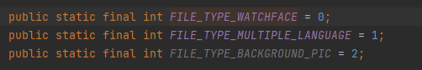

不同的参数

1. 传入待传输zip文件的uri

public static void startActionWatchface(Context context, Uri uri, String BluetoothAddress, int type)

1. 传入待传输zip文件的path

public static void startActionWatchface(Context context, String path, String BluetoothAddress, int type)

1. 通过注册localBroadcast来接收传输结果和进度

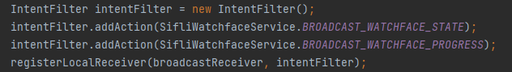

解析广播中的值



传输错误的情况，会在response中附带错误原因



进度



正常传输完成后，退出的STATE值都是0，其他值都是异常退出

//state 查看 WatchfaceError.java

public static final int STATUS_OK = 0;

public static final int STATUS_GENERAL_ERROR = 1;

public static final int STATUS_RECEIVE_ERROR = 2;

public static final int STATUS_LEN_ERROR = 3;

public static final int STATUS_INDEX_ERROR = 4;

public static final int STATUS_STATE_ERROR = 5;

public static final int STATUS_DISCONNECT = 6;

public static final int STATUS_DOWNLOAD_NOT_ONGOING = 7;

public static final int STATUS_REMOTE_ABORT = 8;

public static final int STATUS_REMOTE_FILE_SIZE_CHECK_ERROR = 9;

public static final int STATUS_APP_ERROR = 20;

public static final int STATUS_FILE_SIZE_ALIGNED_MISSING = 21;

public static final int STATUS_FILE_PATH_ERROR = 22;

public static final int STATUS_FILE_TYPE_ERROR = 23;

public static final int STATUS_MEM_MALLOC_ERROR = 24;

public static final int STATUS_FILE_OPEN_ERROR = 25;

public static final int STATUS_FILE_INFO_ERROR = 26;

public static final int STATUS_FILE_WRITE_ERROR = 27;

public static final int STATUS_FILE_CLOSE_ERROR = 28;

public static final int STATUS_FILE_EXTENSION_ERROR = 29;

public static final int STATUS_MKDIR_ERROR = 30;

public static final int STATUS_SWITCH_DIRECTORY_ERROR = 31;

public static final int STATUS_BLE_PARAMETERS_NULL = 32;

public static final int STATUS_MEM_NOT_CONTINUOUS = 33;

public static final int STATUS_FILE_SIZE_ERROR = 34;

public static final int STATUS_CRC_INIT_ERROR = 35;

public static final int STATUS_CRC_CALCULATE_ERROR = 36;

public static final int STATUS_SPACE_ERROR = 37;

public static final int STATUS_TIMEOUT_ERROR = 38;

public static final int STATUS_UI_INVALID = 39;

public static final int STATUS_BLE_DISCONNECT = 40;

public static final int STATUS_USER_ABORT = 41;

public static final int STATUS_RECV_DATA_TIMEOUT = 42;