NEURAL NETWORK TERMINOLOGY & ACTIVATION FUNCTIONS

TERMINOLOGY OF NEURAL NETWORKS
Before going into how a network learns, it helps to fix the vocabulary. The diagram below traces a single signal from the moment it enters the network to the moment it leaves, and each stage is paired with the term used for it.
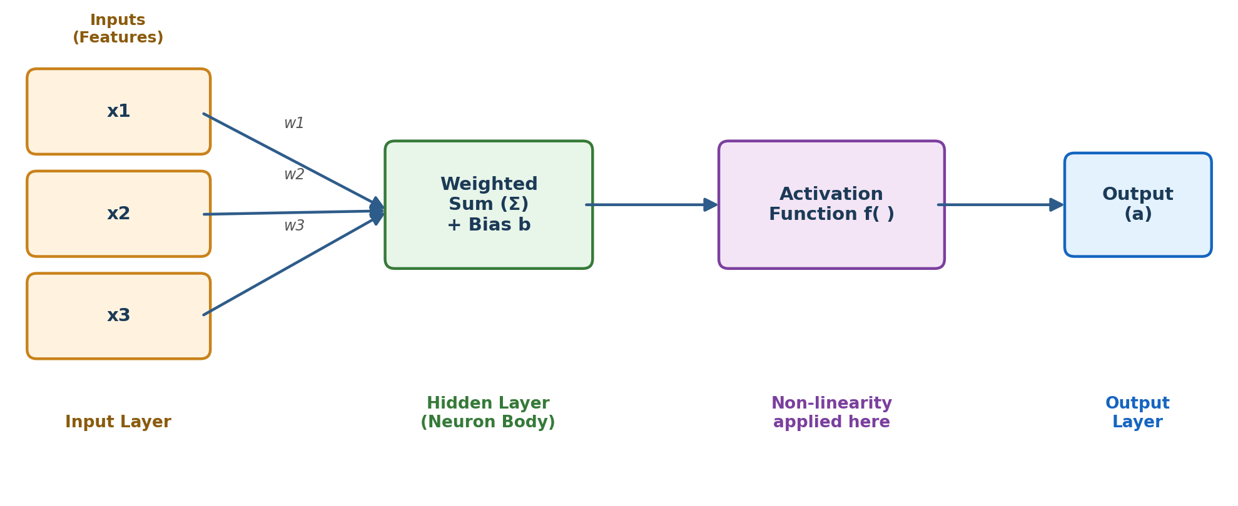
Diagram 1: How one signal moves through a neuron, with the matching terminology at each stage.

Core Building-Block Terms
- Node (Unit): a single processing point in the network; every node combines its inputs and passes the result onward.
- Input / Feature: one measurable value fed into the network, e.g. a pixel intensity or a sensor reading.
- Weight: a tunable number attached to a connection that scales how much that input matters.
- Bias: a free constant added at each node so the output can shift even when all inputs are zero.
- Layer: a group of nodes sitting at the same depth; networks are usually described as input, hidden, or output layers.
- Parameter: the collective name for every weight and bias the network adjusts on its own during training.
- Hyperparameter: a setting chosen by the person building the model before training starts, such as the number of layers or the learning rate.
- Architecture: the specific arrangement of layers and nodes that defines a given network.

Terms Used During Training
- Forward Pass: sending data through the network from input to output to obtain a prediction.
- Loss / Cost: a single number showing how wrong a prediction was compared to the true answer.
- Backpropagation: the calculation that traces the loss backward through the network to find each parameter's share of the error.
- Gradient: the rate at which the loss changes with respect to a given parameter; it tells the optimizer which direction to move.
- Optimizer: the update rule (e.g. SGD, Adam) that nudges every parameter using its gradient.
- Learning Rate: how large a step the optimizer takes on each update.
- Epoch: one complete run through the entire training set.
- Batch: a smaller group of training examples processed together before the parameters are updated once.
- Overfitting: when a network memorises the training data so closely that it performs poorly on new, unseen data.

TYPES OF ACTIVATION FUNCTIONS
A node's weighted sum on its own is only a straight-line calculation. Stacking many such sums, with nothing else added, would still behave like one single straight-line calculation no matter how many layers are used. An activation function is inserted at each node specifically to break that straight-line behaviour, which is what lets a network fit curved, irregular patterns. The map below groups the common activation functions by how they behave, rather than by plotting their curves.
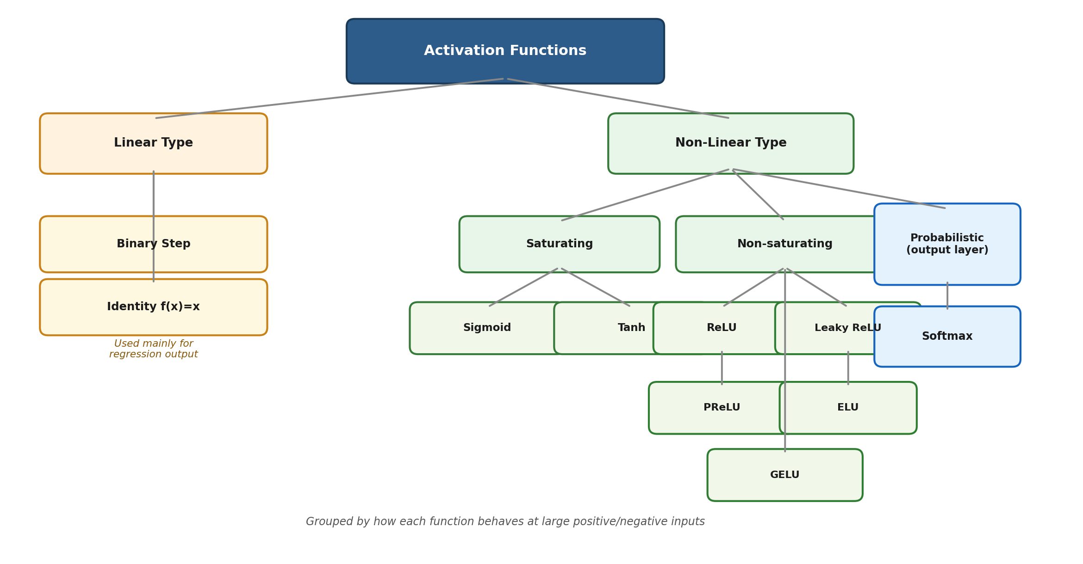
Diagram 2: Activation functions grouped by behaviour rather than by individual plots.

Linear-Type Functions
- Binary Step: outputs 1 once the input crosses zero and 0 otherwise. It cannot support backpropagation because its slope is zero almost everywhere.
- Identity (Linear): simply returns its input unchanged. It only appears at an output node for regression problems and never inside hidden layers, since stacking it adds no extra expressive power.

Saturating Non-Linear Functions
- Sigmoid: squashes any input into a value between 0 and 1, which makes it convenient for representing a probability, but its slope flattens for large positive or negative inputs, slowing down learning in deep networks.
- Tanh: similar to Sigmoid but centred on zero, mapping inputs to a range between -1 and 1; it still suffers the same flattening problem at extreme values.

Non-Saturating Functions
- ReLU: passes positive values through unchanged and blocks negative values at zero. It is cheap to compute and is the standard first choice for hidden layers, though nodes can permanently stop firing if they drift into the negative region (the “dying ReLU” issue).
- Leaky ReLU: the same as ReLU but allows a very small slope for negative inputs instead of a hard zero, keeping the node from dying completely.
- PReLU: identical in shape to Leaky ReLU, except the small negative slope is itself learned during training rather than fixed in advance.
- ELU: curves smoothly toward a negative limit instead of a straight line for negative inputs, which keeps the average output closer to zero and can speed up learning.
- GELU: weights the input by how likely it is to be “kept” under a probability curve, giving a smooth curve that has become the standard choice in transformer-based models such as BERT and GPT.

Probabilistic Output Function
- Softmax: converts a vector of raw output scores into a probability distribution across classes, where every value lies between 0 and 1 and the whole set adds up to 1. It is only used at the output layer of a multi-class classifier.

Quick Comparison
Function | Typical Use | Strength | Weakness
Sigmoid | Binary output | Clean probability | Vanishing gradient
Tanh | Hidden (RNNs) | Zero-centred | Vanishing gradient
ReLU | Hidden (default) | Fast, simple | Dying ReLU
Leaky ReLU | Hidden | Fixes dying ReLU | Slope is fixed
GELU | Transformers | Smooth, accurate | Costlier to compute
Softmax | Multi-class output | Probabilities sum to 1 | Output layer only

