NCERT Smart Assistant — Stage 2
Professional Project Documentation

Overview
Stage 2 focuses on transforming the initial NCERT RAG prototype into a more intelligent and modular AI tutoring system.
The system now supports:
• Semantic retrieval
• Hybrid retrieval
• Equation handling
• Numerical problem routing
• Image retrieval
• Memory handling
• FastAPI backend
• React frontend interface
This stage establishes the backend and frontend architecture required for scaling the project into a complete NCERT AI tutor.

Stage 1 vs Stage 2
Stage 1 Prototype:
• PDF extraction using pdfplumber
• Text cleaning
• BERT tokenizer-based chunking
• BM25 retrieval
• Gemini-based answer generation
Limitations:
• Weak semantic understanding
• Poor handling of equations
• No numerical solving
• No image retrieval
• No memory
• Large chunk retrieval noise
• Basic notebook-only implementation
Stage 2 Goals:
• Modular backend architecture
• Intelligent query routing
• Semantic retrieval
• Hybrid retrieval
• Equation and numerical handlers
• Image retrieval pipeline
• Frontend chat interface
• API-based interaction

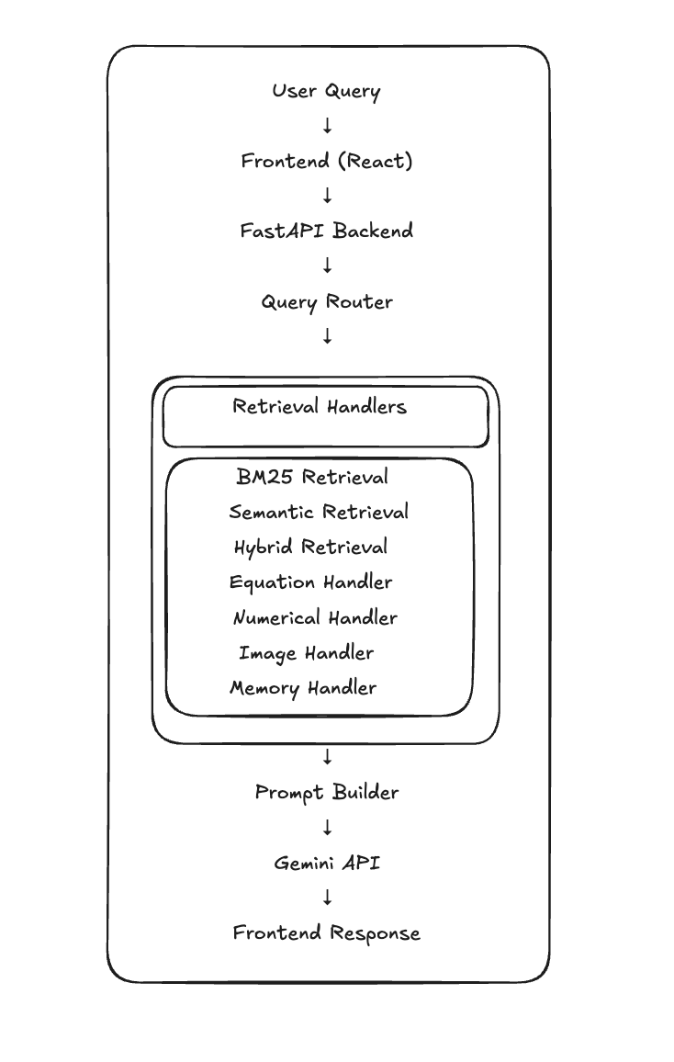
Project Architecture

Features

Implemented
1. Semantic Retrieval
Implemented semantic search using transformer embeddings.
2. Hybrid Retrieval
Combined BM25 keyword retrieval and semantic similarity retrieval.
3. Equation Handler
Handles equation-related queries such as F=ma, v=u+at, momentum equations.
4. Numerical Handler
Basic numerical problem solving.
5. Image Retrieval
OCR-based image retrieval using rendered PDF pages and metadata matching.
6. Memory Handling
Short-term conversational memory.
7. FastAPI Backend
Query routing, APIs, CORS support, static file serving.
8. React Frontend
ChatGPT-style interface, markdown rendering, chat memory, API integration.

Current Folder Structure
RAG_system_NCERT/
├── backend/
├── frontend/
├── data/
├── notebooks/
├── outputs/
├── requirements.txt
└── README_STAGE2.md

Current Known Issues
• Image rendering issues
• Undefined equation response fields
• Numerical parsing limitations
• Momentum solver limitations
• Query routing edge cases
• Gemini API quota handling
• UI refinements
• Full-book scaling
• Deployment pipeline

Stage 3 Goals
1. Full NCERT Book Scaling
2. Numerical Solver Improvements
3. Image System Improvements
4. UI Improvements
5. Gemini Stability
6. Deployment (Vercel + Render/Railway)

Technologies Used
Backend:
• FastAPI
• LangChain
• SentenceTransformers
• BM25
• ChromaDB
• Gemini API
Frontend:
• React
• Vite
• SCSS
• ReactMarkdown
NLP/Retrieval:
• Semantic embeddings
• Hybrid retrieval
• OCR-based image retrieval

Current Status
Stage 1 → Completed
Stage 2 → Completed (Core Architecture)
Stage 3 → Planned

Author
Himkar Vashistha
BTech Data Science Engineering
PG in Agentic AI & AIML Engineering — IIT Gandhinagar

