H.A.L.O.

Production-Ready Phase 3

STATUS  Approved |  | OWNER  H.A.L.O. |  | LAST UPDATED  August 3, 2026

Authors | H.A.L.O. maintainers
Reviewers | Project owner; contributor, security, and accessibility reviewers
Related docs | Halo-PRD.md; phases.md; systemdesign/; techstack/; ui_ux/; VERIFY.md
Scope | Durable, cost-efficient Phase 3.0–3f architecture for a cloneable Windows desktop app.

1. Abstract
Phase 3 adds coding orchestration, MCP integrations, browser automation, real voice, Windows GUI control, and governed self-improvement without replacing Halo's implemented Brain, permission gate, TaskRuntime, persistence, or authenticated IPC. The selected design is a thin core with independently installable capability packs.
Production-ready means an unfamiliar contributor can clone, bootstrap, verify, and run Halo; packaged releases need no developer Python installation; optional failures degrade honestly; and upgrades preserve state. Windows x64 is the Phase 3 target. Licensing remains a Phase 3f release decision.

2. Goals and Non-Goals
Goals | Non-goals
Clone, bootstrap, verify, and run from documented locked commands. | Cross-platform GUI automation; Windows is the supported Phase 3 desktop.
Add capabilities without regressing chat, IPC, permissions, or TaskRuntime. | Automatic replay of torn side-effecting work.
Isolate heavyweight dependencies, crashes, models, and security boundaries. | Hidden use of the default Chrome profile or mandatory hosted telemetry.
Make availability, budgets, approvals, and recovery truthful and accessible. | Automatic activation of generated skills or a second orchestrator.

3. Background and Problem Statement
Phase 0–2 is ready to host heavy capabilities, but the current repository is not clone-to-green: Python workers install separately, Voice needs an editable Brain package, and Tauri still launches source modules. Bundling browser, voice, GUI vision, and integration dependencies into Brain would also enlarge the installer, cold start, CI cost, and vulnerability surface.
Invariant: the Brain is the only orchestrator. Every external action crosses its deterministic permission gate; every task-shaped operation uses TaskRuntime; workers own execution mechanics rather than policy or durable truth. Unknown or unhealthy capability packs fail closed while text chat stays available.

4. Proposed Architecture

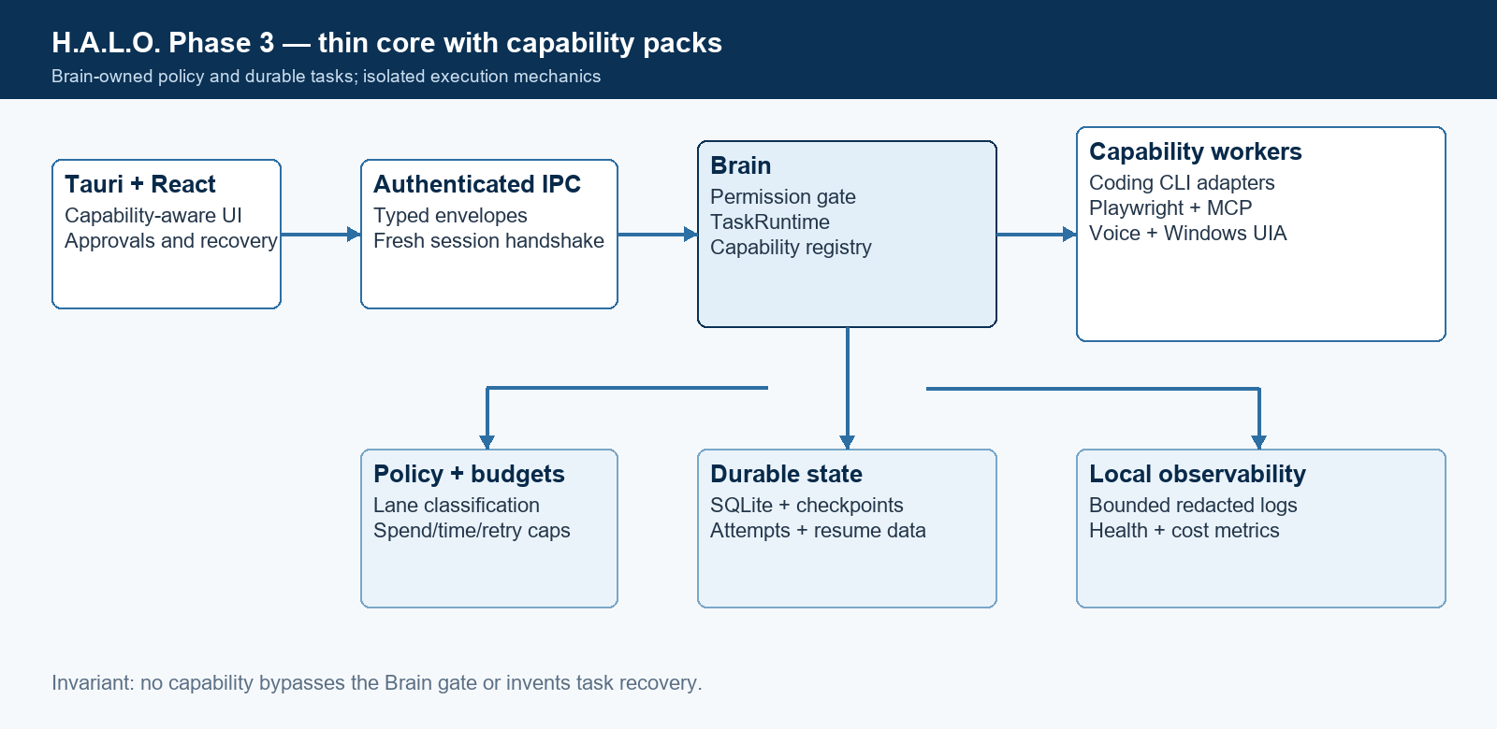
Figure 1. Brain-owned policy and durable execution with isolated capability workers.

Core components

Component | Responsibility | Primary storage | Failure behavior
Brain + gate | Intent, policy, approvals, routing, task admission | SQLite, keyring, LangGraph | Fail closed for mutations; chat survives pack failure
TaskRuntime | Bounded tasks, events, stop/pause, reconciliation | SQLite task/activity records | Torn work is interrupted; never blind replay
Capability registry | Install/version/health/operations/repair truth | Versioned records + manifests | Unknown/incompatible packs unavailable
Adapters + workers | Structured CLI, Playwright, audio, UIA, MCP execution | External sessions/checkpoints | Correlated timeout/stop; isolated crash
UI projection | Capabilities, tasks, budgets, approvals, recovery | Brain frames; bounded stream tails | Stale/unknown state disables consequences

5. Request Lifecycle
- A typed UI request identifies the conversation, capability, operation, target, intent, and initial budgets.
- Brain validates the IPC envelope, caller, manifest compatibility, capability health, lane, approval needs, and untrusted-input boundary.
- The admitted capability/configuration version, permissions, limits, task state, and provider availability are loaded and snapshotted.
- TaskRuntime selects the direct adapter or worker; the worker returns ordered structured events while bounded raw output remains secondary evidence.
- Intent, attempt ID, configuration snapshot, budgets, target, and recovery metadata are durable before downstream side effects begin.
- Calls obey idempotency, timeout, token/spend, retry, and wall-time budgets. Consequential actions stop for correlated approval.
- Brain records outcome and activity, then projects correlated task, spend, capability, and recovery frames only to eligible subscribed clients.

6. API and Data Contracts

Primary data contract

Field | Type | Required | Description
capability_id | string | Yes | Stable globally unique identity owned by Brain.
manifest_version | integer | Yes | Parser/contract compatibility; unknown versions fail closed.
capability_version | semver | Yes | Installed implementation version captured per attempt.
state | enum | Yes | Brain-owned installed/health/busy/update state.
operations | array | Yes | Stable operation IDs and input/output schemas.
permission_classes | map | Yes | Gate classification for each exposed operation.
runtime + artifacts | object | Yes | Entry point, protocol, probes, versions, sizes, hashes.

Contract guarantees

- Intent and the admitted configuration snapshot are durable before any side effect; unknown manifest versions cannot execute.
- Every attempt and structured event has a stable correlation and monotonic sequence; retries create linked attempts rather than overwriting history.
- Persist capability/manifest versions, provider session ID, target identity, budgets, last acknowledged event, checkpoint, and terminal reason.
- Brain/TaskRuntime is authoritative for policy and lifecycle; worker logs and external sessions are evidence, never the source of truth.
The canonical cross-process contract is the hand-mirrored CONTRACT_SPEC in Brain and UI.
shared/check_contract_sync.py verifies parity; there is no JSON schema source of truth.

7. Consistency, Idempotency, and Replay

Configuration is snapshotted per attempt and TaskRuntime serializes authoritative transitions. Resume is permitted only through an adapter's verified session mechanism. Otherwise a torn task becomes interrupted_after_restart. Arbitrary side effects are never replayed from inference alone.
Scenario | Expected behavior | Reasoning
Duplicate request/event | Deduplicate stable transition; retain evidence | Correlation + monotonic event sequence
Required durable write fails | No downstream effect; correlated retryable error | Intent exists before effect or no effect occurs
Timeout/partial failure | Cooperative stop; bounded idempotent retry; terminal state | Budgets bound cost; attempts remain reconstructable
Config changes mid-task | Admitted snapshot remains authoritative | Prevents behavioral drift within an attempt

8. Security and Privacy Considerations

- Keep the authenticated random-port loopback handshake. All CLI, MCP, browser, voice, GUI, and skill actions pass the deterministic gate; incompatible packs fail closed.
- Treat web pages, files, tool descriptions/results, transcripts, screenshots, and GUI text as untrusted data. Keep logs, stream tails, audio, and screenshots bounded and redacted.
- Store credentials only in the OS keystore. Manifests, diagnostics, prompts, examples, repositories, and release artifacts must not contain secrets or signing keys.
- Replay, migration, pack install, vision fallback, generated skills, and destructive actions default disabled or approval-required. Physical input pauses GUI control.
- Telemetry is local and off by default. Dedicated browser profiles, removable local models, explicit retention controls, and redacted diagnostic export preserve user control.

9. Operational Readiness
Signal | SLO or alert | Owner | Launch gate
Core launch + auth | >=99.5% successful sessions; 100% release matrix | Core maintainers | Required
Local control latency | hello_ack <2s; control-frame p95 <250ms | Core/UI maintainers | Required
Unexpected pack errors | No Sev-1; <5% terminal errors during public beta | Capability owner | Required
Contract/manifest drift | Zero sync or compatibility failures in release CI | Core maintainers | Required
Recovery integrity | 100% torn-task tests prove no blind replay | Runtime/security | Required
Rollout constraint: feature-gated tranche, offline fixtures, native maintainer pass, rollback proof, then public beta; text chat is always a regression gate.

10. Alternatives Considered

Alternative | Why it was considered | Why it was not selected
Batteries-included monolith | One installer appears simple | Large default footprint, CI cost, native conflicts, PyInstaller risk
Framework-led assembly | Fast prototype velocity | Duplicates Halo orchestration/gate/state; broad model and telemetry graph
Hosted capability services | Simpler local packaging | Recurring cost plus new privacy, availability, and trust boundaries
Automatic torn-task replay | Convenient-looking recovery | Cannot know whether arbitrary external effects already occurred

11. Open Questions
- Select the project license and repeat the redistribution review before the Phase 3f public release.
- Choose the Windows UIA binding after a focused benchmark against representative applications.
- Decide whether Windows ARM64 joins Phase 3f after x64 packaging evidence exists.
- Choose the official updater channel and signing-key custody before production updates are enabled.

12. Decision and Next Steps
Approve the thin-core architecture and implement it through Phase 3.0–3f. Each tranche ships behind truthful capability availability, passes offline and native gates, preserves text chat, and can be disabled or rolled back without corrupting core state.
Milestone | Deliverable | Exit criteria
M1 / 3.0 | Clone-to-green foundation, uv workspace, registry, packaging proof | Clean Windows x64 checkout runs chat and full gate
M2 / 3a–3b | Coding adapters, MCP, Playwright, dedicated browser profile | Structured recovery and permission-gated native flows pass
M3 / 3c–3e | Frozen sidecars, local Voice, UIA control, governed skills | No Python requirement; interruption, privacy, accessibility gates pass
M4 / 3f | Installer lifecycle, migrations, SBOM, signing docs, license review | Clean-machine public-release matrix and rollback pass

Use footnotes for definitions, assumptions, or terms that need precision without interrupting the main narrative.

