**TS compiles to ES6 and ES6 compiled to ES5 – using ts/babel/webpack**

**Single watch/run of webpack is enough**

* Create new folder “mytestapp”

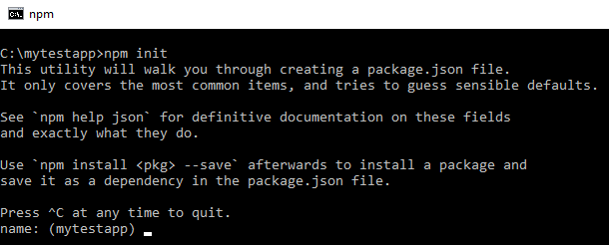

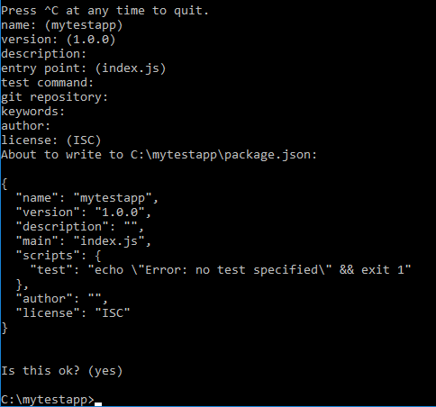

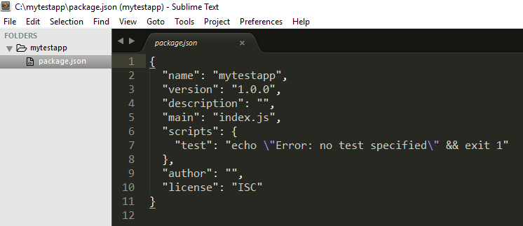

* >npm install --save-dev typescript
* >npm install --save-dev ts-loader
* >npm install --save jquery
* >npm install –save-dev typings
* >npm install --save-dev webpack
* >npm install --save-dev babel-core babel-loader babel-preset-es2015
* >node_modules\.bin\typings install dt~jquery –global –save

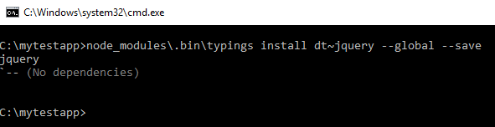

Creates typings/globals/index.d.ts and typings.json

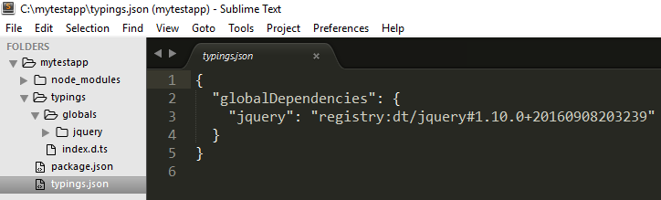

* Create new folder “ts-src”
* Add “ts-src\Message.ts” as follows:

import * as _$ from 'jquery'

const $ = (_$ as any).default;

export default class Message {

show(){

$("#ShowBtn").html('Demo');

alert("Hello world!");

}

}

* Add “ts-src\app.ts” as follows:

import msg from './Message'

import * as _$ from 'jquery'

const $ = (_$ as any).default;

$(function(){

$("#ShowBtn").on("click", function(){

var o = new msg();

o.show();

});

});

* Add “tsconfig.json” to app root as follows:

{

"compilerOptions": {

"module": "es6",

"sourceMap": true,

"target": "es6"

},

"files":[

"typings/index.d.ts",

"ts-src/app.ts"

]

}

* Add “webpack.config.js” to app root as follows:

var path = require('path');

var webpack = require('webpack');

module.exports = {

devtool: 'source-map',

entry: ['./ts-src/app.ts'],

output: {

path: './build',

filename: 'app.js'

},

module:{

loaders:[{

test: /\.ts$/,

include: path.resolve(__dirname, "ts-src"),

loader: 'babel-loader?presets[]=es2015!ts-loader'

}]

},

resolve: {

extensions: ["", ".webpack.js", ".web.js", ".ts", ".js"]

},

watch:true

};

* >node_modules\.bin\webpack

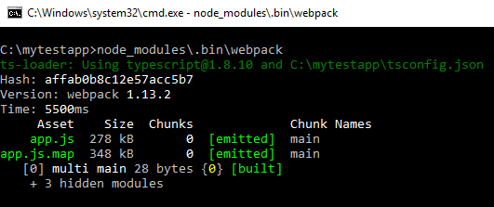

The above should create “app.js” in “build” folder (and still wait for changes to any ‘.ts’ files)

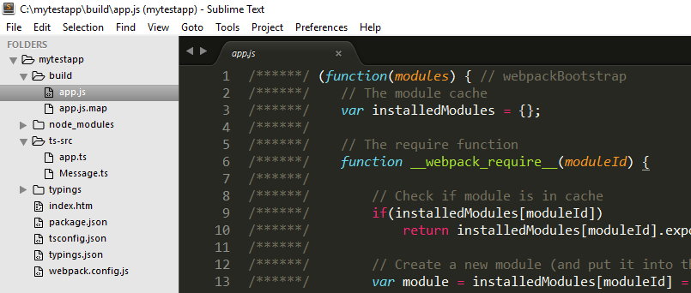

* Create “index.htm” in app root as follows:

<!DOCTYPE html>

<html>

<head>

<title></title>

<script type="text/javascript" src="build/app.js"></script>

</head>

<body>

<button id="ShowBtn">Show</button>

</body>

</html>

* Test the html page

