**TS compiles to CommonJS/ES5 and CommonJS/ES5 compiled to JS – using ts/webpack**

**Single watch/run of webpack is enough**

* Initialize app

>C:\test\mytestapp>npm init

* After completing, you should see this

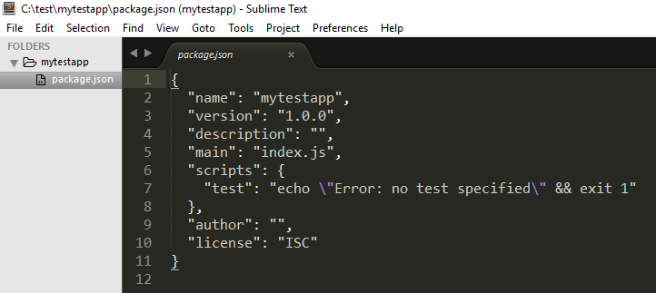

* Install necessary node modules

>C:\test\mytestapp>npm install --save-dev typescript ts-loader

>C:\test\mytestapp>npm install --save-dev webpack

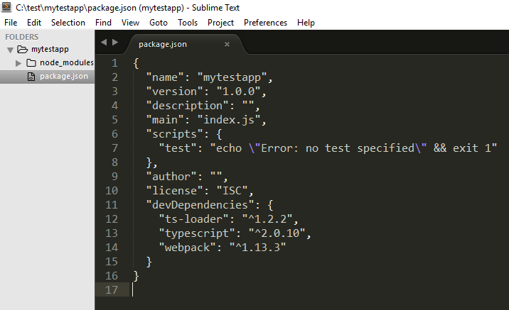

* Create C:\test\mytestapp\ts-src\Message.ts as follows

export default class Message{

show(){

alert("Hello world!");

}

}

* Create C:\test\mytestapp\ts-src\app.ts as follows

import msg from './Message'

window.onload = function(){

var o = new msg();

o.show();

}

* Create C:\test\mytestapp\tsconfig.json as follows

{

"files":[

"ts-src/app.ts"

]

}

* Create C:\test\mytestapp\webpack.config.js as follows

var path = require('path');

var webpack = require('webpack');

module.exports={

entry: ['./ts-src/app.ts'],

output:{

path: './build',

filename: 'app.js'

},

module:{

loaders:[{

test:/\.ts$/,

include: path.resolve(__dirname, "ts-src"),

loader: 'ts-loader'

}]

},

resolve:{

extensions: ["", ".webpack.js", ".web.js", ".ts", ".js"]

}

}

* Compile .ts files using the following command

>C:\test\mytestapp>node_modules\.bin\webpack

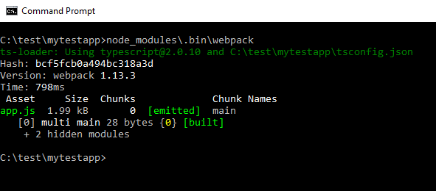

* The above should create app.js as follows:

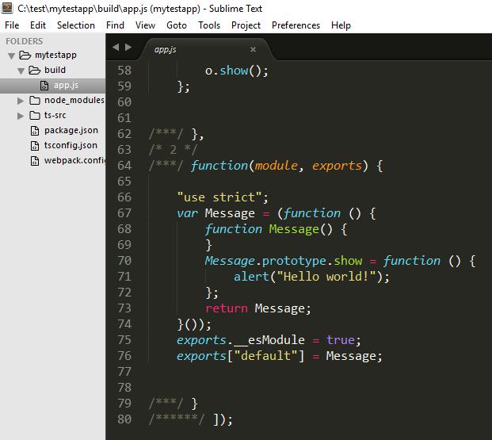

* Create c:\test\mytestapp\index.htm

<!DOCTYPE html>

<html>

<head>

<title></title>

<script type="text/javascript" src="build/app.js"></script>

</head>

<body>

demo

</body>

</html>

* Test the index.htm using web server

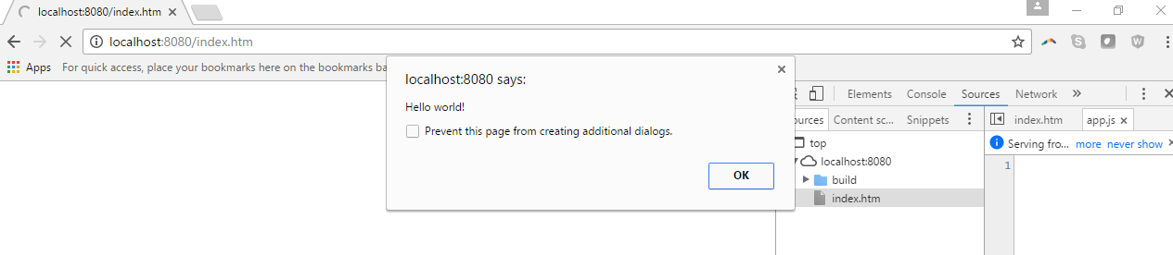

**To add source map**

* Modify tsconfig.json

{

"compilerOptions": {

"sourceMap": true

},

"files":[

"ts-src/app.ts"

]

}

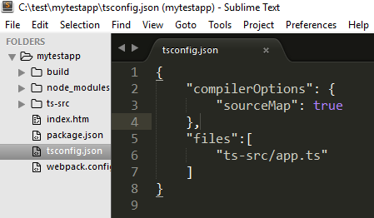

* Modify webpack.config.js

module.exports={

devtool: 'source-map',

…

}

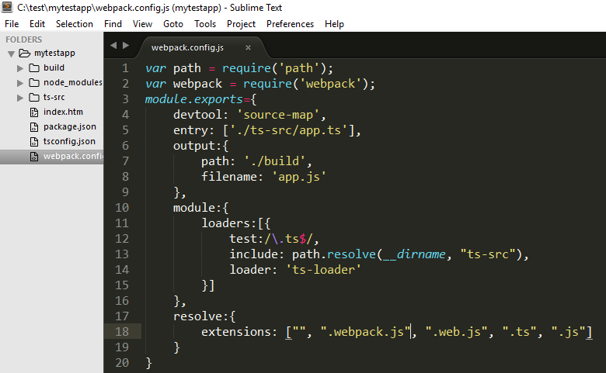

* Compile .ts files using the following command

>C:\test\mytestapp>node_modules\.bin\webpack

* Test the index.htm using web server

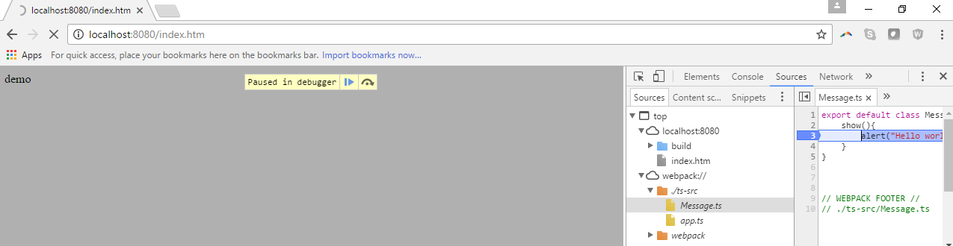

**To add watch**

* Modify webpack.config.js

module.exports={

…,

watch: true

}

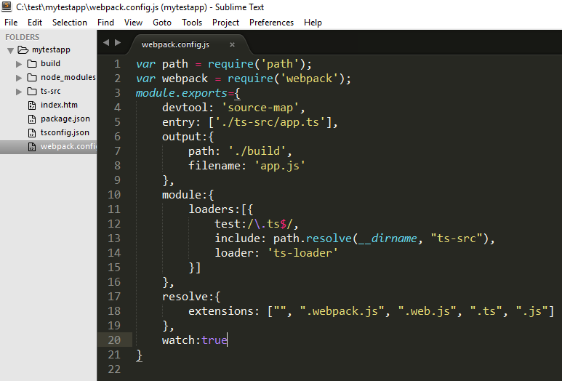

* Now, it is going to wait (while watching) to compile any modified .ts files continuously (without a need to re execute same command over and over again)

