

**Advance topics in software engineering**

**Payroll system: User guide**

**SUBMITTED TO: SUBMITTED BY:**

**Cristina Ruiz Arshpreet Singh- 101138246**

**Jagdeep Singh - 300102863**

**Puneet Singh – 101134691**

**Varinder Dhanda- 101135785**

**Installing Cygwin, GCC**

**Windows – Installation**

1. Visit **http://www.cygwin.com/.**
2. Look for the section "Installing Cygwin" and select the appropriate version (32 bit or 64 bit) for your PC.
3. Download the setup file chosen. Based on the OS version we will get a file named setup-x86_64.exe (64-bit installation) or setup-x86.exe (32-bit installation).

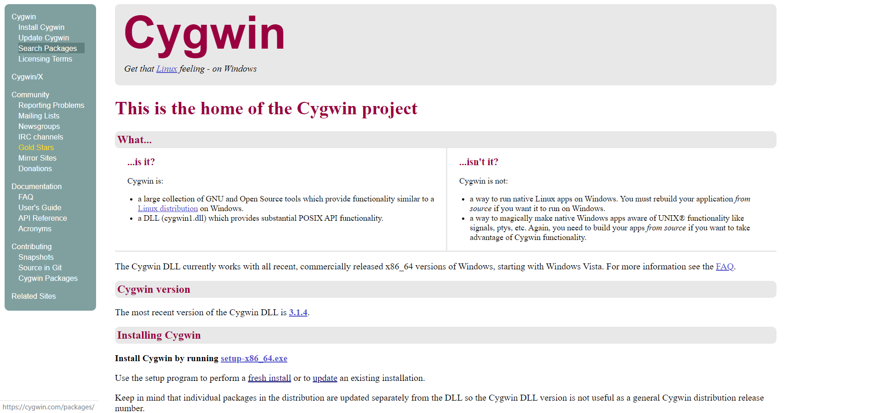

Fig 1: Cygwin page.

1. Execute setup-x86_64.exe (64-bit installation) or setup-x86.exe (32-bit installation) and click on “Next >”. We will see the following welcome screen.

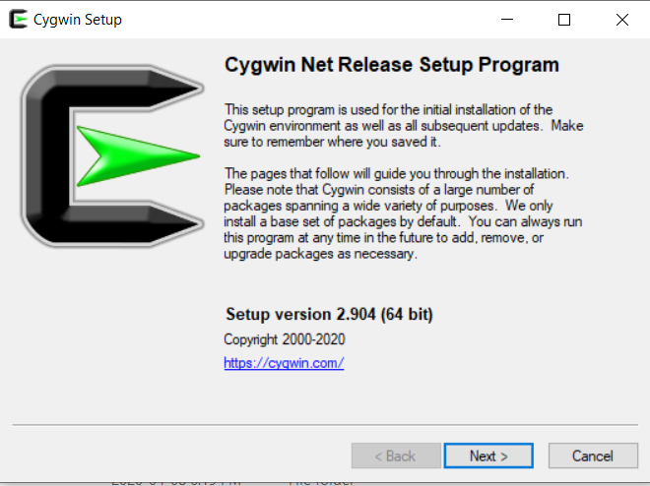

Fig 2: Cygwin Setup Program.

1. Select option to setup from internet and click next.

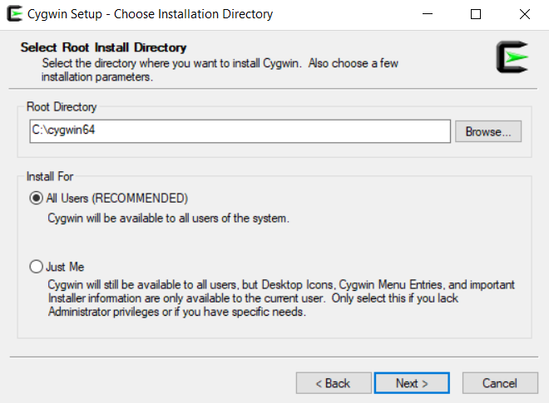

Fig 3: Choose Installation.

1. Choose path to download.

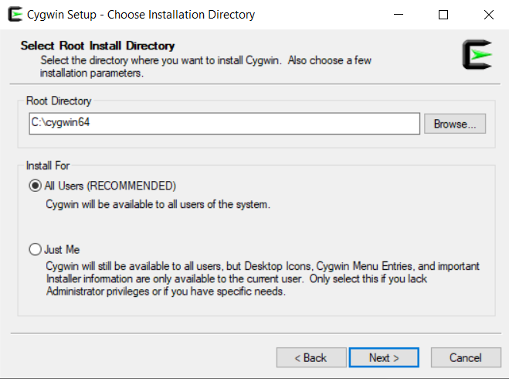

Fig 4: Installation path.

1. Select the option “Use System Proxy Setting” and click on Next.

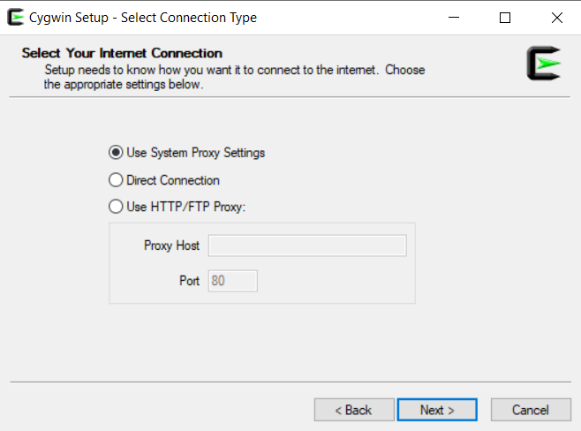

Fig 5: Select Internet connection.

1. Choose download site.

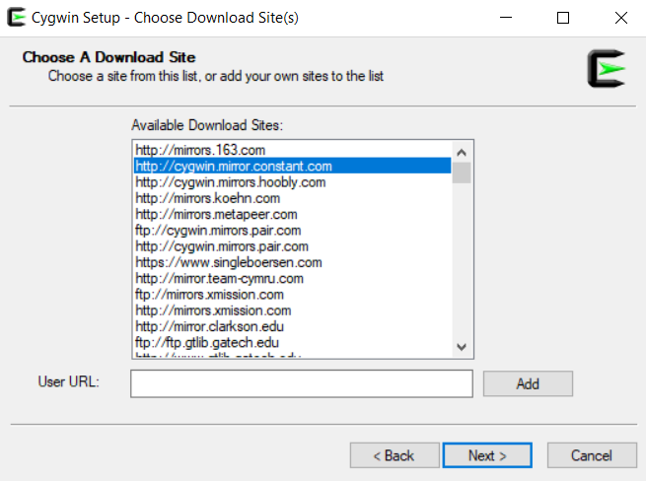

Fig 6: Choose download site.

1. Cygwin will start the installation process. The following window will appear.

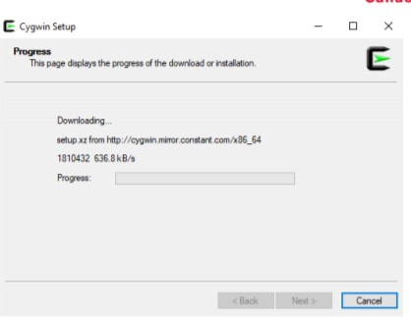

Fig 7: Downloading.

1. When we get the following window, if we click on “All”, we will see all the existing packages. Do not choose anything; simply click Next leaving everything default

This will install the default tools and libraries.

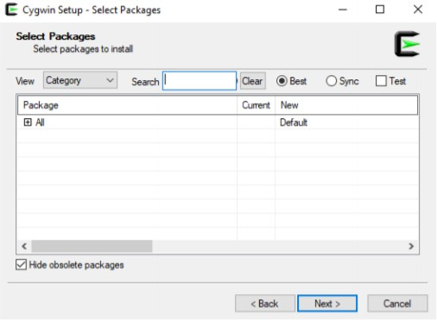

Fig 8: Select packages.

1. The following window will appear. Click on “Next >”

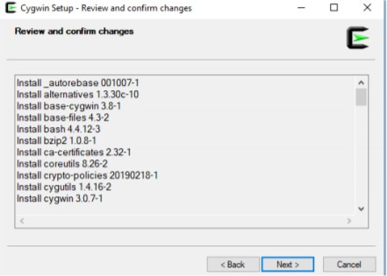

Fig 9: Review and confirm.

1. 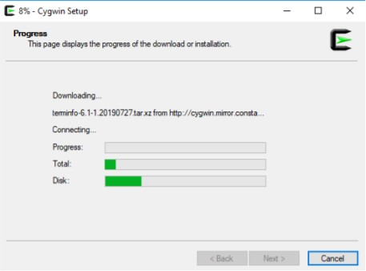The progress window below will appear.

Fig 10: Setup progress.

1. Once the installation finishes, select the option “Create icon on Desktop” to easily access the Cygwin terminal. Click on “Finish”

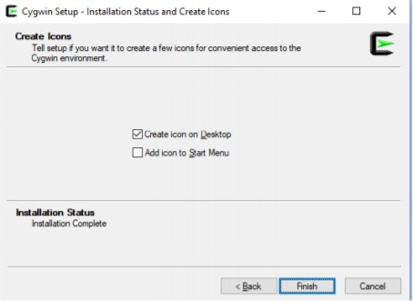

Fig 11 Setup Finish.

1. Once the installation finishes, if we open the cygwin64 folder, it should have the following content.

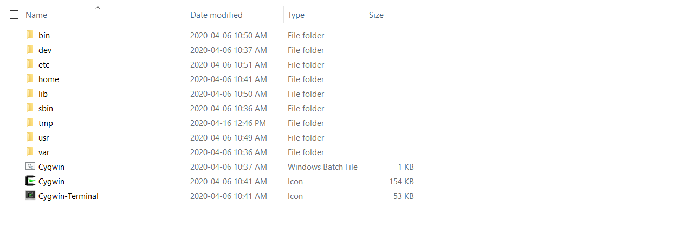

Fig 12: C:\cygwin64

1. Open the windows terminal (Command Prompt; type “cmd” on your Windows search). Type cd c:\cygwin64

For the 64-bit installation, type:

setup-x86_64.exe -q -P chere -P wget -P gcc-g++ -P make -P diffutils -P libmpfr-devel -P libgmp- devel -P libmpc-devel -P git(For 32-bit installation, replace by setup-x86.exe)

It will install all the necessary libraries and the last version of gcc/g++ compiler.

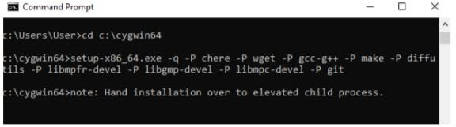

Fig 13: Command prompt.

1. A Progress window will pop up while all the required packages along with their dependencies are downloaded and installed, as in the following screen capture.

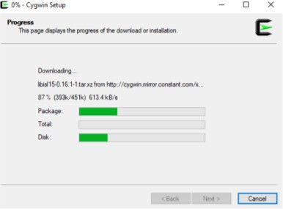

Fig 14: Setup.

The installation process will take several minutes. Once the installation process finishes, the window will disappear automatically, and we can close the Command Prompt.

1. Run Cygwin on your desktop, in administrator mode (right-click on the desktop icon and select the option “Run as administrator”; we can also use c:\cygwin64, and run the script “cygwin.bat” in Administrator mode).

The skeleton files will be created.

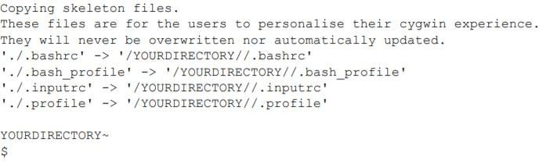

1. Type the following command on the terminal and press “Enter” (in this case, we show an example for user “User” running Cygwin on the Desktop):

wget rawgit.com/transcode-open/apt-cyg/master/apt-cyg

1. Type the following command and press “Enter” install apt-cyg /bin

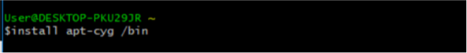

"apt-cyg" is a command in Cygwin similar to the "sudo apt-get" command in Linux. It is used to install packages, update them, list them, etc.

1. Type the following command and press “Enter” chere -i -t mintty -s bash

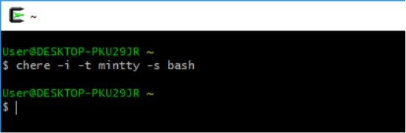

This will allow us to open a Cygwin bash terminal from any folder in your Windows File Explorer or other applications.

1. Type the following command on Cygwin terminal and press “Enter”. apt-cyg install libboost-devel

This installs the Boost Library. A progress message will show the installation.

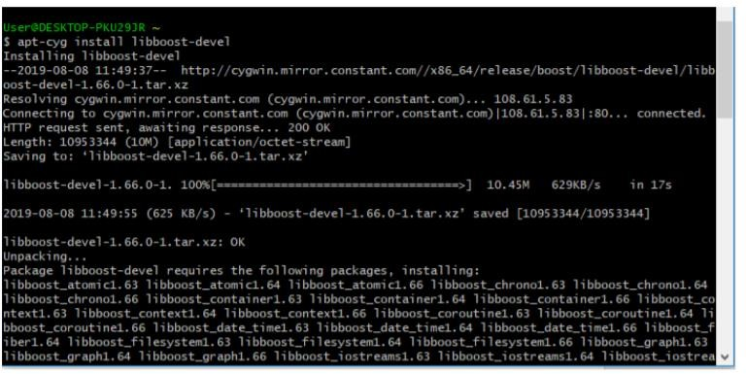

23). Go to C:\cygwin64\lib\gcc\x86_64-pc-cygwin\9.3.0\include

Add files: my_alloc.h, my_list.h,mysql.h,mysql_com.h, mysql_time.h ,typelib.h and mysql_version.h.

**Installing MySQL:**

1. **Go to** <https://dev.mysql.com/downloads/installer/>, select the operating system.

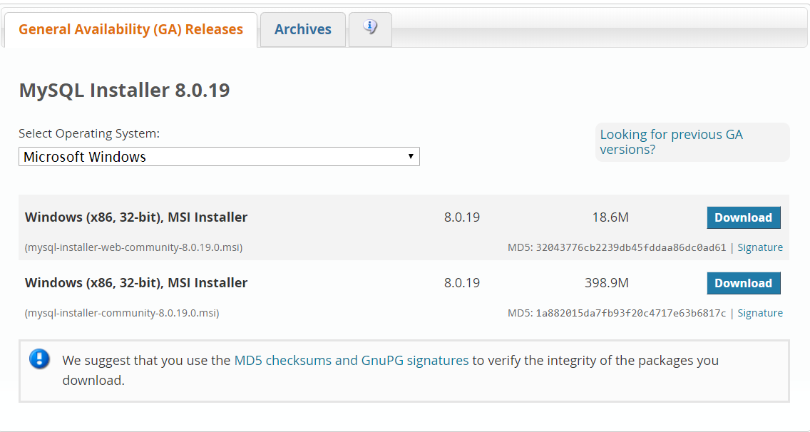

1. Choose one the installer and click on download.
2. You can wish to choose option to just download without login, as shown below.

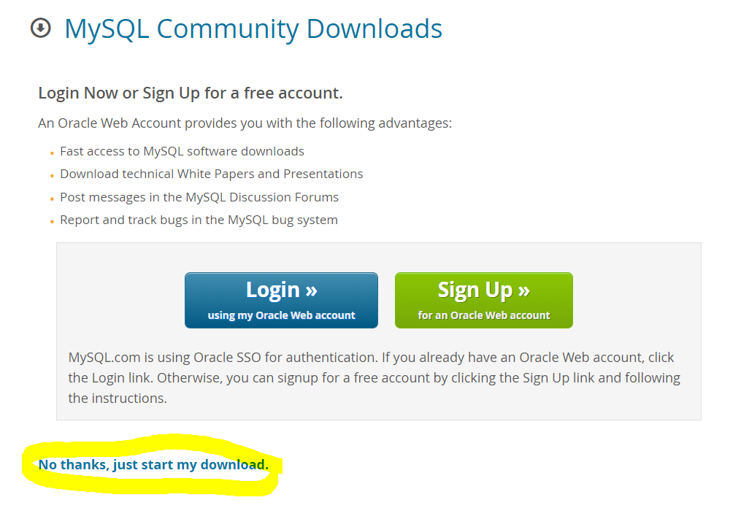

1. After download is complete double click on the downloaded file, the downloading will start.

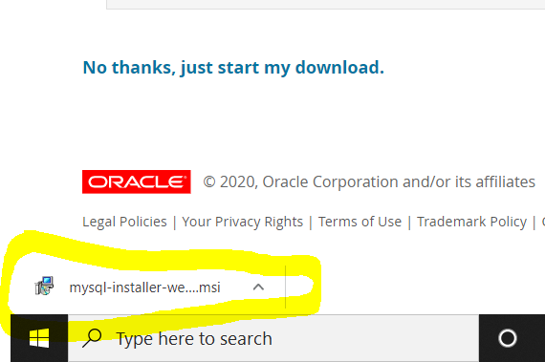

1. In the above dialog box, just check in in the radio button and accept the License Agreement. After that, click on **Next.**

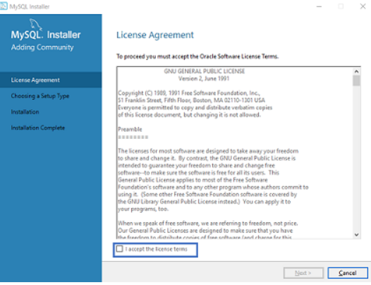

1. In the next wizard, you have to choose the **setup type**. Basically, this is where you choose which features you wish to install. Here I will choose the option **Full**and click on **Next.**

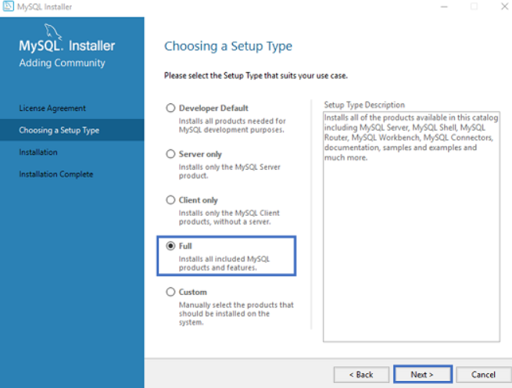

1. Once you click on **Next**, you might see that some features may fail to install due to lack of requirements. So, either you can resolve them, or can skip them, by clicking on **Next**. Here I will click on **Next.**

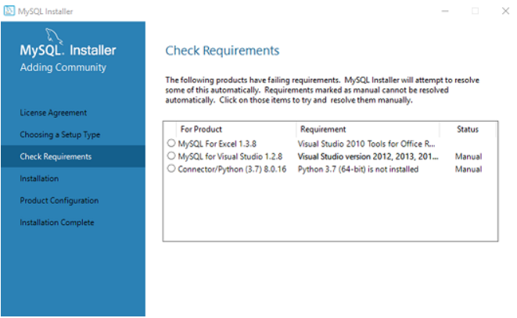

1. Next, you will see a dialog box asking for your confirmation of a few products not getting installed. So, you can just click on **Yes.**Refer below.

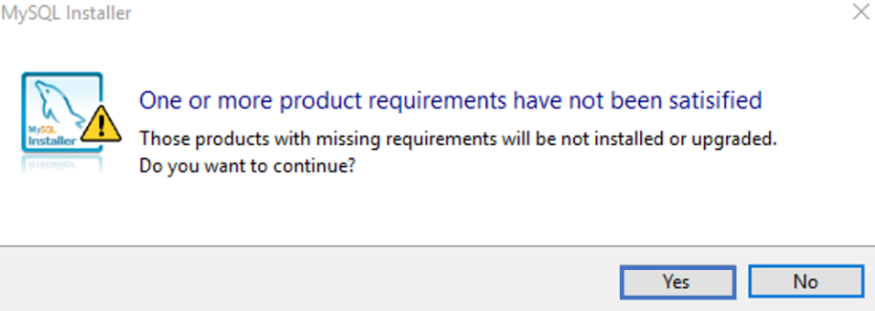

1. Once you hit on Execute, you will see that the products are getting installed. Refer below:

Now, once the installation is complete, click on **Next.**

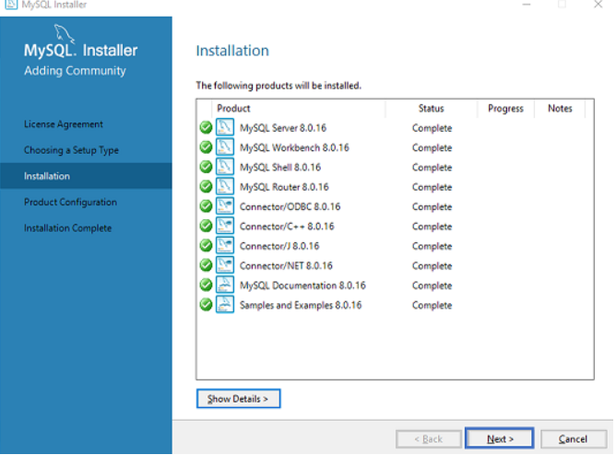

1. Now will see option to configure , just click on next option.

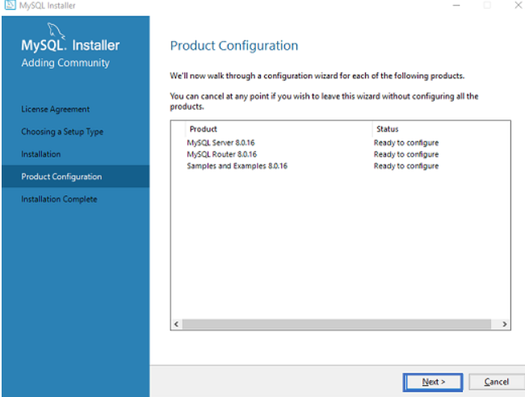

1. Choose, Standalone MySQL Cluster and then click on **Next.**

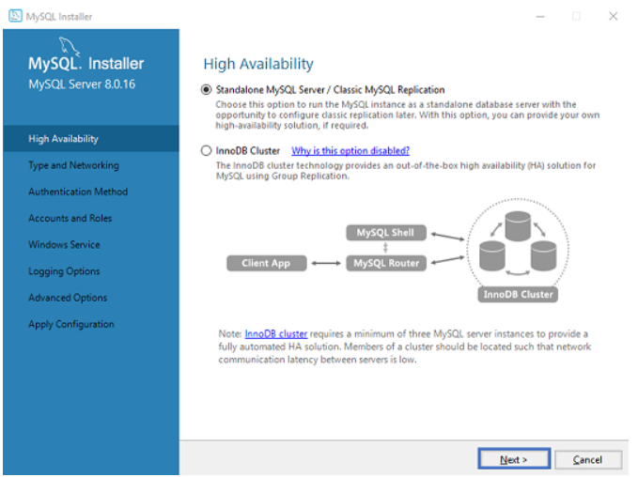

1. Once, you click on Next, you have to mention the**server configuration**. So, make sure port number is 3306 and then click on **Next.**

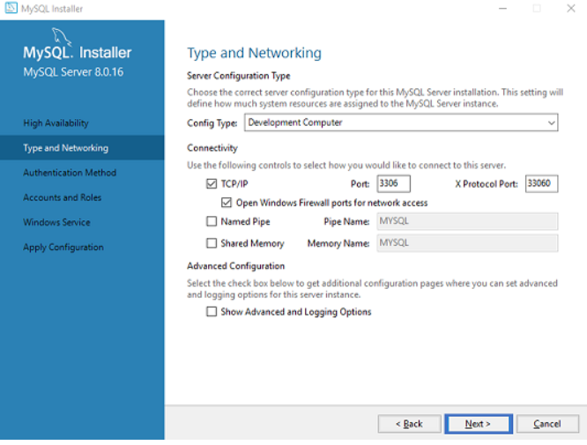

1. Now for authentication option , choose encryption option

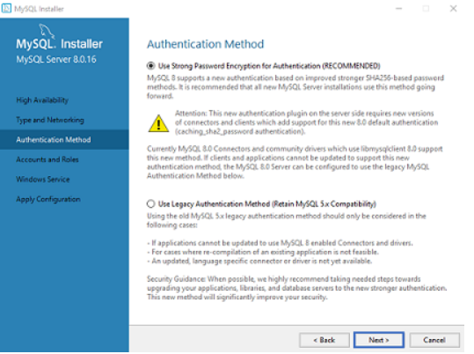

1. For password you should chose ‘1234’.
2. Click on start server option and click next.

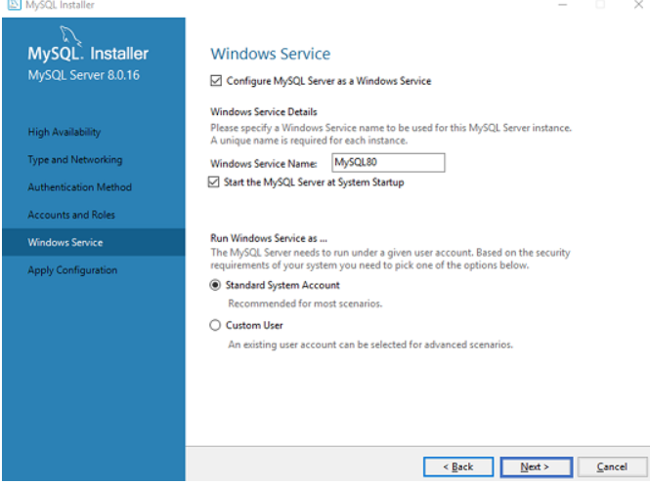

1. Now, the wizard will give you a list of the configurations which will be applied. So, if you agree with the configuration click on **Execute.** Once the execution is done, click on **Finish**. This will finish the configuration of Server.

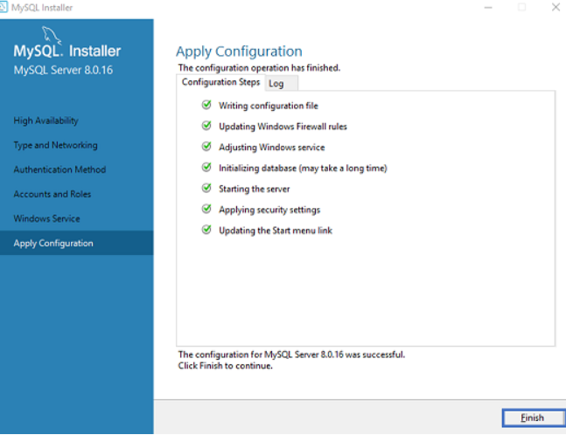

1. In the next wizard that comes up, you can choose to configure the Router. So just click on **Next** and click on **Finish.**

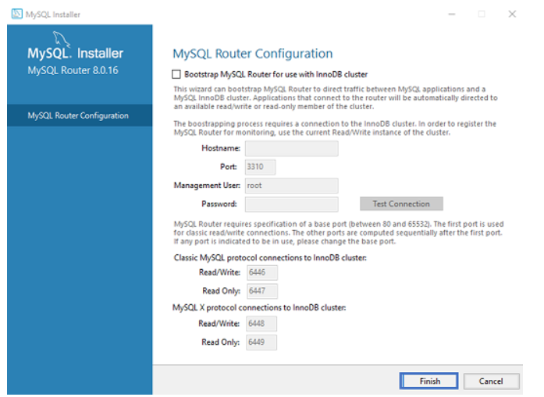

1. Once, you click on **Finish**, you will see the following wizard, to **Connect to server**. Here mention the root password (1234). Refer below.

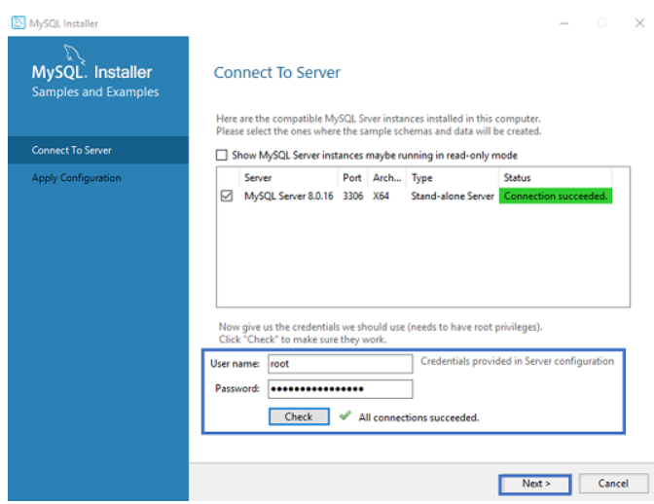

1. Once, you click on **Next**, choose the configurations applied and click on **Execute.** After the configurations get applied, you will see the following screen. So, here just click on **Finish**. Refer below.

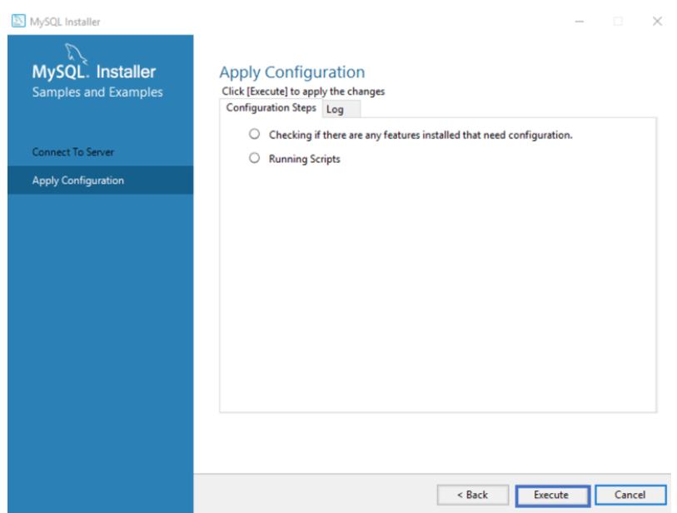

1. Now, to check whether MySQL is installed or not, you can open the MySQL Shell and mention the root password.

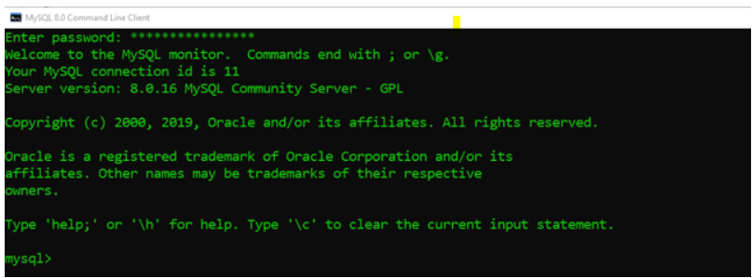

1. Now got start and launch “MySQL workbench”, click on “MySQL connections” and enter your password.

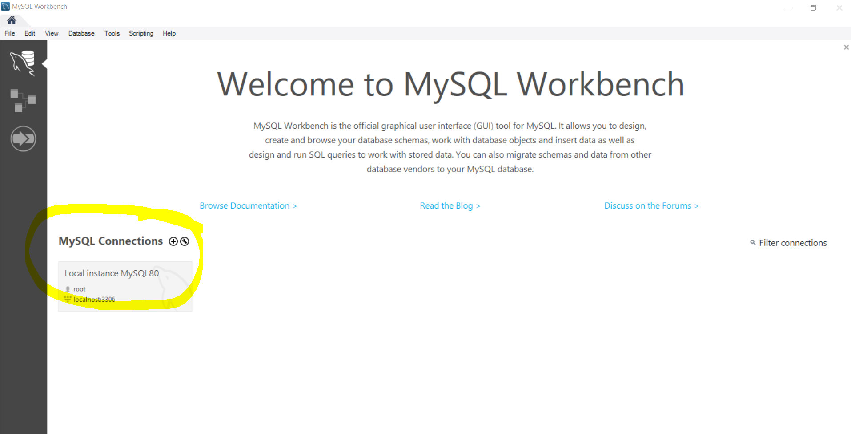

1. Now, you should open the script “Payroll_database” , which is present under database folder of project. and run this script.

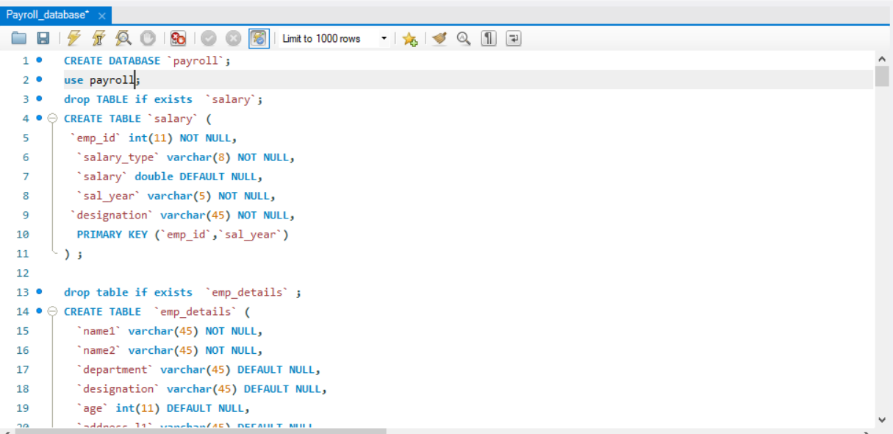

# Downloading Payroll

* 1. Install Git (User can use Git bash or any other software of choice to clone the project).
  2. Create a new folder for the project. Right Click inside the folder and open a git bash here. Right Click +” Git Bash here”.
  3. Type the following command in the git terminal:

Git clone <https://github.com/jagdeepbaidwan/employee_payroll>

* 1. Or go to the link <https://github.com/jagdeepbaidwan/employee_payroll> and click on Clone or Download and download the zip folder of the software.

Running payroll application:

1. Compiling the project.
2. Open the downloaded folder, open /src.
3. Copy path.
4. Open Cygwin64 Terminal, type cd (path) and enter.
5. Type “make” and enter.

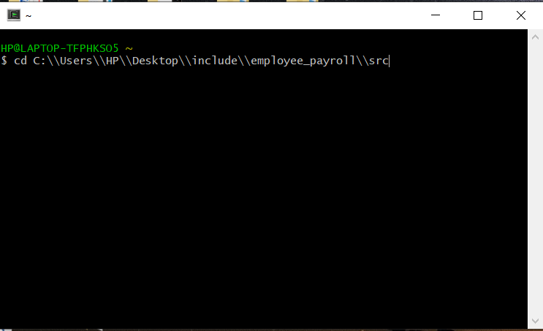

Fig : Copy make file folder path .

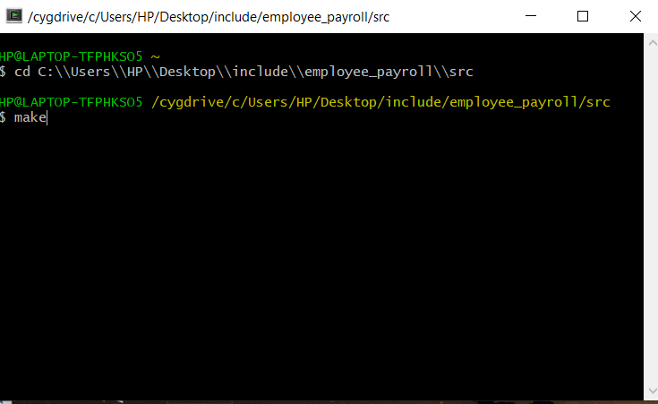

Fig : Type make and enter.

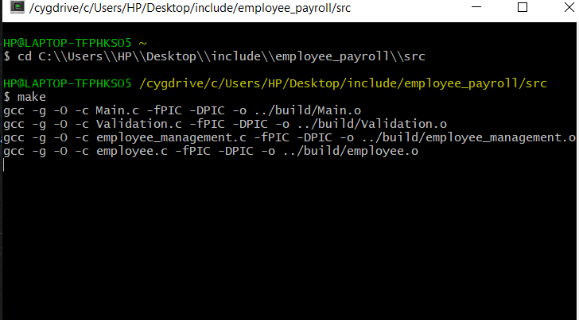

Fig : Creation of object file.

2) You will see Login screen.

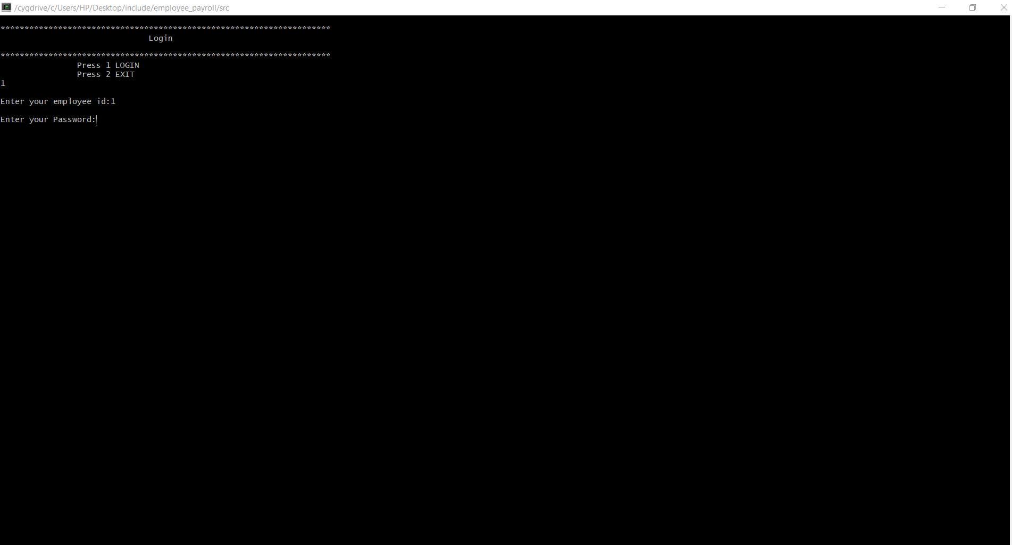

1. If user is “Admin”, it can see following options.

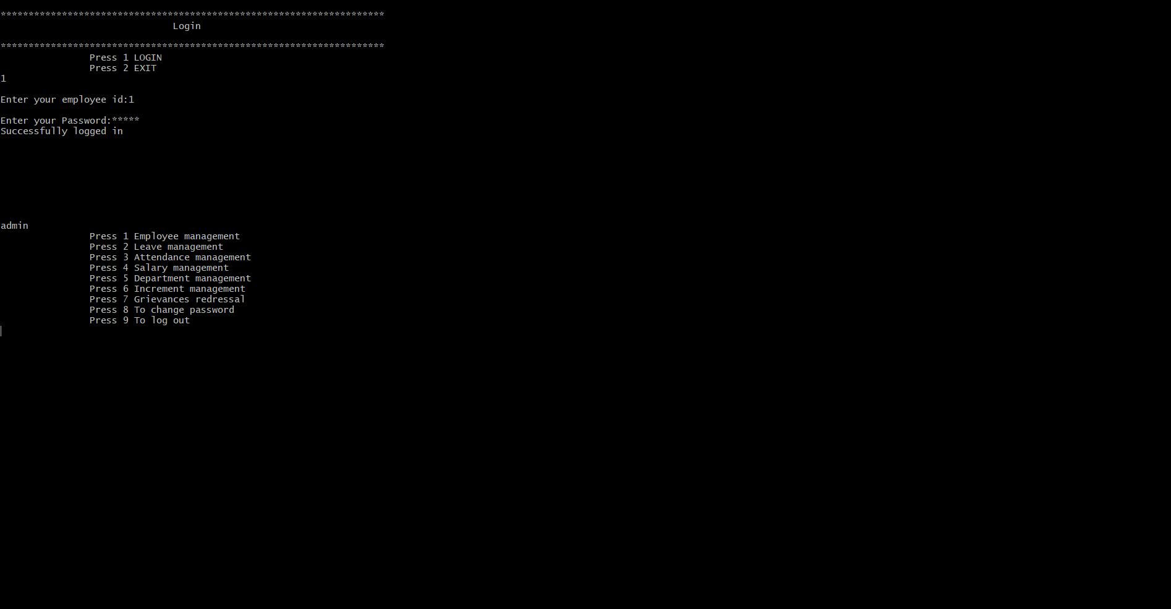

Fig : Admin login

1. If user login as “Employee” the following option will appear.

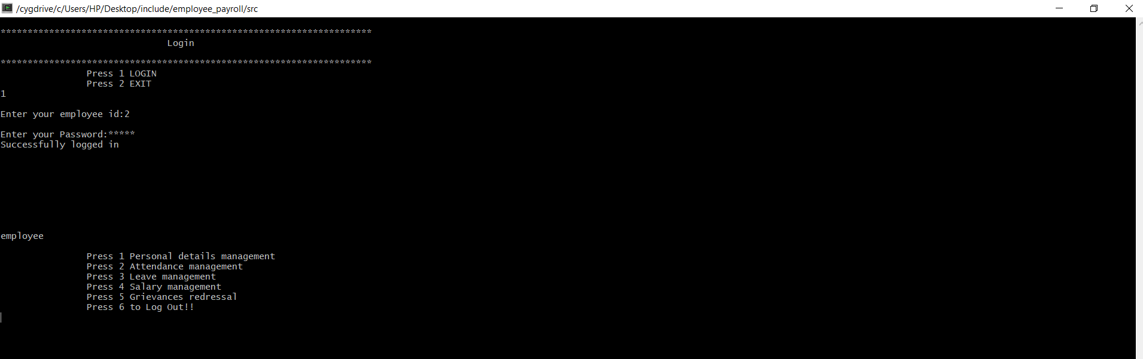

1. If user logins as “Manager” the following option will appear

