**SYSC 5709 – Winter 2020 – Course Project**

**Payroll Management**

Managing accounts and maintaining proper records of all employee’s time and attendance to

prepare payroll manually is a complex and time-consuming process. It is comparatively tedious to

prepare and becomes even difficult to manage as employee data grows. Additionally, such system

is prone to human errors which may lead to business penalties as accurate payroll processing is

crucial to remain compliant with federal and state laws. In order to mitigate risks, provide real time

data analytics and accurate calculation of employee payroll it is important to have an automated

payroll system that can be used by any organization for the management of employee attendances,

salaries, bonuses, taxes and other deductions with ease and precision.

This system manages following for employees:

1. Personal data.
2. Attendance.
3. Leaves.
4. Salary.
5. Performance.

In this project, there are three type of users:

1. Admin: admin has all the update, delete, add and view privileges.
2. Employees: Employees have privileges to view data, raise request to change data and update personal information.
3. Manager: Manager has all the privileges of an employee as well as privilege to give performance rating to employee.

**File and Folder Structure Organization**

1. **bin:** This folder has executable and data file for the Payroll system one input file:
2. payroll.exe
3. test.exe
4. **database:** This folder has the script of SQL queries for creating and inserting the data in the database.
5. payroll_database.sql
6. **doc:** It contains all the documents for the project.
7. html: The html folder generated by Doxigen for our project.
8. latex: The latex folder generated by Doxigen for our project.
9. user_manual.docs
10. developer_guide.docs
11. **external_files:** This folder contains seven mysql extra header files which, successfully execute the queries and paste in the C:\cygwin64\lib\gcc\x86_64-pc-cygwin\9.3.0\include folder.
12. my_alloc.h
13. my_list.h
14. mysql.h
15. mysql_time.h
16. mysql_com.h
17. mysql_version.h
18. typelib
19. **obj:** This folder has all the object files generated using make file.
20. admin_attend_mgmt.o
21. admin_dept_management.o
22. attendance_display.o
23. employee.o
24. employee_attdnce_management.o
25. employee_management.o
26. employee_personal_dtl_management.o
27. Main.o
28. manager_dept_management.o
29. validation.o
30. leave_request.o
31. salary_management.o
32. objtest: The folder contains object file for test file as test.o
33. **include:** It contains all the header files included in the project.
34. admin_attendance.h
35. attendance_display.h
36. employee.h
37. employee_management.h
38. employee_personal_dtl_management.h
39. manager_dept_management.h
40. validation.h
41. salary_management.h
42. **lib:** It has following dll files:
43. libmysql.dll
44. **src:** It has following .c files:
45. admin_attend_mgmt.c
46. admin_dept_management.c
47. attendance_display.c
48. employee.c
49. employee_attdnce_management.c
50. employee_management.c
51. employee_personal_dtl_management.c
52. Main.c
53. manager_dept_management.c
54. validation.c
55. leave_request.c
56. salary_management.c
57. **test:** It has following files:
58. test.c

**Flow diagram**

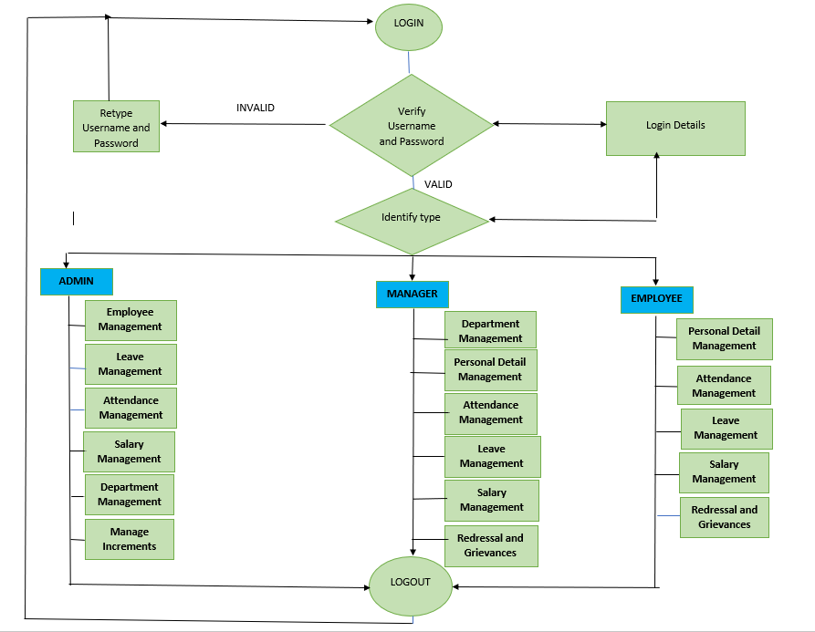

**GitHub Link:** <https://github.com/jagdeepbaidwan/employee_payroll>