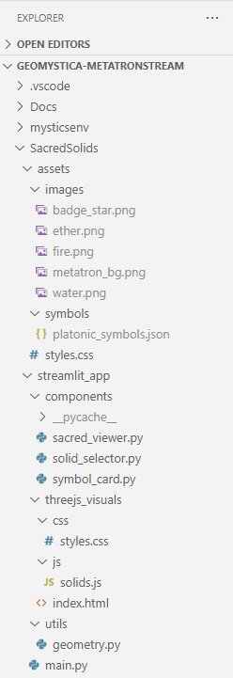

**requirements.txt**

streamlit>=1.30.0

numpy>=1.24.0

sympy>=1.12

pillow>=10.0.0

plotly>=5.20.0

watchdog>=3.0.0

streamlit-extras>=0.3.0

scipy

# streamlit-authenticator>=0.2.3      # For login/auth features

# pymongo>=4.6.0                      # If connecting to MongoDB

# streamlit-analytics>=0.1.0         # For tracking user interactions

# matplotlib>=3.8.0                   # For static plots

**styles.css**

body {

    font-family: 'Segoe UI', sans-serif;

    background-color: #f4f6f9;

    color: #333;

**}**

/* Title styling */

h1 {

    font-size: 2.5em;

    color: #2c3e50;

    text-align: center;

    margin-bottom: 0.5em;

}

/* Sidebar customization */

[data-testid="stSidebar"] {

    background-color: #ecf0f1;

    border-right: 2px solid #bdc3c7;

}

[data-testid="stSidebar"] .css-1d391kg {

    padding-top: 2em;

}

/* Plotly chart container */

.plot-container {

    border-radius: 12px;

    box-shadow: 0 4px 12px rgba(0,0,0,0.1);

    padding: 1em;

    background-color: #ffffff;

}

/* Latex and symbolic section */

.stMarkdown h2, .stMarkdown h3 {

    color: #34495e;

}

.stMarkdown .latex {

    font-size: 1.2em;

    color: #2c3e50;

}

/* Footer */

footer {

    text-align: center;

    font-size: 0.9em;

    color: #7f8c8d;

    margin-top: 2em;

}

/* Button hover effect */

button:hover {

    background-color: #3498db !important;

    color: white !important;

    transition: background-color 0.3s ease;

}

/* Smooth fade-in animation */

@keyframes fadeIn {

    from { opacity: 0; transform: translateY(10px); }

    to { opacity: 1; transform: translateY(0); }

}

.stApp {

    animation: fadeIn 0.6s ease-in-out;

}