# Git Repository Setup Guide

This document provides a step-by-step guide to creating a Git repository named '2402030430029' and setting up two folders: 'assignment-1' and 'assignment-2'.

## Step 1: Create a GitHub Repository

1. Go to https://github.com/ and log in to your account.

2. Click on the '+' icon in the top-right corner and select 'New repository'.

3. In the 'Repository name' field, enter: 2402030430045.

4. Choose 'Public' or 'Private' based on your preference.

5. (Optional) Check 'Add a README file' to initialize the repository.

6. Click 'Create repository'.

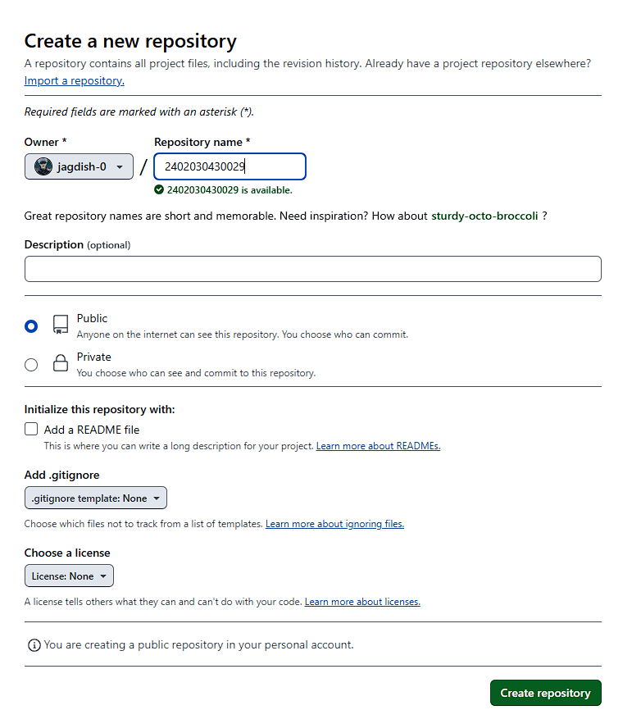

## Step 2: Clone the Repository Locally

1. Open a terminal (Command Prompt, Git Bash, or Terminal on macOS/Linux).

2. Run the following command to clone your repository:

```sh  
 git clone https://github.com/YOUR_USERNAME/2402030430029.git  
 ```

3. Navigate to the cloned repository:

```sh  
 cd 2402030430029  
 ```

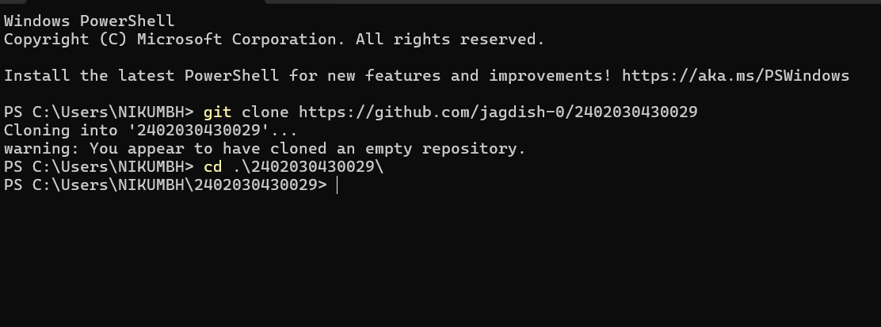

## Step 3: Create Folders

1. Run the following commands to create the required folders:

```sh  
 mkdir assignment-1 assignment-2  
 ```

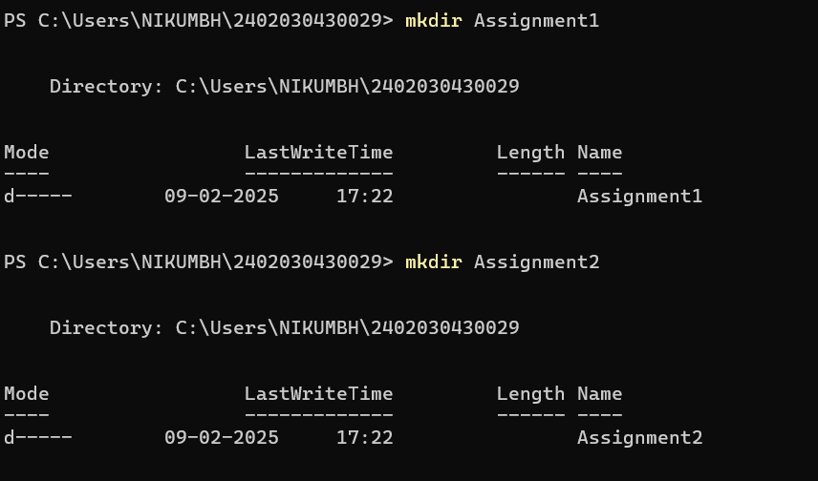

## Step 4: Add and Commit Changes

1. Stage the changes using:

```sh  
 git add .  
 ```

2. Commit the changes with a message:

```sh  
 git commit -m "Added assignment-1 and assignment-2 folders"  
 ```

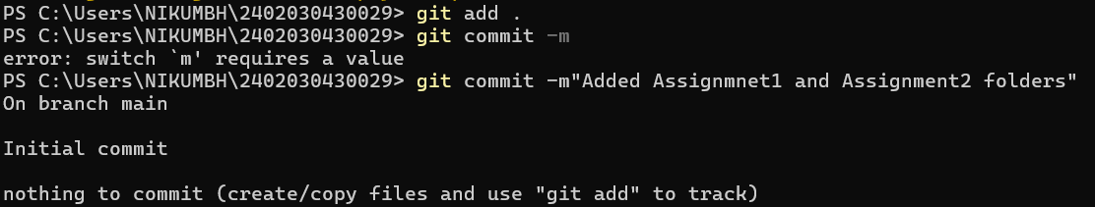

## Step 5: Push Changes to GitHub

1. Push the changes to the remote repository:

```sh  
 git push origin main  
 ```

## Conclusion

Your GitHub repository is now set up with the required folder structure. You can now start adding your files to 'assignment-1' and 'assignment-2'.