1. Introduction to SQL
LAB EXERCISES:
• Lab 1: Create a database called library_db and a table books with columns: book_id, title, author, publisher, year_of_publication, and price. Insert five records into the table.
CREATE DATABASE library_db;
USE library_db;
CREATE TABLE books (
book_id INT AUTO_INCREMENT PRIMARY KEY,
title VARCHAR(100),
author VARCHAR(100),
publisher VARCHAR(100),
year_of_publication INT,
price DECIMAL(10,2)
);
INSERT INTO books (title, author, publisher, year_of_publication, price)
VALUES
('The Alchemist', 'Paulo Coelho', 'HarperCollins', 1988, 399.00),
('Wings of Fire', 'A.P.J. Abdul Kalam', 'Universities Press', 1999, 250.00),
('Harry Potter and the Philosopher\'s Stone', 'J.K. Rowling', 'Bloomsbury', 1997, 450.00),
('The Power of Your Subconscious Mind', 'Joseph Murphy', 'Penguin', 1963, 299.00),
('Rich Dad Poor Dad', 'Robert Kiyosaki', 'Warner Books', 1997, 350.00);
select *from books;
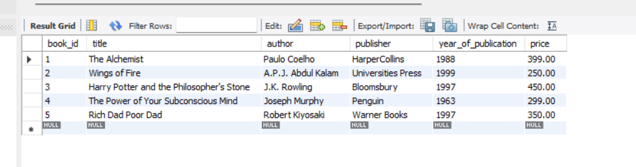
• Lab 2: Create a table members in library_db with columns: member_id, member_name, date_of_membership, and email. Insert five records into this table.
CREATE TABLE members (
member_id INT AUTO_INCREMENT PRIMARY KEY,
member_name VARCHAR(100),
date_of_membership DATE,
email VARCHAR(100)
);
INSERT INTO members (member_name, date_of_membership, email)
VALUES
('Rohan Shah', '2024-01-15', 'rohan.shah@example.com'),
('Sneha Patil', '2024-02-10', 'sneha.patil@example.com'),
('Vikas Mehta', '2024-03-05', 'vikas.mehta@example.com'),
('Aditi Rao', '2024-04-22', 'aditi.rao@example.com'),
('Amit Kulkarni', '2022-01-12', 'amit.kulkarni@example.com'),
('Pooja Desai', '2022-06-18', 'pooja.desai@example.com'),
('Rahul Joshi', '2022-11-25', 'rahul.joshi@example.com'),
('Kunal Verma', '2024-05-30', 'kunal.verma@example.com');
Select *from members;
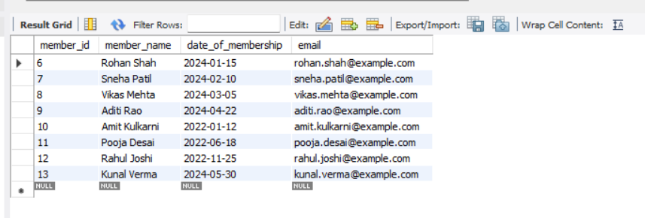
2. SQL Syntax LAB EXERCISES:
• Lab 3: Retrieve all members who joined the library before 2022. Use appropriate SQL syntax with WHERE and ORDER BY.
Query :
SELECT *
FROM members
WHERE date_of_membership BETWEEN '2022-01-01' AND '2022-12-31'
ORDER BY date_of_membership ASC;
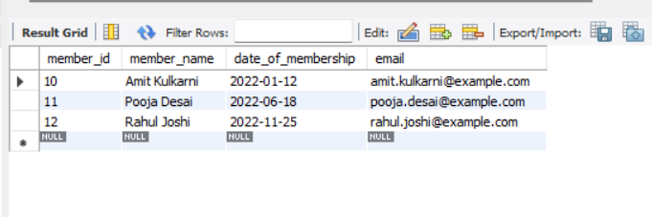

• Lab 4: Write SQL queries to display the titles of books published by a specific author. Sort the results by year_of_publication in descending order.
Query:
SELECT title, year_of_publication
FROM books
WHERE author = 'Paulo Coelho'
ORDER BY year_of_publication DESC;

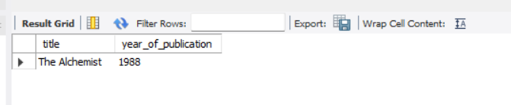

3. SQL Constraints
LAB EXERCISES:
• Lab 3: Add a CHECK constraint to ensure that the price of books in the books table is greater than 0.
ALTER TABLE books
ADD CONSTRAINT chk_book_price
CHECK (price > 0);

INSERT INTO books (title, author, publisher, year_of_publication, price)
VALUES ('Test Book', 'Test Author', 'Test Pub', 2024, -100);
Output Error
-- Prevents invalid data entry
• Lab 4: Modify the members table to add a UNIQUE constraint on the email column, ensuring that each member has a unique email address.
ALTER TABLE members
ADD CONSTRAINT unique_member_email
UNIQUE (email);
- Prevents duplicate member registrations

4. Main SQL Commands and Sub-commands (DDL)
LAB EXERCISES:
• Lab 3: Create a table authors with the following columns: author_id, first_name, last_name, and country. Set author_id as the primary key.
Query:
CREATE TABLE authors (
author_id INT PRIMARY KEY AUTO_INCREMENT,
first_name VARCHAR(50) NOT NULL,
last_name VARCHAR(50) NOT NULL,
country VARCHAR(50)
);
Desc authors;
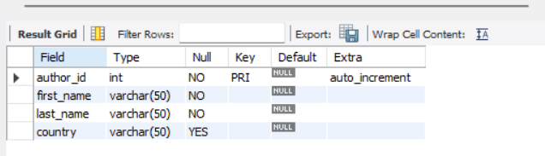
• Lab 4: Create a table publishers with columns: publisher_id, publisher_name, contact_number, and address. Set publisher_id as the primary key and contact_number as unique.
Query:
CREATE TABLE publishers (
publisher_id INT PRIMARY KEY AUTO_INCREMENT,
publisher_name VARCHAR(100) NOT NULL,
contact_number VARCHAR(15) UNIQUE,
address VARCHAR(150)
);
desc publishers;
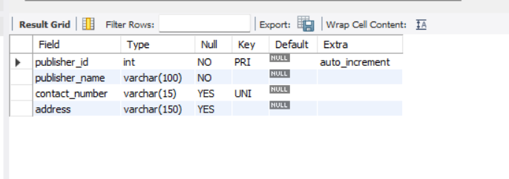

5. ALTER Command LAB EXERCISES:
• Lab 3: Add a new column genre to the books table. Update the genre for all existing records.
Step 1: Add new column genre
ALTER TABLE books
ADD genre VARCHAR(50);

Step 2 : Update different genres
UPDATE books
SET genre = 'Inspirational'
WHERE book_id = 1;

UPDATE books
SET genre = 'Autobiography'
WHERE book_id = 2;

UPDATE books
SET genre = 'Fantasy'
WHERE book_id = 3;

UPDATE books
SET genre = 'Self-Help'
WHERE book_id = 4;

UPDATE books
SET genre = 'Finance'
WHERE book_id = 5;

select *from books;
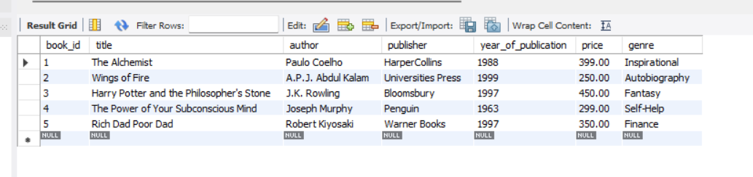
• Lab 4: Modify the members table to increase the length of the email column to 100 characters.
ALTER TABLE members
MODIFY email VARCHAR(100);

desc members;
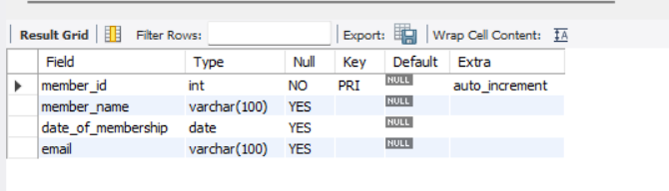

6. DROP Command LAB EXERCISES:
• Lab 3: Drop the publishers table from the database after verifying its structure.
Query:
DESC publishers;
DROP TABLE publishers;
SHOW TABLES;
• Lab 4: Create a backup of the members table and then drop the original members table.
CREATE TABLE members_backup AS
SELECT * FROM members;

DROP TABLE members;
SELECT * FROM members_backup;
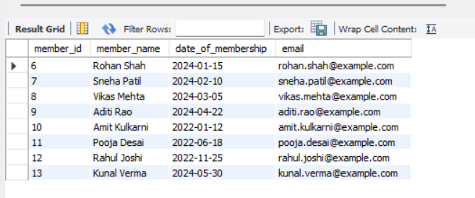

7. Data Manipulation Language (DML) LAB EXERCISES:
• Lab 4: Insert three new authors into the authors table, then update the last name of one of the authors.
Query:
INSERT INTO authors (first_name, last_name, country)
VALUES
('Paulo', 'Coelho', 'Brazil'),
('J.K.', 'Rowling', 'United Kingdom'),
('A.P.J.', 'Kalam', 'India');

SELECT * FROM authors;

UPDATE authors
SET last_name = 'Abdul Kalam'
WHERE author_id = 3;

SELECT * FROM authors;
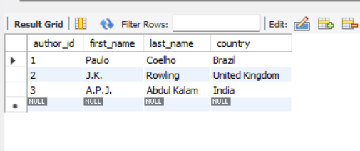
• Lab 5: Delete a book from the books table where the price is higher than $100.
Query:
SET SQL_SAFE_UPDATES = 0;
DELETE FROM books
WHERE price > 100;

select * from books;
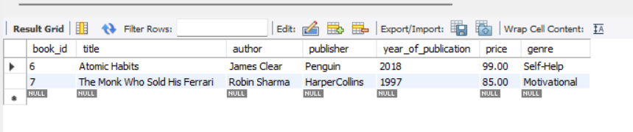

8. UPDATE Command LAB EXERCISES:
• Lab 3: Update the year_of_publication of a book with a specific book_id.
UPDATE books
SET year_of_publication = 2005
WHERE book_id = 7;
Select * from books;

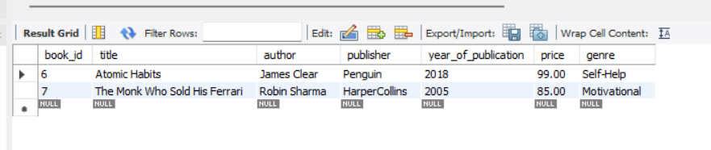
• Lab 4: Increase the price of all books published before 2015 by 10%.
UPDATE books
SET price = price * 1.10
WHERE year_of_publication < 2015;
Select * from books;
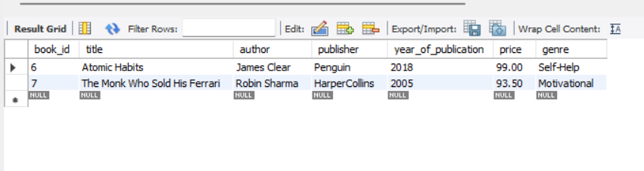
9. DELETE Command LAB EXERCISES:
• Lab 3: Remove all members who joined before 2020 from the members table.
DELETE FROM members
WHERE date_of_membership < '2020-01-01';
• Lab 4: Delete all books that have a NULL value in the author column.
DELETE FROM books
WHERE author IS NULL;

10. Data Query Language (DQL) LAB EXERCISES:
• Lab 4: Write a query to retrieve all books with price between $50 and $100.
SELECT *
FROM books
WHERE price BETWEEN 50 AND 100;
• Lab 5: Retrieve the list of books sorted by author in ascending order and limit the results to the top 3 entries.
SELECT *
FROM books
ORDER BY author ASC
LIMIT 3;

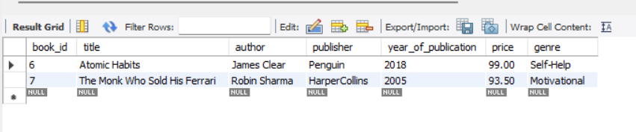
11. Data Control Language (DCL) LAB EXERCISES:
• Lab 3: Grant SELECT permission to a user named librarian on the books table.
Query:
GRANT SELECT
ON library_db.books
TO 'librarian'@'localhost';
Allows librarian to only view data from books
Cannot insert, update, or delete
• Lab 4: Grant INSERT and UPDATE permissions to the user admin on the members table.
Query:
GRANT INSERT, UPDATE
ON library_db.members
TO 'admin'@'localhost';

✔ Allows admin to add and modify records
✔ No permission to delete or drop

12. REVOKE Command LAB EXERCISES:
• Lab 3: Revoke the INSERT privilege from the user librarian on the books table.
REVOKE INSERT
ON library_db.books
FROM 'librarian'@'localhost';
✔ Result:
- librarian cannot INSERT into books
- Other privileges (like SELECT) remain unchanged

• Lab 4: Revoke all permissions from user admin on the members table.
REVOKE ALL PRIVILEGES
ON library_db.members
FROM 'admin'@'localhost';

✔ Result:
- admin loses all access to members
- Table still exists

13. Transaction Control Language (TCL) LAB EXERCISES:
• Lab 3:
Use COMMIT after inserting multiple records into the books table, then make another insertion and perform a ROLLBACK.
Step 1: Insert multiple records
INSERT INTO books (title, author, publisher, year_of_publication, price, genre)
VALUES
('Think Like a Monk', 'Jay Shetty', 'Simon & Schuster', 2020, 180, 'Self-Help'),
('Ikigai', 'Hector Garcia', 'Penguin', 2016, 150, 'Motivational');
Step 2: COMMIT the transaction
COMMIT;
✔ These records are permanently saved

Step 3: Insert another record
INSERT INTO books (title, author, publisher, year_of_publication, price, genre)
VALUES ('Temporary Book', 'Temp Author', 'Temp Pub', 2024, 200, 'Test');
Step 4: ROLLBACK
ROLLBACK;
✔ The last insert is undone
✔ Previously committed records remain

Verify
SELECT title FROM books;
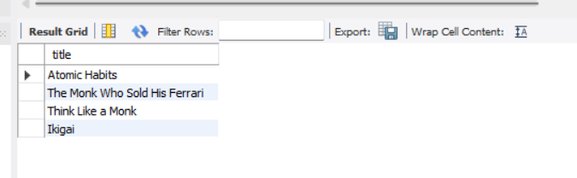
• Lab 4:
Set a SAVEPOINT before making updates to the members table, perform some updates, and then roll back to the SAVEPOINT.
Step 1: Start transaction
SET AUTOCOMMIT = 0;
Step 2: Create a SAVEPOINT
SAVEPOINT before_updates;
Step 3: Perform updates
UPDATE members
SET member_name = 'Updated Name'
WHERE member_id = 1;

UPDATE members
SET email = 'updated.email@example.com'
WHERE member_id = 2;
Step 4: Roll back to SAVEPOINT
ROLLBACK TO before_updates;
✔ Updates after the savepoint are undone
✔ Data before savepoint remains unchanged
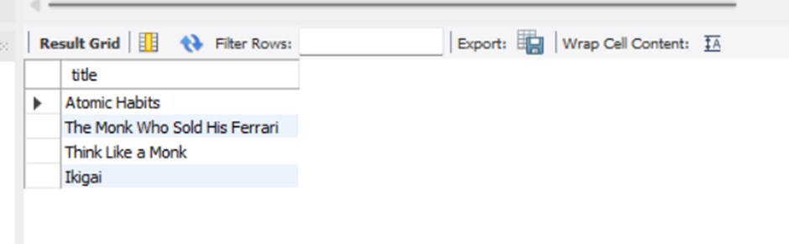
14. SQL Joins LAB EXERCISES:
• Lab 3: Perform an INNER JOIN between books and authors tables to display the title of books and their respective authors' names.
SELECT
b.title,
a.first_name,
a.last_name
FROM books b
INNER JOIN authors a
ON b.author = CONCAT(a.first_name, ' ', a.last_name);

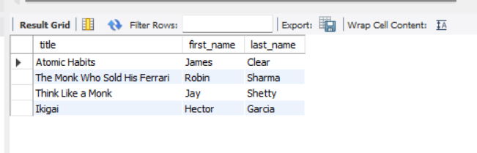
• Lab 4: Use a FULL OUTER JOIN to retrieve all records from the books and authors tables, including those with no matching entries in the other table.
SELECT
b.title,
a.first_name,
a.last_name
FROM books b
LEFT JOIN authors a
ON b.author = CONCAT(a.first_name, ' ', a.last_name)

UNION

SELECT
b.title,
a.first_name,
a.last_name
FROM books b
RIGHT JOIN authors a
ON b.author = CONCAT(a.first_name, ' ', a.last_name);
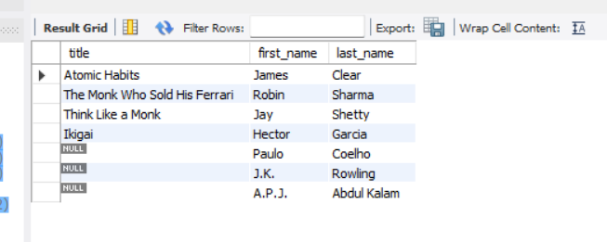
15. SQL Group By LAB EXERCISES:
• Lab 3: Group books by genre and display the total number of books in each genre.
SELECT
genre,
COUNT(*) AS total_books
FROM books
GROUP BY genre;
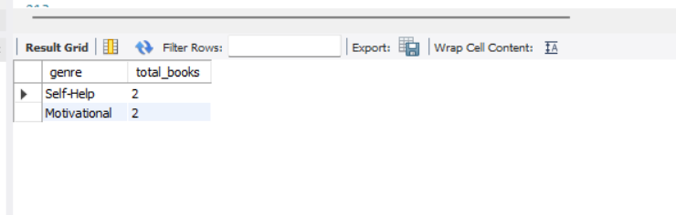
• Lab 4: Group members by the year they joined and find the number of members who joined each year.
SELECT
YEAR(date_of_membership) AS join_year,
COUNT(*) AS total_members
FROM members
GROUP BY YEAR(date_of_membership)
ORDER BY join_year;
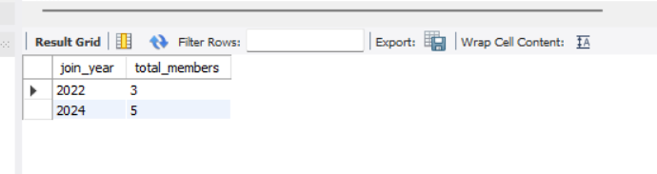
16. SQL Stored Procedure LAB EXERCISES:
• Lab 3: Write a stored procedure to retrieve all books by a particular author.
DELIMITER $$

CREATE PROCEDURE get_books_by_author (
IN p_author VARCHAR(100)
)
BEGIN
SELECT
book_id,
title,
author,
publisher,
year_of_publication,
price,
genre
FROM books
WHERE author = p_author;
END $$

DELIMITER ;

CALL get_books_by_author('James Clear');
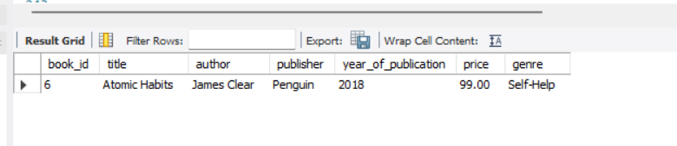
• Lab 4: Write a stored procedure that takes book_id as an argument and returns the price of the book.
DELIMITER $$

CREATE PROCEDURE get_book_price (
IN p_book_id INT
)
BEGIN
SELECT
book_id,
title,
price
FROM books
WHERE book_id = p_book_id;
END $$

DELIMITER ;
CALL get_book_price(6);
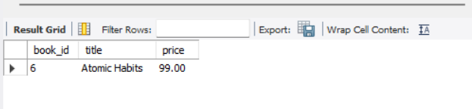
17. SQL View LAB EXERCISES:
• Lab 3: Create a view to show only the title, author, and price of books from the books table.
CREATE VIEW book_basic_details AS
SELECT
title,
author,
price
FROM books;

SELECT * FROM book_basic_details;
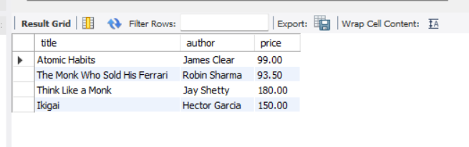
• Lab 4: Create a view to display members who joined before 2020.
CREATE VIEW members_before_2020 AS
SELECT
member_id,
member_name,
date_of_membership,
email
FROM members
WHERE date_of_membership < '2020-01-01';

SELECT * FROM members_before_2020;
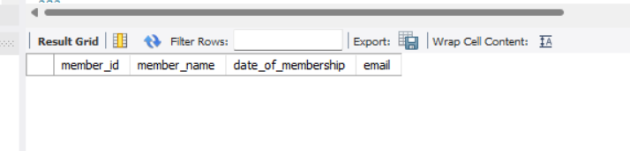

18. SQL Trigger LAB EXERCISES:
• Lab 3: Create a trigger to automatically update the last_modified timestamp of the books table whenever a record is updated.
ALTER TABLE books
ADD last_modified TIMESTAMP DEFAULT CURRENT_TIMESTAMP;

DELIMITER $$

CREATE TRIGGER trg_books_last_modified
BEFORE UPDATE ON books
FOR EACH ROW
BEGIN
SET NEW.last_modified = CURRENT_TIMESTAMP;
END $$

DELIMITER ;

UPDATE books
SET price = price + 10
WHERE book_id = 6;

SELECT book_id, title, last_modified FROM books;
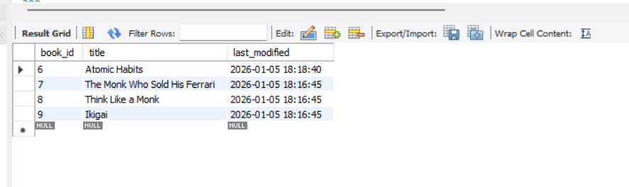
• Lab 4: Create a trigger that inserts a log entry into a log_changes table whenever a DELETE operation is performed on the books table.
CREATE TABLE log_changes (
log_id INT AUTO_INCREMENT PRIMARY KEY,
book_id INT,
action_type VARCHAR(20),
action_time TIMESTAMP DEFAULT CURRENT_TIMESTAMP
);

DELIMITER $$

CREATE TRIGGER trg_books_delete_log
AFTER DELETE ON books
FOR EACH ROW
BEGIN
INSERT INTO log_changes (book_id, action_type)
VALUES (OLD.book_id, 'DELETE');
END $$

DELIMITER ;

DELETE FROM books
WHERE book_id = 9;

SELECT * FROM log_changes;
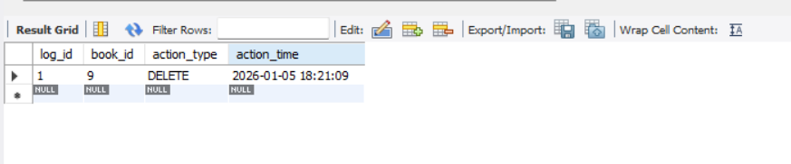
19. Introduction to PL/SQL LAB EXERCISES:
• Lab 3: Write a PL/SQL block to insert a new book into the books table and display a confirmation message.
DELIMITER $$

CREATE PROCEDURE insert_new_book()
BEGIN
INSERT INTO books
(title, author, publisher, year_of_publication, price, genre)
VALUES
('Deep Work', 'Cal Newport', 'Penguin', 2016, 120.00, 'Self-Help');

SELECT 'Book inserted successfully' AS message;
END $$

DELIMITER ;
CALL insert_new_book();
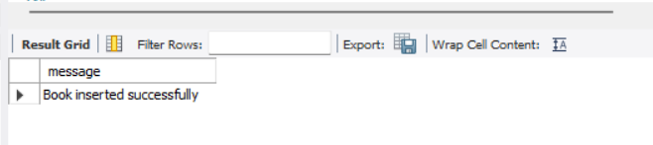
• Lab 4: Write a PL/SQL block to display the total number of books in the books table.
DELIMITER $$

CREATE PROCEDURE total_books_count()
BEGIN
SELECT COUNT(*) AS total_books
FROM books;
END $$

DELIMITER ;

CALL total_books_count();
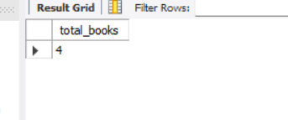
20. PL/SQL Syntax LAB EXERCISES:
• Lab 3: Write a PL/SQL block to declare variables for book_id and price, assign values, and display the results.
DELIMITER $$

CREATE PROCEDURE show_book_variables()
BEGIN
DECLARE v_book_id INT;
DECLARE v_price DECIMAL(10,2);

SET v_book_id = 6;
SET v_price = 99.00;

SELECT
v_book_id AS book_id,
v_price AS price;
END $$

DELIMITER ;
CALL show_book_variables();
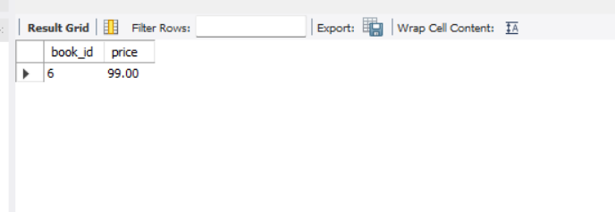
• Lab 4: Write a PL/SQL block using constants and perform arithmetic operations on book prices.
DELIMITER $$

CREATE PROCEDURE price_calculation()
BEGIN
DECLARE base_price DECIMAL(10,2) DEFAULT 100.00;
DECLARE tax_rate DECIMAL(5,2) DEFAULT 0.10;
DECLARE final_price DECIMAL(10,2);

SET final_price = base_price + (base_price * tax_rate);

SELECT
base_price AS original_price,
final_price AS price_after_tax;
END $$

DELIMITER ;
CALL price_calculation();
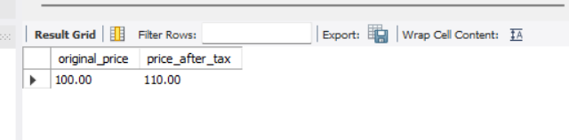

21. PL/SQL Control Structures LAB EXERCISES:
• Lab 3: Write a PL/SQL block using IF-THEN-ELSE to check if a book's price is above $100 and print a message accordingly.
DELIMITER $$

CREATE PROCEDURE check_book_price(IN p_book_id INT)
BEGIN
DECLARE v_price DECIMAL(10,2);

SELECT price INTO v_price
FROM books
WHERE book_id = p_book_id;

IF v_price > 100 THEN
SELECT 'Book price is above 100' AS message;
ELSE
SELECT 'Book price is 100 or below' AS message;
END IF;
END $$

DELIMITER ;
CALL check_book_price(6);
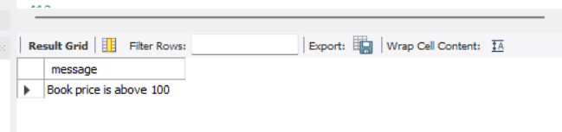
• Lab 4: Use a FOR LOOP in PL/SQL to display the details of all books one by one.
DELIMITER $$

CREATE PROCEDURE display_all_books()
BEGIN
DECLARE done INT DEFAULT 0;
DECLARE v_id INT;
DECLARE v_title VARCHAR(100);
DECLARE v_author VARCHAR(100);
DECLARE v_price DECIMAL(10,2);

DECLARE book_cursor CURSOR FOR
SELECT book_id, title, author, price FROM books;

DECLARE CONTINUE HANDLER FOR NOT FOUND SET done = 1;

OPEN book_cursor;

read_loop: LOOP
FETCH book_cursor INTO v_id, v_title, v_author, v_price;

IF done = 1 THEN
LEAVE read_loop;
END IF;

SELECT v_id AS book_id,
v_title AS title,
v_author AS author,
v_price AS price;
END LOOP;

CLOSE book_cursor;
END $$

DELIMITER ;
CALL display_all_books();
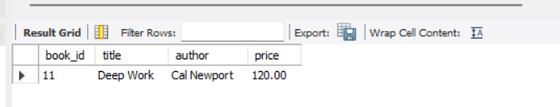

22. SQL Cursors LAB EXERCISES:
• Lab 3: Write a PL/SQL block using an explicit cursor to fetch and display all records from the members table.
DELIMITER $$

CREATE PROCEDURE display_all_members()
BEGIN
DECLARE done INT DEFAULT 0;
DECLARE v_id INT;
DECLARE v_name VARCHAR(100);
DECLARE v_date DATE;
DECLARE v_email VARCHAR(100);

DECLARE member_cursor CURSOR FOR
SELECT member_id, member_name, date_of_membership, email
FROM members;

DECLARE CONTINUE HANDLER FOR NOT FOUND SET done = 1;

OPEN member_cursor;

read_loop: LOOP
FETCH member_cursor INTO v_id, v_name, v_date, v_email;

IF done = 1 THEN
LEAVE read_loop;
END IF;

SELECT
v_id AS member_id,
v_name AS member_name,
v_date AS date_of_membership,
v_email AS email;
END LOOP;

CLOSE member_cursor;
END $$

DELIMITER ;
CALL display_all_members();
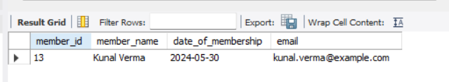
• Lab 4: Create a cursor to retrieve books by a particular author and display their titles.
DELIMITER $$

CREATE PROCEDURE display_books_by_author(IN p_author VARCHAR(100))
BEGIN
DECLARE done INT DEFAULT 0;
DECLARE v_title VARCHAR(100);

DECLARE book_cursor CURSOR FOR
SELECT title
FROM books
WHERE author = p_author;

DECLARE CONTINUE HANDLER FOR NOT FOUND SET done = 1;

OPEN book_cursor;

read_loop: LOOP
FETCH book_cursor INTO v_title;

IF done = 1 THEN
LEAVE read_loop;
END IF;

SELECT v_title AS book_title;
END LOOP;

CLOSE book_cursor;
END $$

DELIMITER ;
CALL display_books_by_author('James Clear');
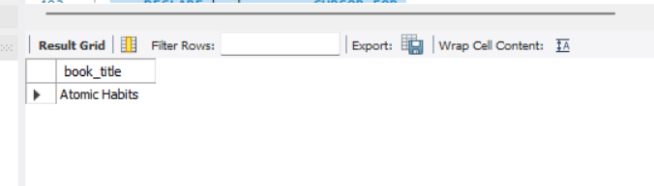

23. Rollback and Commit Savepoint
LAB EXERCISES:
• Lab 3: Perform a transaction that includes inserting a new member, setting a SAVEPOINT, and rolling back to the savepoint after making updates.
Step 1: Turn OFF autocommit
SET AUTOCOMMIT = 0;

Step 2: Insert a new member
INSERT INTO members (member_name, date_of_membership, email)
VALUES ('Test Member', '2024-06-01', 'test.member@example.com');

Step 3: Set SAVEPOINT
SAVEPOINT before_update;

Step 4: Perform updates
UPDATE members
SET member_name = 'Updated Member'
WHERE email = 'test.member@example.com';

Step 5: Rollback to SAVEPOINT
ROLLBACK TO before_update;
✔ Update is undone
✔ Insert remains

Verify
SELECT * FROM members
WHERE email = 'test.member@example.com';

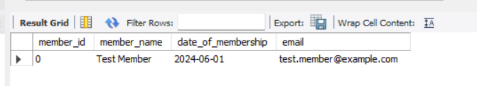
• Lab 4: Use COMMIT after successfully inserting multiple books into the books table, then use ROLLBACK to undo a set of changes made after a savepoint.
Step 1: Insert multiple books
INSERT INTO books (title, author, publisher, year_of_publication, price, genre)
VALUES
('Book A', 'Author A', 'Pub A', 2015, 120.00, 'Fiction'),
('Book B', 'Author B', 'Pub B', 2016, 140.00, 'Drama');

Step 2: COMMIT
COMMIT;
✔ Books are permanently saved

Step 3: Create SAVEPOINT
SAVEPOINT after_commit;

Step 4: Make changes
UPDATE books
SET price = price + 50
WHERE year_of_publication < 2018;

Step 5: ROLLBACK to SAVEPOINT
ROLLBACK TO after_commit;
✔ Price updates undone
✔ Inserted books remain

Verify
SELECT title, price FROM books;

