Freight Rate Prediction — Solution Report
Machine Learning Engineer Assessment · HistGradientBoostingRegressor on log(rate-per-mile) · seed = 42

1. Summary
The goal is to predict posted_rate (freight load price in USD) for 12,000 unseen loads covering November–December 2025, using 48,000 labeled loads (January–October 2025) for training. The model is a gradient-boosted tree (sklearn HistGradientBoostingRegressor) that learns log(rate-per-mile); the dollar prediction is recovered as exp(output) × distance. Cross-validation uses three rolling-origin (expanding-window) folds, matching the temporal structure of the holdout set. The best model achieves an average non-outlier WAPE of 3.34% versus 8.76% for the naive median-rate-per-mile baseline on the same rows (a 62% reduction in weighted absolute error); including the outlier rows the figures are 5.47% versus 10.74% (a 49% reduction).

2. Data and Quality Issues
data/train_test.csv contains 48,000 rows (Jan–Oct 2025, 14 columns). data/validation.csv contains 12,000 rows (Nov–Dec 2025, 13 columns — no posted_rate). The following issues were identified and treated before feature engineering:
Issue | Scale (train / val) | Treatment
Weight negative (sign error) | 292 train / 145 val | abs() — take absolute value
Weight missing | 300 train / 165 val | Median by equipment type, then global median
Weight right-censored ≥ 47,500 lb | 1,191 train / 297 val | Kept as-is; ceiling value is informative
market_index missing | 374 train / 249 val | Per-date median from same dataset's non-missing rows only (no leakage)
quote_signal missing | 0 train / 0 val | No action required
RPM outliers < $1.20/mi or > $4.50/mi | 335 + 335 = 670 train / — | Excluded from training only; kept in 'all rows' evaluation
Duplicate load_ids | 0 train / 0 val | No action required
Cities in val absent from train | 8 cities (e.g. Chicago, Laredo) | Mapped to an '__unknown__' code (never seen in training, so not learned); lat/lon features still describe the city
road distance vs haversine | Mean gap = +170 mi (road >> straight-line) | Both distance and haversine_dist used as features; diff = routing detour proxy

3. Train / Validation Split
Why random K-fold is wrong here: The validation set (Nov–Dec 2025) is strictly later than the training set (Jan–Oct 2025). Random K-fold would mix future labels into earlier training folds, artificially inflating performance estimates, and it would not mimic the real task of predicting a later period (Nov–Dec) from earlier data only.
Strategy used — rolling-origin (expanding window): Three forward-chaining folds were used. In each fold the training window expands by one month and the two-month validation window advances by one month (adjacent validation windows overlap by one month), mirroring production conditions.
Fold | Training window | Validation window | n train | n val
1 | Jan 2025 – Jun 2025 | Jul 2025 – Aug 2025 | 28,806 | 9,671
2 | Jan 2025 – Jul 2025 | Aug 2025 – Sep 2025 | 33,718 | 9,429
3 | Jan 2025 – Aug 2025 | Sep 2025 – Oct 2025 | 38,477 | 9,523

4. Model
Target — log(rate-per-mile): Rate-per-mile (RPM = posted_rate / distance) is strongly right-skewed (skewness 8.72 raw, −0.04 after the log). Modelling log(RPM) gives a near-symmetric target, ensures predictions are always positive, and respects the multiplicative relationship between price-per-mile and distance. Predictions are recovered as exp(model output) × distance.
Algorithm — HistGradientBoostingRegressor (sklearn): Gradient-boosted histogram trees handle the mixed feature space (numeric distances, temporal day features, and equipment, city and lane columns label-encoded as integers). Missing weight and market_index values are imputed before modelling, so the model never sees NaNs. max_iter=500, learning_rate=0.05, max_depth=6, min_samples_leaf=20, l2_regularization=0.1, seed=42.
What else was compared: (a) Naive baseline: median RPM from non-outlier training rows × distance. (b) HGBR with squared_error loss on log(RPM). (c) HGBR with absolute_error loss on log(RPM). Both HGBR variants far outperform the baseline. squared_error was selected (avg non-outlier WAPE 3.34% vs 3.38% for absolute_error).
Features (22 total): distance, haversine_dist, road−haversine gap, weight_clean, market_index_filled, quote_signal, quote×distance, quote×haversine, day_of_week, day_of_month, is_weekend, week_of_month, pickup_lat/lon, delivery_lat/lon, lat_diff, lon_diff, equipment_enc, pickup_enc, delivery_enc, lane_enc. month_of_year and day_of_year are intentionally excluded — tree models cannot extrapolate a monotone trend to Nov–Dec.

5. Results
3-fold rolling-origin CV averages. 'All rows' includes the 670 RPM outliers; 'Non-outlier' excludes rows where RPM < $1.20/mi or > $4.50/mi. Selected model marked ✓.
Model | Rows | MAE ($) | RMSE ($) | MAPE (%) | MedAPE (%) | WAPE (%)
Naive baseline | All rows | 255.75 | 677.70 | 11.42 | 8.02 | 10.74
Naive baseline | Non-outlier | 206.04 | 306.26 | 9.22 | 7.89 | 8.76
HGBR / squared_error ✓ | All rows | 130.13 | 630.37 | 5.81 | 2.62 | 5.47
HGBR / squared_error ✓ | Non-outlier | 78.49 | 132.27 | 3.57 | 2.58 | 3.34
HGBR / absolute_error | All rows | 131.05 | 630.80 | 5.97 | 2.46 | 5.50
HGBR / absolute_error | Non-outlier | 79.39 | 134.07 | 3.73 | 2.42 | 3.38

Per-fold breakdown — HGBR / squared_error (selected model), non-outlier rows:
Fold | Val window | n val | MAE ($) | RMSE ($) | MAPE (%) | MedAPE (%) | WAPE (%)
1 | Jul–Aug 2025 | 9,538 | 76.70 | 117.09 | 3.84 | 2.08 | 3.27
2 | Aug–Sep 2025 | 9,298 | 74.97 | 134.04 | 3.49 | 2.47 | 3.20
3 | Sep–Oct 2025 | 9,381 | 83.80 | 145.68 | 3.36 | 3.20 | 3.55
Avg | — | — | 78.49 | 132.27 | 3.57 | 2.58 | 3.34

6. Fixed December Chart
Assumption — market_index and quote_signal: The data/december_chart_inputs.csv file does not include these columns. Both are filled with their per-date median from data/validation.csv inputs for December 2025 (market_index median per day from the 6,030 non-missing December validation rows; quote_signal median per day from all 6,164 December validation rows). Lexington coordinates (36.99152, −84.99876) and Fort Wayne coordinates (41.31561, −85.36206) are taken from data/train_test.csv. Predictions range $785.49–$803.38 (mean $795.59), a swing of about $18 (2%). The curve repeats weekly: the weekday means are highest on Thursday ($801.9) and lowest on Sunday ($789.8).
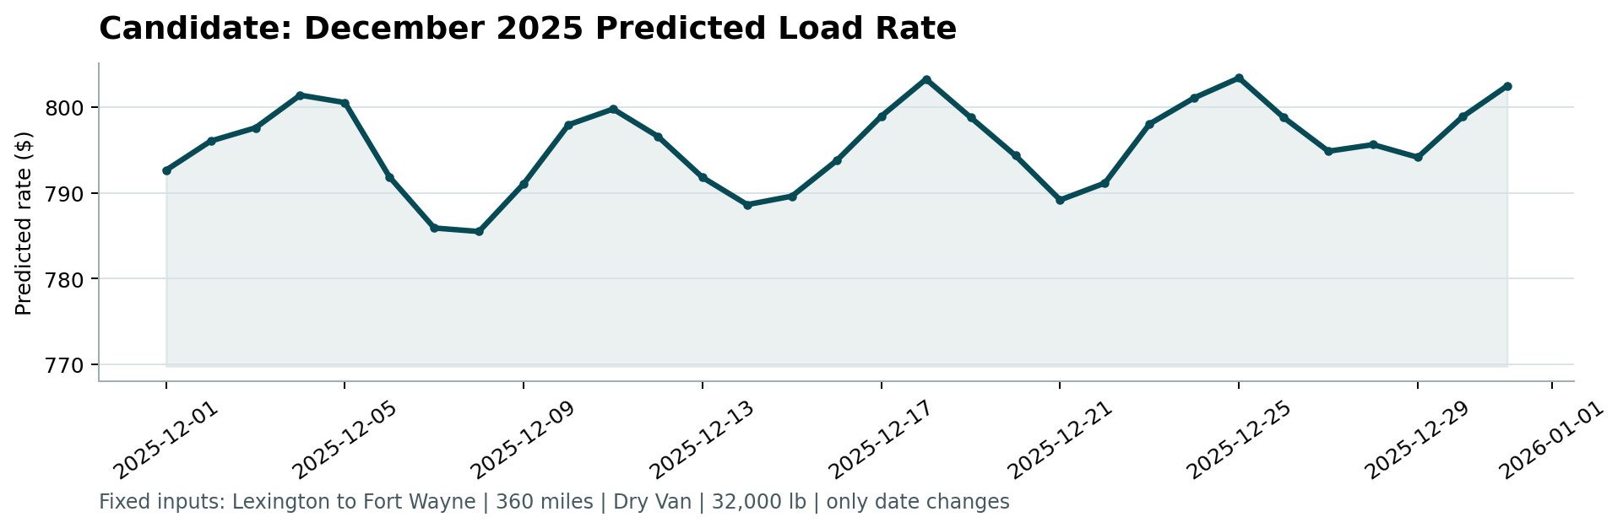
Figure 1: December 2025 predicted load rate — Lexington → Fort Wayne, 360 mi, Dry Van, 32,000 lb. Generated by score.py from december_chart_inputs_completed.csv.

7. Reproducibility
All commands are run from the ML_assignment/ repository root.
# 1. Install dependencies
pip install -r requirements.txt
# 2. Train, cross-validate, and generate all prediction files
python src/train.py
# 3. Validate submissions and produce the December chart
python score.py \
--predictions validation_predictions.csv \
--december-predictions december_chart_inputs_completed.csv \
--output-dir scorer_results
# 4. (Optional) Regenerate this report
python make_report_docx.py

Seed 42 is fixed in every call to HistGradientBoostingRegressor. Label encoders are fitted once on training data and reused for inference. Byte-for-byte identical outputs confirmed across two independent runs (max difference: 0.0).

