Project Title : Brick Breaker

- Name of students
  - Akram Khan – 180050006
  - Jagdish Suthar – 180050039
  - Shivanshu Gour – 180050099

- Brief description of the problem
  - Aim of the project is to simulate the Brick Breaker Game.
  - Provide one player and two player option, with one-player vs computer mode.
  - Different levels and pause/play option during the gameplay.

- Program Design
- The program is divided into four files.
- Definition of bricks and the pattern in which different bricks are to be placed in a particular level is given in brick-utils.rkt. Bricks are represented as their position ans value, so we used hash-tables to represent them. Value of brick represents strength of brick and weather it has power-up or not.
- Algorithm for collision between ball and bricks, wall and paddle is given in collision.rkt. It has two types of functions, first detects weather any type of collision happens or not and, second type of function perform that collision.
- Definations of the objects (Ball, Paddle, Power-ups), and interface are included in objects.rkt. Interface are the initial diagrams through which user can navigate to select level and mode of game. We used struct for each object i. e. for ball, paddle, power-up.
- main.rkt includes all the event-handler definations and algorithm for vs-computer mode.

- Challeges to the User
- You can play any level of your choice in single player mode.
- You can win the level by breaking all the bricks, without dying more than given number of lives.
- Limitations and bugs
- Our game assumes that utmost one collision take place in single frame. So we have ensured sufficient velocity and distance between bricks. For the larger velocity of ball, and small distance between bricks multiple collisions can take place in a single frame that is not been implemented here.
- In vs-computer mode computer can only reflect ball gently but not according to brick pattern etc.
- Time limit for a power-up is not been set i.e. once we get a power-up it remain till either of the player out or game ends. And also only four power-ups are implemented.

- Sample Input/Output
  - Input for the canvas will be mouse-clicks and key-presses and their output will be another canvas or world.
  - Input for world will be left -key, right-key, left-mouse key, space-bar. Space-bar for pause/play and left-mouse key for throwing ball.
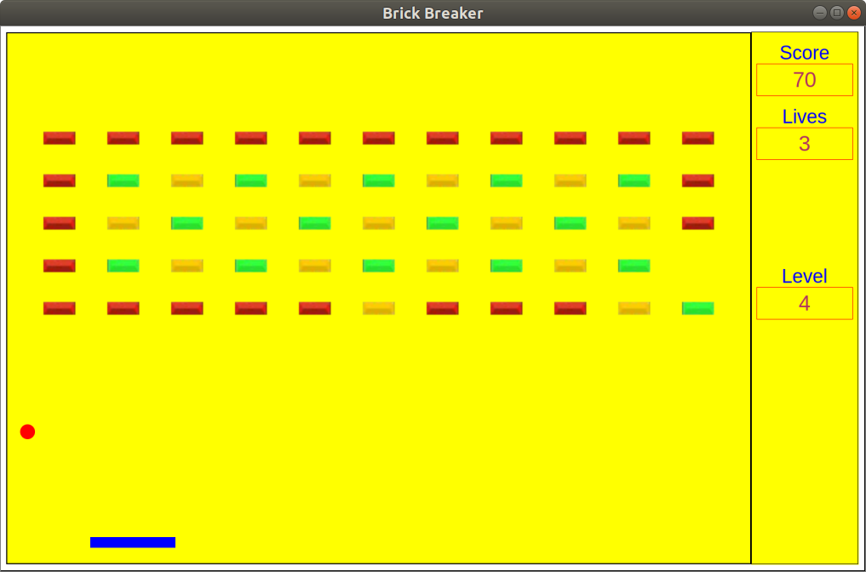
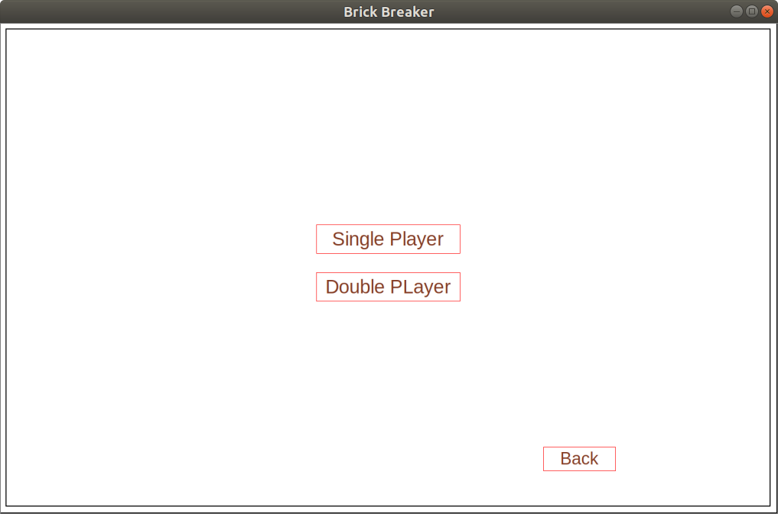

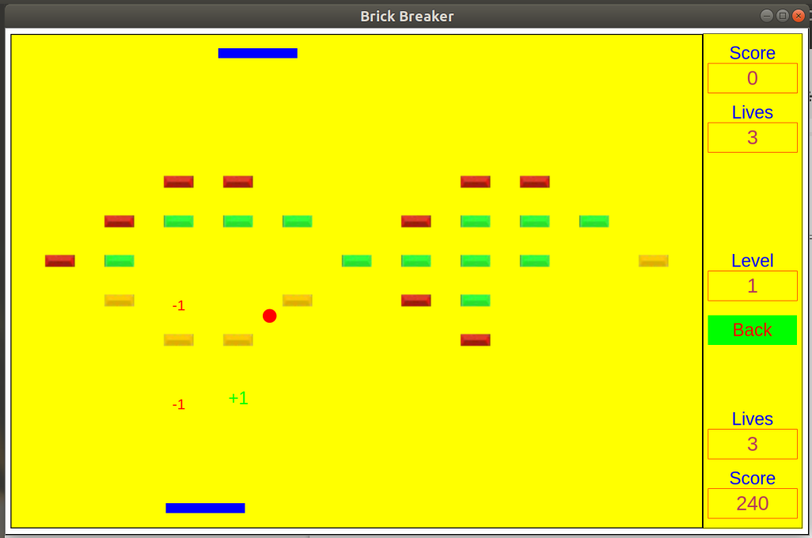

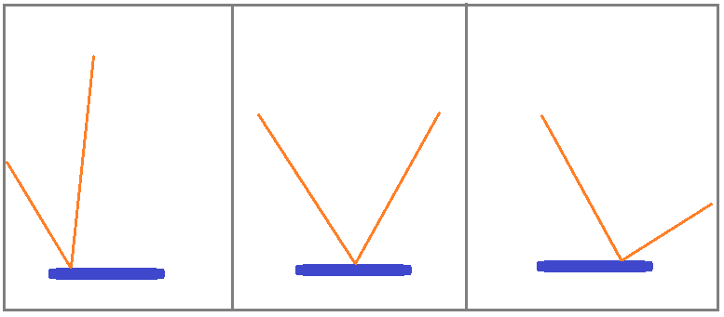

Point of interest
- We are using stack to keep track of the interface we are in and to get access to previous interface on pressing back button.
- Path of ball after bouncing off from slider will depend on where the ball strikes the slider.
- Computer can reflect ball gently ensuring that if ball is more inclined then it tries to make it less inclined and vice-versa.
- In each collision of ball with paddle we are ensuring that ball should not get more inclined if it is already too inclined.

