**Step 1: Install Java Version 8**

To install Java version 8 execute the below command:

**sudo yum install java-1.8.0-openjdk**

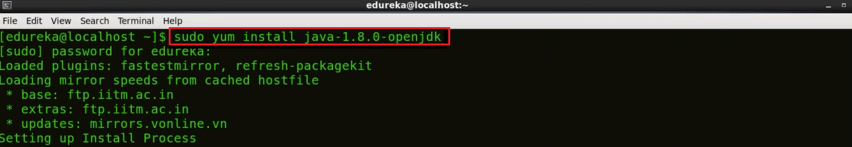

**Step 2: Install Apache Tomcat 9**

In order to install Jenkins we need to deploy the Jenkins war file by using Apache Tomcat. I will use **wget command** to install specific version of Apache Tomcat i.e. Tomcat 9 in this case.

First, to install wget execute the below command:

**sudo yum install wget**

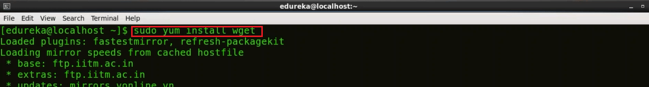

Now I will use wget to download the Tar file for Tomcat 9 using the below command:

**wget https://archive.apache.org/dist/tomcat/tomcat-9/v9.0.0.M10/bin/apache-tomcat-9.0.0.M10.tar.gz**

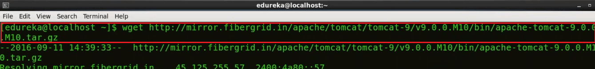

Next, I will show you how to extract the contents from this downloaded Tomcat 9 tar file. For this I will use tar command:

**tar xzf apache-tomat-9.0.0.M10.tar.gz**



To make it simple I will move this extracted file to a new directory Tomcat9 using the **mv command** and to do that I will execute the following command:

**mv apache-tomcat-9.0.0.M10 tomcat9**

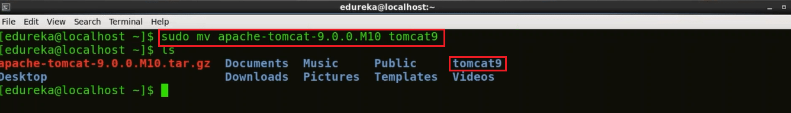

Our next step is to provide a username and password for Apache Tomcat and for that I will use **gedit editor**, you can use any other editor as per your comfort.

**gedit /home/edureka/tomcat9/conf/tomcat-users.xml**

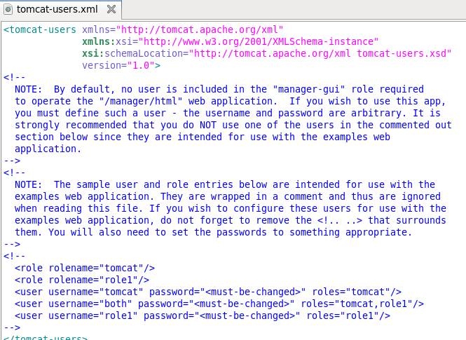

Now delete the content of the tomcat-users.xml file. Copy the below block and paste it in tomcat-users.xml file.

<?xml version='1.0' encoding='utf-8'?>

<tomcat-users>

    <role rolename="manager-gui"/>

    <role rolename="manager-script"/>

    <role rolename="manager-jmx"/>

    <role rolename="manager-jmx"/>

    <role rolename="admin-gui"/>

    <role rolename="admin-script"/>

    <user username="edureka" password="edureka" roles="manager-gui,manager-script,manager-jmx,manager-status,admin-gui,admin-script"/>

</tomcat-users>

The updated tomcat-users.xml file will look like this:

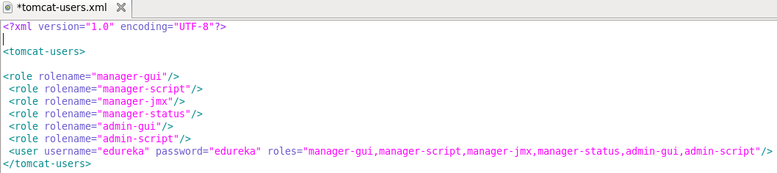

In the above image, as you can see that I have defined several roles and for all these roles I have given one single username and password i.e. edureka. If you want to assign different username and password for different roles you can do that as well.

Now save it and close the file to go back to the terminal.

We need to start Apache Tomcat now, but before that I will change my directory to Tomcat9 by executing the below command:

**cd tomcat9**

To start Tomcat use the below command:

**./bin/startup.sh**

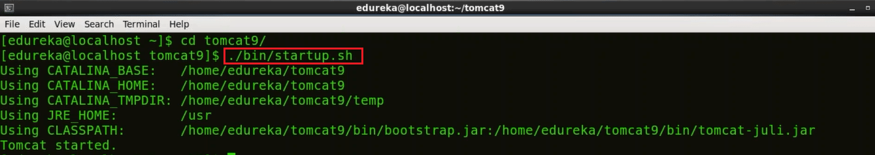

So, Tomcat has now started.

Now open your browser and access localhost:8080 to confirm that Tomcat is up and running. For your information port 8080 is the default port for Apache Tomcat.

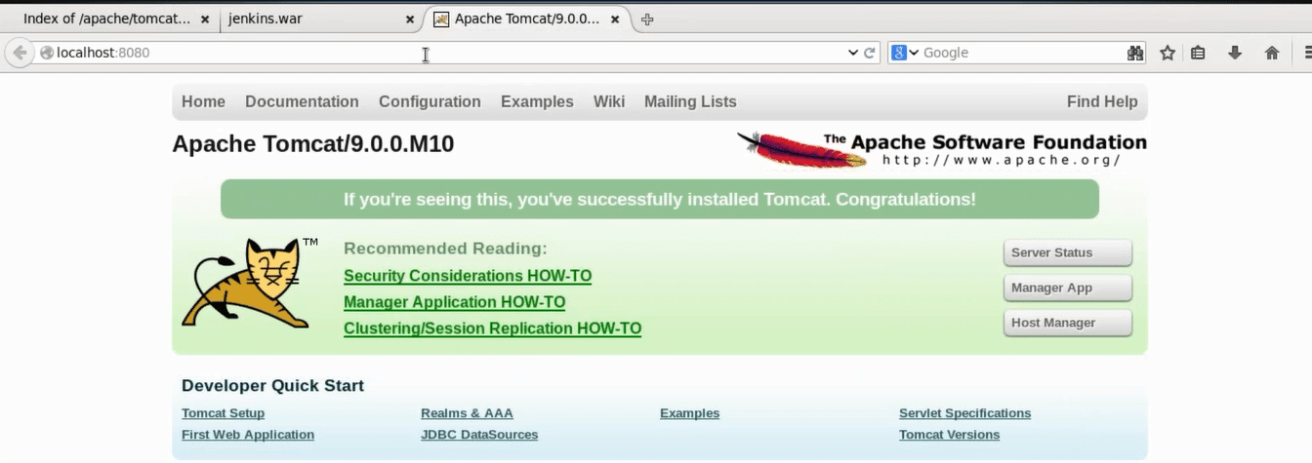

**Step 3: Download Jenkins war File**

I will again use the wget command to download Jenkins war (web archive) file. To get the release list of Jenkins war you can use the URL [***Jenkins releases***](http://updates.jenkins-ci.org/download/war/)

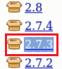

Here copy the link location of the version of Jenkins that you wish to install. I will install Jenkins version 2.7.3, which is highlighted in the snapshot.

Go back to the terminal and move to the home directory by executing the below command.

**cd**

Now download Jenkins war file by using wget command:

**wget http://updates.jenkins-ci.org/download/war/2.7.3/jenkins.war**

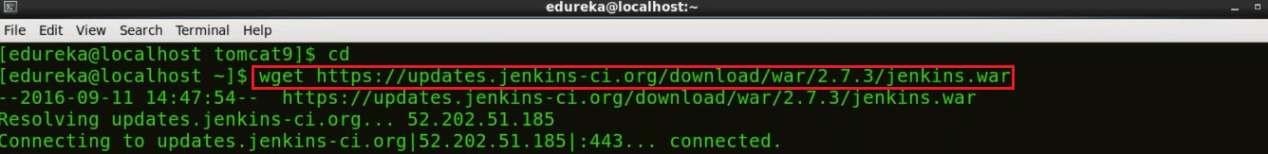

**Step 4: Deploy Jenkins war File**

To deploy Jenkins war file that you have downloaded in the previous step, open your browser and access localhost:8080 again. Now click on the Manager App.

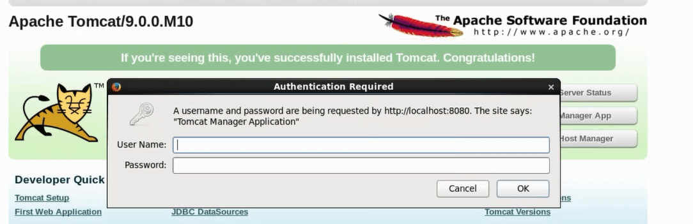

When you click on the Manager app, it will ask for username and password. If you remember I have given one single username and password for all the roles i.e. edureka. Type the below mentioned username and password and click OK.

* Username: edureka
* Password: edureka

Now you will be directed to  Tomcat web application manager page. When you scroll down you will find an option called Deploy. Over here you need to give the context path, i.e. /jenkins and directory URL, i.e. location of the Jenkins war file in your system in my case it is /home/edureka/jenkins.war and finally click on Deploy.

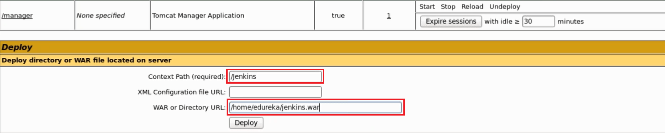

Now in the Tomcat web application manager page you can find Jenkins listed under Applications along with other web apps.

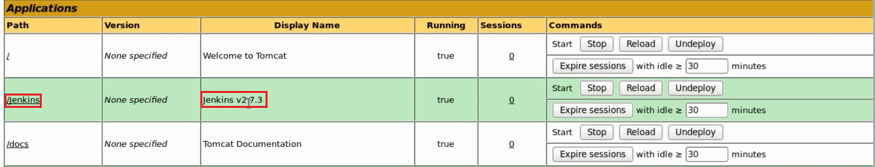

Now I will click on “/jenkins” which is highlighted in the above image.

**Step 5: Install Suggested Plugins**

When I clicked on jenkins I was directed to Unlock Jenkins page. Please refer to the below snapshot:

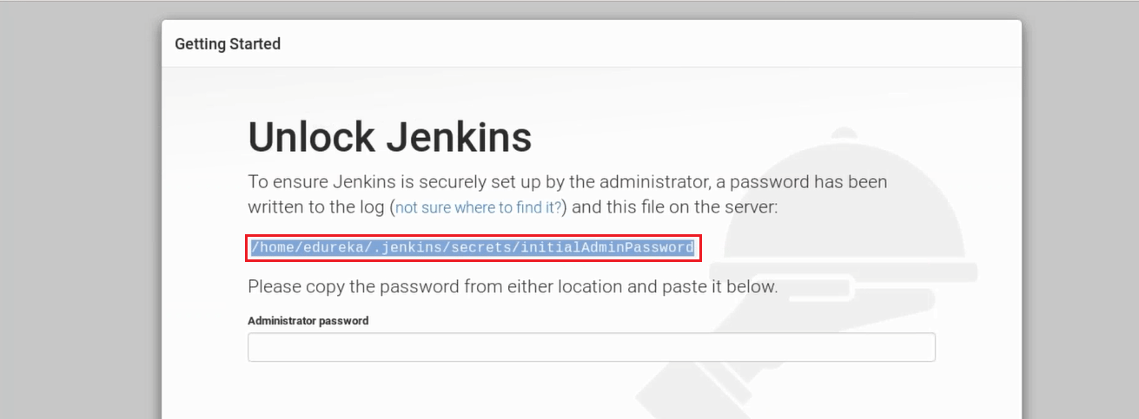

In order to unlock Jenkins first copy the part that I have highlighted in the screenshot above. This is the location that contains your one time password for Jenkins i.e. **/home/edureka/.jenkins/secrets/initialAdminPassword** in my case, it will be different for you. Hence, just copy the path from the screen on your end and go back to the terminal.

Finally, use the following command to get your one time password:

**cat <paste the location that you have copied>**

This cat command will read the contents of the file that contains the one time password and will display it on the terminal.

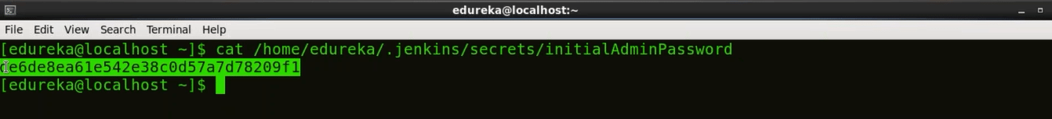

Just copy this password and paste it in the Administrator password text-box in the Unlock Jenkins page. Please refer to the below snapshot.

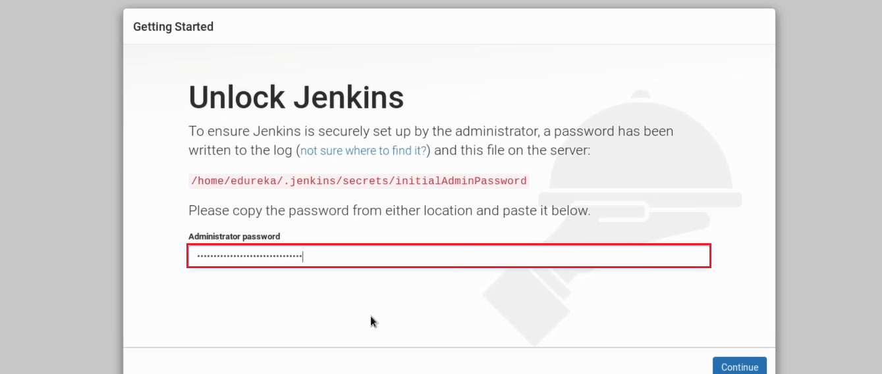

Once you have pasted the password, click on continue.

Now I will install plugins. As you see in the below snapshot there are two options i.e. either I can go with suggested plugins or I can select plugins on my own.

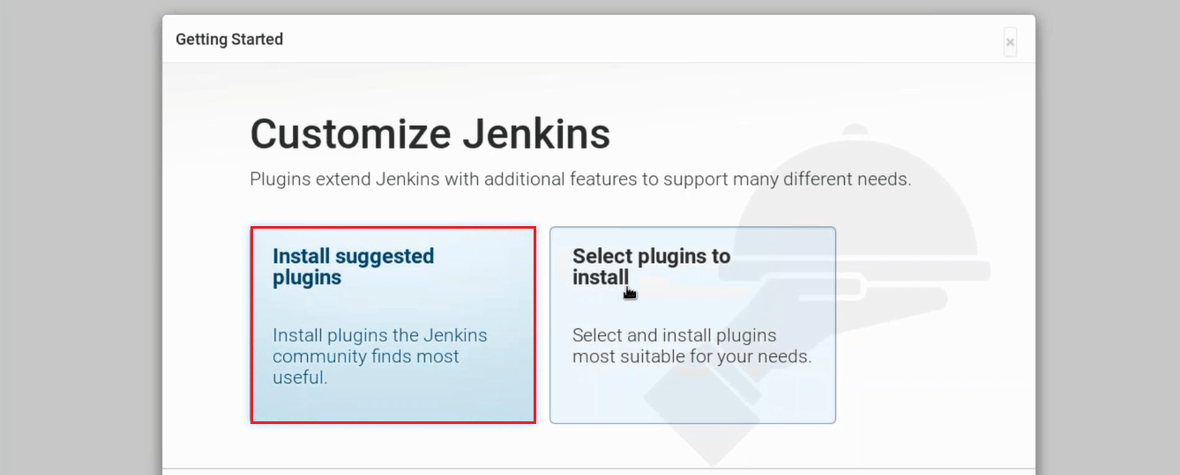

I will go with **Install Suggested Plugins.**

Snapshot below will give you a list of plugins that will be installed when you click on **Install Suggested Plugins**.

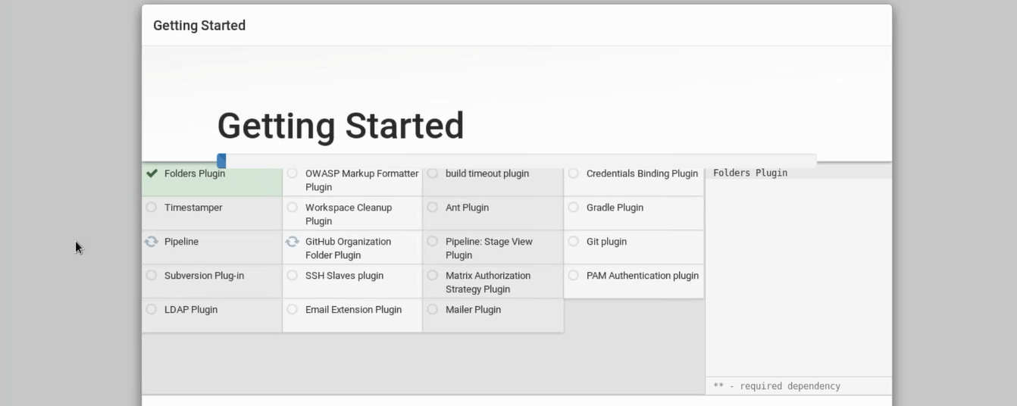

Once the plugins are installed, you will be directed to a page where you have to Create First Admin User. Please fill your relevant details.

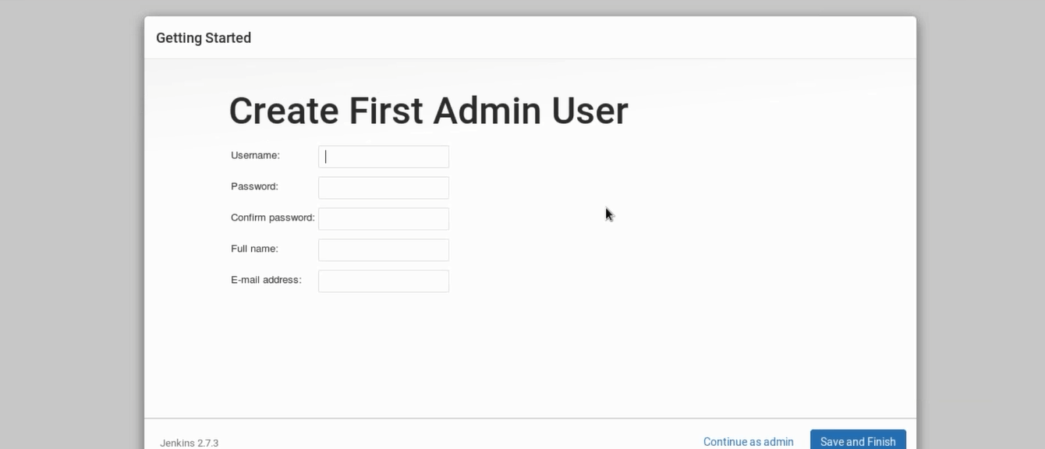

After filling this form, click on save and finish.

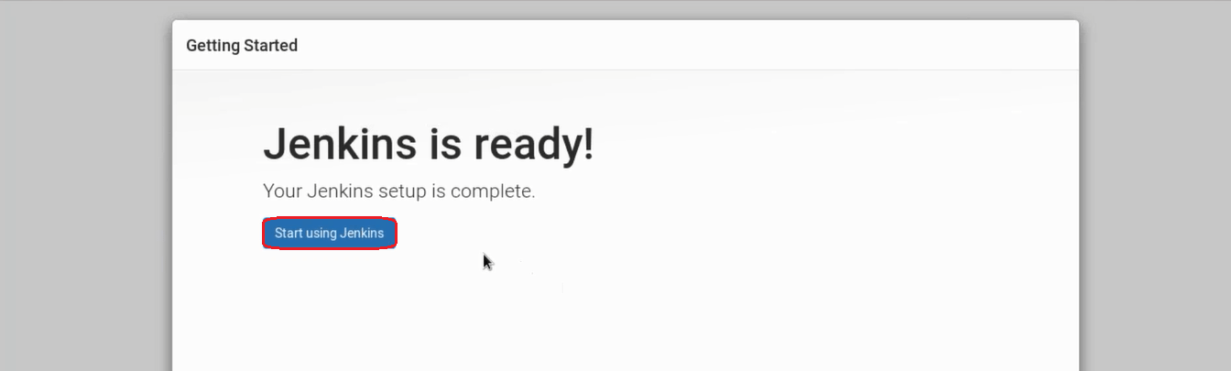

**Congratulations!** Jenkins is ready now, once you click on start using Jenkins you will be directed to Jenkins dashboard. You can now use Jenkins to continuously trigger build and test for every change made in the source code.

