**Lesson 02 Demo 01**

**Demonstrating Lifecycle of Containers**

**Objective:** To demonstrate the lifecycle of containers for efficient management and optimization of Docker container orchestration

**Tools required:** Ubuntu

**Prerequisites:** None

Steps to be followed:

1. Demonstrate Docker container lifecycle management

**Step 1: Demonstrate Docker container lifecycle management**

1. Pull a Docker image from Docker hub using the following command: **sudo docker pull nginx**

1. Execute the following command to run a container from the Nginx image:  
   **sudo docker run -d --name my-nginx -p 8080:80 nginx**  
     
   A screenshot of a computer

   Description automatically generated
2. Run the following command to list the running containers:

**sudo docker ps**  
  
1. Click on the **master** dropdown and select the **desktop** option as shown in the screenshot below:  
     
   A screenshot of a computer

   Description automatically generated
2. Open a web browser and navigate to [**http://localhost:8080**](http://localhost:8080)to view the default Nginx welcome page  
     
   A screenshot of a computer

   Description automatically generated
3. Execute the following command to inspect the details of the running container, including its configuration and networking information as shown in the screenshots below:  
   **sudo docker inspect my-nginx**  
     
   A screenshot of a computer

   Description automatically generated

1. Run the following command to stop the running container:  
   **sudo docker stop my-nginx**  
     
   A screenshot of a computer

   Description automatically generated
2. Run the following command to list the running containers:  
   **sudo docker ps**  
     
   A screenshot of a computer

   Description automatically generated
3. Use the following command to start the container as shown in the screenshot below:  
   **sudo docker start my-nginx**  
     
   A screen shot of a computer

   Description automatically generated
4. Run the following command to list the running containers:  
   **sudo docker ps**  
     
   A black background with white text

   Description automatically generated
5. Run the following command to remove the running container:  
    **sudo docker rm my-nginx**  
     
   A black background with white text

   Description automatically generated

|  |
| --- |
| **Note**: You need to first stop the running container and then remove it as shown in the next steps. |

1. Run the following command to stop the running container:  
   **sudo docker stop my-nginx**  
     
   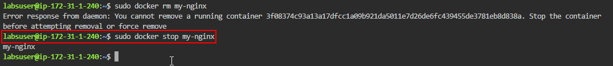
2. Use the following command to remove the running container:  
   **sudo docker rm my-nginx**  
     
   A black background with white text

   Description automatically generated
3. Check the list of running and stopped containers to ensure that the running container has been removed using the following command:  
   **sudo docker ps -a**  
     
   A screenshot of a computer

   Description automatically generated

By following these steps, you have successfully demonstrated the lifecycle of containers for efficient management and optimization of Docker container orchestration.