**Lesson 02 Demo 02**

**Creating a Docker Image**

**Objective:** To create a Docker image using a Docker file, which installs and configures a Nginx web server with a custom welcome message

**Tools required:** Docker

**Prerequisites:** None

Steps to be followed:

1. Create a Docker image using the Docker file

**Step 1: Create a Docker image using the Docker file**

1. Use the following command to create a directory:

**mkdir demo**

**cd demo**

1. Use the following command to create the Docker file:

**vi Dockerfile**

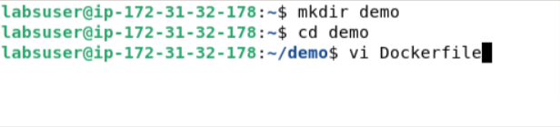

1. Add the following code to the **Dockerfile**:

**FROM ubuntu**

**RUN apt-get update**

**RUN apt-get install -y nginx**

**COPY index.nginx-debian.html /var/www/html**

**CMD nginx -g 'daemon off;'**

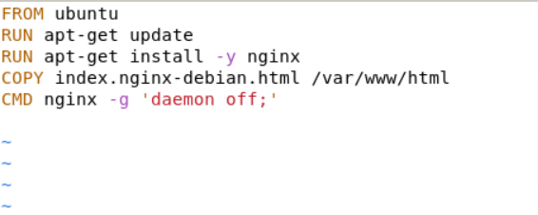

1. Use the following command to create another file in the same directory:

**vi index.nginx-debian.html**

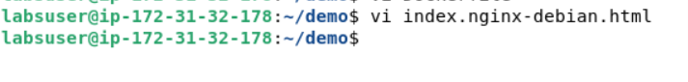

1. Add the following welcome message to the index file:

**WELCOME TO NGINX.**

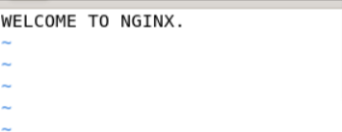

1. Use the following command to execute the Docker file:

**sudo docker build .**

1. Execute the given command to display the images. This will confirm that the image has been created.

**sudo docker images**

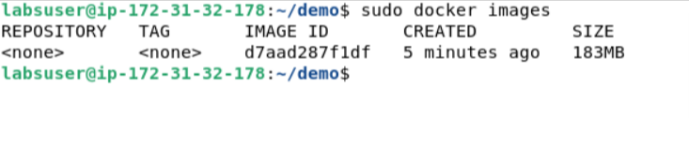

By following these steps, you have successfully created a Docker image containing a Nginx web server with a custom welcome message using a Docker file. This image can then be used to spin up containers with the configured web server environment.