**Lesson 02 Demo 03**

**Tagging an Image**

**Objective:** To demonstrate the process of tagging Docker images using various methods for easier management and distribution

**Tools required:** Docker

**Prerequisites:** None

Steps to be followed:

1. Pull a Docker image
2. Tag an image referenced by name
3. Tag an image for a private repository

**Step 1: Pull a Docker image**

1. Use the following command to pull the latest nginx image:

**sudo docker pull nginx:latest**

1. List all the running images and check the newly pulled image:

**sudo docker images**

1. Use the following command to tag the nginx image, referenced by Image ID, into the demo repository with version1.0:

**sudo docker tag IMAGE_ID demo/nginx_img:version1.0**

**sudo docker images**

**example:** **sudo docker tag e4720093a3c1 demo/nginx_img:version1.0**

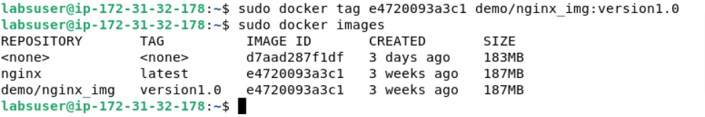

|  |
| --- |
| **Note**: Replace IMAGE_ID with the Image ID of your nginx image |

**Step 2: Tag an image referenced by name**

1. Use the following commands to tag the nginx image, referenced by image name, into the demo repository with version2.0:

**sudo docker tag IMAGE_NAME demo/nginx_img:version2.0**

**sudo docker images**

**example: sudo docker tag nginx demo/nginx_img:version2.0**

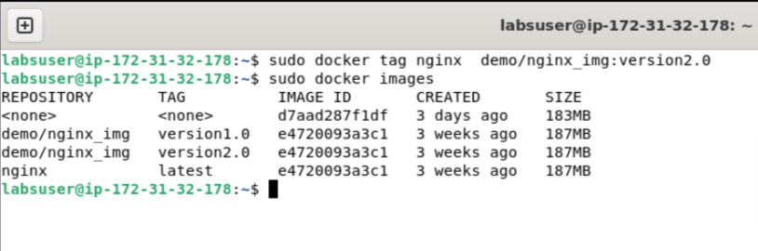

|  |
| --- |
| **Note:** Replace IMAGE_NAME with the name of your nginx image |

1. Use the following command to tag the nginx image, referenced by name and tag, into the demo repository with version3.0:

**sudo docker tag nginx:latest demo/nginx_img:version3.0.latest**

|  |
| --- |
| **Note:** Replace IMAGE_NAME and IMAGE_TAG with the Name and Tag of your nginx image |

**Step 3: Tag an image for a private repository**

1. Use the following commands to tag an image for a private repository:

**sudo docker tag IMAGE_ID myregistry:5000/demo/nginx_img:version4.0**

**sudo docker images**

**example: sudo docker tag e4720093a3c1 myregistry:5000/demo/nginx_img:version4.0**

|  |
| --- |
| **Note:** Replace IMAGE_ID with the Image ID of your nginx image  **Note:** Use sudo docker images command to see the newly tagged image under myregistry:5000/demo/nginx_img repository |

By following these steps, you have successfully tagged Docker images with different versions and repository names for easier management and distribution.