**Lesson 02 Demo 04**

**Displaying Layers of a Docker Image**

**Objective:** To display the layered structure of Docker images for providing insight into the hierarchical arrangement of image layers within Docker's architecture

**Tools required:** Ubuntu

**Prerequisites:** None

Steps to be followed:

1. Create and display the layers of a Docker image

**Step 1: Create and display the layers of a Docker image**

1. Create a Docker file with multiple instructions using the following command: **nano Dockerfile**

1. Add the following configurations in the **Dockerfile** as shown in the screenshot below:  
   **# Dockerfile**

**FROM ubuntu:latest**

**# Layer 1: Update package lists**

**RUN apt-get update**

**# Layer 2: Install curl**

**RUN apt-get install -y curl**

**# Layer 3: Install wget**

**RUN apt-get install -y wget**

**# Layer 4: Create a directory**

**RUN mkdir /my_directory**

**# Layer 5: Copy a file**

**COPY myfile.txt /my_directory/myfile.txt**

**# Layer 6: Set environment variable**

**ENV MY_VAR="Hello Docker!"  
  
**

1. Create a text file using the following command:  
   **nano myfile.txt**  
     
   A screenshot of a computer

   Description automatically generated
2. Add the following sentence in the **myfile.txt**:  
   **This is a sample text file.**

1. Execute the following command to build the Docker image using the Dockerfile:  
   **sudo docker build -t my_custom_image .**  
     
   A screenshot of a computer

   Description automatically generated

1. Execute the following command to view the history of the image, including all the layers:  
   **sudo docker history my_custom_image**  
   A screenshot of a computer

   Description automatically generated
2. Run the following command to inspect individual layers of the image using their respective layer IDs:  
   **sudo docker history --no-trunc my_custom_image**  
     
   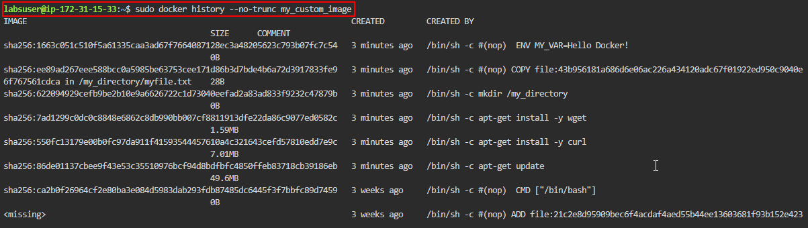  
     
   A black screen with white text

   Description automatically generated

By following these steps, you have successfully displayed the layered structure of Docker images to provide insight into the hierarchical arrangement of image layers within Docker's architecture.