**Lesson 02 Demo 05**

**Deploying and Configuring a Registry**

**Objective:** To configure a local Docker registry for efficient storage and transfer of container images, facilitating streamlined image management within the development environment

**Tools required:** Docker

**Prerequisites:** None

Steps to be followed:

1. Run a local registry

**Step 1: Run a local registry**

1. Run the following command to start the registry container:

**sudo docker run -d -p 5000:5000 --restart=always --name registry registry:2**

1. Run the following command to list the running containers to check the newly created container:

**sudo docker ps**

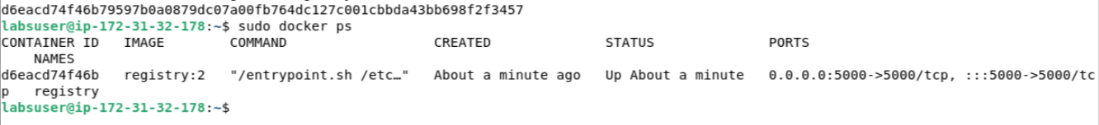

1. Pull the Ubuntu image using the following command:

**sudo docker pull ubuntu:16.04**

1. Use the following commands to tag the Ubuntu image and check the running images:

**sudo docker tag ubuntu:16.04 localhost:5000/my-ubuntu**

**sudo docker images**

1. Push the image to the local registry using the following command:

**sudo docker push localhost:5000/my-ubuntu**

1. Remove the locally cached images using the following commands:

**sudo docker image remove ubuntu:16.04**

**sudo docker image remove localhost:5000/my-ubuntu**

1. Pull the localhost:5000/my-ubuntu image from the local registry

**sudo docker pull localhost:5000/my-ubuntu**

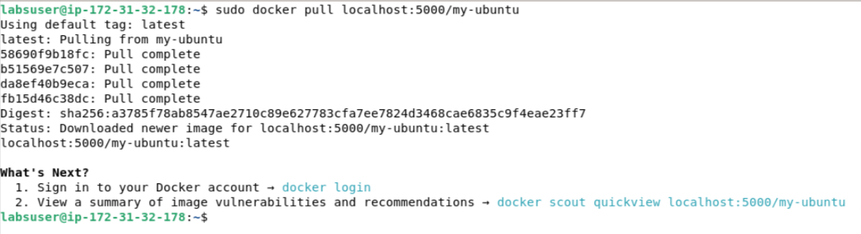

1. Use the following command to stop the running registry container:

**sudo docker container stop registry**

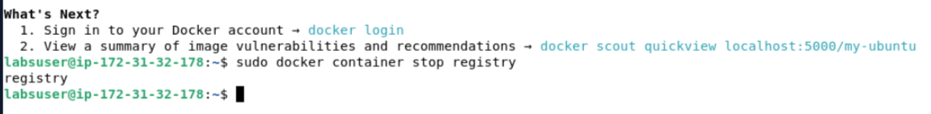

By following these steps, you have successfully configured a local registry, transferred an Ubuntu image to it, and demonstrated the ability to push and pull images to and from the registry.