**Lesson 02 Demo 06**

**Pushing an Image to Registry**

**Objective:** To illustrate the process of copying an image from Docker Hub to a local registry

**Tools required:** Docker and Ubuntu

**Prerequisites:** None

Steps to be followed:

1. Copy an image from the docker hub to your registry

**Step 1: Copy an image from docker hub to your registry**

1. Pull the nginx image from Docker Hub using the following command:

**sudo docker pull nginx**

1. Tag the image using the following command:

**sudo docker tag nginx localhost:5000/nginx**

1. Push the image to the local registry using the following command:

**sudo docker push localhost:5000/nginx**

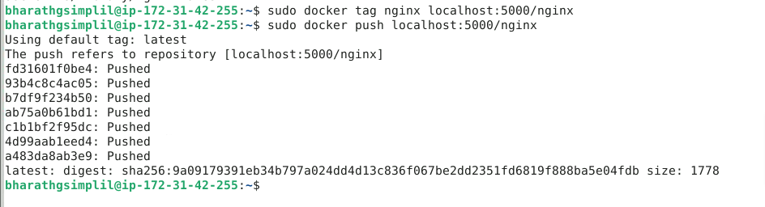

1. Remove the locally cached images using the following command:

**sudo docker image remove nginx**

1. Pull the localhost:5000/nginx image from the local registry using the following command:

**sudo docker pull localhost:5000/nginx**

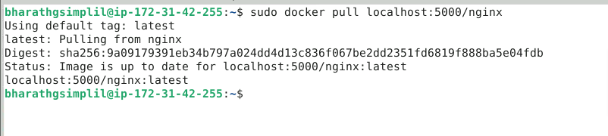

1. List all the running containers to check the registry container using the command given below:

**sudo docker ps**

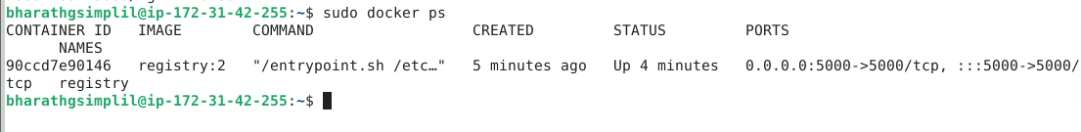

1. Stop the registry container using the following command:

**sudo docker container stop registry**

By following these steps, you have successfully copied the nginx image from Docker Hub to your local registry. You accomplished this by pulling the nginx image, tagging it with the address of your local registry, pushing it to the registry, and finally confirming its presence within the registry.