**Lesson 03 Demo 02**

**Creating a Docker Volume and Mounting It to a Container**

**Objective:** To create a Docker volume and mount it to a container for enhanced data management and containerized application deployment

**Tools required:** Ubuntu

**Prerequisites:** None

Steps to be followed:

1. Create and mount a Docker volume to a container

**Step 1: Create and mount a Docker volume to a container**

1. Create a new Docker volume using the following command: **sudo docker volume create myvolume**

1. Run the following command to list all the volumes that exist on a Docker host:  
   **sudo docker volume ls  
     
   A screenshot of a computer

   Description automatically generated**
2. Run the following command to check the volume configuration:  
   **sudo docker volume inspect myvolume**  
     
   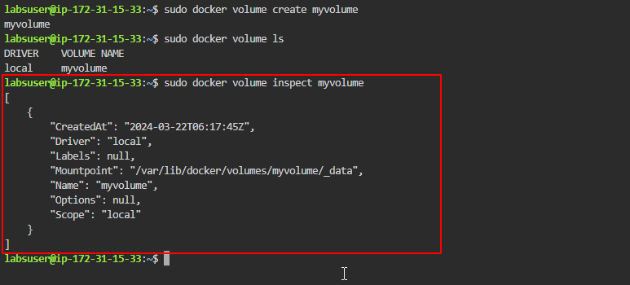
3. Run the following command to start a container with volume using **-v** flag:  
   **docker run -it --name cont01 -v myvolume:/app nginx /bin/bash**
4. 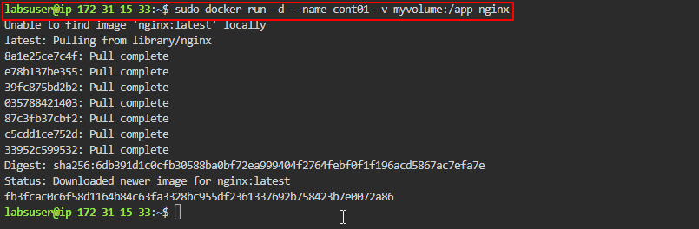

1. Run the following command and check under the mounts section to verify the volume attached to the container:  
   **sudo docker inspect cont01**  
     
   A screenshot of a computer

   Description automatically generated

By following these steps, you have successfully created a Docker volume and mounted it to a container, enabling enhanced data management and containerized application deployment.