**Lesson 05 Demo 01**

**Creating a Docker Bridge Network**

**Objective:** To create a bridge network to enable communication between Docker containers running on different networks

**Tools required:** Docker

**Prerequisites:** None

Steps to be followed:

1. Create a default network in Docker
2. Inspect the network for the network driver

**Step 1: Create a default network in Docker**

1. Use the following command to create a network:

**sudo docker network create mynetwork1**



1. Use the following command to list the current networks:

**sudo docker network ls**

**Step 2: Inspect the network for the network driver**

1. Use the following command to inspect the network:

**sudo docker network inspect mynetwork1**

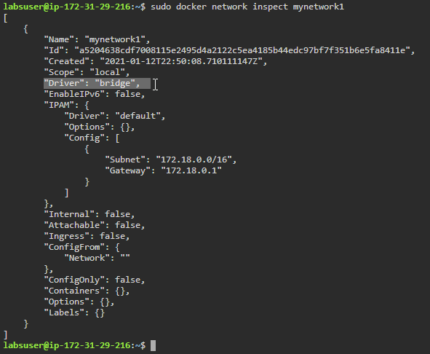

**Note:** A bridge driver is the default driver that automatically gets installed and configured while creating a network.

By following these steps, you have successfully created a bridge network that will allow you to communicate between Docker containers running on different networks.