**Lesson 05 Demo 02**

**Creating User-Defined Bridge Network**

**Objective:** To create a user-defined bridge network for better control, isolation, and communication between containers within a customized network environment

**Tools required:** Docker

**Prerequisites:** None

Steps to be followed:

1. Create and delete user-defined network
2. Connect a ngnix container to the my-net network
3. Connect the running my-nginx container to the my-net network
4. Inspect the container and disconnect it from the network

**Step 1: Create and delete user-defined network**

1. Use the following commands to create a user network:

**sudo docker network create my-net1**

**sudo docker network rm my-net1**

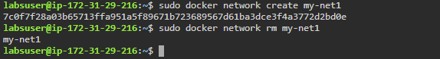

**Step 2: Connect a nginx container to the my-net network**

1. Use the following commands to create a new Docker container named **my-nginx**, attach it to the **my-net** network, and map port 8080 on the host to port 80 in the container:

**sudo docker create --name my-nginx \**

**--network my-net \**

**--publish 8080:80 \**

**nginx:latest**

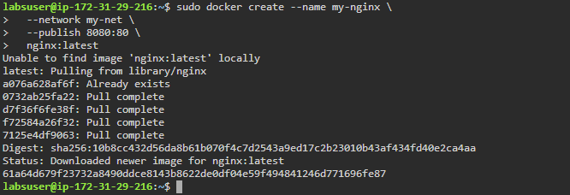

**Step 3: Connect the running my-nginx container to the my-net network**

1. Use the following command to connect the running **my-nginx** container to the existing

**my-net** network:

**sudo docker network connect my-net my-nginx**



**Step 4: Inspect the my-nginx container and check the networks**

1. Use the following command to inspect and check the network:

**sudo docker container inspect my-nginx**

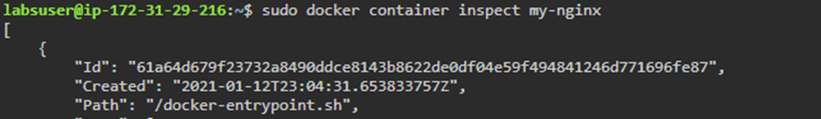

1. Use the following command to disconnect the container from the network:

**sudo docker network disconnect my-net my-nginx**



1. Use the following command to inspect the container and check the network:

**sudo docker container inspect my-nginx**

By following these steps, you can successfully create a user-defined bridge network for better control, isolation, and communication between containers within a customized network environment.