**Interface Diagram**

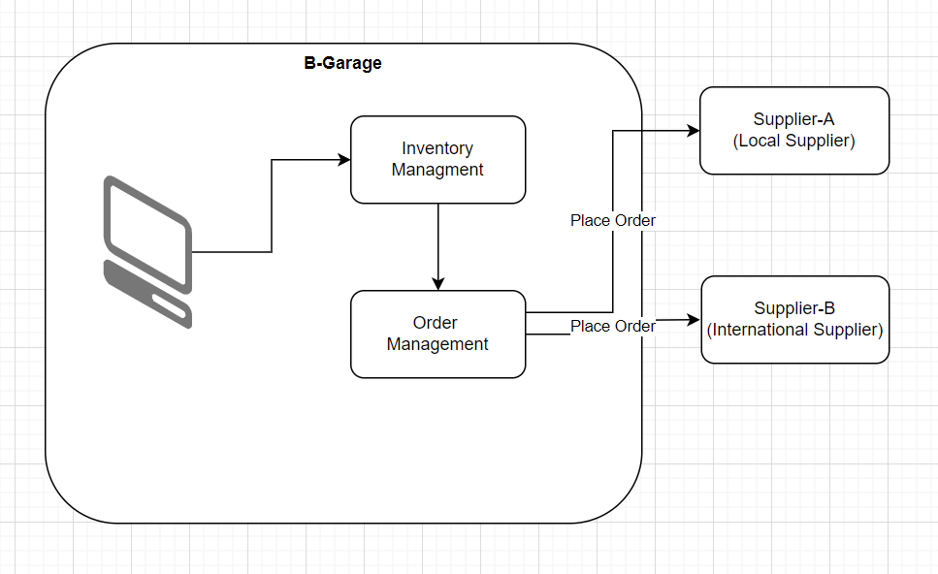

**Component Diagram**

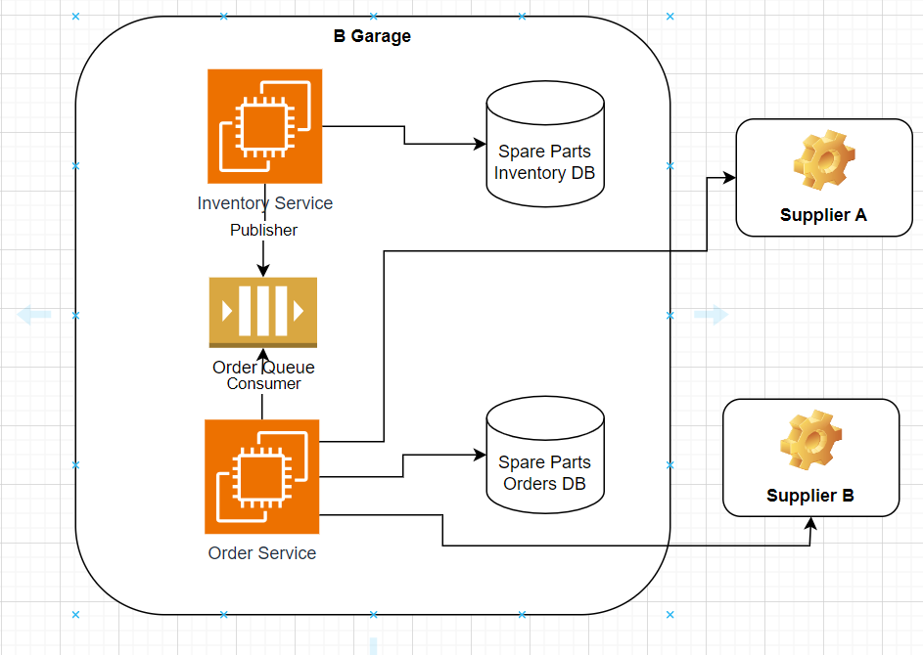

**Low Level Design**

**Data Model**

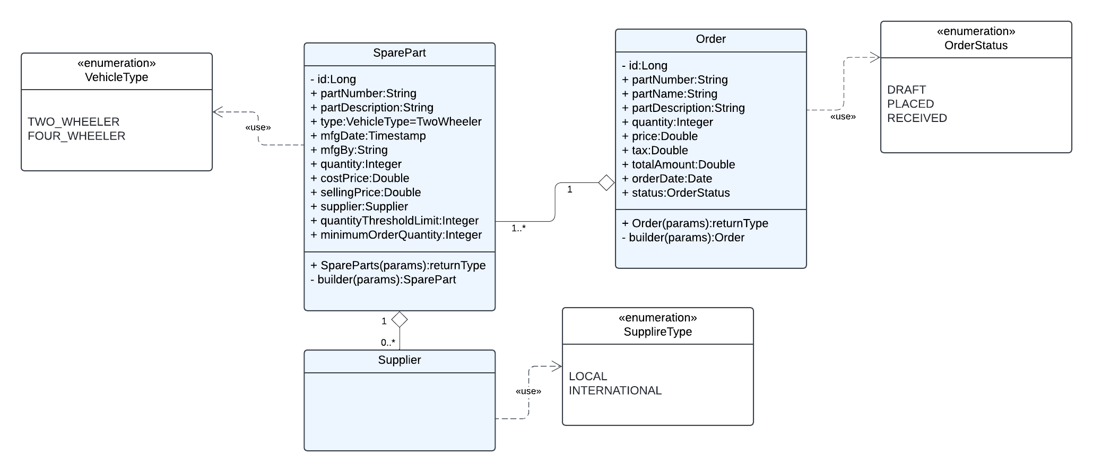

**Request Flow**

**Class Diagram**

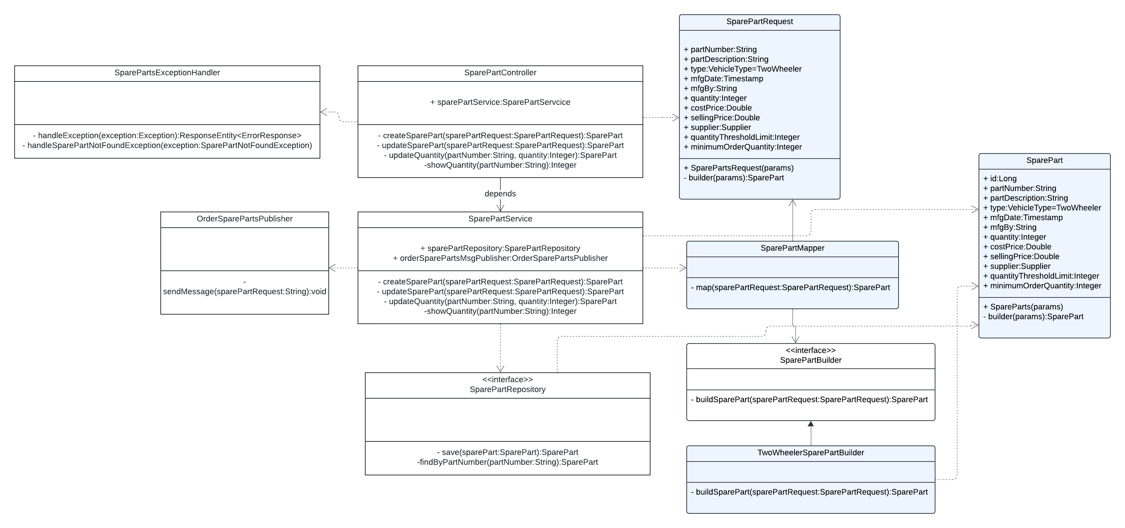

**Sequence Diagram**

**Use Case 1**: Order spare parts when threshold reached for Local Supplier Parts

**Use Case 2**: Order Spare parts when threshold reached for International Supplier parts

**API Endpoints**

**Spare Parts Service**

1.Http Method: POST

Desc : Create Spare Part

Endpoint URI : /v1/api/sparepart

Accept Content Type: json

Request Body : SparePartRequest

2. Http Method: PUT

Desc : Update Spare Part

Endpoint URI : /v1/api/sparepart

Accept Content Type: json

Request Body : SparePartRequest

**Order Service**

Local Orders are placed as messages arrive on queue and saved to db

International orders are saved to db but orders are placed on schedule run