SOFTWARE PROJECT MANAGEMANT SYSTEM
A DBMS Capstone Project Report submitted in partial fulfillment of the requirements for the award of the degree of

BACHELOR OF TECHNOLOGY
in

ARTIFICIAL INTELLIGENCE AND MACHINE LEARNING

Submitted By

MANDELA MAHITHA – 26B21AI167 JAGGAMSETTI PRAGATHI – 26B21AI169 PALLA SUHASINI – 26B261AI003
KARNATI KIRAN KUMAR REDDY – 26B21AI104

Under the esteemed guidance of
Mr. T.Srinivasulu M.Tech, (Ph.D.)

Assistant Professor


DEPARTMENT OF ARTIFICIAL INTELLIGENCE AND MACHINE LEARNING

ADITYA UNIVERSITY
(Formerly Aditya Engineering College (A))
Aditya Nagar, ADB Road, Surampalem, Andhra Pradesh, India

2026 – 2027


Aditya Nagar, ADB Road, Surampalem, Andhra Pradesh, India
DEPARTMENT OF ARTIFICIAL INTELLIGENCE AND MACHINE LEARNING

CERTIFICATE

This is to certify that the DBMS Capstone Project report entitled “SOFTWARE PROJECT MANAGEMENT SYSTEM” is being submitted M.MAHITHA (26B21AI167), J.PRAGATHI( 26B21AI169),P.SUHASINI( 26B261AI003), K.KIRAN KUMAR REDDY
(26B21AI104) in partial fulfillment of the requirements for the award of the B.Tech. degree in Artificial Intelligence and Machine Learning. The work documented in this report was carried out as part of the Capstone Project for the course Database Management Systems (2501IT05) during the academic year 2026–2027, and records the database design, implementation, and documentation undertaken by the team.

Project Guide Head of the Department
Mr. T. Srinivasulu, M. Tech, (Ph.D.) Dr. K. Naga Bhargavi, M. Tech, Ph.D. Associate Assistant professor Assistant Professor & HOD

External Examiner

DECLARATION

We hereby declare that the DBMS Capstone Project entitled “SOFTWARE PROJECT MANAGEMENT SYSTEM” is a genuine work carried out by us. The database design, SQL implementation, queries and documentation presented in this report are our own work, completed under the guidance of Mr. T. Srinivasulu, Department of “AFTIFICIAL INTELLIGENCE AND MACHINE LEARNING, Aditya University, Surampalem. We further declare that this work has not been submitted, in full or in part, for the award of any degree of this or any other educational institution.

Project Associates
Mandela Mahitha (26B21AI167)
Jaggamsetti Pragathi( 26B21AI169)
Palla Suhasini ( 26B261AI003)
Karnati Kiran Kumar Reddy (26B21AI104)

Date: 28-09-2026
Place: Surampalem

ACKNOWLEDGEMENT

It is with immense pleasure that we express our indebted gratitude to our project guide Mr. T. Srinivasulu, Department of “AFTIFICIAL INTELLIGENCE AND MACHINE LEARNING “, who guided us throughout the capstone project. We are thankful for the constant encouragement and valuable suggestions received at every review stage.
We are grateful to Dr. K. Naga Bhargavi, Head of the Department, for inspiring us and for arranging the facilities and resources needed for this project.
We extend our sincere thanks to the Management, Dr. M. Sreenivasa Reddy, Deputy Pro-Chancellor, Dr. M. B. Srinivas, Vice-Chancellor, and Dr. A. Ramesh, Pro Vice-Chancellor (Engineering & Sciences), for providing an excellent academic environment.
Not to forget, we thank the Teaching and Non-Teaching Staff, our parents and our friends, who have directly or indirectly supported us in completing this project on time.

Project Associates
Mandela Mahitha – 26B21AI167 Jaggamsetti Pragathi – 26B21AI169 Palla Suhasini – 26B261AI003
Karnati Kiran Kumar Reddy – 26B21AI104

ABSTRCT

The Software Project Management System is a database-based system designed to manage software projects in an organized and efficient manner. It stores and manages information about employees, projects, teams, sprints, tasks, and bugs. The system maintains relationships between these entities using primary keys and foreign keys.
The database helps project managers track project details, assign employees to teams and tasks, monitor sprint progress, and manage software bugs. SQL operations such as DDL, DML, DQL, DCL, and TCL are used to create, maintain, retrieve, and manage the database. The system reduces data duplication, improves data consistency, and provides easy access to project information.


INDEX

Chapter | Title | Page No.
 | Certificate | i
 | Declaration | ii
 | Acknowledgement | iii
 | Abstract | iv
 | List of Figures | v
 | List of Tables | vi
1 | Introduction | 1
 | 1.1 Introduction to the Domain | 1
 | 1.2 Problem Statement | 1
 | 1.3 Motivation and Need for a Database | 1
 | 1.4 Objectives of the Project | 2
 | 1.5 Scope of the Project | 2
 | 1.6 Organization of the Report | 2
2 | System Study and Tools | 3
 | 2.1 Existing System and Its Limitations | 3
 | 2.2 Proposed Database System | 3
 | 2.3 Tools and Technologies Used | 3
 | 2.4 Software and Hardware Requirements | 4
3 | Database Design (Review – I) | 5
 | 3.1 Identified Entities | 5
 | 3.2 Entity Attributes and Attribute Types | 5
 | 3.3 ER Diagram | 7
 | 3.4 Relationships and Cardinality | 8
 | 3.5 Relational Database Schema | 9
 | 3.6 Primary Keys and Foreign Keys | 10
 | 3.7 Normalization up to 3NF | 11
4 | Database Implementation (Review – II) | 13
 | 4.1 Database and Table Creation – DDL | 13
 | 4.2 Sample Data Insertion – DML | 15
 | 4.3 Constraints and Data Integrity | 23
 | 4.4 Data Validation Rules | 24
5 | SQL Operations and Queries | 25
 | 5.1 DQL – Basic Retrieval Queries | 25
 | 5.2 Join Operations | 26
 | 5.3 Aggregate Functions, GROUP BY and HAVING | 26
 | 5.4 Nested and Correlated Subqueries | 27
 | 5.5 Views and Relational Set Operations | 27
 | 5.6 DCL and TCL Operations | 28
6 | Modules and Functionalities | 29
7 | Results – Sample Outputs and Screenshots | 30
8 | Testing and Data Validation | 32
9 | GitHub Repository and Team Contribution | 34
10 | Conclusion and Future Enhancements | 35
 | References | 37
 | Appendix A – Complete SQL Script | 38

LIST OF FIGURES

Figure No. | Title of the Figure | Page No.
Fig. 3.1 | ER Diagram of Software Project Management System | 7
Fig. 3.2 | Relational Schema Diagram | 9
Fig. 4.1 | Sample Employee Table Creation Output | 16
Fig. 4.2 | Sample Project Table Creation Output | 22
Fig. 5.1 | Example of Basic Retrieval Query | 25
Fig. 5.2 | Example of Join Operation | 25
Fig. 5.3 | Example of Aggregate Function with GROUP BY | 26
Fig. 7.1 | Screenshot of Project Management Dashboard | 30

LIST OF TABLES

Table No. | Title of the Table | Page No.
Table 2.1 | Tools and Technologies Used | 3
Table 2.2 | Software and Hardware Requirements | 4
Table 3.1 | Entities Identified for the Selected Domain | 5
Table 3.2 | Attributes of Each Entity | 5
Table 3.3 | Relationships and Cardinality | 9
Table 3.4 | Relational Database Schema | 8
Table 3.5 | Primary Keys and Foreign Keys | 10
Table 3.6 | Normalization Steps | 11

CHAPTER 1

INTRODUCTION
  - Introduction to the Domain
Software Project Management is the process of planning, organizing, and controlling software projects. It includes managing project tasks, team members, resources, deadlines, and project progress. Proper project management helps to complete projects on time and within the required budget.
The Software Project Management System provides a centralized platform to manage all project-related information. It helps project managers assign tasks, monitor progress, manage team members, and track deadlines. The system reduces manual work, improves communication, and makes project management easier and more efficient.

  - Problem Statement
Managing a software project manually can be difficult because project information, tasks, team members, and deadlines may be stored in different places. This can lead to delays, communication problems, missed deadlines, and difficulty in tracking project progress.
The Software Project Management System is developed to solve these problems by providing a single system for managing projects, assigning tasks, tracking progress, managing team members, and monitoring deadlines. The system helps project managers and team members manage software projects in an organized and efficient way.

  - Motivation and Need for a Database
A database is needed in a Software Project Management System to store and manage project information in an organized way. A project contains a large amount of data such as project details, team members, tasks, deadlines, and project status.
Using a database helps to store all this information safely and makes it easy to add, update, delete, and retrieve data when required. It also reduces data duplication and improves data accuracy.
The main motivation for using a database is to make project management faster, easier, and more reliable. It helps project managers and team members access the required information quickly and supports better project tracking and decision-making.

Objectives of the Project
    - To design a normalized relational database for the selected domain with at least six entities.
    - To implement the database with appropriate primary keys, foreign keys and integrity constraints.
    - To store and manage project, employee, task, and other project-related information efficiently.
    - To reduce data redundancy and maintain data consistency and accuracy.
    - To provide easy access to project information for better project management

Scope of the Project
The Software Project Management System focuses on managing and storing important information related to software projects. The system covers project details, employees, teams, tasks, deadlines, and project progress.
The scope of the project includes:
    - Managing project details such as project name, start date, end date, and status.
    - Managing employees and team members involved in projects.
    - Assigning tasks to team members.
    - Tracking task status and project progress.
    - Managing project deadlines and schedules.
    - Storing all project-related information in a centralized database.
    - Maintaining data accuracy using primary keys, foreign keys, and constraints.
    - Generating useful project information for better management and decision-making.

1.6 organization of the Report
This report is organized into ten chapters. Chapter 2 presents the system study and the tools used. Chapter 3 covers the complete database design including the ER diagram, relational schema and normalization. Chapter 4 describes the database implementation with DDL and sample data. Chapter
5 presents the SQL operations and queries executed. Chapter 6 explains the modules and functionalities. Chapter 7 presents the results with sample outputs. Chapter 8 covers testing and data validation. Chapter 9 details the GitHub repository and the contribution of each team member. Chapter 10 concludes the report and outlines future enhancements.

CHAPTER 2

SYSTEM STUDY AND TOOLS
  - Existing System and Its Limitations
In the existing system, software project information is managed manually using notebooks, spreadsheets, emails, and separate files. Project managers maintain details about projects, team members, tasks, deadlines, and project progress in different places.

Limitations
Manual work takes more time. Data may be duplicated or lost. Manual data entry can cause errors.
Tracking tasks and project progress is difficult. Information is not stored in one centralized place. Updating project information is time-consuming. Maintaining and protecting data is difficult.
Preparing reports manually takes more effort.

  - Proposed Database System
The proposed Software Project Management Database System is designed to store and manage all project-related information in a centralized database. It manages details such as projects, employees, teams, tasks, deadlines, and project progress.
The system uses a normalized relational database with primary keys, foreign keys, and integrity constraints to maintain accurate and consistent data. It reduces data duplication and makes it easier to add, update, delete, and retrieve information.
The proposed system helps project managers and team members access project information quickly and manage software projects in an organized and efficient way.

Tools and Technologies Used

Category | Tool / Technology Used | Version / Remarks
Database | MySQL | 8.0 / store data
Language | SQL | Standard / Run queries
Frontend | HTML | HTML5 /create web pages
Design | CSS | CSS3/Design page
Editor | VS Code | Latest/write code
Server | XAMPP | 8.2/Run project

Table 2.1: Tools and Technologies Used

Software and Hardware Requirements

Operating System | Windows 10 / 11 (64-bit) or Ubuntu 22.04
Database Server | MySQL 8.0 or above
Client Tool | MySQL Workbench 8.0 CE / MySQL command-line client
Processor | Intel Core i3 or above
RAM | 4 GB minimum, 8 GB recommended
Disk Space | 2 GB free (server, sample data and documentation)

Table 2.2: Software and Hardware Requirements

CHAPTER 3
DATABASE DESIGN

  - Identified Entities
Six core entities were identified from the study of the domain, together with two supporting tables introduced during normalization to hold multi-valued attributes.
S.No | Entity Name | Description

1 | Team | Stores team details such as Team ID, Team Name, Team Size, Project ID, and Lead ID.
2 | Project | Stores project details such as Project ID, Project Name, Description, Start Date, End Date, Status, Duration, and Manager ID.
3 | Employee | Stores employee details such as Employee ID, First Name, Last Name, Email, Designation, Skills, Experience, and Salary.
4 | Sprint | Stores sprint details such as Sprint ID, Sprint Name, Project ID, Goal, Start Date, End Date, and Status.
5 | Task | Stores task details such as Task ID, Sprint ID, Description, Task Title, Priority, Status, Due Date, Completion Date, and Days Taken.
6 | Bug | Stores bug details such as Bug ID, Title, Status, Reported By, Reported Date, Resolved Date, and Resolution Time.

Table 3.1: Entities Identified for the Selected Domain

  - Entity Attributes and Attribute Types

The attributes of each entity are listed below with the data type, the key role and the attribute classification. The classification follows the ER model: an attribute is Simple if it cannot be divided further, Composite if it is made up of smaller attributes, Multi-valued if one entity instance may hold several values, and Derived if its value is computed from other stored attributes

Entity | Attribute | Data Type | Key | Attribute Type
Employee | employee_id | INT | PK | simple
Employee | name | VARCHAR(10) | ___ | simple
Employee | designation | VARCHAR(10) | ----- | simple
Employee | email | VARCHAR(10) | UNIOUE | simple

Employee | email | INT | PK | Simple
Employee | salary | DECIMAL(1.6) | ----- | Simple
Project | Project_id | INT | PK | simple
Project | project_name | VARCHAR(10) | — | Simple
Project | description | TEXT | ---- | Simple
Project | start_date | DATE | ---- | Simple
Project | end_date | DATE | — | simple
Project | status | VARCHAR(30) |  | Simple
Project | manager_id | INT | FK | Simple
Team | team_id | INT | PK | Simple
Team | Team_name | VARCHAR(15) | — | Simple
Team | project_id | INT | FK | Simple
Team | lead_id | INT | PK | Simple
Bug | Bug_id | INT | PK | Simple
Sprint | Sprint_id | INT | PK | Simple
Sprint | sprint_name | VARCHAR(10) | ---- | Simple
Sprint | Project_id | INT | FK | Simple
Sprint | Start_date | DATE | ---- | Simple
Sprint | End_date | TEXT | ---- | Simple
Task | Task_id | INT | PK | Simple
Task | description | TEXT | ---- | Simple
Task | priority | VARCHAR(20) | ---- | Simple
Task | Story_points | INT | ---- | Simple
Task | status | VARCHAR(20) | ---- | Simple

ER Diagram
The ER diagram below shows the six core entities as rectangles, their attributes as ellipses with primary key attributes underlined, and the relationships as named diamonds with the cardinality marked on every line. Derived attributes (age and percentage) are drawn with a dashed outline and multi-valued attributes (phone_no and qualification) with a double of

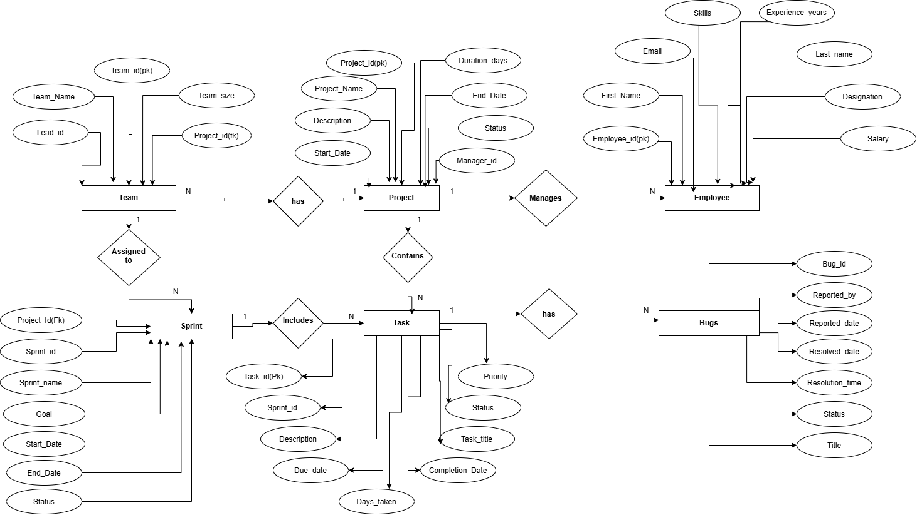

Fig. 3.3: ER Diagram of software management system

Relationships and Cardinality

Entity 1 | Relationship | Entity 2 | Cardinality (1:1 / 1:N  / M:N) | Participatio n
Team | Has | Project | 1:N | Team – Total; Project – Total
PROJECT | Manages | Employee | 1:N | Project – Total; Employee – Partial
TEAM | Assigned to | Sprint | 1:N | Team – Partial; Sprint – Total
Project | Contains | Task | 1:N | Project – Partial; Task – Total
Sprint | Includes | Task | 1:N | Sprint – Total; Task – Total
Task | Has | bug | 1:N | Task – Partial; Bug – Total

Table 3.4: Relationships and Cardinality

Relational Database Schema

Table Name | Column Name |  | Data Type | Key (PK / FK / —) | Constraints
Team | team_id |  | INT | PK | NOT NULL
Team | team_name |  | VARCHAR(100) | — | NOT NULL
Team | team_size |  | INT | — | Derived
Team | project_id |  | INT | FK | REFERENCES Project(project_id)
Team | lead_id |  | INT | FK | REFERENCES Employee(employee_id)
Project | project_id |  | INT | PK | NOT NULL
Project | project_name |  | VARCHAR(150) | — | NOT NULL
Project | description |  | TEXT | — | —
Project | start_date |  | DATE | — | —
Project | end_date |  | DATE | — | —
Project | status |  | VARCHAR(30) | — | DEFAULT 'Planning'
Project | duration_days |  | INT | — | Derived
Project | manager_id |  | INT | FK | REFERENCES Employee(employee_id)
Employee | employee_id |  | INT | PK | NOT NULL
Employee | first_name |  | VARCHAR(50) | — | NOT NULL
Employee | last_name |  | VARCHAR(50) | — | NOT NULL
Employee | email |  | VARCHAR(100) | — | UNIQUE, NOT NULL
Employee | designation |  | VARCHAR(50) | — | —
Employee | skills |  | TEXT | — | Multi-valued
Employee | experience_years |  | INT | — | CHECK (experience_years >= 0)
Employee | salary |  | DECIMAL(10,2) | — | CHECK (salary > 0)
Sprint | sprint_id |  | INT | PK | NOT NULL
Sprint | sprint_name |  | VARCHAR(100) | — | NOT NULL
Sprint | project_id |  | INT | FK | REFERENCES Project(project_id)
Sprint | goal |  | TEXT | — | —
Sprint | start_date |  | DATE | — | —
Sprint | end_date |  | DATE | — | —
Sprint | status |  | VARCHAR(20) | — | DEFAULT 'Planned'
Task | task_id |  | INT | PK | NOT NULL
Task | sprint_id |  | INT | FK | REFERENCES Sprint(sprint_id)
Task | description |  | TEXT | — | —
Task | task_title |  | VARCHAR(200) | — | NOT NULL
Task | priority |  | VARCHAR(20) | — | —
Task | status |  | VARCHAR(20) | — | DEFAULT 'Todo'
Task | due_date |  | DATE | — | —
Task | completion_date |  | DATE | — | —
Task | days_taken |  | INT | — | Derived
Bug | bug_id |  | INT | PK | NOT NULL
Bug | reported_by |  | INT | FK | REFERENCES Employee(employee_id)
Bug | reported_date |  | DATE | — | —
Bug | resolved_date |  | DATE | — | —
Bug | resolution_time |  | INT | — | Derived
Bug | status |  | VARCHAR(20) | — | DEFAULT 'Open'
Bug | title |  | VARCHAR(200)
Table 3.5: Relational Database Schema

3.6 Schema Diagram: 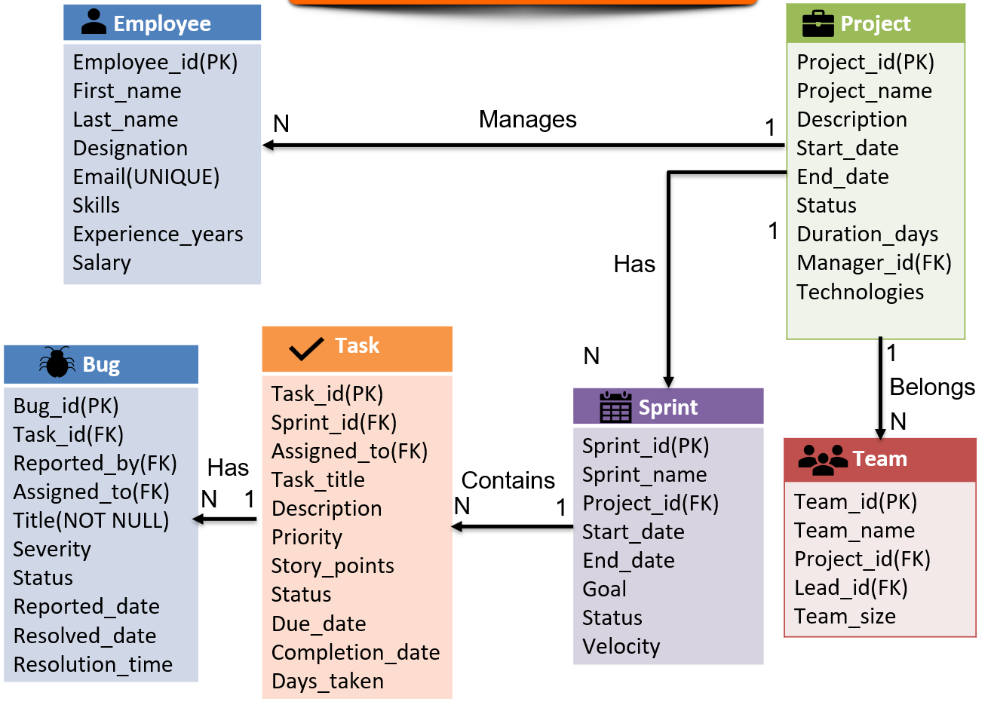

Fig. 3.6: Relational Schema Diagram

Primary Keys and Foreign Keys

Table | Primary Key | Foreign Key | References (Table.Column)
Employee | employee_id | ------ | -----
Project | project_id | manager_id | Employee.employee_id
Team | team_id | project_id, lead_id | Project.project_id, Employee.employee_id
Sprint | sprint_id | project_id | Project.project_id
Task | task_id | sprint_id, assigned_to | Sprint.sprint_id,
Bug | bug_id | task_id, reported_by, assigned_to | Task.task_id, Employee.employee_id,

Fig. 3.7:Primary Keys and Foreign Keys

3.8 Normalization up to 3NF
In the unnormalized form, all information such as client, project, employee, task, team, and milestone details may be stored in one large table. The same client, project, or employee information can appear many times. This creates duplicate data and makes updating information difficult.

First Normal Form (1NF)
In 1NF, all attributes must contain atomic values, meaning each field contains only one value. Repeating groups and multivalued fields are removed. Each row represents a single record.
This reduces problems caused by repeated or multiple values in a single field.

Second Normal Form (2NF)
In 2NF, the table must already be in 1NF, and there must be no partial dependency. Attributes that depend on different keys are separated into different tables.
For example, employee details are stored in the EMPLOYEE table, client details in the CLIENT table, and project details in the PROJECT table.
This reduces repeated information and prevents update, insertion, and deletion anomalies. Third Normal Form (3NF)
In 3NF, the table must already be in 2NF and must have no transitive dependency.
A non-key attribute should depend only on the primary key, not on another non-key attribute.
For example, Client_Name depends on Client_ID, so client information is kept in the CLIENT table rather than being repeatedly stored in the PROJECT table.

UNF → 1NF → 2NF → 3NF

Normal Form | Condition Satisfied | Anomaly Removed | Resulting Tables
1NF | Each attribute contains a single value and each record is uniquely identified by a primary key. | Removes repeating groups and non-atomic data. | Employee, Project, Team, Sprint, Task, Bug
2NF | All tables are in 1NF and every non-key attribute depends completely on the primary key. | Removes partial dependency and reduces data duplication. | Employee, Project, Team, Sprint, Task, Bug
3NF | All tables are in 2NF and non-key attributes depend only on the primary key, not on other non-key attributes. | Removes transitive dependency and reduces update, insertion, and deletion anomalies. | Employee, Project, Team, Sprint, Task, Bug
Table 3.8: Normalization Steps

CHAPTER 4

DATABASE IMPLEMENTATION

CREATE TABLE Employee (
employee_id INT GENERATED ALWAYS AS IDENTITY PRIMARY KEY,
first_name VARCHAR(50) NOT NULL,
last_name VARCHAR(50) NOT NULL,
designation VARCHAR(50),
email VARCHAR(100) UNIQUE NOT NULL,
experience_years INT CHECK (experience_years >= 0),
salary DECIMAL(10, 2)
);
CREATE TABLE Project (
project_id INT GENERATED ALWAYS AS IDENTITY PRIMARY KEY,
project_name VARCHAR(150) NOT NULL,
description TEXT,
start_date DATE,
end_date DATE,
status VARCHAR(30) DEFAULT 'Planning',
manager_id INT,
FOREIGN KEY (manager_id) REFERENCES Employee (employee_id)
);

CREATE TABLE Team (
team_id INT GENERATED ALWAYS AS IDENTITY PRIMARY KEY,
team_name VARCHAR(100) NOT NULL,
project_id INT NOT NULL,
lead_id INT,
FOREIGN KEY (project_id) REFERENCES Project (project_id),
FOREIGN KEY (lead_id) REFERENCES Employee (employee_id)
);
CREATE TABLE Team_Member (
team_id INT NOT NULL,
employee_id INT NOT NULL,
joined_date DATE,
PRIMARY KEY (team_id, employee_id),
FOREIGN KEY (team_id) REFERENCES Team (team_id),
FOREIGN KEY (employee_id) REFERENCES Employee (employee_id)
);

4.1 Database and Table Creation – DDL

CREATE TABLE Sprint (
sprint_id INT GENERATED ALWAYS AS IDENTITY PRIMARY KEY,
sprint_name VARCHAR(100),
project_id INT NOT NULL,
start_date DATE,
end_date DATE,
goal TEXT,
status VARCHAR(20) DEFAULT 'Planned',
FOREIGN KEY (project_id) REFERENCES Project (project_id)
);
CREATE TABLE Task (
task_id INT GENERATED ALWAYS AS IDENTITY PRIMARY KEY,
sprint_id INT,
assigned_to INT,
task_title VARCHAR(200) NOT NULL,
description TEXT,
priority VARCHAR(20) DEFAULT 'Medium',
story_points INT,
status VARCHAR(20) DEFAULT 'Todo',
due_date DATE,
completion_date DATE,
FOREIGN KEY (sprint_id) REFERENCES Sprint (sprint_id),
FOREIGN KEY (assigned_to) REFERENCES Employee (employee_id)
);
CREATE TABLE Bug (
bug_id INT GENERATED ALWAYS AS IDENTITY PRIMARY KEY,
task_id INT,
reported_by INT NOT NULL,
assigned_to INT,
title VARCHAR(200) NOT NULL,
severity VARCHAR(20),
status VARCHAR(20) DEFAULT 'Open',
reported_date DATE DEFAULT CURRENT_DATE,
resolved_date DATE,
FOREIGN KEY (task_id) REFERENCES Task (task_id),
FOREIGN KEY (reported_by) REFERENCES Employee (employee_id),
FOREIGN KEY (assigned_to) REFERENCES Employee (employee_id)
);

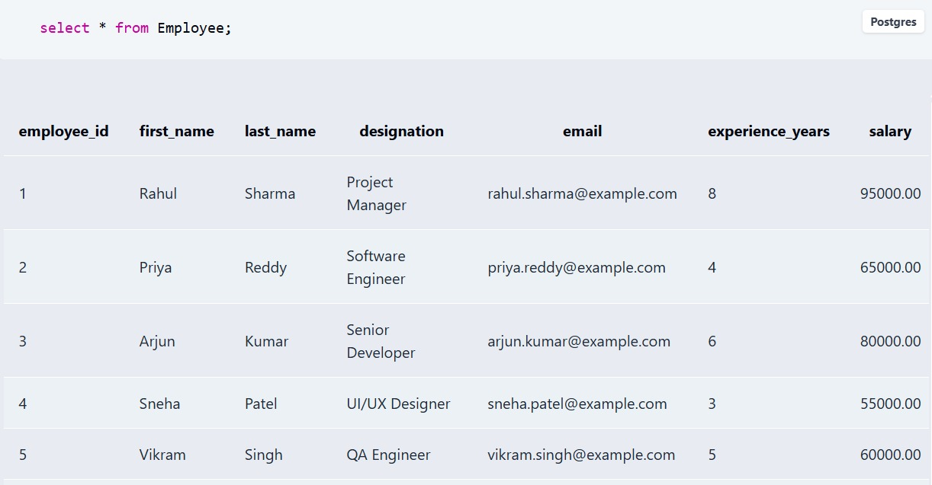

Fig. 4.1: Successful Creation of Tables

4.2 Sample Data Insertion – DML

INSERT INTO Employee

(first_name, last_name, designation, email, experience_years, salary)

VALUES

('Rahul', 'Sharma', 'Project Manager', 'rahul.sharma@example.com', 8, 95000.00),

('Priya', 'Reddy', 'Software Engineer', 'priya.reddy@example.com', 4, 65000.00),

('Arjun', 'Kumar', 'Senior Developer', 'arjun.kumar@example.com', 6, 80000.00),

('Sneha', 'Patel', 'UI/UX Designer', 'sneha.patel@example.com', 3, 55000.00),

('Vikram', 'Singh', 'QA Engineer', 'vikram.singh@example.com', 5, 60000.00),

('Ananya', 'Rao', 'Software Engineer', 'ananya.rao@example.com', 2, 50000.00),

('Kiran', 'Varma', 'DevOps Engineer', 'kiran.varma@example.com', 5, 72000.00),

('Meena', 'Das', 'Business Analyst', 'meena.das@example.com', 4, 62000.00),

('Rohit', 'Naidu', 'Backend Developer', 'rohit.naidu@example.com', 3, 58000.00),

('Divya', 'Iyer', 'Frontend Developer', 'divya.iyer@example.com', 2, 52000.00);

INSERT INTO Project

(project_name, description, start_date, end_date, status, manager_id)

VALUES

('E-Commerce Platform',

'Development of an online shopping platform',

'2026-01-10',

'2026-06-30',

'Completed',

1),

('Student Management System',

'Web-based system for managing student information',

'2026-02-01',

'2026-07-31',

'Completed',

1),

('AI Chatbot',

'Development of an AI-powered customer support chatbot',

'2026-04-01',

'2026-10-31',

'In Progress',

2),

('Mobile Banking App',

'Secure mobile application for banking services',

'2026-05-15',

'2026-12-31',

'In Progress',

3);

INSERT INTO Team

(team_name, project_id, lead_id)

VALUES

('E-Commerce Development Team', 1, 3),

('Student System Team', 2, 2),

('AI Development Team', 3, 3),

('Banking App Team', 4, 7),

('QA Team', 1, 5),

('UI Design Team', 2, 4);

INSERT INTO Team_Member

(team_id, employee_id, joined_date)

VALUES

(1, 3, '2026-01-10'),

(1, 4, '2026-01-11'),

(1, 5, '2026-01-12'),

(1, 9, '2026-01-12'),

(2, 2, '2026-02-01'),

(2, 6, '2026-02-02'),

(2, 10, '2026-02-02'),

(2, 8, '2026-02-03'),

(3, 3, '2026-04-01'),

(3, 6, '2026-04-02'),

(3, 7, '2026-04-03'),

(3, 9, '2026-04-03'),

(4, 7, '2026-05-15'),

(4, 2, '2026-05-16'),

(4, 5, '2026-05-17'),

(5, 5, '2026-01-15'),

(5, 2, '2026-01-16'),

(6, 4, '2026-02-05'),

(6, 10, '2026-02-06');

INSERT INTO Sprint

(sprint_name, project_id, start_date, end_date, goal, status)

VALUES

('Sprint 1 - Planning', 1, '2026-01-10', '2026-01-24',

'Requirement analysis and project setup', 'Completed'),

('Sprint 2 - Development', 1, '2026-01-25', '2026-02-15',

'Develop product catalog and user module', 'Completed'),

('Sprint 3 - Testing', 1, '2026-02-16', '2026-03-05',

'Testing and bug fixing', 'Completed'),

('Sprint 1 - Student Module', 2, '2026-02-01', '2026-02-20',

'Develop student registration module', 'Completed'),

('Sprint 2 - Reports', 2, '2026-02-21', '2026-03-15',

'Develop student reports and dashboard', 'Completed'),

('Sprint 1 - Chatbot', 3, '2026-04-01', '2026-04-20',

'Build chatbot basic architecture', 'Completed'),

('Sprint 2 - AI Model', 3, '2026-04-21', '2026-05-15',

'Integrate AI and NLP model', 'Active'),

('Sprint 1 - Banking', 4, '2026-05-15', '2026-06-05',

'Develop login and authentication', 'Active');

INSERT INTO Task

(sprint_id, assigned_to, task_title, description,

priority, story_points, status, due_date, completion_date)

VALUES

(1, 3, 'Requirement Analysis',

'Analyze project requirements',

'High', 5, 'Completed',

'2026-01-20', '2026-01-19'),

(1, 8, 'Database Design',

'Design database schema',

'High', 5, 'Completed',

'2026-01-22', '2026-01-21'),

(2, 9, 'Product Catalog',

'Develop product catalog module',

'High', 8, 'Completed',

'2026-02-10', '2026-02-09'),

(2, 4, 'UI Design',

'Design e-commerce user interface',

'Medium', 5, 'Completed',

'2026-02-12', '2026-02-11'),

(3, 5, 'System Testing',

'Perform functional testing',

'High', 8, 'Completed',

'2026-03-01', '2026-02-28'),

(4, 2, 'Student Registration',

'Create student registration module',

'High', 8, 'Completed',

'2026-02-15', '2026-02-14'),

(4, 6, 'Student Login',

'Develop student login functionality',

'Medium', 5, 'Completed',

'2026-02-18', '2026-02-17'),

(5, 10, 'Dashboard Design',

'Create student dashboard',

'Medium', 5, 'Completed',

'2026-03-10', '2026-03-09'),

(6, 6, 'Chatbot Interface',

'Develop chatbot user interface',

'High', 8, 'Completed',

'2026-04-18', '2026-04-17'),

(7, 3, 'AI Model Integration',

'Integrate NLP model with chatbot',

'High', 13, 'In Progress',

'2026-05-10', NULL),

(7, 9, 'API Development',

'Develop backend APIs for chatbot',

'High', 8, 'In Progress',

'2026-05-12', NULL),

(8, 7, 'Banking Login',

'Develop secure banking login',

'Critical', 8, 'In Progress',

'2026-05-30', NULL);

INSERT INTO Bug

(task_id, reported_by, assigned_to, title, severity, status,

reported_date, resolved_date)

VALUES

(3, 5, 9,

'Product image not loading',

'Medium',

'Resolved',

'2026-02-08',

'2026-02-09'),

(5, 5, 2,

'Checkout button not working',

'High',

'Resolved',

'2026-02-27',

'2026-02-28'),

(6, 8, 2,

'Registration validation error',

'Medium',

'Resolved',

'2026-02-13',

'2026-02-14'),

(7, 5, 6,

'Login password validation issue',

'High',

'Resolved',

'2026-02-16',

'2026-02-17'),

(9, 5, 6,

'Chatbot UI alignment issue',

'Low',

'Resolved',

'2026-04-16',

'2026-04-17'),

(10, 8, 3,

'Incorrect chatbot response',

'Critical',

'Open',

'2026-05-05',

NULL),

(11, 5, 9,

'API timeout issue',

'High',

'Open',

'2026-05-08',

NULL),

(12, 5, 7,

'Login authentication failure',

'Critical',

'Open',

'2026-05-25',

NULL);

S.No | Table Name | No. of Records Inserted | Screenshot Reference
1 | Employee | 5 | Screenshot 4.1
2 | Project | 3 | Screenshot 4.2
3 | Team | 4 | Screenshot 4.3
4 | Sprint | 4 | Screenshot 4.4
5 | Task | 5 | Screenshot 4.5
6 | Bug | 3 | Screenshot 4.6
Table 4.2: Sample Data Summary

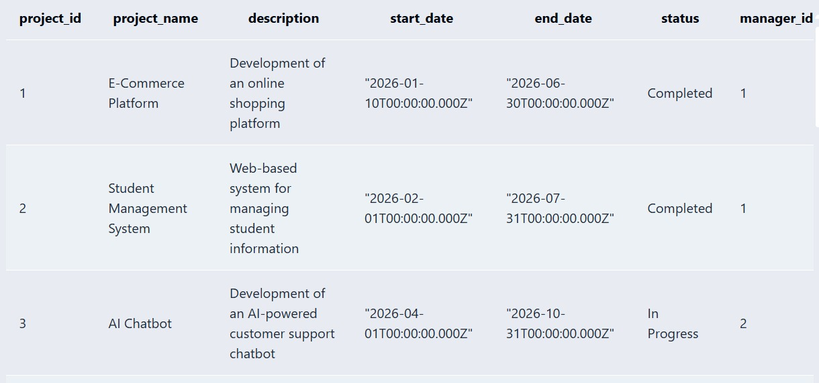

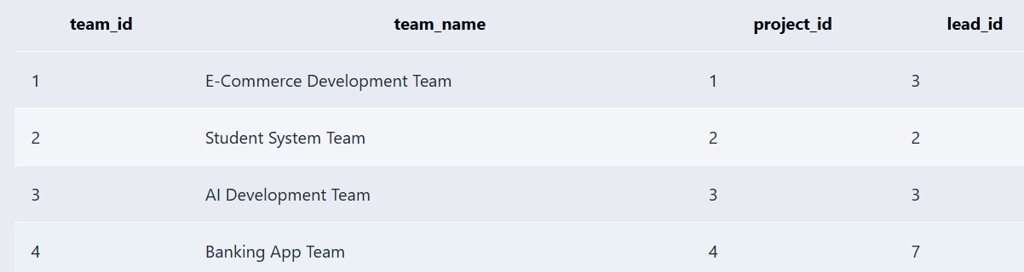

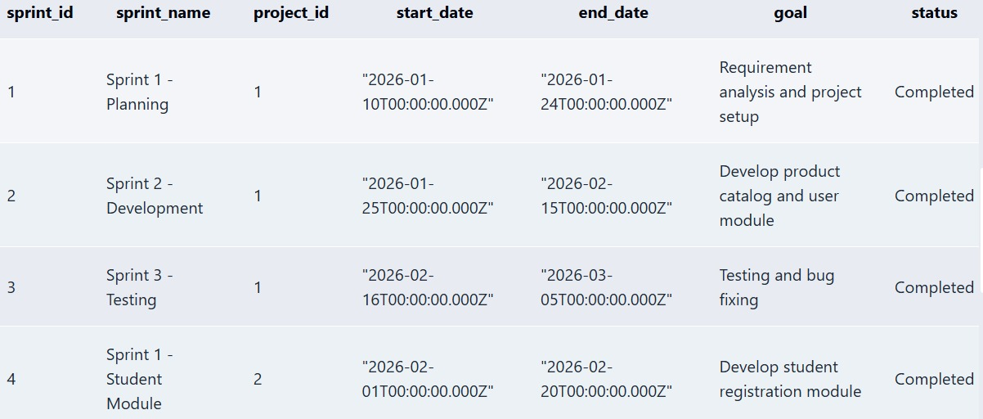
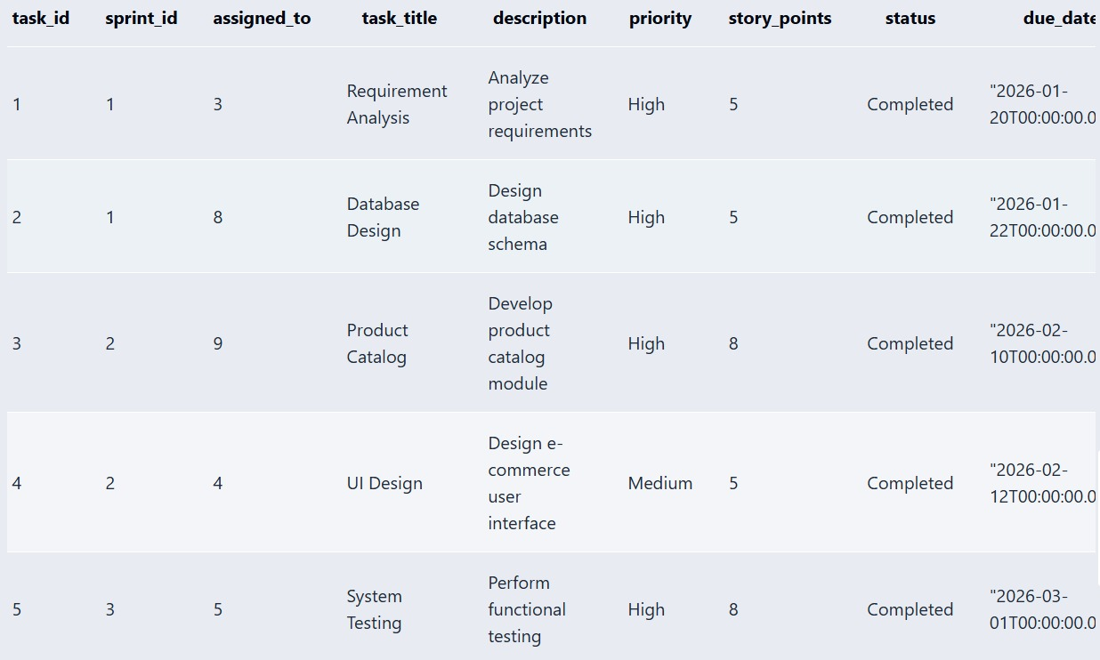

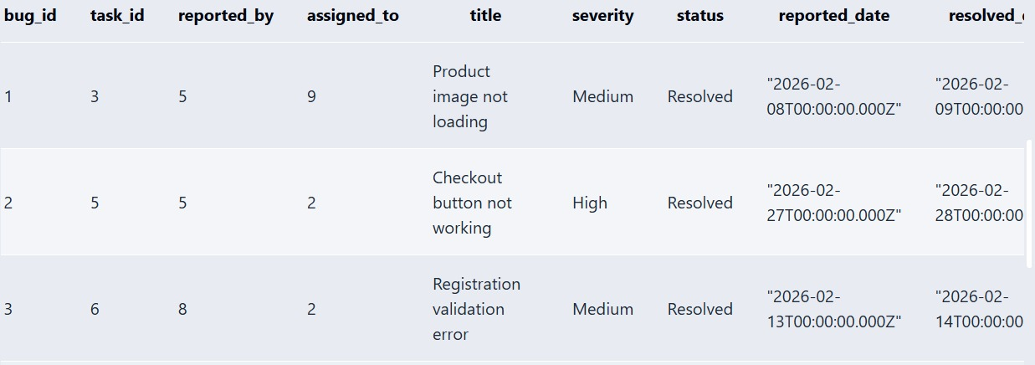

Fig. 4.2: Sample Data Inserted into the Tables

4.3 Constraints and Data Integrity

Constraint / Validation | Applied On (Table.Column) | Purpose | Evidence / Screenshot Ref.
PRIMARY KEY | Employee.employee_id | Uniquely identifies each employee | Screenshot 4.1
NOT NULL | Employee.first_name | Ensures employee first name is provided | Screenshot 4.2
UNIQUE | Employee.email | Prevents duplicate email addresses | Screenshot 4.3
CHECK | Employee.experience_years | Prevents negative experience values | Screenshot 4.4
CHECK | Employee.salary | Ensures salary is greater than zero | Screenshot 4.5
PRIMARY KEY | Project.project_id | Uniquely identifies each project | Screenshot 4.6
NOT NULL | Project.project_name | Ensures every project has a name | Screenshot 4.7
DEFAULT | Project.status | Automatically sets status to Planning | Screenshot 4.8
FOREIGN KEY | Project.manager_id | Links the project manager to Employee | Screenshot 4.9
PRIMARY KEY | Team.team_id | Uniquely identifies each team | Screenshot 4.10
NOT NULL | Team.team_name | Ensures every team has a name | Screenshot 4.11
FOREIGN KEY | Team.project_id | Links the team to a project | Screenshot 4.12
FOREIGN KEY | Team.lead_id | Links the team lead to an employee | Screenshot 4.13
PRIMARY KEY | Sprint.sprint_id | Uniquely identifies each sprint | Screenshot 4.14
FOREIGN KEY | Sprint.project_id | Links the sprint to a project | Screenshot 4.15
DEFAULT | Sprint.status | Automatically sets sprint status to Planned | Screenshot 4.16
PRIMARY KEY | Task.task_id | Uniquely identifies each task | Screenshot 4.17
NOT NULL | Task.task_title | Ensures every task has a title | Screenshot 4.18
FOREIGN KEY | Task.sprint_id | Links the task to a sprint | Screenshot 4.19
DEFAULT | Task.status | Automatically sets task status to Todo | Screenshot 4.20
PRIMARY KEY | Bug.bug_id | Uniquely identifies each bug | Screenshot 4.21
NOT NULL | Bug.title | Ensures every bug has a title | Screenshot 4.22
FOREIGN KEY | Bug.task_id | Links the bug to its related task | Screenshot 4.23
FOREIGN KEY | Bug.reported_by | Identifies the employee who reported the bug | Screenshot 4.24
DEFAULT | Bug.status | Automatically sets bug status to Open | Screenshot 4.25
Table 4.3: Constraints and Data Integrity Rules

Data Validation Rules
    - Duplicate IDs: PRIMARY KEY constraints ensure that every record has a unique ID. Therefore, duplicate IDs cannot be inserted.
    - Invalid values: CHECK constraints prevent invalid values. For example, Budget and Salary cannot be negative, and Team_Size must be greater than zero.
    - Missing values: NOT NULL constraints ensure that important fields cannot be left empty.
    - Duplicate emails: UNIQUE constraints prevent duplicate email addresses.
    - Orphan records: FOREIGN KEY constraints ensure that a record can reference only an existing record in the parent table.

Referential Integrity Violation
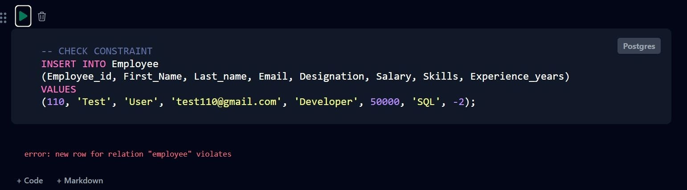
For example, PROJECT.Client_ID is a foreign key referencing CLIENT.Client_ID. If we try to insert a project with a non-existing client ID:

Fig. 4.5: Referential Integrity Violation

CHAPTER 5

SQL OPERATIONS AND QUERIES

This section demonstrates the SQL operations performed on the Software Project Management System database. It includes data retrieval, filtering, sorting, grouping, joins, subqueries, views, and aggregate functions.

DQL – Basic Retrieval Queries
Q1 – Display all employee records
SELECT * FROM Employee;
Q2 – Display all project records
SELECT * FROM Project;
Q3 – Display employee names, designations and salaries
SELECT first_name, last_name, designation, salary FROM Employee;
Q4 – Display all sprint records
SELECT * FROM Sprint;
Q5 – Display all task records
SELECT * FROM Task;

Q.No | Purpose of the Query | SQL Statement | Output Ref.
Q1 | Display all employee records | SELECT * FROM Employee; | Output 5.1
Q2 | Display all project records | SELECT * FROM Project; | Output 5.2
Q3 | Display employee names, designations and salaries | SELECT first_name, last_name, designation, salary FROM Employee; | Output 5.3
Q4 | Display all sprint records | SELECT * FROM Sprint; | Output 5.4
Q5 | Display all task records | SELECT * FROM Task; | Output 5.5

Table 5.1: Basic Retrieval Queries

Join Operations
Join operations are used to combine records from two or more related tables using common columns. The following queries demonstrate Natural Join, Equi Join, Inner Join, Left Outer Join, Right Outer Join, and Full Outer Join.
Q.No | Type of Join | SQL Statement | Output Ref.
Q6 | Natural Join | SELECT * FROM Project NATURAL JOIN Team; | Figure 5.6
Q7 | Equi Join | SELECT P.project_name, E.first_name, E.last_name FROM Project P, Employee E WHERE P.manager_id = E.employee_id; | Figure 5.7
Q8 | Inner Join | SELECT P.project_name, E.first_name, E.last_name FROM Project P INNER JOIN Employee E ON P.manager_id = E.employee_id; | Figure 5.8
Q9 | Left Outer Join | SELECT E.first_name, E.last_name, P.project_name FROM Employee E LEFT JOIN Project P ON E.employee_id = P.manager_id; | Figure 5.9
Q10 | Right Outer Join | SELECT E.first_name, E.last_name, P.project_name FROM Employee E RIGHT JOIN Project P ON E.employee_id = P.manager_id; | Figure 5.10
Q11 | Full Outer Join | SELECT E.first_name, E.last_name, P.project_name FROM Employee E FULL OUTER JOIN Project P ON E.employee_id = P.manager_id; | Figure 5.11
Table 5.2: Join Operations

Aggregate Functions, GROUP BY and HAVING
Q.No | Function Used | SQL Statement | Output Ref.
Q12 | SUM | SELECT SUM(salary) AS Total_Salary FROM Employee; | Figure 5.12
Q13 | AVG | SELECT AVG(salary) AS Average_Salary FROM Employee; | Figure 5.13
Q14 | MAX | SELECT MAX(salary) AS Highest_Salary FROM Employee; | Figure 5.14
Q15 | COUNT+GROUP BY | SELECT designation, COUNT(*) AS Employee_Count FROM Employee GROUP BY designation; | Figure 5.15
Q16 | GROUP BY+HAVING | SELECT designation, COUNT(*) AS Employee_Count FROM Employee GROUP BY designation HAVING COUNT(*) > 1; | Figure 5.16
Table 5.3: Aggregate, GROUP BY and HAVING Queries

Nested and Correlated Subqueries
Q.No | Type (Nested / Correlated) | SQL Statement | Output Ref.
Q17 | Nested Subquery | SELECT first_name, last_name, salary FROM Employee WHERE salary > (SELECT AVG(salary) FROM Employee); | Figure 5.17
Q18 | Nested Subquery | SELECT project_name, start_date FROM Project WHERE start_date = (SELECT MIN(start_date) FROM Project); | Figure 5.18
Q19 | Correlated Subquery | SELECT E.first_name, E.last_name, E.salary FROM Employee E WHERE E.salary > (SELECT AVG(E2.salary) FROM Employee E2 WHERE E2.designation = E.designation); | Figure 5.19
Q20 | Correlated Subquery | SELECT T.task_title, T.story_points FROM Task T WHERE T.story_points > (SELECT AVG(T2.story_points) FROM Task T2 WHERE T2.sprint_id = T.sprint_id); | Figure 5.20
Table 5.4: Subqueries

Views and Relational Set Operations

This section demonstrates updatable views, non-updatable views, and relational set operations: UNION, INTERSECT, and EXCEPT (MINUS).
Q.No | View / Set Operation | SQL Statement | Output Ref.
Q21 | Updatable View | CREATE VIEW Employee_View AS SELECT employee_id, first_name, last_name, designation, salary FROM Employee; | Figure 5.21
Q22 | Non-Updatable View | CREATE VIEW Project_Manager_View AS SELECT P.project_name, E.first_name, E.last_name FROM Project P JOIN Employee E ON P.manager_id = E.employee_id; | Figure 5.22
Q23 | UNION | SELECT first_name AS Name FROM Employee WHERE designation = 'Developer' UNION SELECT first_name AS Name FROM Employee WHERE designation = 'Manager'; | Figure 5.23
Q24 | INTERSECT | SELECT first_name AS Name FROM Employee WHERE designation = 'Developer' INTERSECT SELECT first_name AS Name FROM Employee WHERE designation = 'Manager'; | Figure 5.24
Q25 | EXCEPT | SELECT first_name AS Name FROM Employee WHERE designation = 'Developer' EXCEPT SELECT first_name AS Name FROM Employee WHERE designation = 'Manager'; | Figure 5.25
Table 5.5: Views and Set Operations

DCL and TCL Operations
This section demonstrates DCL (Data Control Language) commands such as GRANT and REVOKE, and TCL (Transaction Control Language) commands such as COMMIT, SAVEPOINT, and ROLLBACK.
Q.No | Command | Purpose | SQL Statement | Output Ref.
Q26 | GRANT | Give SELECT permission to a user | GRANT SELECT ON ALL TABLES IN SCHEMA public TO project_user; | Figure 5.26
Q27 | REVOKE | Remove SELECT permission from a user | REVOKE SELECT ON ALL TABLES IN SCHEMA public FROM project_user; | Figure 5.27
Q28 | SAVEPOINT | Create a savepoint during a transaction | SAVEPOINT sp1; | Figure 5.28
Q29 | ROLLBACK | Roll back changes to the savepoint | ROLLBACK TO SAVEPOINT sp1; | Figure 5.29
Q30 | COMMIT | Permanently save transaction changes | COMMIT; | Figure 5.30
Table 5.6: DCL and TCL Operations

CHAPTER 6

MODULES AND FUNCTIONALITIES
The Software Management System is divided into several modules. Each module performs a specific function and operates on related database tables.

S.No | Module Name | Functionality | Tables Involved
1 | Employee Management | Manages employee details such as name, designation, email, experience, and salary. | Employee, Employee_Skills
2 | Project Management | Manages project details, project manager, project dates, status, and technologies. | Project, Project_Tech, Employee
3 | Team Management | Creates teams, assigns teams to projects, manages team leads, and maintains team members. | Team, Team_Member, Employee
4 | Sprint Management | Manages sprints associated with projects, including sprint name, dates, goal, status, and velocity. | Sprint, Project
5 | Task Management | Manages tasks assigned to employees within sprints and tracks priority, story points, status, and deadlines. | Task, Sprint, Employee
6 | Bug Management | Records bugs related to tasks and manages bug reporting, assignment, severity, status, and resolution. | Bug, Task, Employee
Table 6.1:A Modules and Their Functionalities
The User Management module handles user registration, login, and user information. It ensures that users can access the system according to their assigned

Employee Management:
Stores employee information and their skills.
Project Management:
Stores project information and identifies the employee responsible as project manager.
Team Management:
Maintains project teams, team leaders, and team members.
Sprint Management:
Maintains sprints under each project and tracks their progress.
Task Management:
Stores tasks belonging to sprints and records the employee assigned to each task.
Bug Management:
Stores bugs associated with tasks and records who reported and who is assigned to fix each bug

CHAPTER 7

RESULTS – SAMPLE OUTPUTS AND SCREENSHOTS
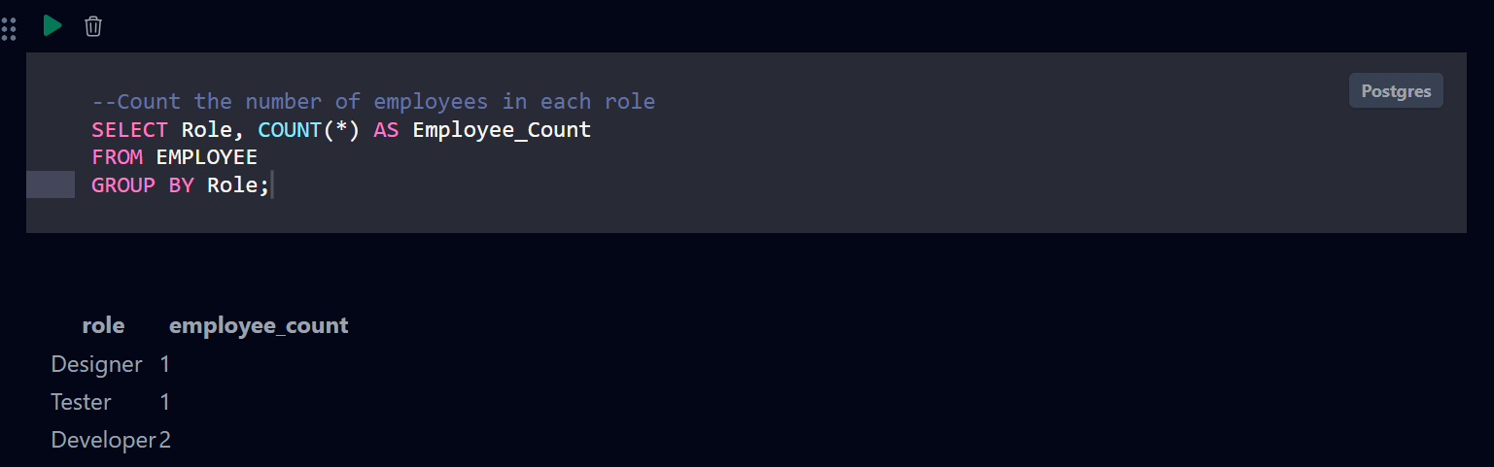 [ Insert Screenshot 1 here ]

Fig. 7.1:

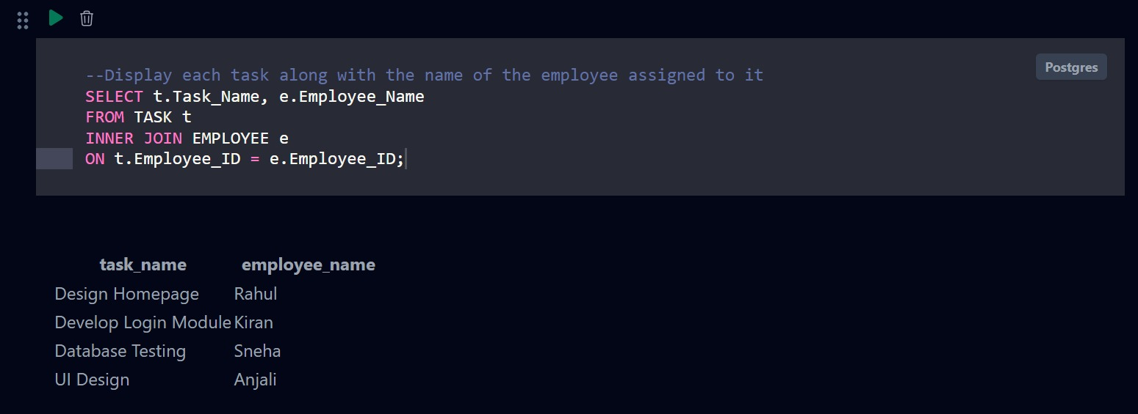

Fig. 7.2:
[ Insert Screenshot 3 here ]

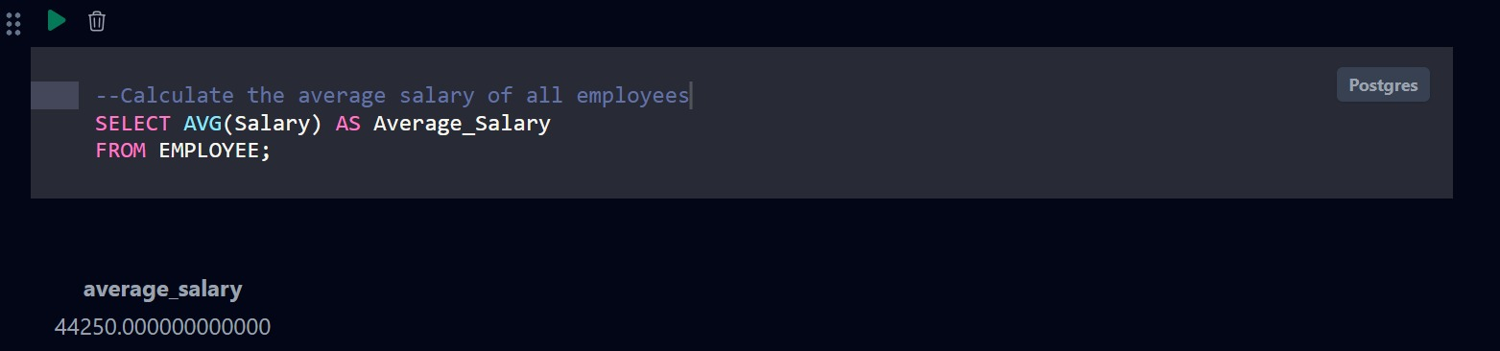

Fig. 7.3:

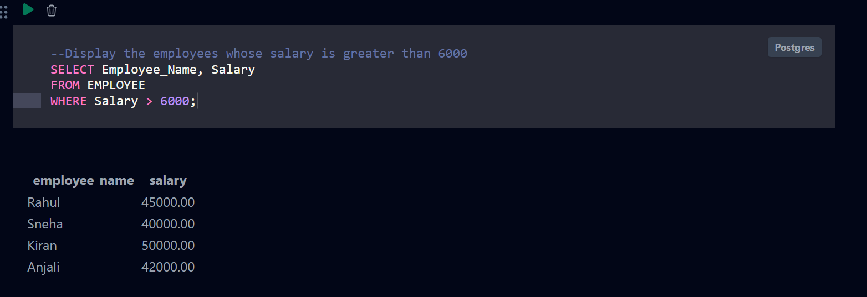

Fig. 7.4:

CHAPTER 8

TESTING AND DATA VALIDATION

TC No. | Test Case Description | Input / Action | Expected Result | Actual Result | Status
TC-01 | Insert employee record | Enter valid employee details | Employee record should be inserted successfully | Employee record inserted successfully | Pass
TC-02 | Insert duplicate employee email | Enter an email already existing in Employee | Database should reject duplicate email | Duplicate email rejected | Pass
TC-03 | Insert project record | Enter valid project details with manager ID | Project should be created successfully | Project created successfully | Pass
TC-04 | Insert project with invalid manager | Enter a manager ID that does not exist | Foreign key constraint should reject the record | Invalid manager rejected | Pass
TC-05 | Create team | Enter valid team details and project ID | Team should be created successfully | Team created successfully | Pass
TC-06 | Add employee to team | Insert valid Team ID and Employee ID | Employee should be added to the team | Employee added successfully | Pass
TC-07 | Create sprint | Enter valid sprint and project details | Sprint should be created successfully | Sprint created successfully | Pass
TC-08 | Create task | Enter valid task details and sprint ID | Task should be created successfully | Task created successfully | Pass
TC-09 | Assign task to employee | Enter valid Employee ID in assigned_to | Task should be assigned to the employee | Task assigned successfully | Pass
TC-010 | Create bug | Enter valid bug details and task ID | Bug should be recorded successfully | Bug recorded successfully | Pass
TC-011 | Invalid task assignment | Enter a non-existing Employee ID | Foreign key constraint should reject the assignment | Invalid assignment rejected | Pass
TC-012 | Update task status | Change task status from Todo to Done | Task status should be updated | Status updated successfully | Pass
TC-013 | Retrieve project details | Execute project SELECT query | Project records should be displayed | Project records displayed | Pass
TC-014 | Join project and employee | Execute Project–Employee JOIN query | Project and manager details should be displayed together | JOIN executed successfully | Pass
TC-015 | Calculate average salary | Execute AVG(salary) query | Average employee salary should be displayed | Average salary displayed | Pass
TC-016 | Test transaction rollback | Update data and execute ROLLBACK | Uncommitted changes should be cancelled | Changes rolled back successfully | Pass
Table 8.1: Test Cases and Results

CHAPTER 9

GITHUB REPOSITORY AND TEAM CONTRIBUTION

Repository Details

GitHub Repository: SOFTWARE MANAGEMENT SYSTEM
The GitHub repository contains all the project files, including:
Database SQL code
Table creation scripts
Sample data
SQL queries
ER diagram
Project documentation
PPT/presentation

.

Team Responsibilities and Contribution

S.No | Student Name | Roll Number | Role / Responsibility | Modules Contributed
1 | M.Mahitha | 26B21AI167 | Team lead , ER design | Unit 1 and 3-ER model
2 | J.Pragathi | 26B21AI169 | Schema design and documentation | Unit 2-Realtional model, project documentation
3 | P.Suhasini | 26B61AI003 | DDL,DML and SQL query implementation | Unit 2-SQL ,Unit 3-Advanced SQL
4 | K.Kiran kumar reddy | 26B21AI104 | SQL  implementation and testing | Unit 2 -testing and implementation

CHAPTER 10

CONCLUSION AND FUTURE ENHANCEMENTS

10.1 Conclusion
This project successfully designed and implemented a Software Management System to manage software products, users, developers, clients, projects, licenses, and related activities. The system provides a centralized platform for storing, organizing, updating, and retrieving software-management information efficiently.
Several SQL operations were implemented in the system. CREATE TABLE statements were used to create the database structure, while INSERT statements were used to add software, user, project, client, and license records. SELECT queries enabled users to retrieve and view information. UPDATE statements allowed existing records to be modified, and DELETE statements enabled unwanted records to be removed. In addition, JOIN, filtering, sorting, grouping, and aggregate queries were used to produce meaningful information and reports from multiple related tables.
The objectives stated in Section 1.4 were achieved as follows:
To design a database for managing software-related information: This was achieved by creating a structured relational database containing tables for the main entities involved in software management.
To store and manage software records efficiently: Software details, versions, categories, developers, and other relevant information can be added, updated, searched, and maintained within the system.
To manage users and their roles: The system stores user information and supports the management of different users, such as administrators, developers, managers, and clients.
To manage software projects and development activities: Project-related information can be recorded and linked to the appropriate software, users, developers, or clients.
To maintain data accuracy and integrity: Primary keys, foreign keys, appropriate data types, and normalization were used to prevent invalid and inconsistent data.
To retrieve useful information through SQL queries: SQL operations, including joins and conditional queries, were implemented to generate relevant records and reports.
To provide a reliable and maintainable system: The organized database structure makes the system easier to update, expand, and maintain in the future.
Overall, the Software Management System achieved its main objectives by providing a centralized, normalized, and functional solution for managing software-related data. It improves data organization, reduces redundancy, supports efficient information retrieval, and provides a strong foundation for future system enhancements.

10.2 Limitations of the Present Work

The present database has certain limitations. It primarily stores and manages basic information related to users, projects, tasks, teams, and other project-related activities. The database does not currently support advanced features such as real-time data synchronization, distributed database management, automated backup and recovery, or integration with external databases and applications. The current design may also have limited scalability when handling a very large volume of records or simultaneous users. Advanced database security features, detailed audit trails, data encryption, and sophisticated data analytics are not fully implemented. Some data validation and maintenance activities may also require manual intervention. These limitations can be addressed in future work by improving database scalability, security, backup mechanisms, automation, and integration capabilities.

Future Enhancements

The Software Management System can be enhanced in several ways in the future. A user-friendly front-end application can be developed to make data entry, project management, and report generation easier. Additional modules such as employee management, attendance, project progress tracking, notifications, and resource management can be added. Stored procedures and triggers can be implemented to automate frequently performed database operations and maintain data consistency. Indexing can be improved to increase query performance when the database contains a large amount of data. Stronger security features, including role-based access control, authentication, and authorization, can be implemented to protect sensitive information. Regular database backup and recovery mechanisms can also be introduced to prevent data loss. Finally, reporting and analytics features can be added to generate project summaries, task reports, employee performance reports, and other useful management information.

REFERENCES
- MySQL 8.0 documentation and SQL reference.
- Database Management Systems concepts: relational modelling, keys and normalization.
- draw.io / diagrams.net for ER and relational schema diagrams.
- Git and GitHub documentation for version control and collaboration.
- Capstone Project — Database Design & Implementation source material provided for the Software Project Management System.
- Abraham Silberschatz, Henry F. Korth and S. Sudarshan, “Database System Concepts”, 8th Edition, McGraw-Hill, ISBN: 978-1260230508.
- Raghurama Krishnan and Johannes Gehrke, “Database Management Systems”, 4th Edition, McGraw-Hill, ISBN: 978-1260091195.
- Ramez Elmasri and Shamkant B. Navathe, “Fundamentals of Database Systems”, 7th Edition, Pearson, ISBN: 978-0137504277.
- C. J. Date, “An Introduction to Database Systems”, 9th Edition, Pearson, ISBN: 978-0133970777.
- MySQL 8.0 Reference Manual, Oracle Corporation, https://dev.mysql.com/doc/refman/8.0/en/
- W3Schools SQL Tutorial, https://www.w3schools.com/sql/
- NPTEL Online Course on Database Management Systems,

APPENDIX A – COMPLETE SQL SCRIPT

The following consolidated script contains the table definitions used in this report. Execute the statements in dependency order in MySQL.

CREATE TABLE Employee (
employee_id INT GENERATED ALWAYS AS IDENTITY PRIMARY KEY,
first_name VARCHAR(50) NOT NULL,
last_name VARCHAR(50) NOT NULL,
designation VARCHAR(50),
email VARCHAR(100) UNIQUE NOT NULL,
experience_years INT CHECK (experience_years >= 0),
salary DECIMAL(10, 2)
);
CREATE TABLE Project (
project_id INT GENERATED ALWAYS AS IDENTITY PRIMARY KEY,
project_name VARCHAR(150) NOT NULL,
description TEXT,
start_date DATE,
end_date DATE,
status VARCHAR(30) DEFAULT 'Planning',
manager_id INT,
FOREIGN KEY (manager_id) REFERENCES Employee (employee_id)
);

CREATE TABLE Team (
team_id INT GENERATED ALWAYS AS IDENTITY PRIMARY KEY,
team_name VARCHAR(100) NOT NULL,
project_id INT NOT NULL,
lead_id INT,
FOREIGN KEY (project_id) REFERENCES Project (project_id),
FOREIGN KEY (lead_id) REFERENCES Employee (employee_id)
);
CREATE TABLE Team_Member (
team_id INT NOT NULL,
employee_id INT NOT NULL,
joined_date DATE,
PRIMARY KEY (team_id, employee_id),
FOREIGN KEY (team_id) REFERENCES Team (team_id),
FOREIGN KEY (employee_id) REFERENCES Employee (employee_id)
);
CREATE TABLE Sprint (
sprint_id INT GENERATED ALWAYS AS IDENTITY PRIMARY KEY,
sprint_name VARCHAR(100),
project_id INT NOT NULL,
start_date DATE,
end_date DATE,
goal TEXT,
status VARCHAR(20) DEFAULT 'Planned',
FOREIGN KEY (project_id) REFERENCES Project (project_id)
);
CREATE TABLE Task (
task_id INT GENERATED ALWAYS AS IDENTITY PRIMARY KEY,
sprint_id INT,
assigned_to INT,
task_title VARCHAR(200) NOT NULL,
description TEXT,
priority VARCHAR(20) DEFAULT 'Medium',
story_points INT,
status VARCHAR(20) DEFAULT 'Todo',
due_date DATE,
completion_date DATE,
FOREIGN KEY (sprint_id) REFERENCES Sprint (sprint_id),
FOREIGN KEY (assigned_to) REFERENCES Employee (employee_id)
);
CREATE TABLE Bug (
bug_id INT GENERATED ALWAYS AS IDENTITY PRIMARY KEY,
task_id INT,
reported_by INT NOT NULL,
assigned_to INT,
title VARCHAR(200) NOT NULL,
severity VARCHAR(20),
status VARCHAR(20) DEFAULT 'Open',
reported_date DATE DEFAULT CURRENT_DATE,
resolved_date DATE,
FOREIGN KEY (task_id) REFERENCES Task (task_id),
FOREIGN KEY (reported_by) REFERENCES Employee (employee_id),
FOREIGN KEY (assigned_to) REFERENCES Employee (employee_id)
);

