Hearthbuddy\Triton\Game\TritonHs.cs

游戏主界面的4/5个按钮点击函数

Hearthbuddy\Triton\Bot\Logic\Bots\DefaultBot\DefaultBot.cs

private async Task method_45(PegasusScene **pegasusScene_0**)

[HubScene]按收藏按钮等过程

Hearthstone.exe -launch -uid hs_beta

Battle.net.exe --exec="launch WTCG"

Ls

更改文件：ass ：

Logger print():

加入了写入c//1//1.txt

注释了两个地方的限制输出

LoginService update():

判断请求登录状态，登录

LoginService ProcessChallenge(url):

有一个url，可能是请求的地址

可能是请求，获取token吧

DesktopLoginTokenFetcher FetchToken(url)

获取token等可能是设置本地token

GetTokenIfAvailable

获取token，一种是GetTokenFromTokenFetcher

一种是BattleNet.GetLaunchOption

第一种已弃用

registrywin

RetrieveString()

计算机\HKEY_CURRENT_USER\Software\Blizzard Entertainment\Battle.net\Launch Options\WTCG

using System.IO;

using System.Text;

                StreamWriter streamWriter = new StreamWriter("C:\\1\\11.txt", true, Encoding.Default);  
                streamWriter.WriteLine(**path**+"  "+**name**);  
                streamWriter.Flush();  
                streamWriter.Close();

TavernBrawlDisplay OnPlayButtonExecute()

如何让ls输出所有调试信息呢？

先反编译Assembly-CSharp.dll(位置：Hearthstone目录\Hearthstone_Data\Managed)（工具dnspy）

找到Logger类中的print函数发现输出日志时

​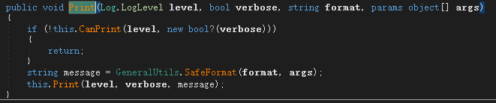

有CanPrint限制，说明在exe中指定了某些配置通过CanPrint的判断让很多log没有输出

右键-编辑方法-删除if语句（注意备份）

发现炉石log下的日志没变（。。。。。？）

遂怀疑在日志print链条内还进行了CanPrint判断

dnspy搜索CanPrint，（注意，搜索时不要选择所有文件，因dnspy使用的是递归搜索，不指定范围可能把整个net框架给搜索一便（这也是近两个版本dnspy容易崩溃的原因））



将每一个CanPrint第一行直接返回True，保存，ok！

结果：

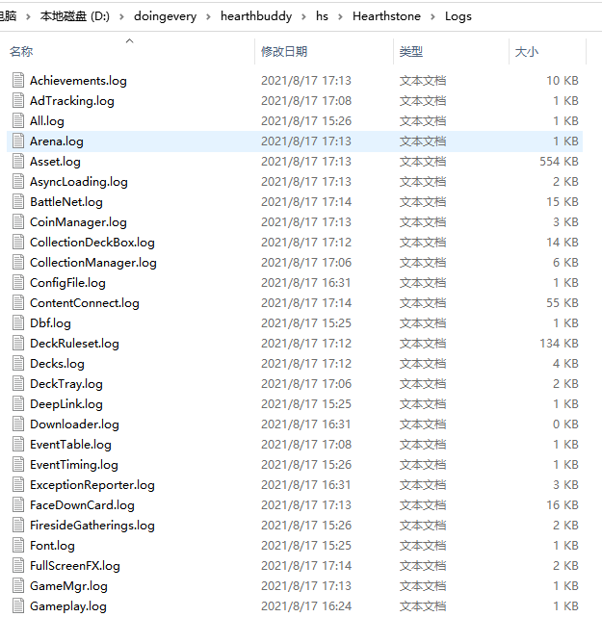

这样我们就能很方便的对ls进行定位了测试了

声明：此行为仅可用于学习使用，请各位健康游戏

再给大家讲一下游戏启动的问题吧，因为中控是最好写的，可以用任何一个语言实现，相信大家都尝试过

但大家肯定发现现在跟以前不太一样了，不能从ls（炉石）的exe直接启动

为什么呢？

​通过日志的报错信息，我们补全参数

Hearthstone.exe -launch -uid hs_beta

发现还是不行

怎么回事呢？

先反编译Assembly-CSharp.dll（dnspy）

通过log追踪函数发现ls是用token验证登录的，定位到token获取函数后发现有两种方式：

1通过请求方式

2获取注册表内的token值

发现方式1一直没有使用，猜测方法1已经弃用

追踪注册表指定值

发现在暴雪界面每按一下进入游戏就会更新一次注册表的值，然后ls就会读取注册表内的信息，然后获取token，提交请求实现登录。

结论：无法从ls的exe文件直接启动

解决方法：

带参数运行战网exe：

Battle.net.exe --exec="launch WTCG"

hb：

点击运行按钮到运行脚本逻辑的框架：

MainWindow.button_0_Click():

BotManager.Start();//开始bot脚本

BotManager.Start():

BotThread = new Thread(smethod_4);

BotThread.Name = "BotThread";

BotThread.Start();

BotManager.smethod_4():

1.

smethod_0(CurrentBot);

->ibot_1.Start();

->DefaultBots.Start():

->coroutine_0 = new Coroutine(() => method_21())

定义了taskProducer异步委托:method_21()

定义了action_0异步委托：里面有taskProducer()

2.

smethod_1(CurrentBot);

这里实现的循环：

while (!autoResetEvent_0.WaitOne(0))

{

try

{

if (MsBeforeNextTick != 0)

{

Thread.Sleep(MsBeforeNextTick);

MsBeforeNextTick = 0;

}

smethod_1(CurrentBot);//这里

bool_3 = false;

if (MsBetweenTicks != 0)

{

Thread.Sleep(MsBetweenTicks);

}

}

catch (InjectionDesyncException)

{

ilog_0.DebugFormat("[BotThreadFunction] An InjectionDesyncException was detected.");

bool_3 = true;

TritonHs.InvokeEvent(eventHandler_1, null, new ClientFrozenEventArgs());

}

catch

{

}

}

BotManager..smethod_1(IBot ibot_1):

ibot_1.Tick();//DefaultBots.Tick

DefaultBots.Tick():

coroutine_0.Resume();//bot动作

coroutine_0.Resume()

coroutine_0.method_0(bool_2: false);

private void method_0(bool bool_2)

{

SynchronizationContext current = SynchronizationContext.Current;

Coroutine coroutine = coroutine_0;

try

{

coroutine_0 = this;

SynchronizationContext.SetSynchronizationContext(null);

Action action = action_0;

action_0 = null;

action();

if (!bool_2)

{

Ticks++;

}

method_2(bool_2);

}

finally

{

coroutine_0 = coroutine;

SynchronizationContext.SetSynchronizationContext(current);

}

}

action会进入 action_0异步委托：里面有taskProducer()

taskProducer会进入DefaultBots.method_21()

后面会进入多个async

最后会

private static async Task smethod_3()

{

Class65 @class = Current.class65_0.GetAwaiter();

if (!@class.Boolean_1)

{

await @class;

//object obj = default(object);

//@class = (Class65)obj;

}

@class.method_1();

}

进入自定义的awaiter

自定义的awaiter无任何任务，只是将await后面需要运行的通过await内的异步方法生成器掉用awaiter的OnCompleted

public void OnCompleted(Action continuation)

{

if (Current.action_0 != null)

{

Current.bool_0 = true;

}

Current.action_0 = continuation;

}

重新定义Current.action_0

在下一个循环会运行之前await的后半部分

然后进入DefaultBots.method_21()

private async Task method_21()

{

while (true)

{

await Coroutine.Yield();

PegasusScene scene = SceneMgr.Get().GetScene();

SceneMgr.Mode mode = SceneMgr.Get().GetMode();

if (!(await method_20()))

{

switch (mode)

{

case SceneMgr.Mode.INVALID:

ilog_0.DebugFormat("[MainCoroutine] Unprocessed mode: {0}.", mode);

await Coroutine.Sleep(1000);

break;

到达await后循环之前的过程

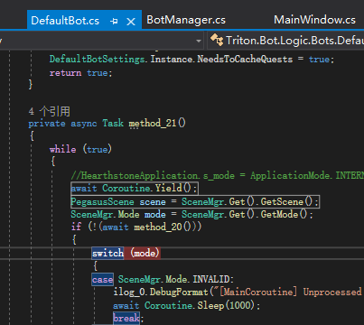

intptr_1 = intptr_0 + 0x31060;//94 5D 00030CA0 mono_class_get

intptr_2 = intptr_0 + 0x32080;//111 6E 00031CC0 mono_class_get_name

intptr_3 = intptr_0 + 0x32090;//112 6F 00031CD0 mono_class_get_namespace

intptr_4 = intptr_0 + 0x28D70;//21 14 000289A0 mono_assembly_get_image

intptr_5 = intptr_0 + 0x320A0;//113 70 00031CE0 mono_class_get_nested_types

intptr_6 = intptr_0 + 0x2B200;//47 2E 0002ACE0 mono_assembly_open

intptr_7 = intptr_0 + 0x29550;//30 1D 00029180 mono_assembly_load_from_full

intptr_8 = intptr_0 + 0x318E0;//103 66 00031520 mono_class_get_fields

intptr_9 = intptr_0 + 0x26090;//274 111 00025CC0 mono_domain_get

intptr_10 = intptr_0 + 0xEF800;//371 172 000EE030 mono_gchandle_free

intptr_11 = intptr_0 + 0x9C230;//320 13F 0009B570 mono_field_get_value_object

intptr_12 = intptr_0 + 0xEFB90;//374 175 000EE3C0 mono_gchandle_new

intptr_13 = intptr_0 + 0x5D350;//481 1E0 0005CC10 mono_image_open_from_data_with_name

intptr_14 = intptr_0 + 0x5C4D0;//466 1D1 0005BD90 mono_image_get_table_rows

intptr_15 = intptr_0 + 0x63120;//665 298 000629F0 mono_method_signature

intptr_16 = intptr_0 + 0x32470;//120 77 000320A0 mono_class_get_type

intptr_17 = intptr_0 + 0x80937;//intptr_17 = intptr_0 + 0x80937;

intptr_18 = intptr_0 + 0xB3C90;//946 3B1 000B27F0 mono_thread_detach

intptr_19 = intptr_0 + 0x32010;//110 6D 00031C50 mono_class_get_methods

intptr_20 = intptr_0 + 0x320F0;//114 71 00031D30 mono_class_get_nesting_type

intptr_21 = intptr_0 + 0x392E0;//301 12C 00038DD0 mono_event_get_raise_method

intptr_22 = intptr_0 + 0x9EE40;//710 2C5 0009E130 mono_object_unbox

intptr_23 = intptr_0 + 0xD45A0;//1005 3EC 000D2FC0 mono_type_get_object

intptr_24 = intptr_0 + 0x9E1E0;//695 2B6 0009D4E0 mono_object_get_class

intptr_25 = intptr_0 + 0xA1190;//930 3A1 000A0480 mono_string_new

intptr_26 = intptr_0 + 0xA0150;//861 35C 0009F360 mono_runtime_invoke

intptr_27 = intptr_0 + 0xB3B90;//945 3B0 000B26F0 mono_thread_current

intptr_28 = intptr_0 + 0x32150;//115 72 00031D90 mono_class_get_parent

intptr_29 = intptr_0 + 0x26410;//437 1B4 00026040 mono_get_root_domain

intptr_30 = intptr_0 + 0x392C0;//298 129 00038DB0 mono_event_get_name

intptr_31 = intptr_0 + 0xB35C0;//942 3AD 000B2120 mono_thread_attach

intptr_32 = intptr_0 + 0xA1770;//938 3A9 000A0A30 mono_string_to_utf8

intptr_33 = intptr_0 + 0xA1A30;//949 3B4 000A0D20 mono_thread_get_main

intptr_34 = intptr_0 + 0x99F90;//6 5 000992D0 mono_array_addr_with_size

intptr_35 = intptr_0 + 0x2E7D0;//9 8 0002E410 mono_array_element_size

intptr_36 = intptr_0 + 0x9E260;//698 2B9 0009D560 mono_object_get_virtual_method

intptr_111 = intptr_0 + 0x9C590;//321 140 0009B8D0 mono_field_set_value

intptr_112 = intptr_0 + 0x9C230;//319 13E 0009B500 mono_field_get_value

intptr_113 = intptr_0 + 0x9C5E0;//322 141 0009B920 mono_field_static_get_value

intptr_114 = intptr_0 + 0x9C710;//323 142 0009BA50 mono_field_static_set_value

intptr_115 = intptr_0 + 0x9BA80;//147 92 0009ADD0 mono_class_vtable

intptr_116 = intptr_0 + 0x39390;//317 13C 00038E80 mono_field_get_parent

2021-09-19 05:49:24,312 [BotThread] ERROR Logger (null) - [Tick] Exception during execution:

GreyMagic.InjectionDesyncException: Process must have frozen or gotten out of sync: Injection Finished Event was never fired

at GreyMagic.Executor.WaitForInjection(Int32 timeout)

at GreyMagic.Executor.SharedExecuteLogicEnd(Int32 timeout)

at GreyMagic.Executor.Execute(Int32 timeout)

at GreyMagic.Executor.GrabFrame()

at GreyMagic.ExternalProcessMemory.AcquireFrame(Boolean isHardLock)

at Triton.Game.TritonHs.AcquireFrame()

at Triton.Bot.BotManager.smethod_1(IBot ibot_1)

因为炉石本身会冻结，没有问题

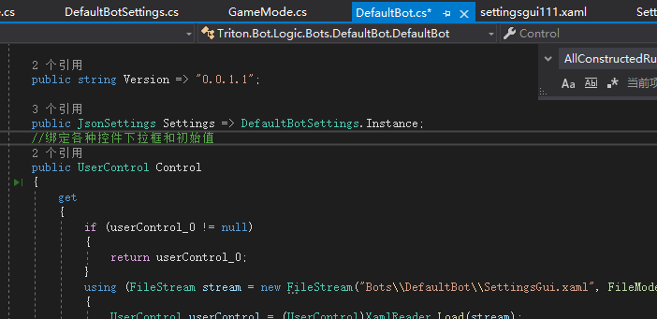

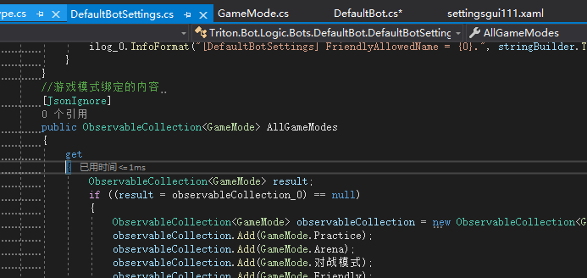

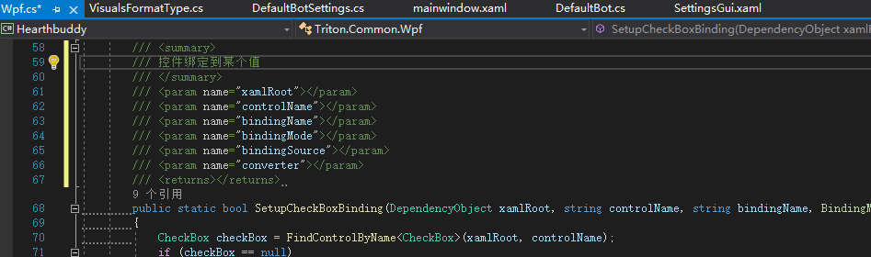

GraphicsResolution

IsAspectRatioWithinLimit

