public static void main(String[] args) {

System.setProperty("webdriver.chrome.driver","C:\\chromedriver_win32\\chromedriver.exe");

ChromeOptions options = new ChromeOptions();

options.addArguments("--remote-allow-origins=*");

options.addArguments("--disable-notifications");

options.addArguments("test-type");

options.addArguments("start-maximized");

options.addArguments("--js-flags=--expose-gc");

ChromeDriver driver = new ChromeDriver(options);

driver.manage().timeouts().implicitlyWait(Duration.ofSeconds(20));

driver.get("https://accounts.google.com/v3/signin/identifier?dsh=S-1761191847%3A1686368914063368&continue=https%3A%2F%2Faccounts.google.com%2F&ffgf=1&followup=https%3A%2F%2Faccounts.google.com%2F&ifkv=Af_xneGfm4SLf-_WMw4Mj8ZWtH6POKib_TA0EghYDBLOrFbsWSey_p0kWiIoGnfvzmcQj3OZ_kSs&passive=1209600&flowName=GlifWebSignIn&flowEntry=ServiceLogin");

WebDriverWait wait = new WebDriverWait(driver,Duration.ofSeconds(20));

WebElement emailBox = driver.findElement(By.xpath("//input[@type='email']"));

wait.until(ExpectedConditions.visibilityOf(emailBox));

emailBox.sendKeys("kmkhemanth");

WebElement nextBtn = driver.findElement(By.xpath("//span[text()='Next']/.."));

nextBtn.click();

WebElement pwdBox = driver.findElement(By.xpath("//input[@type='password']"));

wait.until(ExpectedConditions.visibilityOf(pwdBox));

pwdBox.sendKeys("123kanugolu@");

nextBtn.click();

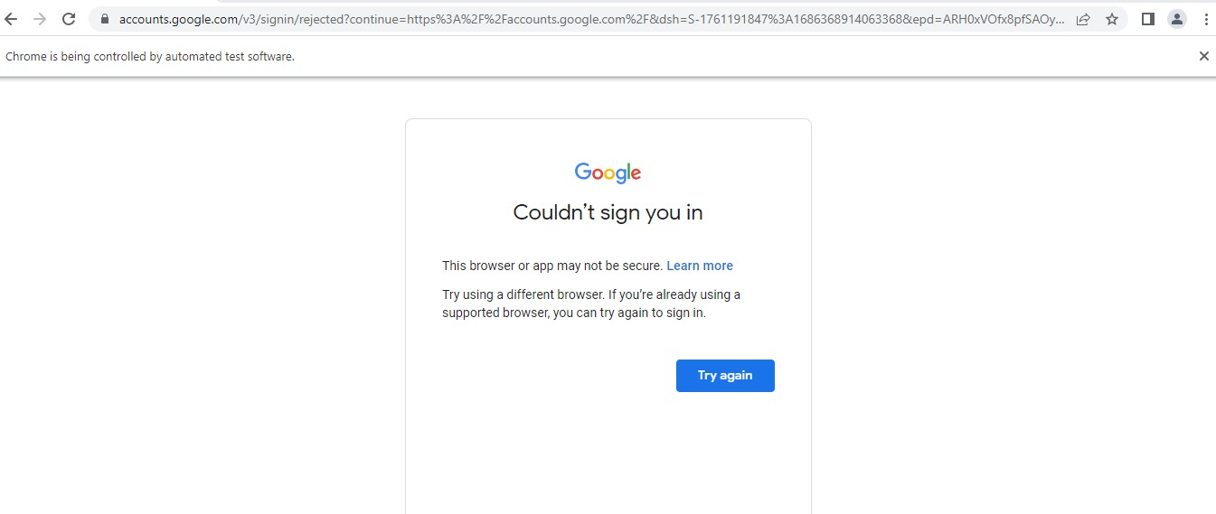

there is an issue in Gmail security, I tried to resolve it but was not able to do it.

Test Cases:

Feature: Compose Functionality in Gmail  
  
Scenario: Compose and send an email in Gmail  
Given I am logged in to my Gmail account  
When I click on the "Compose" button  
Then a new email draft should open  
And the email subject field should be empty  
And the email body field should be empty  
  
Scenario: Compose an email with a subject and body  
Given I am logged in to my Gmail account  
When I click on the "Compose" button  
And I enter "Incubyte" in the subject field  
And I enter "Automation QA test for Incubyte" in the email body field  
And I click on the "Send" button  
Then the email should be sent successfully  
And I should see a success message indicating the email has been sent  
  
Scenario: Compose an email without a subject  
Given I am logged in to my Gmail account  
When I click on the "Compose" button  
And I leave the subject field empty  
And I enter "Automation QA test for Incubyte" in the email body field  
And I click on the "Send" button  
Then I should see an error message indicating that the subject is required  
  
Scenario: Compose an email without a body  
Given I am logged in to my Gmail account  
When I click on the "Compose" button  
And I enter "Incubyte" in the subject field  
And I leave the email body field empty  
And I click on the "Send" button  
Then I should see an error message indicating that the email body is required