**FAKE REVIEWS DETECTION USING SUPERVISED MACHINE LEARNING**

**OJECTIVE:**

The objective of this project is to create an Effective Detection system for Fake reviews from the text in order to get rid from fake reviews while purchasing a product.

**ABSTRACT:**

With the continuous evolve of E-commerce systems, online reviews are mainly considered as a crucial factor for building and maintaining a good reputation. Moreover, they have an effective role in the decision making process for end users. Usually, a positive review for a target object attracts more customers and lead to high increase in sales. Nowadays, deceptive or fake reviews are deliberately written to build virtual reputation and attracting potential customers. Thus, identifying fake reviews is a vivid and ongoing research area. Identifying fake reviews depends not only on the key features of the reviews but also on the behaviours of the reviewers. This paper proposes a machine learning approach to identify fake reviews. In addition to the features extraction process of the reviews, this paper applies several features engineering to extract various behaviours of the reviewers. The paper compares the performance of several experiments done on a real Yelp dataset of restaurants reviews, we compare the performance of machine learning classifiers; KNN, Naive Bayes (NB), Logistic Regression. The results reveal that Logistic Regression outperforms the rest of classifiers in terms of accuracy achieving best. The results show that the system has better ability to detect a review as fake or original.

**KEYWORDS**: Machine learning, fake, reviews, Logistic Regression….

**Existing Method:**

The increasing growth of machine learning, computer techniques divided into traditional methods and machine learning methods. This section describes the related works of fake review detections and how machine learning methods are better than traditional methods. The existing method in this project have a certain flow and also RF is used for model development. But it requires large memory and result is not accurate.

**Disadvantages:**

* Low Accuracy
* High complexity.
* Highly inefficient.
* Requires skilled persons

**Proposed System:**

We propose this application that can be considered a useful system since it helps to reduce the limitations obtained from traditional and other existing methods. The objective of this study to develop fast and reliable method which detects and estimates anaemia accurately. To design this system is we used a powerful algorithm in a based Python environment with Django frame work.

**Block Diagram:**

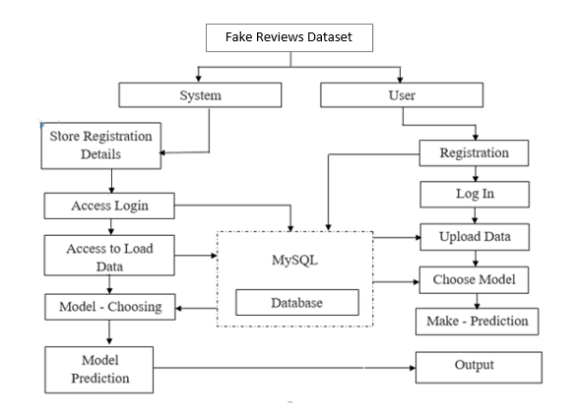

**Advantages**:

* Accuracy is good.
* Low complexity.
* Highly efficient.
* No need of skilled persons

# **H/W SPECIFICATIONS:**

# Processor - I3/Intel Processor

# RAM - 8GB (min)

* Hard Disk - 128 GB
* Key Board - Standard Windows Keyboard
* Mouse - Two or Three Button Mouse
* Monitor - Any

**S/W SPECIFICATIONS:**

* Operating System : Windows 10
* Server-side Script : Python 3.6
* IDE : PyCharm
* Libraries Used : Pandas, NumPy, Scikit-Learn.
* Frame Work : Django
* Data Base : MySql