**Monument: (15) Hieron**

Date: ca. 325 B.C.

Material: Limestone, marble, plaster

Location: Central Sanctuary

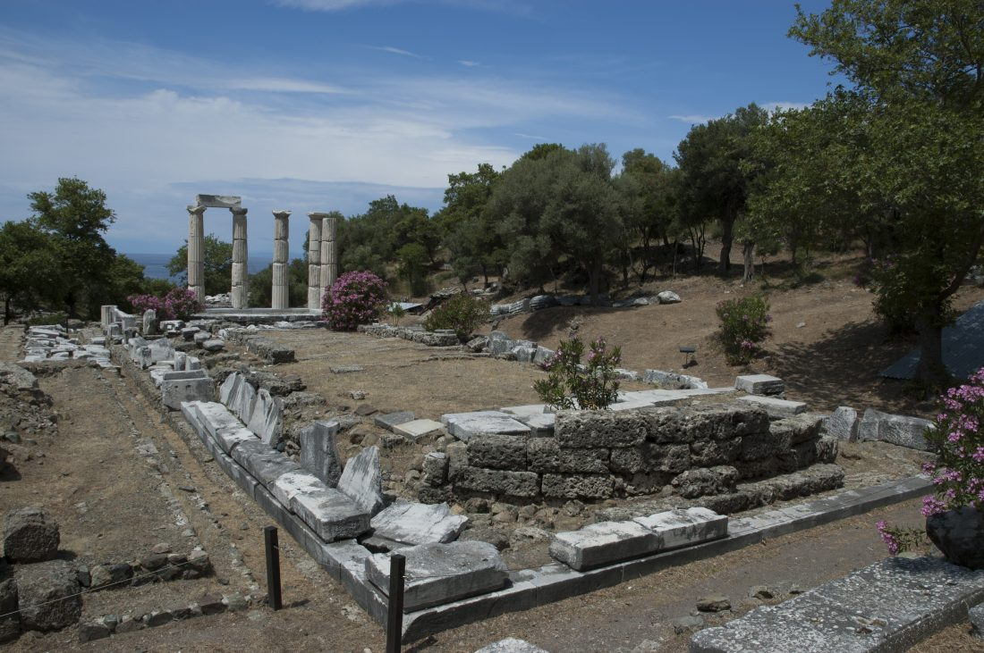 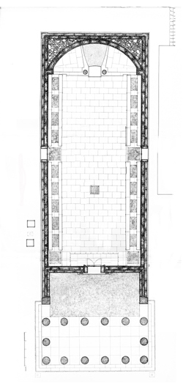

Caption: (Left) View of the Hieron from the south (Right) Plan of the Hieron © American Excavations Samothrace

The Hieron, one of the most impressive buildings in the Sanctuary, stands in the southern end of the central valley, adjacent to the Altar Court. Although the centerpiece of the Sanctuary today, in antiquity the Hieron was obscured almost entirely from view by the broad Hall of Choral Dancers. Rounding the corner from the central plateia during their carefully choreographed approach, the ancient visitor would have been delighted by the sudden appearance of such a grand structure.

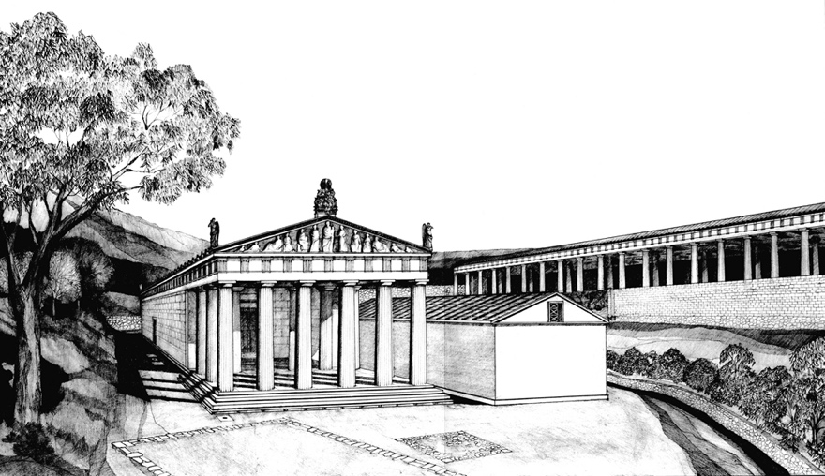 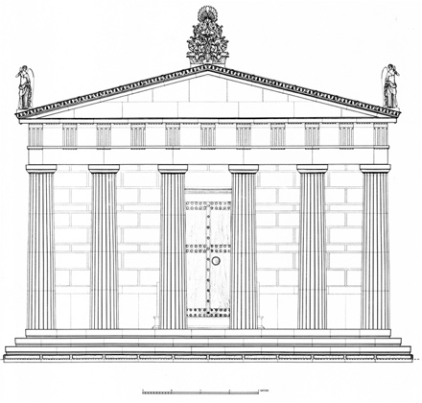

Caption: (Left) Reconstructed view of the Hieron (Right) North elevation of the Hieron © American Excavations Samothrace

The Thasian marble building is oriented on a north-south axis and rests on limestone foundations measuring ca. 13 m wide by 40 m long. The building features a Doric double colonnade of six columns before a long cella terminating in a hidden apse that is not betrayed by the rectilinear design on the exterior. Elaborate architectural embellishments and sculptural additions adorn both the inside and the outside of the building. The roofline was enhanced on both the north and south sides with akroteria in the form of floral motifs at the apex and sculpted figures of Nike, the goddess of victory, at the corners. Both pediments contained figural sculpture; at the north, the sculpture was carved in the round, while relief sculpture decorated the southern pediment. A decorative gutter with palmette antefixes and lion-head waterspouts framed the structure. In addition to the main door, the Hieron had two lateral doors, each decorated with meander patterns. The walls of the interior were painted to imitate coursed masonry. The marble ceilings of the porch and pronaos featured a complex system of coffers, some of which were crowned with magnificent prancing centaurs that were impressive enough to elicit the praise of the Hellenistic poet Kallistratos. The long interior had wooden coffers adorned with bronze fittings.

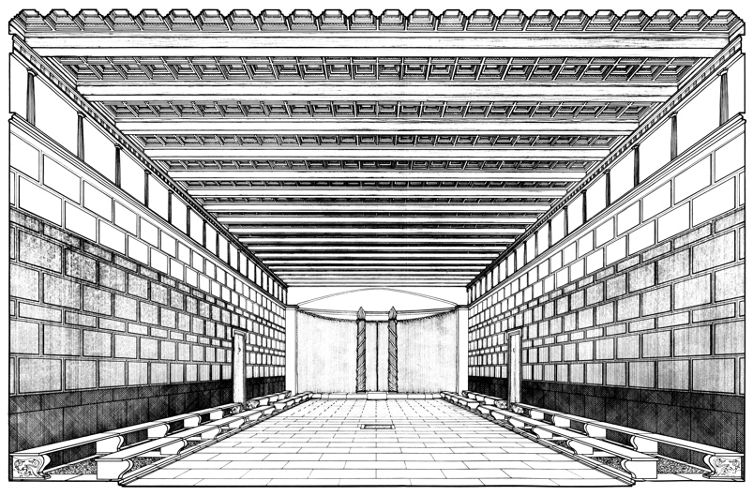 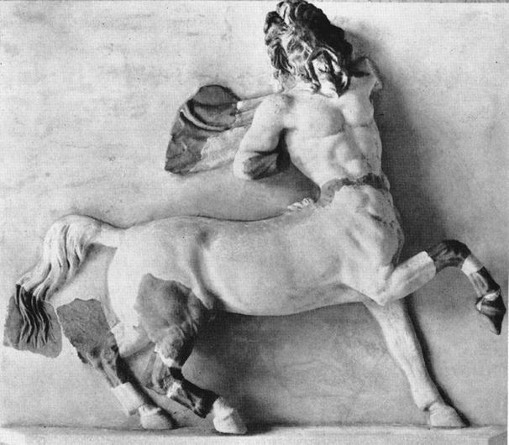

Caption: (Left) Reconstruction of the interior of the Hieron (Right) A coffer from the Hieron with decorative centaur. © American Excavations Samothrace

Aside from its unusual orientation, planned approach, and fine decorative program, the architecture of the Hieron included several unusual features that must have been built in response to the needs of the Mysteries. Two long rows of marble benches supported by sculpted lion’s legs stood along the side walls, affording seats for spectators and/or participants in the initiation ceremonies. The main cella leads to an apse at the southern end. In addition to the main door on the central axis, leading from the pronaos to the cella, two lateral doors provided access from the sides of the building. Inside the cella, an *eschara* and *bothros* provide archaeological evidence for both burned sacrifices and poured libations.

Determining the date of the Hieron’s construction is somewhat problematic because we have clear evidence for multiple phases of construction and renovation. Phyllis Lehmann discerned the foundations of two apsidal predecessors beneath the curved foundations of the Hellenistic structure, but these are likely related to the present structure. According to Lehmann, it was begun in the late 4th century, ca. 325 B.C., although other scholars place the building in the early 3rd century. There is clear evidence that the porch was added after the construction of the main building. Major renovations took place in the Imperial period, ca. 200 A.D. Five of the columns belonging to the porch were re-erected in 1956, giving today’s visitors an evocative glimpse into what an ancient viewer must have seen.

In the vicinity of the building, the Lehmanns found an inscription forbidding the uninitiated to enter “*to hieron*.” Working with a passage from Kallistratos using the same descriptive language, they named the building the Hieron. The Hieron was referred to as “the sanctuary” at the time of its Hellenistic construction (the word “*hieron*” translates to “the sanctuary”), suggesting that it was regarded as the holiest building within the greater sanctuary complex. Given the unusual configuration of the structure, its emphasis on communal gatherings, and sacred nature, scholars have proposed that it was likely the site for the second stage of initiation, known as the *epopteia*.

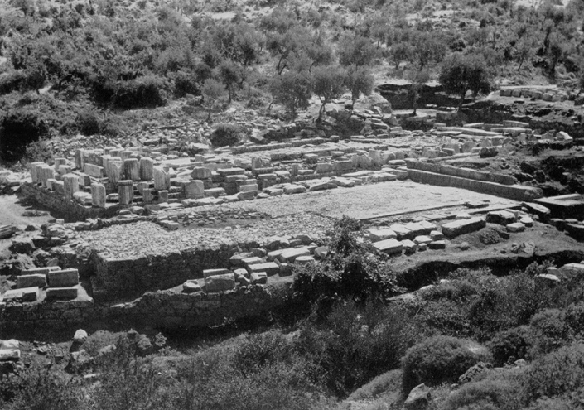 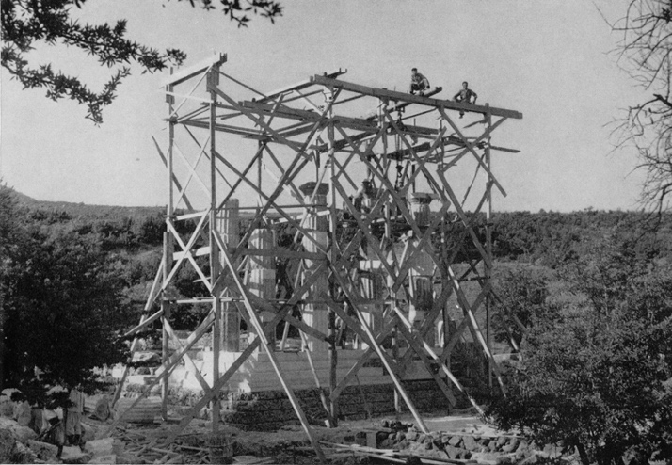

Caption: (Left) The Lehmann excavations (Right) Anastylosis: Re-erection of columns from the porch of the Hieron. © American Excavations Samothrace

The remains of the Hieron were still visible in 1444, when the writer Cyriacus of Ancona described it during his visit to the island. Early scholars and excavators believed the Hieron to be a Doric temple. In the 1860s, the French team excavated some parts of the Hieron, but did not produce a complete study of its remains. During their campaigns in 1873 and 1875, the Austrian team picked up where the French left off and uncovered the Hieron’s apse and threshold, as well as fragments of the building’s figural decoration and in the early 20th century, the French-Czech expedition reinvestigated the “New Temple,” as the Hieron was called. The Americans, under Karl Lehmann, systematically excavated the Hieron between 1948 and 1953. In 1956, the American team and the Greek Anastylosis Service reconstructed part of the porch’s colonnade, giving the modern visitor a striking visual reminder of the original nature of the Central Sanctuary.

Select Bibliography:

des Courtils, J. 1999. “Thasos, Samothrace, et l’architecture Macédonienne,”*Ancient Macedonia* 6.1, pp. 357-374.

Lehmann, K. 1998. *Samothrace: A Guide to the Excavations and the Museum*, 6th ed., rev. J.R. McCredie, Thessaloniki, pp. 78-86.

Lehmann, P.W. 1969. *Samothrace, Excavations Conducted by the Institute of Fine Arts of New York University*. Vol. 3*, The Hieron*, Princeton.

Palagia, O., et al. 2009. “New investigations on the pedimental sculptures of the ‘Hieron’ of Samothrace: a preliminary report,” in *ASMOSIA* VII, *The Study of Marble and Other Stones in Antiquity*, ed. Y. Maniatis,*BCH* Supplement 51, pp. 113-132.