**Monument: (16) Hall of Votive Gifts**

Date: Early Hellenistic Period

Material: Trachyte, limestone, and basalt

Location: Central Sanctuary

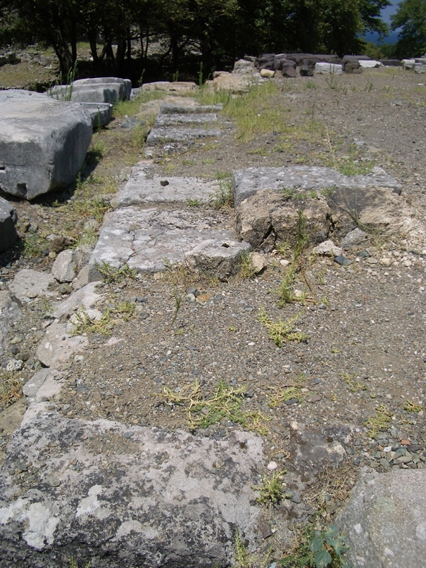 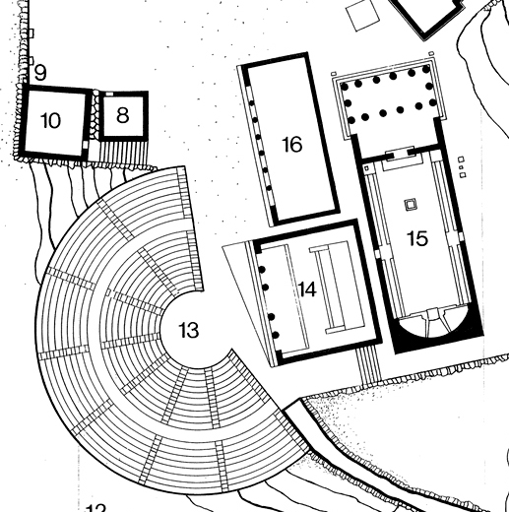

Caption: (Left) View of the foundations of the Hall of Votive Gifts (Right) Reconstructed plan of area around the Hall of Votive Gifts (16). © American Excavations Samothrace

The building known as the Hall of Votive Gifts stands to the west of the Hieron and north of the Altar Court.  The three buildings are aligned with one another to form a tight cluster.  The excavator, Karl Lehmann, interpreted the building as an Archaic structure used for the display of votives dedicated to the Great Gods. Closer investigation has revealed, however, that the 6th century B.C. architectural elements that Lehmann observed were in fact cut and reused in the Hall of Votive Gifts from earlier, unidentified buildings. Georges Roux has proposed that the structure served as a dining hall.  The building is currently under reinvestigation.

 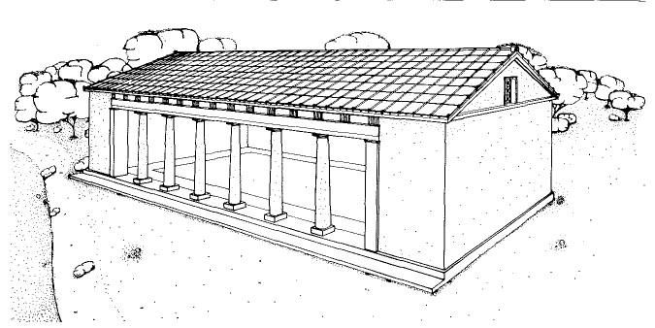

Caption: (Left) Plan of the Hall of Votive Gifts (Right) Reconstructed view of the Hall of Votive Gifts. © American Excavations Samothrace

The Austrian excavators uncovered the northeast corner of the Hall of Votive Gifts during their investigations into the Hieron in 1875, but it remained mostly hidden. In 1951 and 1952, the American team excavated in the area west of the Hieron and uncovered the foundations of the building.

Selected Bibliography:

Lehmann, K. 1998. *Samothrace: A Guide to the Excavations and the Museum*, 6th ed., rev. J.R. McCredie, Thessaloniki, pp. 66-67.

Lehmann, K. and P. W. Lehmann. 1962. *Samothrace, Excavations Conducted by the Institute of Fine Arts of New York University*. Vol. 4,I*, The Hall of Votive Gifts*, New York.