**Monument: (5) Byzantine Fortification**

Date: 10th century A.D.

Material: Reused limestones and marbles, partially joined with cement

Location: Western Hill

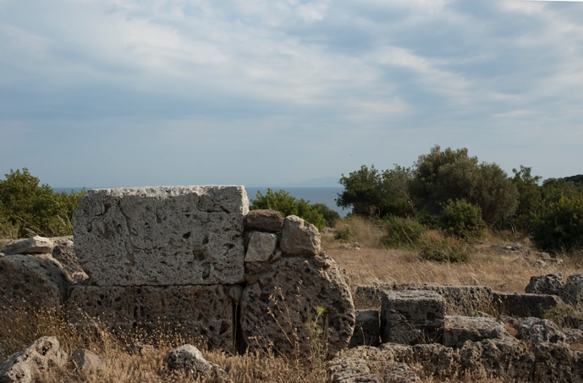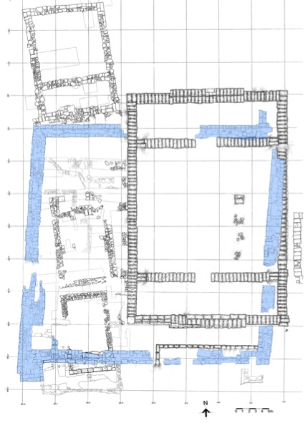

Caption: (Left) Wall from the Byzantine structure (Right) Plan. © American Excavations Samothrace

Centuries after the cult of the mysteries had been abandoned and the Sanctuary of the Great Gods had fallen into disrepair, the area was reoccupied. During the 10th century A.D., Byzantine inhabitants constructed a roughly square (ca. 36 m x 38.40 m), unroofed military fortification with towers along the north and south corners. The erection of this defensive building along the northern terrace of the Western Hill covered the unfinished Building A and the foundations of three smaller Hellenistic buildings, reusing spoliated marble and sandstone blocks from these much earlier structures, as well as blocks from other buildings in the vicinity, including the Stoa, Neorion, and Milesian Banquet Hall. The builders of the fortification used cement to bind these materials as needed. The fortification seems to have first served a military purpose for about a century before it was later repurposed as a domestic building with the construction of additional walls.

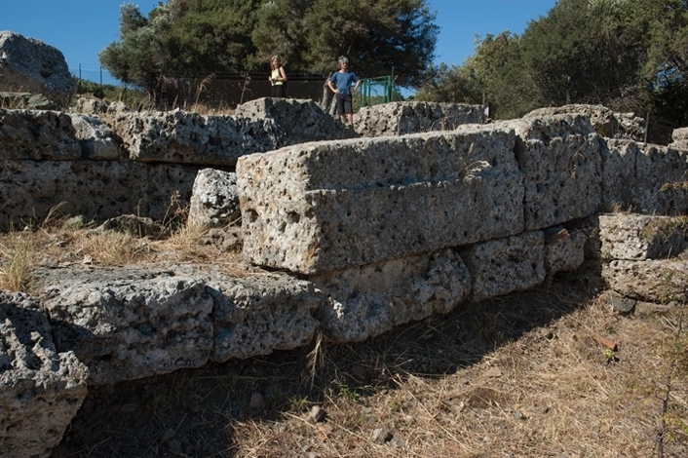 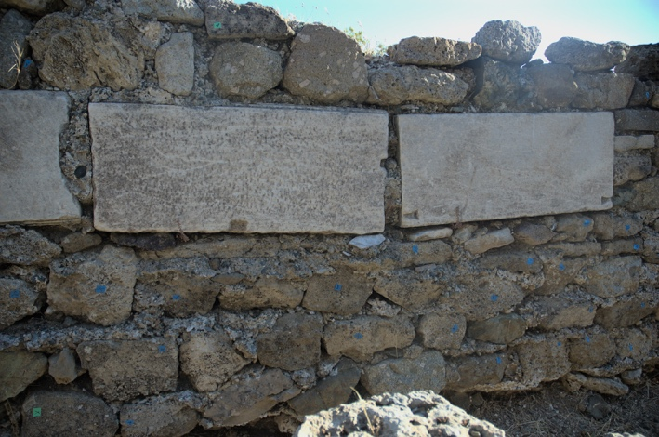

Caption: (Left) Detail of reused limestone blocks (Right) Detail of reused marble blocks. © American Excavations Samothrace

The fortification’s foundations and walls were visible and accessible in the 19th century and was even identified as a labyrinth by the Austrian team. The French-Czech expedition excavated the structure in 1923 and 1927 and, after identifying the medieval date of construction, intentionally destroyed parts of the fortification in a quest to recover the ancient materials embedded within it. During excavations in 1965, the American team cleaned and stabilized the building.

Selected Bibliography:

Lehmann, K. 1998. *Samothrace: A Guide to the Excavations and the Museum*, 6th ed., rev. J.R. McCredie, Thessaloniki, pp. 113-114.

McCredie, J. R. 1968. “Samothrace: Preliminary Report on the Campaigns of 1965-1967,” *Hesperia* 37, pp. 204-208.

­­­­–––. 1979. “Samothrace: Supplementary Investigations, 1968-1977,” *Hesperia* 48, pp. 23-24.

Document updated: Glennon 2021205