**Monument: (6) Banqueting Hall dedicated by a Woman from Miletos**

Date: Second half of the 3rd century B.C.

Material: Porous sandstone, Thasian marble

Location: Western Hill

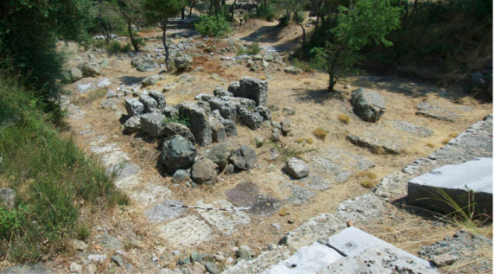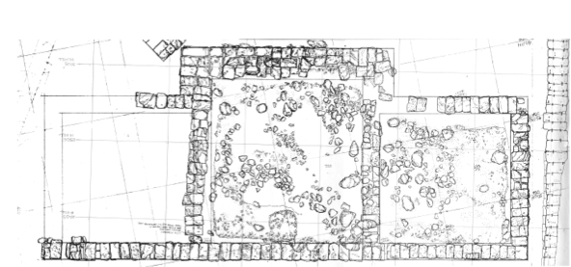

Caption: (Left) Current state photo (Right) Plan. © American Excavations Samothrace

The Milesian Banquet Hall is an unusual three-chambered building that occupies the northern side of the Western Hill. It faces south and consists of a central open chamber with a hexastyle (six columns) prostyle Ionic façade, which provides access to the slightly smaller chambers that flank each side. The west and central chambers rest on natural soil, but a deep foundation of 14 courses had to be constructed for the eastern chamber, which crossed into the ravine cut by the central torrent through the center of the Sanctuary. The foundations of the building consist of a variety of materials including porous sandstone, andesite, reused andesite porphyry, and a highly friable gray limestone. The ordered part of the superstructure was built of Thasian marble. Some marble wall blocks also survive, but it is possible that sections of the wall were composed of porous sandstone covered with stucco. The design of the entablature follows Samothracian tradition in combining epistyle, frieze, and dentils. The proportions and design of this part of the building reflect Hellenistic and particularly Macedonian practice. The remains of the epistyle and anta prove that while the side rooms were smaller, they rose to the same height as the main chamber and were tied together aesthetically by the entablature, which wrapped around the entire structure.

19th century excavators identified this building as a temple. Its design, however, resembles the three-room suites found in Macedonian palaces at Vergina and Pella and associated with dining facilities. Our building is most likely a grand dining hall as well. It is distinctive, however, in being a freestanding structure with a monumental, temple-like façade. The internal dimensions of the side chambers, roughly 8.5 m square, allow for an arrangement of 15 couches.

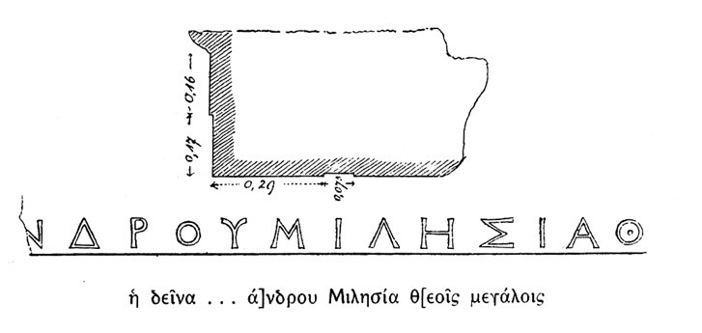

Caption: (Left) Milesian inscription (Right) Reconstruction of the building. © American Excavations Samothrace

An inscription discovered in the mid-19th century identifies the donor of the building as a private woman from the ancient Greek city of Miletos on the western coast of modern Turkey. Two further fragments of the inscription have come to light, but they are not enough to determine her name. While Hellenistic queens are well known as donors of monumental architectural projects (not least Arsinoe II, who gave the Sanctuary its famous Rotunda), the largess of a private woman at this early date and so far from her home is remarkable.

When the Austrian team excavated in the sanctuary in the mid-19th century, they pitched their tents within the Banquet Hall and included a brief description of the building in their publication. In 1923, the French-Czech expedition uncovered the foundations of the Banquet Hall and J. R. McCredie and the American team cleaned and studied the building in 1965. A storm in 2000 revealed several marble blocks within the soil that belonged to the Banquet Hall and from 2008 to 2012, B. D. Wescoat and the American team completed a reconstruction of the monument.

Selected Bibliography:

Bouzek, J. et al. 1985. *Samothrace: 1923/1927/1978. The Results of the Czechoslovak Excavation in 1927 conducted by A. Salač and J. Nepomucký and the Unpublished Results of the 1923 Franco-Czechoslovak Excavations conducted by A. Salač and F. Chapouthier*. Prague, pp. 14-9, 30-4, 68-74.

Lehmann, K. 1998. *Samothrace: A Guide to the Excavations and the Museum*. 6th ed. Thessaloniki, p. 111.

McCredie, J. R. 1968. “Preliminary Report on the Campaigns of 1965-1967,” *Hesperia* 37, pp. 208-209.

Salviat, F. 1962. “Addenda Samothraciens,” *BCH* 86, pp. 281-90.

Wescoat, B. D. 2015. “Recalibrating Samothracian Architecture,” in *L’architecture monumentale grecque au IIIe s. a.C.,* Bordeaux, pp. 132-134, 137-138.

––––. 2019. “More Corinthian on Samothrace,” in *Listening to the Stones: Essays on Architecture and Function in Ancient Greek Sanctuaries in Honour of Richard Alan Tomlinson,* eds. E. C. Patrida and B. Schmidt-Dounas, Oxford, pp. 153-161.

Document updated: Glennon 20211205