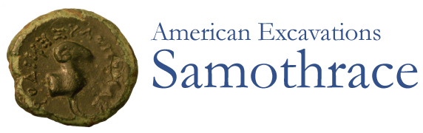

Caption:

Title: Sanctuary of the Great Gods: Interactive Monuments Plan

American Excavations Samothrace is the latest in a long succession of archaeological investigations on Samothrace.  French, German, Greek, Austrian, and Czech investigators have all helped to build the story of Samothrace. The American team, sponsored by the Institute of Fine Arts of New York University, began its work at the Sanctuary in 1938. In 2012, Emory University joined the Institute of Fine Arts as the American sponsors of the research team, directed by Bonna D. Wescoat of Emory. Excavations are conducted under the auspices of the American School of Classical Studies at Athens and the supervision of the Ephoreia of Antiquities of Evros.

In antiquity, the fame of Samothrace emanated from its cult of the Megaloi Theoi, the Great Gods. Their sanctuary was set in a valley facing the northern coast of Samothrace, framed by converging torrents that poured off the slopes of the mountain above. This valley was filled with monumental structures that played a fundamental role in the mysteria, the rites of initiation. The Sanctuary of the Great Gods was built and redeveloped over centuries of use, spanning from the 7th century BCE to the 4th century CE.

Click on the interactive plan to learn more about the monuments in the Sanctuary of the Great Gods. You can also navigate using the menu above the map.