**Monument: (7) Dining Rooms**

Date: 4th century B.C.

Material: Vuggy crystalline limestone, trachyte, basalt fieldstones

Location: Western Hill

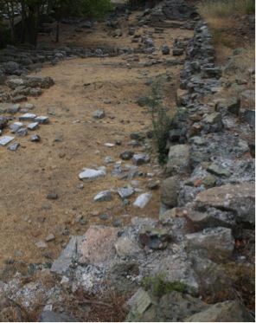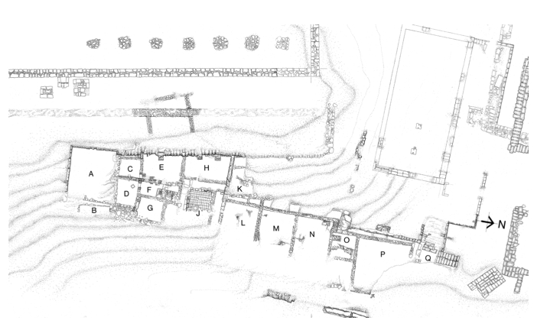

Caption: (Left) The remains of the dining rooms L and M (Right) Plan of dining rooms. © American Excavations Samothrace

Multiple dining chambers lined the base of the Western Hill below the Stoa. One set of rooms (L, M, and N) formed a large dining complex divided into three chambers, each measuring approximately 6.50 m on each side.  The square plan of the rooms, along with a raised marble border preserved on the floor of the two outer rooms, provide evidence that dining couches once lined the walls of these chambers. Within the marble border, the rooms were paved with marble chips in set cement, while the central room was entirely paved with black and white pebbles. Here pilgrims could recline and dine as part of the ceremonies that accompanied initiation.

The dining rooms faced the nearby Hall of Choral Dancers on the opposite side of the central torrent. Given the very limited passage around the western side of the Hall of Choral Dancers to the southern part of the Sanctuary, it is likely that the torrent was covered, at least in large stretches through the center of the Sanctuary.  If so, the dining rooms would have communicated directly with the center of the Sanctuary.  Although no longer preserved, either a porch or paved terrace on the eastern side of the building provided access to this complex of dining rooms.

 

Caption: (Left) Marble border on floor of Room L (Right) Mosaic floor of Room O. © American Excavations Samothrace

In the late Hellenistic period, a small square room (O) was attached to the northern end of the central dining complex. Its off-center threshold indicates that Room O was also a dining room.  The surviving floor was composed of roughly cut tessarae set in cement.

Yet another larger square room (P), measuring approximately 9.60 m on each side, was added to the north side of the small chamber during the Roman expansion of the Sanctuary, using mortar to bind fieldstone masonry.  It may have replaced an earlier chamber.  Based on its shape and location, it most likely served as an additional dining room.

The dining rooms remained hidden until the American team dug the area east of the Stoa between 1968-1977, when rooms L-P, as well as other chambers further to the south (A and B), were exposed.

Selected Bibliography:

Lehmann, K. 1998. *Samothrace: A Guide to the Excavations and the Museum.* 6th ed., rev. J.R. McCredie. Thessaloniki, pp. 114-116.

McCredie, J.R. 1979. “Samothrace: Supplementary Investigations, 1968-1977,” *Hesperia* 48, pp. 21- 22.

Wescoat, B. D., S. L. Blevins, M. L. Popkin, J. Paga, A. Farinholt Ward, M. C. Page, and W. Size. 2020. “Interstitial Space in the Sanctuary of the Great Gods on Samothrace,” in *Hellenistic Architecture and Human Action: A Case of Reciprocal Influence*, eds. A. Haug and A. Müller, Leiden, p. 53.

Document updated: Glennon 20220105