ElectroMacroDiff V5.2 Hybrid
End-to-End Project Dossier
Generated 2026-05-09 | Target: JAK2 | Structure: PDB 5AEP

Metric | Value | Meaning
Curated ligands | 204 | ChEMBL-derived JAK2 ligands after curation
Generated candidates | 595 | Filtered RDKit + SELFIES candidate pool
Generated macrocycles | 30 | 12-20 atom ring candidates
Docked and scored | 147 | Vina score range -11.13 to -4.14 kcal/mol
Final candidates | 5 | Scaffold-diverse final selection
Validation | 48/48 | Project validator checks pass

Scientific boundary
All molecules in this dossier are computational candidates. Docking, pose sanity, ADMET, and synthesis values are prioritization signals, not experimental proof of potency, selectivity, safety, or synthesis.

Document Map
- 1. Executive status
- 2. Dataset and molecule inventory
- 3. Macrocycle and constrained-ring audit
- 4. End-to-end implemented pipeline
- 5. Model inventory: trained, pretrained, new, and remaining
- 6. Current final molecules and evidence
- 7. File locations and artifact contracts
- 8. Validation, limitations, and remaining roadmap
- 9. Appendix: exact commands and source modules

1. Executive Status
This project folder now contains a working, reproducible low-resource computational discovery pipeline for JAK2-focused molecule generation and prioritization. The pipeline is implemented end to end through data collection, curation, descriptor generation, graph tensor construction, SE(3) model debug training, baseline generation, docking, ADMET/synthesis scoring, pose sanity checks, ranking, report assets, and audits.
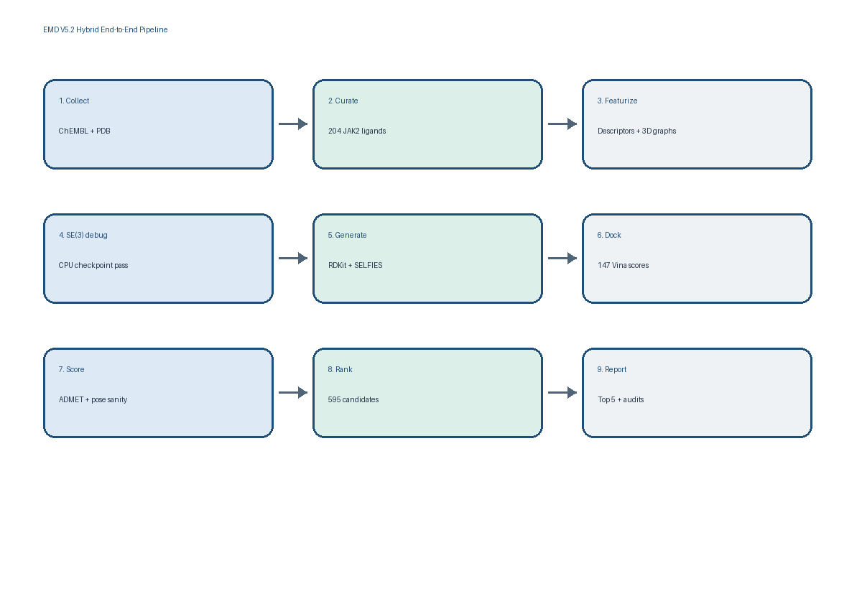
Current truth
The highest-confidence implemented route today is the validated RDKit/SELFIES + Vina + ADMET + pose sanity + consensus ranking route. The custom SE(3) model exists and has passed a CPU debug train/checkpoint gate, but it is not yet a production-trained generative model.

Implemented Outputs
Area | Status | Evidence
Raw-to-curated data | Complete | 300 ChEMBL records -> 204 curated ligands
Feature build | Complete | 204 descriptor rows and 204 graph tensor entries
SE(3) debug gate | Complete | Forward/loss/backward/optimizer/checkpoint reload passed on CPU
Baseline generation | Complete | 595 filtered unique candidates
Docking | Complete | 147 prepared ligands completed in current Vina manifest
Ranking/reporting | Complete | 595 ranked rows, 5 final candidates, cards/images/audits generated
Full production SE(3) training | Remaining | Need GPU run, curves, best checkpoint, and SE(3)-generated candidate export

2. Dataset and Molecule Inventory
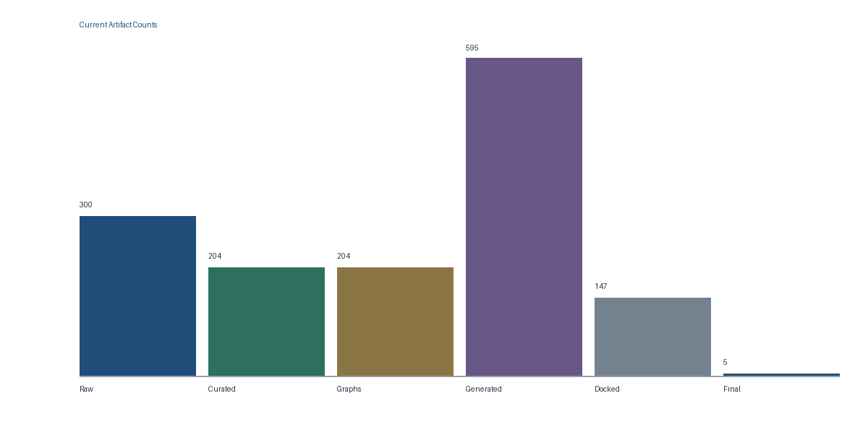
The table below is the authoritative count map for the run. Paths are relative to the project root C:/Users/srira/Desktop/new_plan/EMD_V5_2_Hybrid.
Artifact | Rows | Location | Status | Purpose
Raw JAK2 activity pull | 300 | 01_raw_data/chembl/jak2_activities_raw.csv | implemented | Initial ChEMBL activity records before project curation.
JAK2 structure | 1 | 01_raw_data/pdb/5AEP.pdb | implemented | PDB 5AEP receptor source; co-crystallized QUP ligand used to infer docking grid.
Curated ligand table | 204 | 02_curated_data/jak2_curated_ligands.csv | implemented | Canonical SMILES, activity values, ring labels, and train/val/test split.
Feature table | 204 | 03_features/ligand_features.csv | implemented | RDKit descriptors used for filters, ADMET proxy scoring, and ranking.
SE(3) graph tensors | 204 | 03_features/ligand_graphs/se3_graphs.pt | implemented | Torch list of graph dictionaries: atom features, bonds, 3D coordinates, masks.
RDKit candidates | 250 | 05_generated_candidates/rdkit/generated_rdkit_filtered.csv | implemented | Rule-based aromatic substitution candidates.
SELFIES candidates | 345 | 05_generated_candidates/selfies/generated_selfies_filtered.csv | implemented | SELFIES token mutation candidates, including the generated macrocycle pool.
Merged generated candidates | 595 | 05_generated_candidates/merged/generated_merged_filtered.csv | implemented | Filtered, valid, mostly novel candidate pool ranked downstream.
ADMET/synthesis proxy scores | 595 | 07_admet_synthesis/admet_scores.csv | implemented | QED, SA, Lipinski, Veber, risk labels, and proxy scores.
Docking SDF manifest | 150 | 06_docking/ligands_sdf/docking_input_manifest.csv | 147 prepared, 3 failed embed | Top candidates attempted for 3D conformer/SDF preparation.
Ligand PDBQT manifest | 147 | 06_docking/ligands_pdbqt/ligand_pdbqt_manifest.csv | 147 prepared | Meeko-converted ligand PDBQT files used by Vina.
Vina command manifest | 147 | 06_docking/scores/vina_command_manifest.csv | 147 completed | Authoritative current docking run manifest.
Parsed docking scores | 147 | 06_docking/scores/docking_scores.csv | 147 numeric scores | Best Vina affinities extracted from logs and linked to pose files.
Pose sanity scores | 10 | 06_docking/scores/pose_sanity_scores.csv | 10/10 inspected top poses pass | Lightweight clash/contact/centroid checks for top poses.
Final ranking | 595 | 08_final_ranking/final_ranked_candidates.csv | implemented | Consensus candidate ranking with final/backup/hold/reject labels.

Train/Validation/Test Split
Split | ID file count | Curated table count | Use
Train | 142 | 142 | Used for model fitting/debug graph loader
Validation | 31 | 31 | Used for future training monitoring
Test | 31 | 31 | Held-out evaluation split

3. Macrocycle and Constrained-Ring Audit
Set | Macrocycles 12-20 | Constrained 8-11 | Interpretation
Curated ChEMBL ligands | 0 | 1 | Original curated data contains almost no macrocycle/constrained-ring signal.
RDKit generated | 0 | 0 | Rule-based aromatic substitutions mostly preserve small aromatic ring systems.
SELFIES generated | 30 | 84 | SELFIES mutations produced all current macrocycle and constrained-ring candidates.
Merged generated | 30 | 84 | 5.0% macrocycles; 14.1% constrained-ring molecules.
Final selected top 5 | 0 | 0 | Top scaffold-diverse candidates are strong ranking hits but not macrocycles.

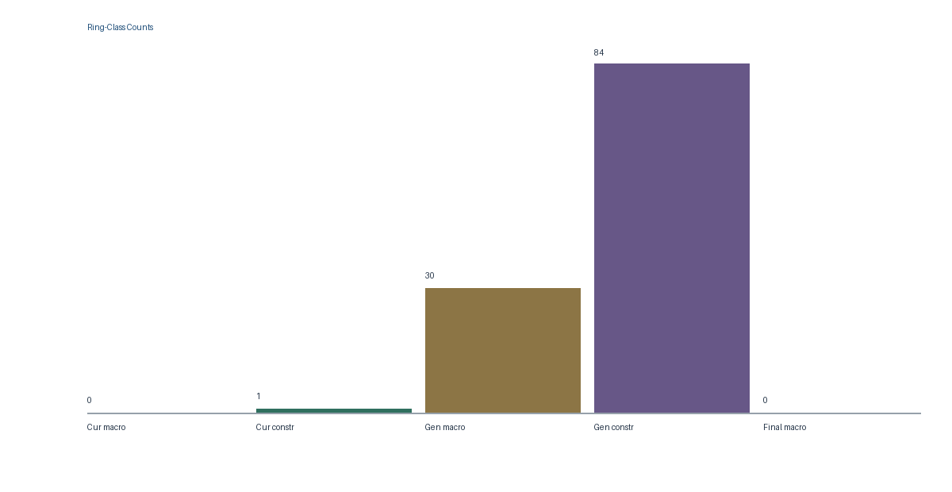
Macrocycle interpretation
The current pipeline can generate macrocycles, but the best-ranked current candidates are not macrocycles. If the project goal requires macrocycles as final winners, the next development step is macrocycle-targeted generation and selection, not merely broader docking.

Top Generated Macrocycle Examples
Rank | Candidate | Ring | Dock | Final | Tier | SMILES preview
135 | CAND_9e995f1d74 | 12 | -6.075 | 0.614395 | backup_candidate | C=C1C=CNC(=O)C12C=C(F)C=CC=CN=CC(C)(C)CN2
138 | CAND_93f72f3176 | 13 | -5.888 | 0.608817 | backup_candidate | CC1C=CC=C[C@H](C)NC=CC=NC(Nc2ccncn2)=N1
141 | CAND_35def203c8 | 15 | -5.378 | 0.575617 | backup_candidate | CCC[CH]NC=C1CCOC(N)=NNC=CC=NC=NC=N1
142 | CAND_9b837e9bd9 | 13 | -5.379 | 0.575226 | backup_candidate | FC1=CC=CNC=CC=NC2(C=CCC=CN=CN2)CC=C1
144 | CAND_8f061e412c | 16 | -4.822 | 0.562716 | backup_candidate | C[CH]NC=C1CC=NCN=NNC=CC=NC=NC=N1
145 | CAND_d92b9ae560 | 12 | -4.827 | 0.547308 | backup_candidate | C[C@H]1C=CC=CC2=CCC=CN=CNC2(C)N=CC=CN1

Top Constrained-Ring Examples
Rank | Candidate | Ring | Dock | Final | Tier | SMILES preview
9 | CAND_a5f0113576 | 10 | -9.723 | 0.880702 | backup_candidate | Nc1nn2cccnc2c1C1=COCNC2C=CC=C(Cl)C2=NC=N1
32 | CAND_a3f0da9158 | 9 | -9.16 | 0.776879 | backup_candidate | c1ccc(CNc2cc(-c3cncccnc[nH]3)ncn2)cc1
106 | CAND_170ff47125 | 8 | -8.032 | 0.717717 | backup_candidate | C1=CN[C@H](c2ccccc2)C=C(n2cnc3ccncc32)N=C1
117 | CAND_f0f34387c4 | 9 | -7.535 | 0.69595 | backup_candidate | C[C@@H]1CC=C(Cl)C=CCC2N=C(c3c(N)nn4cccnc34)C=CN21
119 | CAND_c88cdec083 | 9 | -7.425 | 0.69217 | not_selected | C[C@@H]1CC=C(F)C=CCC2N=C(c3c(N)nn4cccnc34)C=CN21
122 | CAND_3a8a6e5f35 | 9 | -7.313 | 0.683813 | not_selected | CCC[C@@H]1CC=C(F)C=CCC2N=C(c3c(N)nn4cccnc34)C=CN21

4. End-to-End Implemented Pipeline
Stage | Purpose | Main runner | Output | Status
M0 | Initialize project | scripts/00_initialize_project.py | Folder tree, registry, config, environment report | Complete
M1 | Collect and curate data | scripts/01_collect_data.py | Raw ChEMBL CSV, curated ligands, PDB 5AEP | Complete
M2 | Build features | scripts/02_build_features.py | Descriptors, split files, SE(3) graph tensors | Complete
M3 | SE(3) debug train | scripts/03_debug_se3_training.py | CPU debug checkpoint and reload validation | Complete debug only
M4 | Generate baselines | scripts/04_generate_baselines.py | RDKit, SELFIES, merged filtered candidates | Complete
M5 | Docking prep + Vina | scripts/06_*.py | Receptor/ligand PDBQT, manifest, logs, poses, parsed scores | Complete current 147
M6 | ADMET/synthesis | scripts/05_score_admet_synthesis.py | ADMET, synthesis, risk proxy score files | Complete
M7 | Rank candidates | scripts/07_rank_candidates.py | Final ranked candidates and selection tiers | Complete
M8 | Report and audit | scripts/09_*.py, scripts/10_*.py | Candidate cards, images, final/consistency audits | Complete

How Data Moves
- Canonical SMILES and activity values start in curated ligand CSVs.
- RDKit descriptors and 3D graph tensors are built from curated SMILES.
- The SE(3) model consumes atom feature tensors, centered coordinates, and masks.
- RDKit and SELFIES baseline generators produce candidate SMILES records.
- Candidates are filtered, scored by ADMET proxies, converted to SDF/PDBQT, docked by Vina, pose-checked, then ranked.
- The final ranking table is the authoritative downstream decision artifact.

5. Model Inventory: Trained, Pretrained, New, and Remaining
Pretraining truth
No neural pretrained generative model has been fine-tuned in this project. The neural component is a new local SE(3)-aware flow model initialized from scratch. External engines and libraries such as AutoDock Vina, RDKit, SELFIES, and Meeko are used as tools, not modified pretrained neural models.

Model/tool | Type | Inputs | Outputs | Current status | Still needed
SE3FlowMatching | New custom neural model | 03_features/ligand_graphs/se3_graphs.pt: atom_features, coords, mask | 04_models_checkpoints/se3_flow/se3_latest_checkpoint.pt | Debug-trained only; CPU forward/loss/backward/optimizer/reload passed | Full GPU training, validation curves, best checkpoint, and generation export
RDKit aromatic substitution generator | Deterministic baseline, not trained | Curated SMILES seeds from 02_curated_data/jak2_curated_ligands.csv | 05_generated_candidates/rdkit/generated_rdkit_filtered.csv | Implemented; 250 candidates | Optional expanded medchem reaction library
SELFIES mutation generator | Grammar/string mutation baseline, not trained | Curated SMILES seeds encoded to SELFIES tokens | 05_generated_candidates/selfies/generated_selfies_filtered.csv | Implemented; 345 candidates, including all current macrocycles | Macrocycle-targeted token constraints and selection pressure
ADMET/synthesis proxy scorer | New rule/proxy scoring model | Candidate descriptors: QED, SA, MW, logP, TPSA, HBD/HBA, rotatable bonds | 07_admet_synthesis/admet_scores.csv | Implemented for all 595 candidates | Upgrade to calibrated QSAR/ADMET models when labeled data is available
AutoDock Vina | External docking engine, not trained locally | Receptor PDBQT, ligand PDBQT, grid center/size | 06_docking/scores/docking_scores.csv and 06_docking/poses/ | Implemented; official Windows binary used; 147 current scores | Optional redocking controls, higher exhaustiveness, GNINA rescoring
Pose sanity analyzer | New deterministic geometry analyzer | Vina pose PDBQT, cleaned receptor PDB, docking grid JSON | 06_docking/scores/pose_sanity_scores.csv and pose images | Implemented; top 10 inspected pass | Publication-grade PyMOL/ChimeraX visual inspection
Consensus ranker | New weighted scoring/ranking model | Docking score, pose score, ADMET, synthesis, novelty/diversity, safety proxy | 08_final_ranking/final_ranked_candidates.csv | Implemented; 595 ranked, 5 final candidates | Sensitivity analysis and expert reweighting
GNINA / CNN rescoring | Planned external model | Would consume receptor-ligand pose complexes | Not present yet | Not implemented | Stretch goal after Vina pose audit
Synthesis route model | Planned route planner | Top candidate SMILES | 07_admet_synthesis/aizynth_routes/ | Folder exists; route generation not run | Run AiZynthFinder or human route review for top molecules

What We Changed
- Created the project-specific pipeline wrappers, schemas, manifests, ranking rules, validation checks, and reporting assets.
- Implemented a custom SE(3)-aware flow-matching prototype with translation/rotation-aware coordinate vector-field prediction.
- Did not modify internal weights of Vina, RDKit, SELFIES, Meeko, or any pretrained neural model.
- The only saved neural weights are the local debug SE(3) checkpoint created from scratch.

6. Current Final Molecules and Evidence
The final selected set is scaffold-diverse. These are the current computational lead hypotheses, not confirmed inhibitors.
Diverse rank | Candidate | Source | Ring | Dock | Final | Pose | Main risk
1 | CAND_3a8fd34d0b | rdkit | 6 | -11.13 | 0.936263 | pass | no_major_descriptor_risk
2 | CAND_eadd8f8ad8 | selfies | 6 | -10.08 | 0.895281 | pass | no_major_descriptor_risk
3 | CAND_ff18b6effe | selfies | 6 | -10.15 | 0.893336 | pass | no_major_descriptor_risk
4 | CAND_9d6374c432 | selfies | 6 | -9.58 | 0.889904 | pass | no_major_descriptor_risk
5 | CAND_d028052563 | selfies | 6 | -9.864 | 0.889571 | pass | no_major_descriptor_risk

2D Molecule Structures
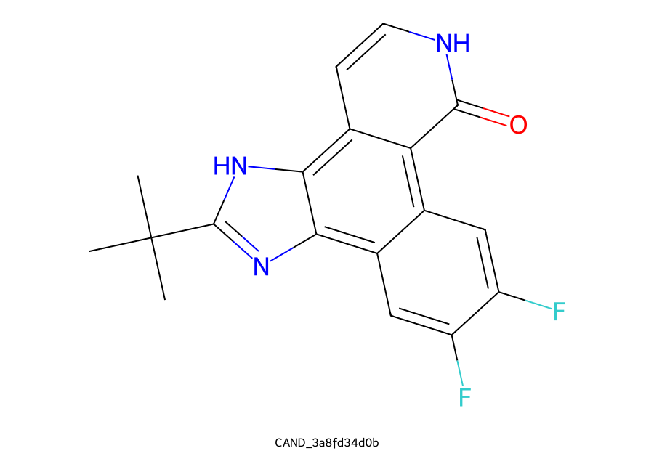  CAND_3a8fd34d0b | dock -11.13 | final 0.936263 | 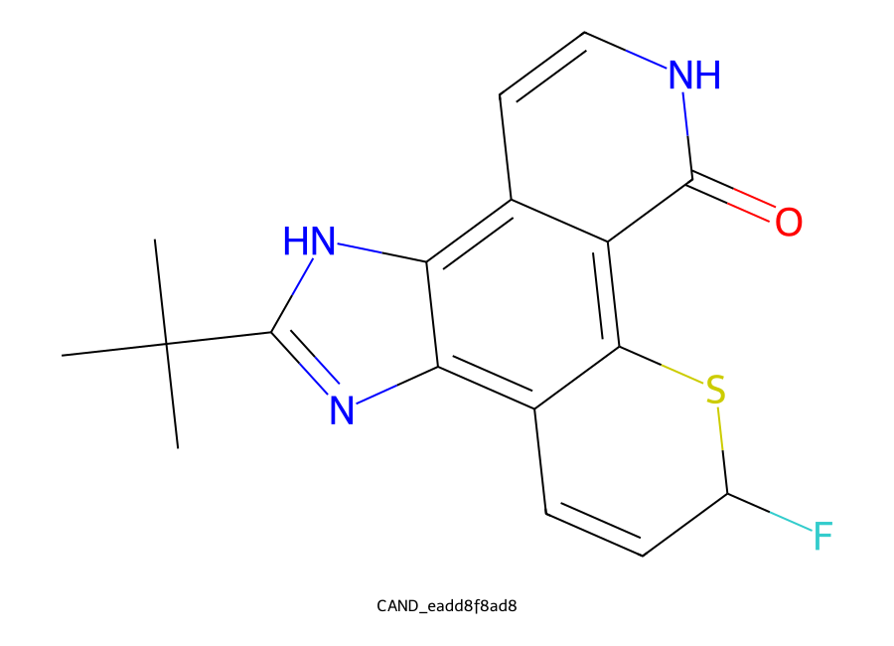  CAND_eadd8f8ad8 | dock -10.08 | final 0.895281
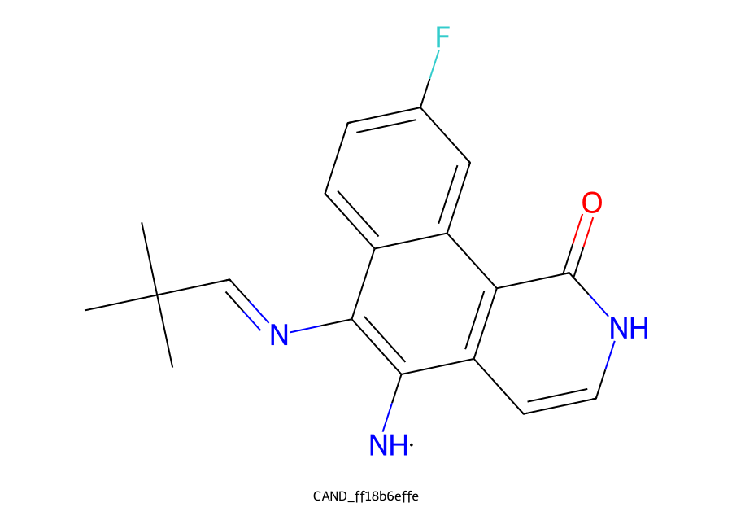  CAND_ff18b6effe | dock -10.15 | final 0.893336 | 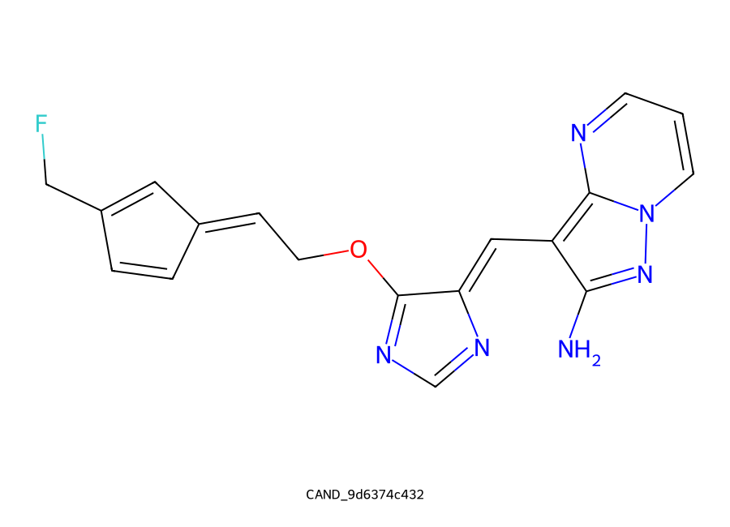  CAND_9d6374c432 | dock -9.58 | final 0.889904
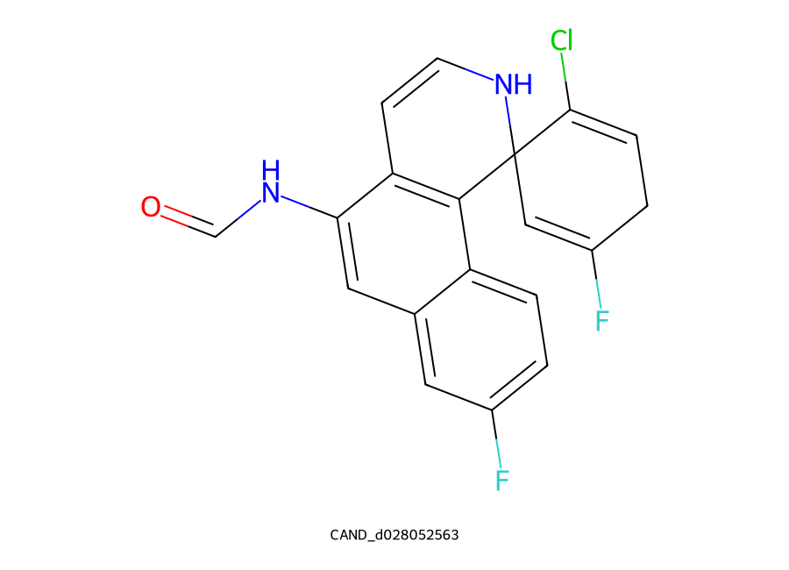
CAND_d028052563 | dock -9.864 | final 0.889571

Where to inspect each final molecule
Candidate | Card | 2D image | Pose image
CAND_3a8fd34d0b | 09_reports/candidate_cards/CAND_3a8fd34d0b_card.md | 09_reports/molecule_images/CAND_3a8fd34d0b.png | 06_docking/images/pose_sanity/CAND_3a8fd34d0b_pose.png
CAND_eadd8f8ad8 | 09_reports/candidate_cards/CAND_eadd8f8ad8_card.md | 09_reports/molecule_images/CAND_eadd8f8ad8.png | 06_docking/images/pose_sanity/CAND_eadd8f8ad8_pose.png
CAND_ff18b6effe | 09_reports/candidate_cards/CAND_ff18b6effe_card.md | 09_reports/molecule_images/CAND_ff18b6effe.png | 06_docking/images/pose_sanity/CAND_ff18b6effe_pose.png
CAND_9d6374c432 | 09_reports/candidate_cards/CAND_9d6374c432_card.md | 09_reports/molecule_images/CAND_9d6374c432.png | 06_docking/images/pose_sanity/CAND_9d6374c432_pose.png
CAND_d028052563 | 09_reports/candidate_cards/CAND_d028052563_card.md | 09_reports/molecule_images/CAND_d028052563.png | 06_docking/images/pose_sanity/CAND_d028052563_pose.png

7. File Locations and Artifact Contracts
Area | Location | Purpose
Configuration | 00_project_registry/campaign_config.yaml (exists) | Target, seeds, model/docking/ranking settings
Run registry | 00_project_registry/run_registry.csv (exists) | Chronological pipeline run records
Artifact registry | 00_project_registry/artifact_registry.csv (exists) | Generated artifact records
Environment | 00_project_registry/environment_versions.txt (exists) | Python/package/version evidence
Curated ligands | 02_curated_data/jak2_curated_ligands.csv (exists) | Core ligand dataset
Graph tensors | 03_features/ligand_graphs/se3_graphs.pt (exists) | SE(3) model input tensors
SE(3) checkpoint | 04_models_checkpoints/se3_flow/se3_latest_checkpoint.pt (exists) | Debug checkpoint
Generated candidates | 05_generated_candidates/merged/generated_merged_filtered.csv (exists) | Candidate pool
Docking manifest | 06_docking/scores/vina_command_manifest.csv (exists) | Authoritative current docking run
Docking scores | 06_docking/scores/docking_scores.csv (exists) | Parsed Vina score table
ADMET scores | 07_admet_synthesis/admet_scores.csv (exists) | Risk and proxy score table
Final ranking | 08_final_ranking/final_ranked_candidates.csv (exists) | Decision table
Reports | 09_reports/ (exists) | Cards, images, report drafts, audits, this dossier
Notebooks | 10_notebooks/ (exists) | Colab execution notebooks
Source code | src/emd_v5_2_hybrid/ (exists) | Reusable project modules
Scripts | scripts/ (exists) | Stage runners and audit/report builders

Authoritative current-run rule
For docking, trust 06_docking/scores/vina_command_manifest.csv and 06_docking/scores/docking_scores.csv as the current run of record. Some folders can contain older physical files from previous iterations; the manifest and parsed score CSV define what is current.

8. Validation, Limitations, and Remaining Roadmap
Check | Latest result | Command/evidence
Project validator | 48 passed / 0 failed | scripts/08_validate_project.py --base .
Consistency audit | 0 failures / 0 warnings | scripts/10_consistency_audit.py --base .
Unit tests | 12 passed | python -m unittest discover -s tests
Compile check | Passed | python -m compileall -q src scripts tests
Pose sanity | 10/10 inspected top poses pass | scripts/06_pose_sanity.py --base . --top-n 10 --render

Remaining Work
- Train the SE(3) model beyond debug mode on GPU for 50-200 epochs; save latest/best checkpoints and training curves.
- Export and evaluate SE(3)-generated molecules, then compare against RDKit/SELFIES baselines on validity, uniqueness, novelty, ring features, docking distribution, and shortlist representation.
- Add macrocycle-specific generation pressure if macrocycle winners are required, because the current final top 5 are not macrocycles.
- Run publication-grade pose rendering and manual binding-mode review in PyMOL or ChimeraX.
- Optionally redock known controls, increase docking exhaustiveness, and add GNINA/CNN rescoring for pose confidence.
- Add synthesis route analysis for the final molecules and macrocycle backup set.
- Move from proxy ADMET to calibrated ADMET/QSAR models when labeled data and validation objectives are available.
- Perform experimental validation: synthesis, biochemical JAK2 assay, selectivity profile, cytotoxicity/safety testing.

Limitations
- Docking scores are approximate computational prioritization signals.
- ADMET, synthesis, and safety values are descriptor-based proxies, not clinical or experimental measurements.
- The low-resource SE(3) checkpoint demonstrates pipeline feasibility, not production-grade molecular generation.
- Macrocycle coverage exists in the generated pool but is not yet driving final candidate selection.
- No wet-lab potency, selectivity, toxicity, or synthesizability has been proven.

9. Appendix: Commands and Source Modules
python scripts/00_initialize_project.py --base .
python scripts/01_collect_data.py --base . --limit 300
python scripts/02_build_features.py --base .
python scripts/03_debug_se3_training.py --base . --hidden-dim 64
python scripts/04_generate_baselines.py --base . --seed-count 50 --selfies-per-seed 8 --rdkit-per-seed 5
python scripts/05_score_admet_synthesis.py --base .
python scripts/06_prepare_docking_inputs.py --base . --top-n 150
python scripts/06_prepare_pdbqt.py --base .
python scripts/06_make_vina_manifest.py --base .
python scripts/06_run_vina_manifest.py --base .
python scripts/06_parse_vina_results.py --base .
python scripts/06_pose_sanity.py --base . --top-n 10 --render
python scripts/07_rank_candidates.py --base .
python scripts/09_render_top_molecules.py --base . --top-n 20
python scripts/09_make_report_assets.py --base . --top-n 10
python scripts/08_validate_project.py --base .
python scripts/10_final_audit.py --base .
python scripts/10_consistency_audit.py --base .
python -m unittest discover -s tests
python -m compileall -q src scripts tests

Core Source Modules
Module | Role
data_collection.py | ChEMBL/PDB fetch and curation
chemistry.py | Canonicalization, descriptors, ring/macrocycle labels
features.py | Feature CSV and split files
se3_dataset.py | RDKit 3D conformer to graph tensors
se3_flow.py | Custom SE(3)-aware flow-matching model
train_se3.py | Debug/full training helpers and checkpoint IO
baseline_generation.py | RDKit and SELFIES candidate generators
docking_prep.py | SDF/PDBQT/receptor preparation
docking.py | Vina manifest, grid inference, score parsing
pose_analysis.py | Pose sanity metrics and quick renders
admet_synthesis.py | ADMET/synthesis/safety proxy scoring
ranking.py | Weighted consensus ranking and labels
validation.py | Project gates and schema checks
reporting.py | Candidate cards and limitations

