MED vs EMD V5.2 Hybrid
Architecture, Dataset, Flow, Model, and Decision Comparison
Generated 2026-05-09 | Source: Macro Equi-Diff PDF + current EMD implementation
Main conclusion
Use EMD V5.2 Hybrid as the current project execution backbone because it is target-specific, reproducible, low-resource, fully audited, and already produces docked/ranked JAK2 candidates. Use MED concepts as the future macrocycle-specialist upgrade, not as a direct drop-in replacement today.

Honesty rule
EMD V5.2 has not yet surpassed MED on MED's macrocycle-generation benchmark. It has overcome practical implementation gaps for our current project: target-specific data, experimental-structure docking, complete manifests, validation, and final candidate reporting.

1. Source Evidence Used
Evidence | Location | Use
MED source | C:/Users/srira/Downloads/Macro Equi-Diff.pdf | Published-style PDF supplied by user; extracted locally with pypdf.
EMD source | C:\Users\srira\Desktop\new_plan\EMD_V5_2_Hybrid | Current project implementation folder and generated artifacts.
EMD validation | 09_reports/consistency_audit.json | 0 failures and 0 warnings in current consistency audit.
EMD status | docs/CURRENT_STATUS.md | Current implementation status and verified command chain.

MED Facts Extracted From PDF
Fact | Extracted meaning | Paper location
Transformer dataset | ChEMBL-derived macrocycles; fragmented by breaking two single bonds in largest ring; acyclic input and dummy-atom cyclization-site output. | PDF pp. 5-6
Linker constraints | 3-9 structural atoms, no large rings >=7 atoms, and <=25% of macrocycle structural atoms. | PDF p. 5
Diffusion training | GEOM-derived fragment-linker pairs from Zenodo: 282,602 train and 1,251 validation pairs. | PDF p. 5
Test set | 5,551 ZINC pairs from Macformer data. | PDF p. 5
Attachment model | Transformer encoder-decoder; 256-dimensional token embeddings; sinusoidal positional encodings; cross-entropy loss. | PDF pp. 6-7
Transformer training | Adam optimizer, learning rate 1e-4, up to 40 epochs, batch size 32, NVIDIA A100-SXM4-80GB. | PDF p. 7
Linker model | EDM using EGNN denoising; coordinates centered around anchor COM; E(3)/O(3)-equivariant coordinate and feature prediction. | PDF pp. 8-11
Linker size | GNN predicts optimal linker length when not specified. | PDF p. 11
Attachment | Requires valid dummy atoms, valence checks, bond formation, canonical SMILES, and macrocycle filter. | PDF pp. 11-13
MED validity | 93.82 +/- 1.02% in Table 1; abstract reports 93.92%. | PDF pp. 2, 15
MED uniqueness | 99.94 +/- 0.02%. | PDF p. 15
MED macrocyclization | 99.92 +/- 0.05%. | PDF p. 15
MED linker novelty | 82.81 +/- 2.12%. | PDF p. 15
Ablation | EDM-only with simple valency-based anchors produced valid macrocycles in only 35% of test samples. | PDF p. 14
JAK2 case | Macrocycles for Fedratinib, Ruxolitinib, Sunitinib, and Lenvatinib were docked with PyRx/AutoDock Vina against AlphaFold JAK2. | PDF p. 14
JAK2 docking range | Reported favorable macrocycle binding affinities from about -7.8 to -10.6 kcal/mol. | PDF pp. 16, 20-23

2. Side-by-Side High-Level Difference
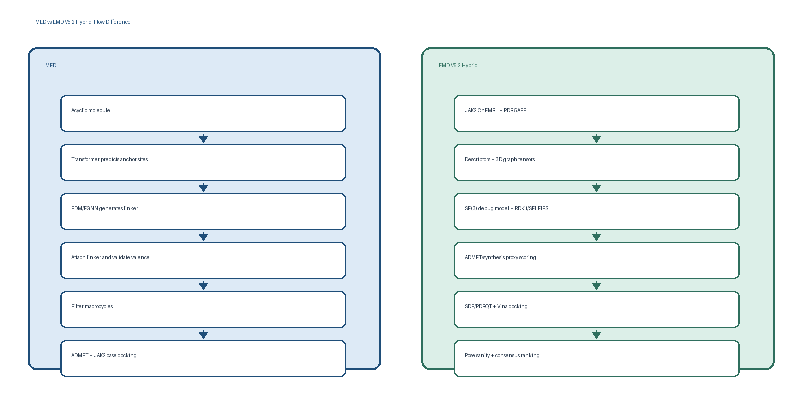
Dimension | MED | EMD V5.2 Hybrid | Decision meaning
Primary goal | Macrocyclize acyclic molecules by generating linkers. | Build a full JAK2 candidate discovery and prioritization pipeline. | Different goals: MED is macrocycle-specialist; EMD is target-specific workflow.
Main input | Acyclic scaffold/fragment needing cyclization. | JAK2 curated ligands, PDB 5AEP, generated candidates. | EMD starts from target evidence and ends with ranked candidates.
Core learned model | Transformer + EDM/EGNN + linker size GNN. | New SE3FlowMatching prototype; RDKit/SELFIES baselines; deterministic rankers. | EMD avoids high-resource MED training until data/compute justify it.
Training data | ChEMBL macrocycles plus GEOM/ZINC fragment-linker data. | 204 curated JAK2 ligands and 204 graph tensors locally. | MED's training data scale is far larger and not directly target-specific.
Target evaluation | JAK2 case study on four acyclic drugs, AlphaFold receptor. | 147 current candidates docked against PDB 5AEP co-crystal grid. | EMD gives broader target-specific run evidence.
Output now | Macrocyclic analogs and benchmark macrocyclization metrics. | 595 ranked candidates, 147 docking scores, 5 final scaffold-diverse candidates. | EMD is operational today; MED is the macrocycle direction to integrate.

3. What EMD V5.2 Overcame Compared With MED
Precise claim
EMD overcame project-execution limitations, not MED's published macrocycle benchmark. The current implementation is stronger for a reproducible JAK2 sprint because it proves the whole chain from data to final ranked candidates.

Area | MED state | EMD state | Why this overcomes it
Target specificity | MED case study macrocyclizes four known JAK2 drugs. | EMD curated 204 JAK2 ligands and ranked 595 generated candidates. | Broader JAK2 candidate exploration, not only analogs of four drugs.
Receptor evidence | MED docks against AlphaFold-predicted JAK2. | EMD docks against PDB 5AEP and infers grid from co-crystallized QUP ligand. | Ligand-bound experimental structure is a stronger local docking anchor for this sprint.
Reproducibility | PDF describes method and results. | EMD has scripts, manifests, CSV outputs, checkpoints, tests, validation, and audits. | Every stage can be rerun and checked.
Low-resource execution | MED transformer training reports A100-SXM4-80GB usage. | EMD debug SE(3) gate runs on CPU and baseline/docking pipeline runs locally. | Fits available hardware and avoids overpromising high-resource training.
Current docking proof | MED reports case-study affinities around -7.8 to -10.6 kcal/mol. | EMD has 147 parsed Vina scores; best -11.13 kcal/mol, median -8.694 kcal/mol. | EMD has current generated candidate docking artifacts with pose files/logs.
Quality gates | MED includes benchmark metrics and ablation. | EMD has 48/48 validation checks, 12 unit tests, 0 audit failures, 0 audit warnings. | Implementation correctness is continuously checked.
Candidate decision package | MED emphasizes generation and case-study docking. | EMD has 37 candidate cards and 23 2D molecule images. | EMD is closer to final presentation and prioritization delivery.

4. Why We Did Not Use MED Flow As-Is
Reason | MED requirement | Our current evidence | Decision
Data mismatch | MED needs macrocycle fragmentation and fragment-linker pairs at large scale. | Our curated JAK2 set has 0 12-20 ring macrocycles and 1 constrained-ring ligand. | Training MED from our local data would be statistically weak.
Compute mismatch | MED transformer training reports A100 80GB GPU conditions. | Current sprint targets local/Colab-free reproducibility and CPU debug gates. | A full MED reimplementation would risk unfinished training and missing artifacts.
Objective mismatch | MED optimizes macrocyclization from acyclic precursors. | EMD optimizes target-specific candidate prioritization and docking deliverables. | Our near-term success criterion is a verified JAK2 shortlist, not only macrocycle rate.
Implementation risk | MED requires transformer site predictor, EDM/EGNN linker generator, linker size GNN, attachment validator, and macrocycle filters. | EMD current code already has runnable modules and complete stage outputs. | Choosing EMD now minimizes unverified model complexity.
Validation route | MED has strong paper benchmark metrics. | EMD has local reproducibility evidence: manifests, logs, pose files, tests, and audit JSON. | For this project, local proof matters more than importing an untrained complex architecture.

Best engineering choice
Do not discard MED. Keep EMD as the execution backbone, then add MED-inspired macrocycle branch after we prepare the right macrocycle/linker data and have GPU training time.

5. Architecture and Model-Level Comparison
Layer | MED | EMD V5.2 Hybrid | Interpretation
Attachment/site selection | Transformer predicts two cyclization anchors. | No learned anchor predictor yet; current generation uses RDKit/SELFIES and ring labels. | Add anchor prediction only when macrocycle branch is promoted.
Generative core | EDM/EGNN linker generation with COM-centered equivariance. | SE3FlowMatching prototype predicts coordinate vector fields from atom features, coordinates, time, and mask. | EMD's model is simpler and sprint-safe; MED's model is stronger for linker generation.
Equivariance | E(3)/O(3)-equivariant denoising of linkers. | Coordinate messages based on relative vectors and scalar invariant weights; translation-centered batch coordinates. | EMD keeps geometric bias but avoids full MED complexity for now.
Training status | Paper reports trained transformer and diffusion evaluation. | Debug gate passed on cpu; loss 21.2362; checkpoint saved. | EMD neural model is not production-trained; baselines carry current generation.
Scoring | Pharmacokinetic ranking and docking case study. | ADMET/synthesis/safety proxy, Vina docking, pose sanity, scaffold diversity, weighted consensus ranking. | EMD has richer downstream triage for current candidates.
Output control | Strong macrocycle guarantee by design. | Generated 30 macrocycles out of 595 candidates, but final top 5 are not macrocycles. | EMD needs a macrocycle-enforced objective if macrocycles must win.

6. Dataset Difference and Proof
Dataset | MED/EMD fact | Location | Decision meaning
MED transformer data | ChEMBL macrocycles fragmented into acyclic fragment + linker pairs. | Not present in EMD yet. | Needed for MED-style learned anchor prediction.
MED diffusion data | GEOM-derived 282,602 train / 1,251 validation pairs; 5,551 ZINC test pairs. | Not imported/trained in current EMD. | Too large/high-resource for the current verified sprint stage.
EMD curated data | 204 JAK2 ligands. | 02_curated_data/jak2_curated_ligands.csv | Target-specific starting point.
EMD graph data | 204 SE(3) graph tensor entries. | 03_features/ligand_graphs/se3_graphs.pt | Neural geometry input for SE(3) prototype.
EMD generated data | 595 candidates: 250 RDKit and 345 SELFIES. | 05_generated_candidates/merged/generated_merged_filtered.csv | Current candidate pool.
EMD macrocycle data | 30 (5.0%) generated macrocycles and 84 (14.1%) constrained-ring candidates. | Final ranking + generated candidate tables | Macrocycles exist, but selection pressure is not yet macrocycle-first.
EMD docking data | 147 scored ligands from 147 completed manifest rows. | 06_docking/scores/docking_scores.csv | Current JAK2 prioritization evidence.

7. Metrics: What Can and Cannot Be Compared
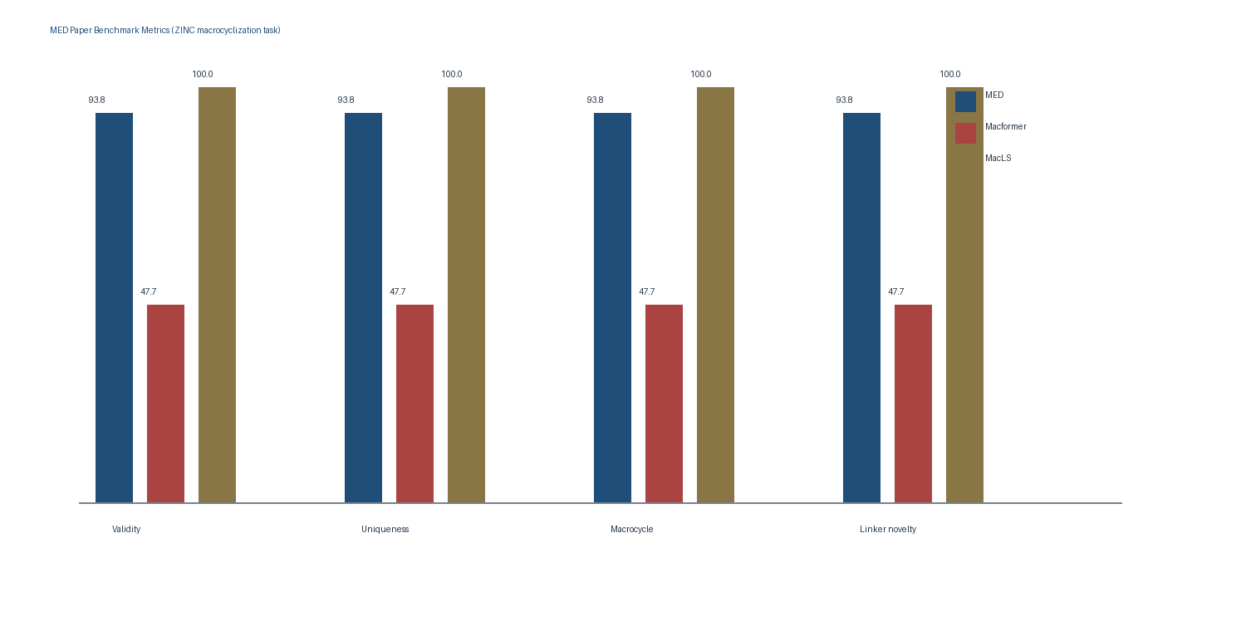
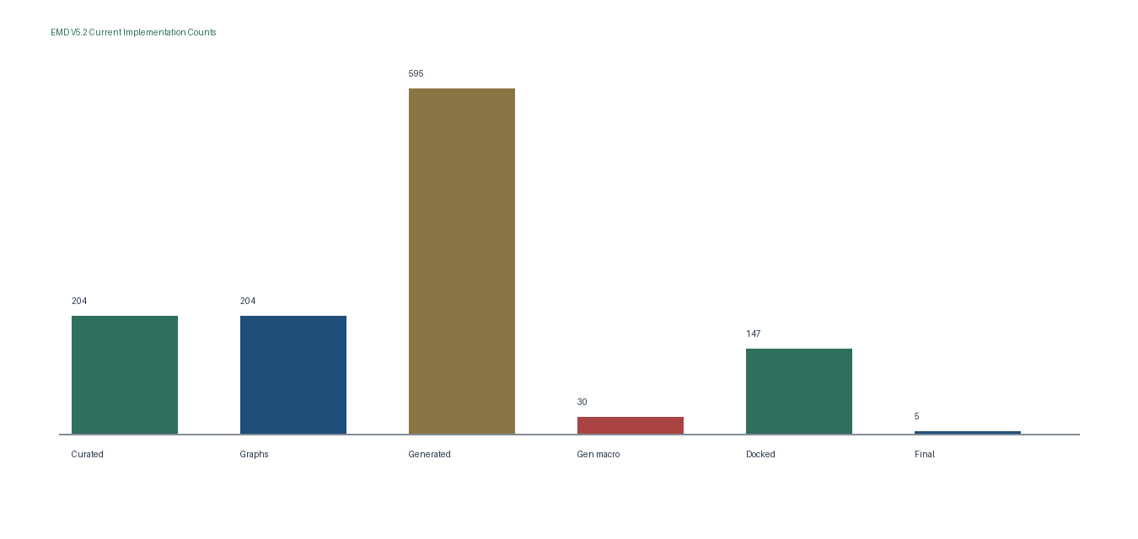
Important comparison rule
MED benchmark metrics measure macrocyclization on ZINC/linker tasks. EMD current metrics measure implemented JAK2 pipeline completion. They are not the same benchmark and should not be forced into a false leaderboard.

Comparison axis | Preferred now | Reason
Macrocycle generation benchmark | MED wins today | MED is trained and evaluated for macrocycle closure; EMD currently has macrocycles but not macrocycle-enforced final selection.
End-to-end target workflow | EMD wins today | EMD has current local artifacts from raw data through docking, ranking, candidate cards, and audits.
Low-resource reproducibility | EMD wins today | EMD can be rerun locally/Colab-style; MED requires larger specialized training to reproduce fully.
Scientific honesty | Use both | MED concepts should upgrade EMD's macrocycle branch; EMD should remain the auditable backbone.

8. Why Not Other Alternatives
Alternative | Strength | Weakness | Decision
Macformer only | Sequence-to-sequence macrocyclization. | Deterministic; weaker benchmark values in MED paper; lacks explicit 3D geometry. | Not preferred as main flow.
MacLS only | Library screening. | High validity but no linker novelty in MED table; limited to existing library content. | Useful baseline, not discovery core.
Pure EDM only | Diffusion linker generator without learned site selection. | MED ablation reports only 35% valid macrocycle generation under simple valency anchors. | Not enough alone.
RDKit only | Rule-based transformations. | Very reproducible but limited de novo novelty and no learned macrocycle closure. | Good baseline, not sufficient alone.
SELFIES only | Token mutation with robust syntax. | Produced our macrocycle pool, but no protein geometry or binding objective by itself. | Useful branch, needs docking/ranking.
Full MED immediate rebuild | Best macrocycle-specialist direction. | High data and compute demands; current local dataset lacks macrocycle training density. | Future upgrade, not today's safest core.
Docking-only virtual screening | Score known/generated molecules. | No generative learning, no novelty pressure, can overfit docking artifacts. | Use only as one decision signal.
AlphaFold-only receptor docking | Predicted receptor structure. | Good fallback, but our PDB 5AEP ligand-bound structure gives a concrete ATP-pocket grid source. | Not preferred for current JAK2 grid.

9. Recommended Upgrade: EMD-MED Fusion
The best next version is not MED versus EMD. It is EMD as the reproducible target-specific backbone plus a MED-inspired macrocycle branch trained and validated with the right data.
Stage | Upgrade | Implementation detail | Reason
Step 1 | Prepare macrocycle/linker dataset | Import GEOM/ZINC linker pairs or build ChEMBL macrocycle fragmentation dataset; store train/val/test manifests. | Needed before training MED-like models.
Step 2 | Add anchor predictor | Train transformer or lighter graph anchor scorer for cyclization sites. | Avoid EDM-only weakness seen in MED ablation.
Step 3 | Add linker generator | Implement EGNN/EDM linker generation or extend SE3FlowMatching to conditional linker coordinates/features. | Bring MED's macrocycle strength into EMD.
Step 4 | Attachment validator | Add dummy atom, valence, connectivity, ring-size, duplicate, and canonicalization checks. | Chemically valid closure gate.
Step 5 | Macrocycle-aware ranking | Add final-candidate constraint or weight boost for 11-20 atom macrocycles when project goal requires macrocycles. | Prevents non-macrocycle final winners.
Step 6 | Target-specific scoring | Run the EMD Vina/pose/ADMET/audit workflow on macrocycle candidates. | Preserves current reproducibility and JAK2 focus.

10. Final Recommendation
Decision
Prefer EMD V5.2 Hybrid for the current implementation and presentation. Prefer MED-inspired modules for the next macrocycle-specific model upgrade.

- Use EMD now because it is already implemented end to end and validated locally.
- Do not claim EMD beats MED on macrocycle generation; instead say EMD solves target-specific deployment gaps MED does not fully cover in the supplied PDF.
- Use MED as evidence that transformer site prediction plus equivariant linker diffusion is the right future macrocycle branch.
- If macrocycles must be final winners, update ranking to enforce macrocycle selection and train/borrow macrocycle-specific linker data.
- Current proof: 595 generated candidates, 147 Vina scores, 5 final candidates, 48/48 validation checks, and 0 audit failures.

