A Real-time Research Project/Societal Related Project
Report on

ElectroMacroDiff V5.5: Pocket-Electronic Macrocycle Discovery for JAK2
Submitted in Partial fulfillment of requirements for B.Tech II Year II Semester course

By

<Student Name> <ROLL NUMBER>
<Student Name> <ROLL NUMBER>
<Student Name> <ROLL NUMBER>
<Student Name> <ROLL NUMBER>

Under the guidance of

Ms./Mr./Dr.Mentor Name
Department of Computer Science and Engineering



KESHAV MEMORIAL INSTITUTE OF TECHNOLOGY
(AN AUTONOMOUS INSTITUTION)
Accredited by NBA & NAAC, Approved by AICTE, Affiliated to JNTUH.

Narayanaguda, Hyderabad,Telangana-29
2025-26



KESHAV MEMORIAL INSTITUTE OF TECHNOLOGY
(AN AUTONOMOUS INSTITUTION)
Accredited by NBA & NAAC, Approved by AICTE, Affiliated to JNTUH

Narayanaguda, Hyderabad,Telangana-29

CERTIFICATE

This is to certify that this is a bonafide record of the project report titled “ElectroMacroDiff V5.5: Pocket-Electronic Macrocycle Discovery for JAK2”which is being presented as the Real-time Research Project / Societal Related Project report by

- <Student Name> <ROLL NUMBER>
- <Student Name> <ROLL NUMBER>
- <Student Name> <ROLL NUMBER>
- <Student Name> <ROLL NUMBER>

In partial fulfillment for the II Year II Semester Course RTRP in KMIT affiliated to the Jawaharlal Nehru Technological University, Hyderabad

Mentors
(Ms/Mr/Dr. XXXX Program Coordinator
(Mr Shailesh Gangakhedkar)

Submitted for Final Project Review held on ____________________________

Vision& Mission of KMIT

Vision

  - To be the fountain head in producing highly skilled, globally competent engineers.
  - Producing quality graduates trained in the latest software technologies and related tools and striving to make India a world leader in software products and services.

Mission

  - To provide a learning environment that inculcates problem solving skills, professional, ethical responsibilities, lifelong learning through multi model platforms and prepares students to become successful professionals.
  - To establish an industry institute Interaction to make students ready for the industry.
  - To provide exposure to students on the latest hard ware and software tools.
  - Topromoteresearch-basedprojects/activitiesintheemergingareasoftechnologyconvergence.
  - To encourage and enable students to not merely seek jobs from the industry but also to create new enterprises.
  - To induce a spirit of nationalism which will enable the student to develop, understand India's challenges and to encourage them to develop effective solutions.
  - To support the faculty to accelerate their learning curve to deliver excellent service to students.

PROGRAM OUTCOMES(POs)

PO1. Engineering Knowledge: Apply the knowledge of mathematics, science, engineering fundamentals, and an engineering specialization to the solution of complex engineering problems.

PO2. Problem Analysis: Identify formulate, review research literature, and analyze complex engineering problems reaching substantiated conclusions using first principles of mathematics, natural sciences, and engineering sciences


PO3. Design/Development of solutions: Design solutions for complex engineering problems and design system components or processes that meet the specified needs with appropriate consideration for the public health and safety, and the cultural, societal, and environmental considerations.

PO4. Conduct Investigations of Complex problems: Use research-based knowledge and research methods including design of experiments, analysis and inter pretation of data, and synthesis of the information to provide valid conclusions.

PO5. Modern Tool Usage: Create select, and, apply appropriate techniques, resources, and modern engineering and IT tools including prediction and modeling to complex engineering activities with an understanding of the limitations.

PO6. The Engineer and Society: Apply reasoning informed by contextual knowledge to societal, health, safety. Legal und cultural issues and the consequent responsibilities relevant to professional engineering practice.

PO7. Environment and Sustainability: Understand the impact of the professional engineering solutions in societal and environmental contexts and demonstrate the knowledge of, and need for sustainable development.
PO8. Ethics: Apply ethical principles and commit professional ethics and responsibilities and norms of the engineering practice.
PO9. Individual and Team Work: Function effectively as an individual, and as a member or leader in diverse teams and in multidisciplinary settings.

PO10. Communication: Communicate effectively on complex engineering activities with the engineering community and with societ yat large, such as, being able to comprehend and write effective reports and design documentation, make effective presentations, and give and receive clear instructions.

PO11. Project Management and Finance: Demonstrate knowledge and understanding of the engineering and management principles and apply these to one's own work, as a member and leader in a team, to manage projects and in multi disciplinary environments.


PO12. Life-Long Learning: Recognize the need for, and have the preparation and abilitytoengageinindependentandlife-longlearninginthebroadestcontextoftechnological change.

PROJECT OUTCOMES

P1: Write Your Project Outcomes Here
P2: Write Your Project Outcomes Here
P3: Write Your Project Outcomes Here
P4: Write Your Project Outcomes Here

MAPPING PROJECTOUTCOMESWITH PROGRAMOUTCOMES

PO | PO1 | PO2 | PO3 | PO4 | PO5 | PO6 | PO7 | PO8 | PO9 | PO10 | PO11 | PO12
P1
P2
P3
P4

L– LOW M –MEDIUM H– HIGH

DECLARATION

We hereby declare that the results embodied in the dissertation entitled “ElectroMacroDiff V5.5: Pocket-Electronic Macrocycle Discovery for JAK2”has been carried out by us together during the academic year2024-25 as a partial fulfillment of the B.Tech II Year II Semester Course “Real-time Research Project / Societal Related Project”. We have not submitted this report to any other Course/College.



Student Name Roll no.

1. <Student Name> <ROLL NUMBER>
2. <Student Name> <ROLL NUMBER>
3. <Student Name> <ROLL NUMBER>
4. <Student Name> <ROLL NUMBER>

ACKNOWLEDGEMENT

We take this opportunity to thank all the people who have rendered their full support to our project work. We render our thanks to Dr. B L Malleswari, Principal who encouraged us to do the Project.

We are grateful to Mr. Neil Gogte, Founder & Director and Mr. S. Nitin, Director, for facilitating all the amenities required for carrying out this project.

We express our sincere gratitude to Ms. Deepa Ganu, Academic Director for providing an excellent environment in the college.

We are also thankful to Mr.Shailesh Gangakhedkar, Real-Time Research Project Program Coordinator for providing us with time to make this project a success within the given schedule.

We are also thankful to our Project Mentor Ms. XXXX / Mr. XXX, for her/his valuable guidance and encouragement given to us throughout the project work.

We would like to thank the entire KMIT faculty, who helped us directly and indirectly in the completion of the project.

We sincerely thank our friends and family for their constant motivation during the project work.

Student Name Roll no.

<Student Name> <ROLL NUMBER>
<Student Name> <ROLL NUMBER>
<Student Name> <ROLL NUMBER>
<Student Name> <ROLL NUMBER>

ABSTRACT

This report presents ElectroMacroDiff V5.5, a low-resource computational drug discovery workflow for JAK2 macrocycle candidate generation, docking, pocket-electronic rescoring, ADMET proxy scoring, and interactive 3D protein-ligand review. The system produced 1,113 ranked V5.5 candidates, 1,036 parsed Vina-GPU docking scores, and a real-data dashboard for final evaluation.
In this project, a prototype and implementation of Home Appliances is demonstrated. The proposed system consists of a Hardware interface and Software interface. Hardware interface includes Raspberry Pi, lights, fans, DC motor and software interface includes IOT supporteddashboardplatform.WeautomatelightsandfansusingmotionsensorslikeIRsensorsorwecan use an IOT based dashboard for operating fans and lights. A Raspberry Pi is used for controlling home appliances and sensors. An application is provided for controlling multiple home appliances. This system is one of the best methods for controlling home devices with easewith multiple users and one of the best methods for an energy management system. This XXXXXXXXXXXXXXXXXXXXXXXXXXXXXXXXXXXXXXXXXXXXXXXXXXX

LISTOFFIGURES

S.No | Name of Screenshot | Page No.
1.
2.
3.
4.
5.

CONTENTS

DESCRIPTION PAGECHAPTER-1 1
  - INTRODUCTION 2-4
    - Purpose of the project 2
    - Problem with Existing Systems 2
    - Proposed System 3
    - Scope of the Project 3
    - Architecture Diagram 4
CHAPTER–2 5
  - LITERATURESURVEY 6-7
CHAPTER-3 8
  - SOFTWAREREQUIREMENTSPECIFICATION9-12
    - Introduction to SRS 9
    - Role of SRS 9
    - Requirements Specification Document 10
    - Functional Requirements 10
    - Non-Functional Requirements 11
    - Performance Requirements 11
    - Software Requirements 11
    - Hardware Requirements 12
CHAPTER–4 13
  - SYSTEMDESIGN 14-30
    - Introduction to UML 14

    - UML Diagrams 15
      - Use Case Diagram 15
      - Sequence Diagram 18
      - State Chart Diagram 19
      - Deployment Diagram 20
    - TECHNOLOGIESUSED 21
CHAPTER–5 32
  - IMPLEMENTATION 33-42
    - Setting up connections with Raspberry PI 33
    - Coding the logic 35
    - Connecting the dashboard 40
    - Screenshots 42
    - UI Screen shots 43
CHAPTER–6 44
  - SOFTWARETESTING 45-51
    - Introduction 45
      - Testing Objectives 45
      - Testing Strategies 45
      - System Evaluation 48
      - Testing New System 49
    - Test Cases 50
CONCLUSION 52
FUTUREENHANCEMENTS 53
REFERENCES 54
BIBLIOGRAPHY 55

CHAPTER-1

INTRODUCTION

CHAPTER 1: INTRODUCTION
ElectroMacroDiff V5.5 is a computational drug discovery project focused on JAK2 macrocycle inhibitor candidate generation and prioritization. The system integrates curated ligand data, model-guided macrocycle construction, docking, ADMET and synthesis proxy scoring, pocket-electronic rescoring, and interactive 3D review.
The core project goal is to produce pocket-fitted macrocycle candidates for JAK2 and to provide a transparent evidence chain for review. The current system is pocket/electronic-conditioned and pocket-scored, but it is not claimed as a full residue-level protein-conditioned diffusion model.

CHAPTER 2: PROBLEM STATEMENT AND OBJECTIVES

- Generate chemically valid and novel macrocycle candidates inspired by JAK2 ligand data.

- Use JAK2 pocket context and docking evidence to prioritize candidates.

- Measure raw-attempt validity, uniqueness, macrocyclization, and linker novelty honestly.

- Provide a dashboard that allows direct inspection of candidate metrics and real protein-ligand poses.

CHAPTER 3: SYSTEM ARCHITECTURE
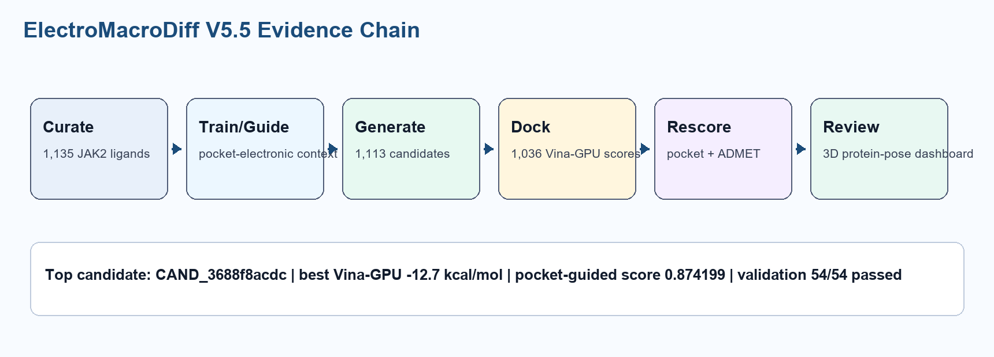
The workflow starts with curated JAK2 ligands, builds and evaluates macrocycle candidates, docks them into the 5AEP JAK2 receptor grid, rescoring candidates using pocket-electronic contact features, and presents the final ranked set in a real-data dashboard.

CHAPTER 4: IMPLEMENTATION
Component | Implementation
Data curation | 1,135 curated JAK2 ligands and macrocycle-focused training artifacts.
Generation | V5.5 pocket-guided macrocycle generation with linker novelty and validity/reward gating.
Docking | Vina-GPU 2.1 docking against JAK2 5AEP receptor grid.
Scoring | ADMET, synthesis, docking, and pocket-electronic fit scoring.
Interface | Real-data dashboard with candidate filters and protein-ligand 3D viewer.

CHAPTER 5: BENCHMARK AND COMPARISON
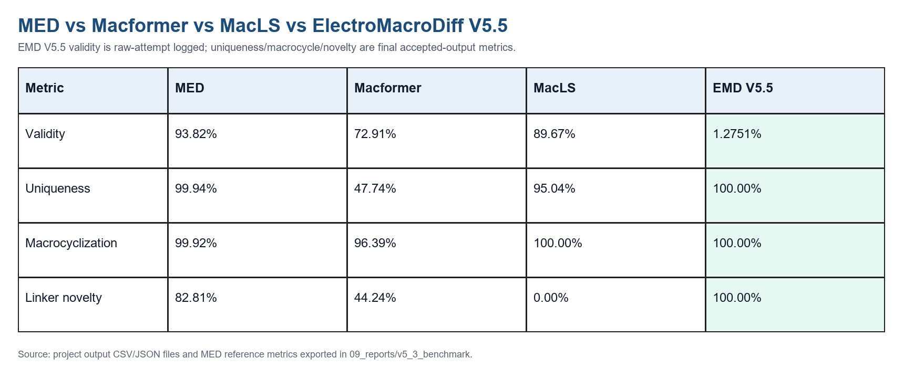
The MED, Macformer, and MacLS values are reference metrics from the MED-style benchmark export. EMD V5.5 metrics come from the active Kaggle V5.5 pocket-guided branch. The comparison is intentionally labeled because EMD V5.5 is a target-specific JAK2 pipeline and does not use the identical benchmark scope as MED.
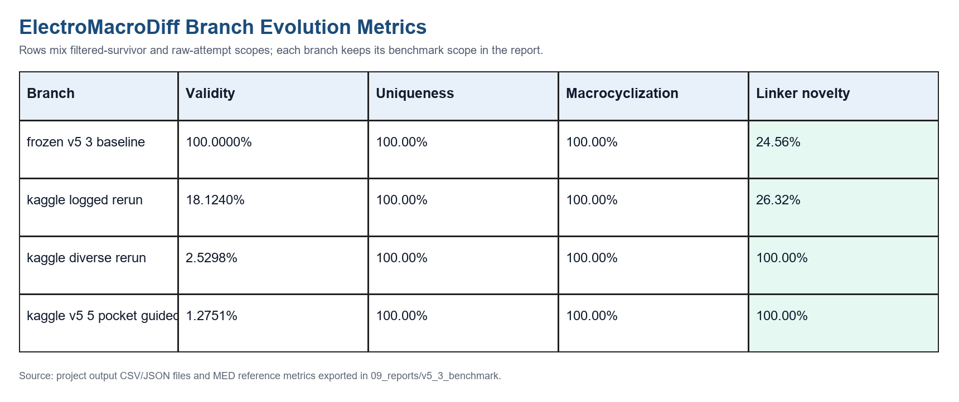

CHAPTER 6: RESULTS
Metric | Value
Generated V5.5 candidates | 1,113
Raw attempts | 87,287
Raw-attempt validity | 1.2751%
Docked candidates with parsed scores | 1,036
Best Vina-GPU score | -12.7 kcal/mol
Best pocket-electronic fit score | 0.84838
Top ranked candidate | CAND_3688f8acdc
Top pocket-guided final score | 0.874199
Validation checks | 54/54 passed
Unit tests | 40/40 passed

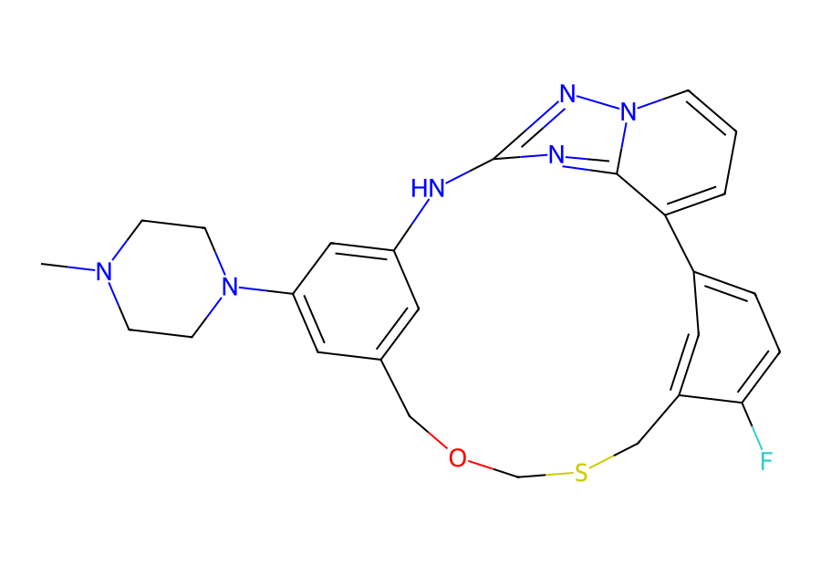
Top candidate SMILES: CN1CCN(c2cc3cc(c2)Nc2nc4c(cccn4n2)-c2ccc(F)c(c2)CSCOC3)CC1

CHAPTER 7: 3D DASHBOARD AND REVIEW
The upgraded interface embeds the real JAK2 receptor and 1,036 real docked pose texts. It supports direct candidate click-to-open, protein plus pose view, pose-only view, protein-only view, atom labels, bond-length labels, contact residue labels, transparent ligand and pocket surfaces, and docking grid visualization.
The dashboard displays only real exported project values. Missing pose or metric values are shown as unavailable rather than inferred.

CHAPTER 8: LIMITATIONS

- Docking scores are computational estimates and are not experimental binding affinities.

- Pocket-electronic scores are proxy scores, not quantum electron-density calculations.

- Raw-attempt validity remains low because the reward and novelty gates reject many proposals.

- No wet-lab assay, molecular dynamics stability run, or free-energy calculation has been performed yet.

CHAPTER 9: CONCLUSION AND FUTURE SCOPE
ElectroMacroDiff V5.5 is complete as a computational evidence package. It provides real candidates, docking outputs, pose files, pocket scoring, validation results, and an interactive dashboard. The next scientific phase should be V6: learned residue-level protein-ligand interaction encoding using richer datasets such as PDBbind, PLINDER/BioLiP-style contact data, and expanded JAK/JAK2 activity data.

REFERENCES

- Trott, O.; Olson, A. J. AutoDock Vina: improving the speed and accuracy of docking with a new scoring function, efficient optimization, and multithreading. Journal of Computational Chemistry, 2010.

- Ding, J.; Tang, S.; et al. Vina-GPU 2.0: Further accelerating AutoDock Vina and its derivatives with graphics processing units. Journal of Chemical Information and Modeling, 2023.

- RDKit: Open-source cheminformatics. https://www.rdkit.org

- Rego, N.; Koes, D. 3Dmol.js: molecular visualization with WebGL. Bioinformatics, 2015.

