ElectroMacroDiff V5.5: Pocket-Electronic Macrocycle Discovery for JAK2
Author 1, Author 2, Author 3, Author 4, Author 5

Abstract
Macrocyclic inhibitors are attractive in kinase discovery because their constrained conformations can improve target engagement and selectivity. We present ElectroMacroDiff V5.5, a low-resource computational workflow for JAK2 macrocycle candidate generation and prioritization. The system combines curated JAK2 ligand data, model-guided macrocycle construction, novelty and validity gating, Vina-GPU docking, ADMET and synthesis proxy scoring, pocket-electronic rescoring, and interactive 3D review. The final branch produced 1,113 ranked candidates from 87,287 logged generation attempts, with 1,036 parsed docking scores and a best Vina-GPU score of -12.7 kcal/mol.

1. Introduction
JAK2 macrocycle discovery requires chemical validity, pocket fit, and interpretable prioritization. ElectroMacroDiff addresses this by connecting generation to a complete evidence chain rather than reporting isolated generator outputs.

2. Methods
The workflow curates JAK2 ligands, generates macrocycles, enforces linker novelty, applies a validity/reward gate, docks candidates against JAK2 5AEP, calculates ADMET and synthesis proxy metrics, and rescoring docked poses using pocket-electronic features.

3. Results
The active V5.5 branch generated 1,113 candidates, retained 100% uniqueness, 100% macrocyclization, and 100% linker novelty in the final accepted set. Raw-attempt validity was 1.2751%, reflecting aggressive rejection by the reward and novelty gates.

4. Discussion
The project is strongest as a reproducible computational prioritization pipeline. It should not be framed as experimentally validated or as a full protein-conditioned diffusion model. Its value is transparent data-to-dashboard traceability and target-specific JAK2 evidence.

5. Conclusion
ElectroMacroDiff V5.5 is ready as a computational research artifact. Future work should train residue-level protein-ligand interaction encoders and align seed poses for true V6 protein-conditioned generation.
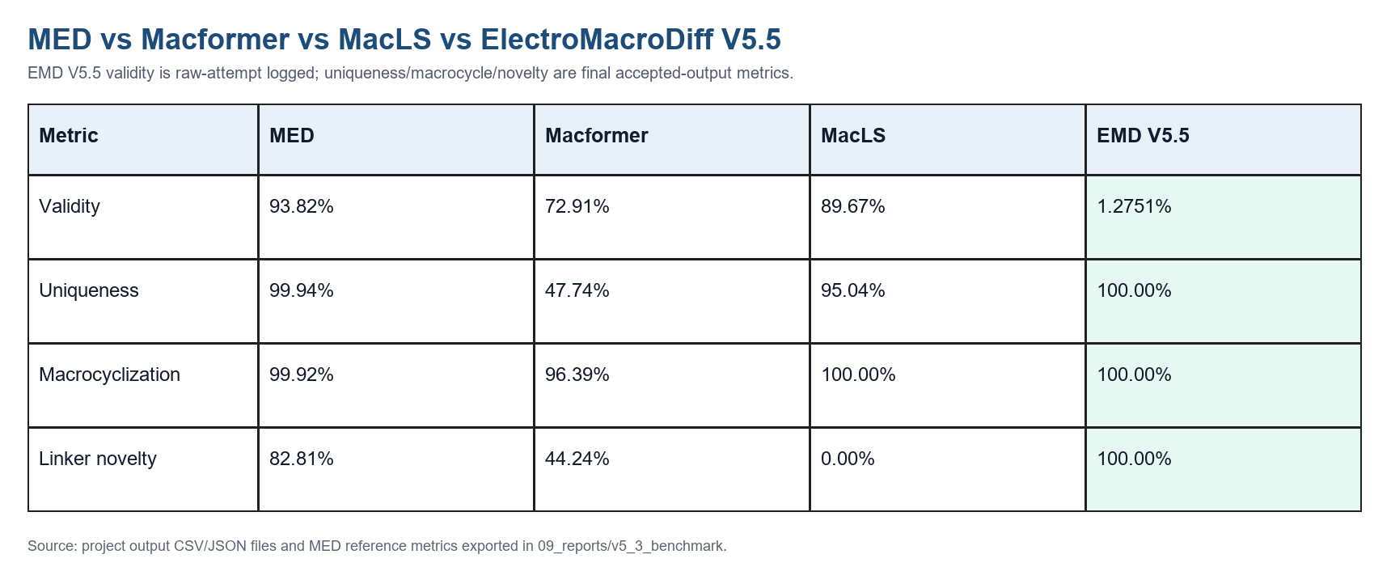
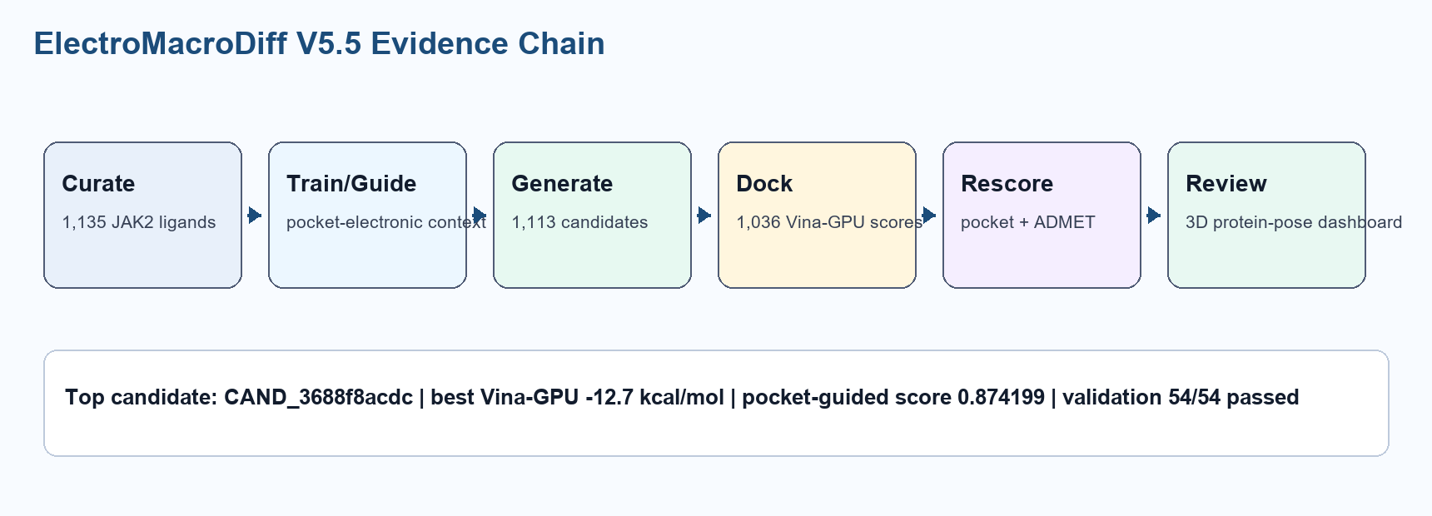

References
- Trott and Olson, AutoDock Vina, Journal of Computational Chemistry, 2010.
- Ding et al., Vina-GPU 2.0, Journal of Chemical Information and Modeling, 2023.
- RDKit open-source cheminformatics.
- Rego and Koes, 3Dmol.js, Bioinformatics, 2015.

