ElectroMacroDiff V5.5 Model Provenance and Training Explanation
For reviewer discussion: model source, datasets, pretraining/fine-tuning, and V5.3 vs V5.5 usage.
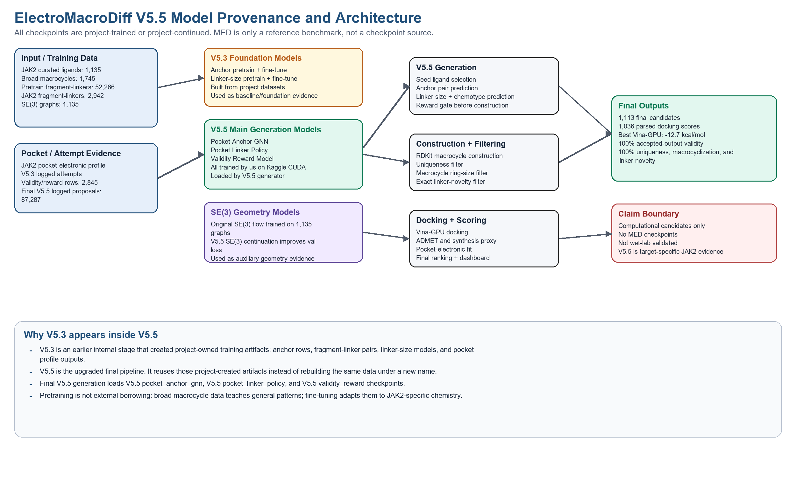

1. Direct Answer
- No MED checkpoints or MED pretrained weights were used. MED was only a benchmark reference.
- All listed checkpoints were trained, fine-tuned, or continued inside this project using project-prepared data.
- The 100% values are final accepted candidate-set properties after filtering, not model training accuracy.
- V5.3 artifacts appear because they are earlier internal project assets reused by the upgraded V5.5 pipeline.

2. Why Pretraining and Fine-tuning Were Used
The JAK2-specific macrocycle set is small, so training only on it would be weak. Pretraining on broader macrocycles teaches general macrocycle/linker patterns. Fine-tuning adapts those patterns to JAK2 chemistry. This is project-owned pretraining, not borrowing from MED.
Stage | Data | Purpose
Pretraining | 1,745 broad macrocycles; 1,667 usable; 52,266 fragment-linker rows | Learn general macrocycle/linker patterns
Fine-tuning | 97 usable JAK2 macrocycles; 2,942 fragment-linker rows | Adapt to JAK2-specific macrocycle chemistry
V5.5 upgrade | JAK2 pocket vector + V5.3 internal artifacts + logged attempts | Add pocket/electronic conditioning and reward gating

3. Datasets Used
Dataset | Size | Use
JAK2 curated ligands | 1,135 unique molecules | Seeds, features, SE(3) graphs
Broad macrocycle pretraining set | 1,745 unique molecules | General macrocycle learning
Pretrain fragment-linker pairs | 52,266 rows from 1,667 molecules | Linker and novelty reference
JAK2 fragment-linker pairs | 2,942 rows from 97 molecules | JAK2 fine-tuning and V5.5 linker policy
Anchor atom pretrain rows | 2,642,513 rows | General anchor learning
Anchor atom JAK2 rows | 94,247 rows | JAK2 anchor learning and V5.5 GNN labels
Validity/reward attempts | 2,845 rows | Reward model training
Final V5.5 attempt log | 87,287 proposals | Audit evidence, not model accuracy claim

4. Model Details
Model | Checkpoint | Origin | Training data | Why used | Metric/note
SE(3) flow model | se3_flow/se3_best_checkpoint.pt | Project-trained | 1,135 SE(3) molecular graphs | Auxiliary geometry foundation | Best val loss 9.0621
V5.3 anchor pretrain | v5_3_anchor_pretrain/anchor_site_model.pt | Project-trained | 2,642,513 atom rows from 1,667 molecules | General anchor pattern learning | Test F1 0.1697
V5.3 anchor fine-tuned | v5_3_anchor/anchor_site_model.pt | Project fine-tuned | 94,247 atom rows from 97 JAK2 molecules | JAK2 anchor adaptation | Test F1 0.2089
V5.3 linker-size pretrain | v5_3_linker_size_pretrain/linker_size_model.pt | Project-trained | 52,266 broad fragment-linker examples | General linker length learning | Exact 19.57%, within-one 40.76%
V5.3 linker-size fine-tuned | v5_3_linker_size/linker_size_model.pt | Project fine-tuned | 2,942 JAK2 fragment-linker examples | JAK2 linker length adaptation | Exact 34.41%, within-one 62.38%
V5.5 pocket anchor GNN | v5_5_pocket_anchor_gnn/pocket_anchor_gnn_best.pt | Project-trained on Kaggle CUDA | 97 graphs/94,247 atom-label rows + pocket vector | Final V5.5 anchor selector | Test F1 0.4848, precision 0.3478, recall 0.8000
V5.5 pocket linker policy | v5_5_pocket_linker_policy/pocket_linker_policy_best.pt | Project-trained on Kaggle CUDA | 55,208 combined fragment-linker samples + pocket vector | Final linker size + chemotype policy | Exact 59.28%, within-one 81.81%, chemotype 75.50%
V5.5 validity reward | v5_5_validity_reward/validity_reward_best.pt | Project-trained on Kaggle CUDA | 2,845 logged attempt examples + pocket vector | Rejects weak proposals before construction | Test ROC-AUC 0.8605
V5.5 SE(3) continuation | v5_5_se3_continuation/se3_v5_5_best_checkpoint.pt | Project-continued from our SE(3) checkpoint | 1,135 SE(3) graphs | Auxiliary geometry evidence | Val loss improved 9.0621 to 7.4328

5. Why V5.3 Is Used in V5.5
V5.5 is the final upgraded pipeline version, not a rule that every file must be newly named V5.5. V5.3 produced internal project assets such as anchor rows, fragment-linker pairs, linker models, logged attempts, and pocket profile files. V5.5 reuses those assets for traceability and adds pocket-conditioned models and reward gating. Final V5.5 generation directly loads V5.5 pocket anchor GNN, V5.5 pocket linker policy, and V5.5 validity reward checkpoints.

6. Simple Explanation for Sir
We did not bring models from MED. MED is only a reference benchmark. Our models are trained by us on our project data. V5.3 means earlier internal project artifacts; V5.5 means the upgraded final pipeline that uses those artifacts plus new pocket/electronic-conditioned models. Pretraining was used to learn general macrocycle behavior from a broader macrocycle set, and fine-tuning was used to specialize to JAK2.

7. Overfitting Clarification
The reported 100% final metrics are not model accuracy. They are final accepted-output metrics after strict filtering: valid accepted molecules, uniqueness, macrocyclization, and linker novelty. Actual held-out model metrics are lower and realistic: pocket anchor GNN test F1 0.4848, linker exact accuracy 59.28%, linker within-one accuracy 81.81%, chemotype accuracy 75.50%, and reward model ROC-AUC 0.8605.

