ElectroMacroDiff V5.5 Working Flow and Six Main Models
Project 1169 | Senior explanation document | Generated from real project artifacts

1. Quick answer
ElectroMacroDiff V5.5 is best explained as six main model blocks. The repository contains more checkpoint files because some model blocks have pretrain, fine-tuned, or continuation versions.
The final molecule generation happens in:
scripts/29_generate_v5_5_pocket_guided.py
Final generated molecules are written to:
05_generated_candidates/v5_5_pocket_guided/generated_v5_5_pocket_guided.csv

2. Six main model blocks
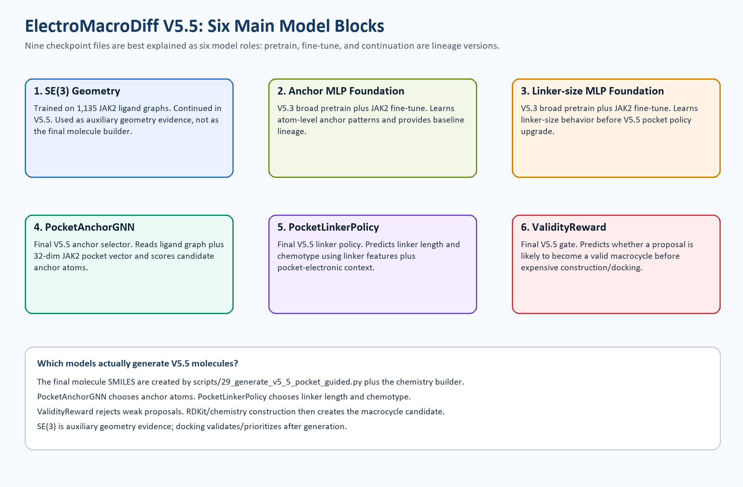
# | Model block | Main role | Training/source
1 | SE(3) geometry | 3D geometry evidence | 1,135 JAK2 ligand graphs
2 | Anchor MLP foundation | Baseline anchor prediction | 2,642,513 broad rows; 94,247 JAK2 rows
3 | Linker-size MLP foundation | Baseline linker size | 52,266 broad rows; 2,942 JAK2 rows
4 | PocketAnchorGNN | Final V5.5 anchor selection | JAK2 graph labels plus 32-dim pocket vector
5 | PocketLinkerPolicy | Final V5.5 linker size and chemotype | 55,208 training samples
6 | ValidityReward | Final V5.5 attempt rejection gate | 2,845 attempt-log samples

3. Full input-to-output working flow
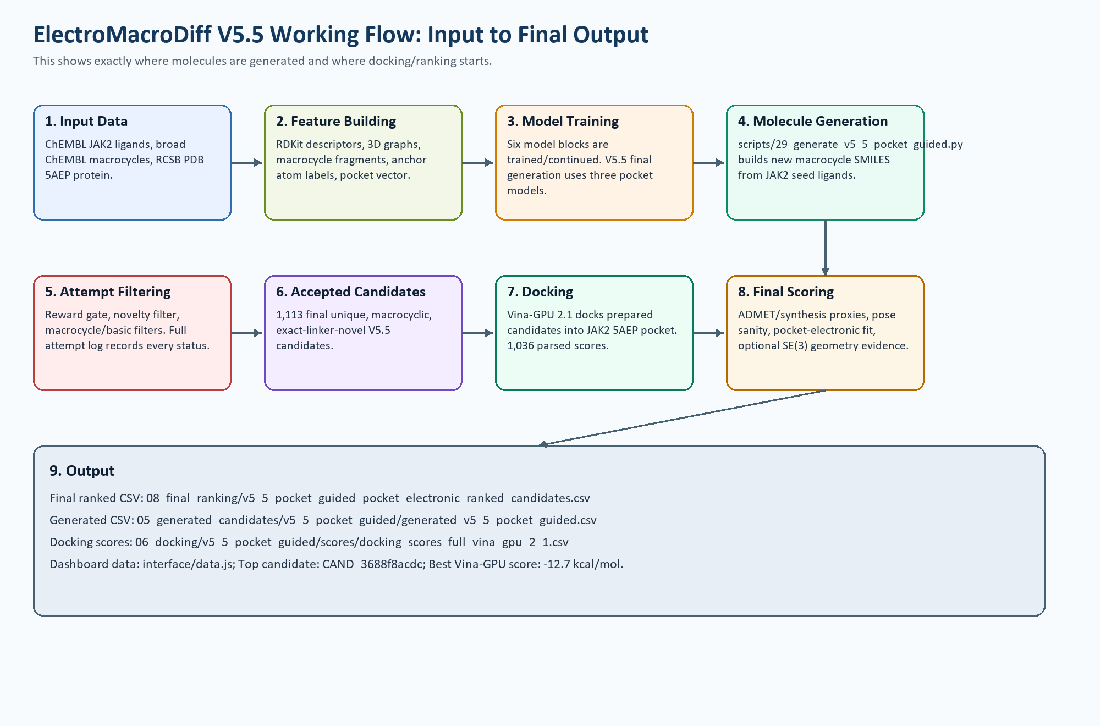

4. Where the molecule is generated
The molecule is generated before docking. Generation is handled by the V5.5 generator script and chemistry construction code. The final V5.5 models guide the decisions, but the script constructs and writes the final candidate SMILES.
- PocketAnchorGNN chooses which atoms in the seed ligand are suitable anchor points.
- PocketLinkerPolicy chooses the linker length and chemotype.
- ValidityReward rejects proposals that are likely to fail before expensive construction/docking.
- The chemistry builder constructs the macrocycle candidate and validates it with RDKit/basic filters.
- Accepted molecules are written to generated_v5_5_pocket_guided.csv.
- Docking starts only after generation; docking validates/ranks candidates but does not generate them.

5. Generation, filtering, docking, and ranking
Stage | What happens | Real artifact
Data input | ChEMBL JAK2 ligands, broad ChEMBL macrocycles, RCSB 5AEP protein | 01_raw_data and 02_curated_data
Model guidance | Anchor, linker, and reward models guide proposals | 04_models_checkpoints/v5_5_*
Molecule generation | New macrocycle SMILES are constructed from seed ligands | 05_generated_candidates/v5_5_pocket_guided/*.csv
Attempt logging | Every proposal is logged with status | v5_5_pocket_guided_attempt_log.csv
Docking | Prepared candidates are docked into JAK2 5AEP using Vina-GPU 2.1 | docking_scores_full_vina_gpu_2_1.csv
Final ranking | Docking, ADMET, pose sanity, novelty, and pocket-electronic fit are combined | 08_final_ranking/*.csv

6. Real final output numbers
Metric | Value
Final accepted V5.5 candidates | 1,113
Unique final candidates | 1,113
Final logged attempts | 87,287
Reward-model rejections | 78,257
Valid output rows | 1,113
Vina-GPU parsed docking scores | 1,036
Best Vina-GPU score | -12.7 kcal/mol
Median Vina-GPU score | -8.4 kcal/mol
Top ranked candidate | CAND_3688f8acdc

7. Copy-paste explanation
Sir, the latest version is V5.5. We can explain it as six model blocks. The older V5.3 names appear because those were our internal foundation/pretraining datasets and checkpoints. The final V5.5 molecules are generated by scripts/29_generate_v5_5_pocket_guided.py, using V5.5 PocketAnchorGNN, PocketLinkerPolicy, and ValidityReward checkpoints. Molecules are first generated as macrocycle candidates, then Vina-GPU docking and pocket-electronic scoring are used only for validation and ranking.

Appendix: Markdown source
# ElectroMacroDiff V5.5 Working Flow and Six Main Models

Project number: 1169

Prepared from real project files in `C:\Users\srira\Desktop\new_plan\EMD_V5_2_Hybrid`.

## Quick answer

ElectroMacroDiff V5.5 is best explained as **six main model blocks**. The repository has more checkpoint files because some model blocks have pretrain, fine-tuned, or continuation versions.

The final V5.5 molecule generation happens in:

`scripts/29_generate_v5_5_pocket_guided.py`

The final generated molecules are written to:

`05_generated_candidates/v5_5_pocket_guided/generated_v5_5_pocket_guided.csv`

The models do not directly output a finished drug molecule in one single step. Instead, they guide a chemistry construction process:

1. choose seed ligand,
2. score/select anchor atoms,
3. choose linker length and chemotype,
4. build the macrocycle using the project chemistry builder,
5. reject weak/duplicate/non-novel/non-macrocycle attempts,
6. keep valid generated molecules,
7. dock and rank them.

## Six main model blocks

![Six model blocks](assets/v5_5_six_main_model_blocks.png)

| # | Model block | Why it exists | Trained on | Used where |
|---:|---|---|---|---|
| 1 | SE(3) geometry model | Learns 3D geometry behavior and provides auxiliary geometry evidence | 1,135 JAK2 ligand graphs | SE(3) training/continuation and auxiliary geometry scoring |
| 2 | Anchor MLP foundation | Earlier foundation model for atom-level anchor prediction | 2,642,513 broad atom rows, then 94,247 JAK2 atom rows | V5.3 baseline/provenance, foundation for comparison |
| 3 | Linker-size MLP foundation | Earlier foundation model for linker-size prediction | 52,266 broad linker rows, then 2,942 JAK2 linker rows | V5.3 baseline/provenance, foundation for comparison |
| 4 | V5.5 PocketAnchorGNN | Selects anchor atoms using graph structure plus JAK2 pocket vector | JAK2 anchor graph labels plus 32-dim pocket vector | Final V5.5 generation |
| 5 | V5.5 PocketLinkerPolicy | Chooses linker size and chemotype using pocket-electronic context | 55,208 linker-policy samples | Final V5.5 generation |
| 6 | V5.5 ValidityReward | Rejects proposals likely to fail before construction/docking | 2,845 attempt-log samples | Final V5.5 generation gate |

## Input-to-output working flow

![Input to output flow](assets/v5_5_input_to_output_working_flow.png)

## Where exactly are molecules generated?

Molecules are generated in **Step 4: Molecule Generation**, inside:

`scripts/29_generate_v5_5_pocket_guided.py`

That script loads these final V5.5 checkpoints:

- `04_models_checkpoints/v5_5_pocket_anchor_gnn/pocket_anchor_gnn_best.pt`
- `04_models_checkpoints/v5_5_pocket_linker_policy/pocket_linker_policy_best.pt`
- `04_models_checkpoints/v5_5_validity_reward/validity_reward_best.pt`

Then it uses JAK2 seed ligands from the curated ChEMBL data. For each seed, it proposes anchor pairs and linker choices. The molecule is physically constructed by the project chemistry/linker construction code, not by docking and not by MED.

Important: docking starts **after** molecule generation. Docking does not generate the molecules. Docking only places the already-generated candidate into the JAK2 pocket and scores the pose.

## Final real outputs

| Output | Real value |
|---|---:|
| Final accepted V5.5 candidates | 1,113 |
| Unique final candidates | 1,113 |
| Final logged attempts | 87,287 |
| Reward-model rejections | 78,257 |
| Valid output rows | 1,113 |
| Vina-GPU parsed docking scores | 1,036 |
| Best Vina-GPU score | -12.7 kcal/mol |
| Median Vina-GPU score | -8.4 kcal/mol |
| Top ranked candidate | CAND_3688f8acdc |

## Short explanation for sir

Sir, the latest version is V5.5. We can explain it as six model blocks. The older V5.3 names appear because those were our internal foundation/pretraining datasets and checkpoints. The final V5.5 molecules are generated by `scripts/29_generate_v5_5_pocket_guided.py`, using V5.5 PocketAnchorGNN, PocketLinkerPolicy, and ValidityReward checkpoints. Molecules are first generated as macrocycle candidates, then Vina-GPU docking and pocket-electronic scoring are used only for validation and ranking.

