Data Analytics – MGB · Project Based Learning
Validating a Data-Driven Campaign Approval Strategy
Synthetic-data analysis of XYZ's Campaign Intelligence & Approval Platform (CIAP)

Individual Submission
[Your name] · [Roll number]
Tools: Python (pandas, NumPy, SciPy, matplotlib, seaborn, Plotly), Streamlit dashboard, Microsoft Excel

Live dashboard: https://ciap-campaign-analytics.streamlit.app
Source code: https://github.com/jagjampiaaditya-byte/ciap-campaign-analytics

Deliverables: data (raw and clean CSV), Python code (5 scripts + Streamlit app), Excel calculation workbook, this report.

Contents
1. Executive summary
2. Business context, objective and hypotheses
3. Synthetic data generation (Step 1)
4. Data preparation: cleaning and transformation (Step 2)
5. Descriptive analytics (Step 3)
6. Correlation analysis (Step 3)
7. Diagnostic analytics (Step 3)
8. Customer-level diagnostics
9. Validating the strategy: CIAP back-test
10. Business strategy and recommendations
11. Limitations and next steps
Appendix A. Rationale for every technique
Appendix B. Files submitted and how to run them

1. Executive summary
XYZ is an e-commerce company that approves marketing campaigns through five departments (Marketing, Supply Chain, Logistics, Inventory, Finance), each working on its own data. Its proposed strategy is the Campaign Intelligence & Approval Platform (CIAP): one shared data platform that forecasts each campaign's demand, checks it against stock, delivery capacity and money through hard "gates", and launches only feasible campaigns. This project uses synthetic data to describe and diagnose the current process and to test whether the CIAP strategy would work (assignment option 1b: the whole business strategy described and diagnosed).
Key findings
- Half of campaigns fail. Only 53% of 1,500 campaigns met their objectives. Stockouts are the largest failure cause (40% of failures), and 1.68M units of demand were lost.
- Stock is the main lever. 37% of campaigns launched with less stock than the upper bound of forecast demand. Their average stockout rate was 13.4% vs 1.4% for those above.
- Delivery capacity has a cliff edge. Above 100% rider utilisation, on-time delivery falls to 76.2% (vs 96.2% below 90%), and late deliveries pull down CSAT.
- Departments disagree on demand. Marketing over-forecasts by a median 18%. A single model forecast is unbiased (2%) with a typical error of 19% vs 30%.
- Bad campaigns cost future value. Stockouts and late deliveries reduce repeat purchase and CLTV. Customers acquired through heavy discounts have 0.6x lower CLTV, and Discount Seekers campaigns succeed only 11% of the time.
- The strategy is validated. Replaying all campaigns through the CIAP gates with pre-launch data only, approved campaigns succeeded 76% of the time and blocked ones 37%. The gates would have caught 74% of failures before launch and blocked $12.01M of losses.
Recommendation: adopt CIAP in stages. Start in shadow mode, enforce the inventory, logistics and finance gates, use one forecast with a prediction range, cap discounts by category, steer budget away from discount-only segments, and record every override.

2. Business context, objective and hypotheses

2.1 The business problem
Today a campaign moves through five departments in sequence by email and meetings. The Business Requirements Document (BRD) lists seven problems, summarised below. Each one can be measured with data, which is what this project does.
Table 1. Business problems and the measures used
ID | Problem (BRD) | How it is measured in this project
PS-01 | Approval is sequential and manual | Approval cycle time; trade-off with checks skipped
PS-02 | Each department decides on its own data | Forecast bias and error by team
PS-03 | Campaigns launch without proven fulfilment capacity | Stock cover, stockout rate, rider utilisation, on-time
PS-04 | Discounts not tested against margin and cash | Contribution margin, ROI, loss-making campaigns
PS-05 | Targeting not tied to CLTV | CLTV uplift and repeat rate by segment and discount
PS-06 | Results do not feed back into planning | Success rate trend over time
PS-07 | Decisions and overrides not recorded | Override frequency and outcome

2.2 The strategy being validated
CIAP evaluates every campaign before launch against business rules (BRD Section 9). The rules simulated in this project are:
Table 2. CIAP rules applied in the back-test
Rule | Domain | Test | Effect
BRL-003 | Inventory | Stock ≥ upper bound of forecast demand | Hard gate
BRL-009 | Logistics | Peak orders ≤ rider capacity (condition inside a 10% buffer) | Hard / condition
BRL-011 | Finance | Projected campaign cost ≤ approved budget | Hard gate
BRL-012 | Finance | Projected margin ≥ 0 (escalate if below 10%) | Hard / escalate
BRL-015 | Marketing | Discount within category ceiling | Escalate

2.3 Objective and hypotheses
Objective: describe the current campaign process, diagnose why campaigns fail, and test whether a gated, data-driven approval process would have separated good campaigns from bad ones before launch.
Table 3. Hypotheses tested
# | Hypothesis
H1 | Campaigns launched with stock below the upper-bound forecast suffer more stockouts and fail more often.
H2 | Peak orders above rider capacity cause late deliveries, which lower customer satisfaction.
H3 | Departmental forecasts are biased; one model forecast is more accurate.
H4 | Skipped departmental checks and overrides increase failure, while full checks slow approval.
H5 | Deep discounts and discount-led targeting erode long-term customer value (CLTV).
H6 | The CIAP gates, using only pre-launch data, identify most failing campaigns before launch.

3. Synthetic data generation (Step 1)

3.1 Why synthetic data
CIAP does not exist yet, and XYZ's history sits in separate departmental systems, so there is no single dataset that links a campaign's design, approval, forecast, stock, delivery and customer outcome. Synthetic data lets us build that linked history with realistic cause-and-effect relationships taken from the BRD, then test the strategy on it. The generator (01_generate_synthetic_data.py) uses a fixed random seed (42), so the data can be reproduced exactly.

3.2 Datasets produced
Table 4. Synthetic datasets
File | Grain | Size (raw) | Content
campaigns_raw.csv | 1 row per campaign | 1,537 rows × 44 cols | Jan 2023 – Sep 2026: design, approval process, forecasts, stock, capacity, financial and customer outcomes
customers_raw.csv | 1 row per acquired customer | 6,090 rows × 13 cols | Segment, demographics, 12-month orders, discount usage, predicted CLTV, acquiring campaign
campaign_daily_raw.csv | 1 row per campaign-day | 3,676 rows × 9 cols | Daily forecast, demand, sales and closing stock for the 250 most recent campaigns

3.3 How the data was simulated (the causal model)
Rather than random numbers, each variable is generated from the variables that drive it in the real business, with random noise added. This is what makes the analysis meaningful.
Table 5. Simulation logic
Element | How it was generated
Demand | Base demand by category × region × (1 + elasticity × discount × segment sensitivity × campaign-type multiplier) × season × random shock
Forecasts | Department forecasts = true expected demand × team bias (Marketing +14%, Inventory −8%, Finance 0%) × noise. CIAP model forecast = expected demand × 12% noise (back-tested model)
Approval process | Each department signs off with a probability (Supply 70%, Inventory 75%, Logistics 65%, Finance 80%). Cycle time grows with the number of sign-offs
Stock | Planned by Inventory around 1.3× expected demand when consulted; about 0.95× (a guess) when skipped. Supply Chain confirmation adds replenishment
Stockouts | Units sold = min(demand, stock); lost sales and stockout rate follow
Delivery | Rider utilisation = (base + peak orders) ÷ capacity. Logistics sign-off plans capacity for the forecast. On-time rate falls above 80% and sharply above 100% utilisation
Money | Revenue, discount cost, COGS, fulfilment (more expensive when over capacity), media; contribution margin and ROI vs a no-campaign baseline
Customers | Repeat rate, CLTV uplift, CSAT and complaints fall with stockouts and late deliveries. Discount Seekers have negative CLTV lift
Success | A campaign meets objectives if CM > 0, stockout < 8%, on-time > 90% and CLTV uplift > 0 (3% random label noise)

3.4 Realistic data-quality problems injected
Real exports are messy, and data preparation is worth 10 marks, so the generator deliberately introduces the problems XYZ would face when combining departmental files: duplicate rows, inconsistent labels ("flash sale", "FLASH SALE ", "Flash-Sale"), three date formats, discounts as text ("25%"), budgets as currency text ("$18,415"), Y/N/TRUE/FALSE flags, missing values (CSAT, media spend, on-time rate, forecast team), negative units, budgets typed with two extra zeros, on-time rates of 150%, customer tiers written four ways, "-1" placeholder values and dropped daily feed values ("NA").

4. Data preparation: cleaning and transformation (Step 2)
All cleaning is done in 02_clean_transform.py and every fix is written to outputs/cleaning_log.csv (also in the Excel workbook). The table below compares data quality before and after.
Table 6. Data quality before vs after cleaning
Dataset | Stage | Rows | Columns | Missing cells | Duplicate rows
campaigns | raw | 1537 | 44 | 318 | 37
campaigns | clean | 1500 | 82 | 345 | 0
customers | raw | 6090 | 13 | 243 | 90
customers | clean | 6000 | 20 | 0 | 0
campaign_daily | raw | 3676 | 9 | 73 | 60
campaign_daily | clean | 3616 | 14 | 0 | 0

Note: the remaining missing cells in the clean campaigns table are CAC (customer acquisition cost) for campaigns that acquired no new customers. CAC is undefined there, so it is correctly left blank.
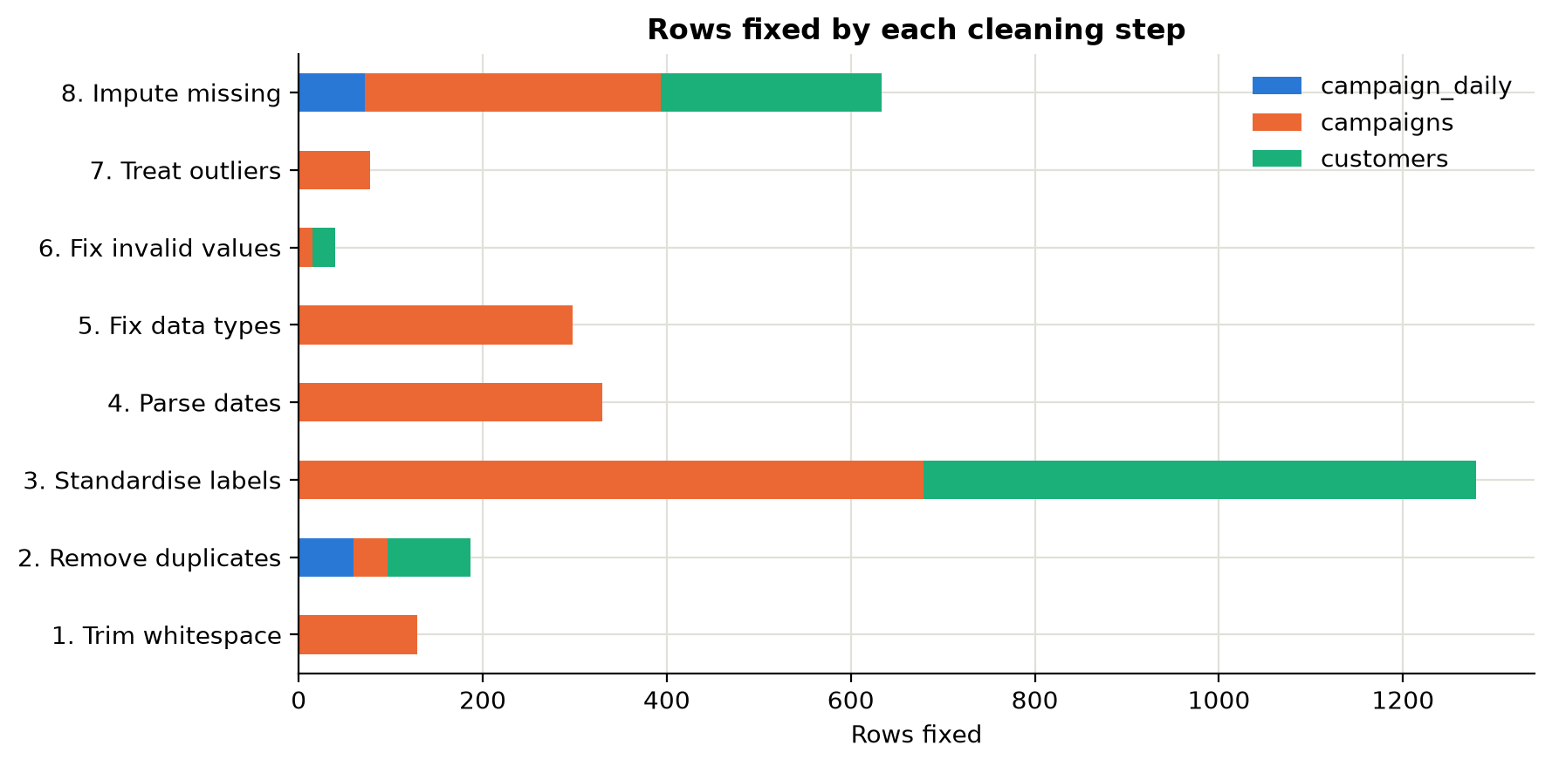
Figure 1. Cleaning summary
What it shows: Rows affected by each cleaning step.
Insight:
Business implication:

4.1 Cleaning steps
Table 7. Cleaning log
Dataset | Step | Issue found | Rows | Action and justification
campaigns | 1. Trim whitespace | Leading/trailing spaces in text fields | 129 | Stripped spaces from all text columns
campaigns | 2. Remove duplicates | Identical rows exported twice | 37 | Dropped exact duplicate rows
campaigns | 2. Remove duplicates | Duplicate campaign_id after exact de-dup | 0 | None found - campaign_id is a valid primary key
campaigns | 3. Standardise labels | Inconsistent spellings/case in campaign_type | 84 | Mapped variants to canonical labels: ['Bundle', 'Clearance', 'Discount', 'Flash Sale', 'Free Delivery', 'Loyalty Reward', 'Seasonal Event']
campaigns | 3. Standardise labels | Inconsistent spellings/case in target_segment | 114 | Mapped variants to canonical labels: ['At-Risk / Lapsed', 'Champions', 'Discount Seekers', 'Loyal Regulars', 'New Prospects', 'Potential Loyalists']
campaigns | 3. Standardise labels | Inconsistent spellings/case in region_scope | 301 | Mapped variants to canonical labels: ['Metro only', 'Nationwide', 'Regional']
campaigns | 3. Standardise labels | inventory_signoff recorded as Y/N/TRUE/FALSE/yes | 90 | Converted to Yes/No
campaigns | 3. Standardise labels | logistics_signoff recorded as Y/N/TRUE/FALSE/yes | 90 | Converted to Yes/No
campaigns | 4. Parse dates | launch_date in DD/MM/YYYY and 'Mon DD, YYYY' formats | 330 | Parsed all formats to ISO dates; unparseable left: 0
campaigns | 5. Fix data types | discount_pct written as text like '25%' | 180 | Removed % and converted to a 0-1 fraction
campaigns | 5. Fix data types | budget written as currency text like '$18,415' | 118 | Removed $ and thousands separators, converted to number
campaigns | 6. Fix invalid values | Negative units_sold (sign typed wrongly; revenue is positive) | 9 | Took absolute value - confirmed against revenue / price
campaigns | 6. Fix invalid values | on_time_delivery_rate above 100% (1.5) | 6 | Set to missing, then imputed in step 8
campaigns | 7. Treat outliers | budget / planned revenue ratio above 5.0 (3xIQR fence 1.25, floor 5) - two extra zeros typed | 6 | Divided by 100 (ratio returns to the normal range)
campaigns | 7. Treat outliers | Extreme but genuine values in contribution_margin (3xIQR rule) | 41 | Kept: they are real large campaigns, flagged for robust (median) statistics
campaigns | 7. Treat outliers | Extreme but genuine values in units_sold (3xIQR rule) | 30 | Kept: they are real large campaigns, flagged for robust (median) statistics
campaigns | 7. Treat outliers | Extreme but genuine values in approval_cycle_hours (3xIQR rule) | 1 | Kept: they are real large campaigns, flagged for robust (median) statistics
campaigns | 8. Impute missing | media_spend missing | 45 | Imputed = category median media-to-planned-revenue rate x planned revenue
campaigns | 8. Impute missing | on_time_delivery_rate missing (incl. the invalid 1.5 values) | 66 | Imputed with median on-time rate of campaigns in the same rider-utilisation band
campaigns | 8. Impute missing | csat_score missing (survey not returned) | 90 | Imputed with campaign-type median
campaigns | 8. Impute missing | repeat_rate_90d missing | 45 | Imputed with target-segment median
campaigns | 8. Impute missing | forecast_team missing | 75 | Labelled 'Unknown' (category kept, not guessed)
campaigns | 9. Consistency check | revenue = units_sold x price x (1 - discount) | 0 | Check passed for all rows
customers | 2. Remove duplicates | Customer rows exported twice | 90 | Dropped exact duplicates
customers | 2. Remove duplicates | Repeated customer_id | 0 | Kept first record per customer
customers | 3. Standardise labels | city_tier as tier-1 / T1 / tier 2 | 600 | Mapped to Tier 1 / Tier 2 / Tier 3
customers | 6. Fix invalid values | orders_12m = -1 (system default for 'unknown') | 25 | Recalculated as revenue_12m / avg_order_value
customers | 8. Impute missing | age_band missing (not provided at sign-up) | 240 | Labelled 'Unknown' - not imputed, to avoid inventing demographics
campaign_daily | 2. Remove duplicates | Day rows loaded twice | 60 | Dropped exact duplicates
campaign_daily | 8. Impute missing | units_sold = 'NA' (feed dropped) | 72 | Recovered exactly from stock movement: previous day stock - today's stock

4.2 Why these cleaning choices
- Group-median imputation. Missing values were filled with the median of a comparable group (same category, segment, campaign type or rider-utilisation band), not the overall mean. This keeps group differences intact and is robust to skewed data.
- No guessing of categories. Categorical gaps (age band, forecast team) were labelled "Unknown" rather than guessed, to avoid inventing demographics or blaming a team.
- Outliers kept, errors fixed. Large campaigns are real, so extreme values were kept and flagged (3×IQR rule). Medians and Spearman correlation are used where outliers could distort results. Only values that were provably typing errors were corrected.
- Exact recovery where possible. Missing daily sales were recovered exactly from the stock movement (yesterday's closing stock − today's), rather than estimated.
- Consistency validation. Revenue = units × price × (1 − discount) was re-checked for every row after cleaning; all rows passed.

4.3 Transformation and feature engineering
Table 8. Engineered features
Feature(s) | Definition | Used for
stock_cover_ratio | Stock ÷ upper bound of CIAP forecast (forecast × 1.15) | The inventory gate BRL-003
demand_units, forecast_error_pct | Units sold + lost sales; (forecast − demand) ÷ demand | Forecast accuracy by team (PS-02)
cm_margin_pct, roi, campaign_cost, cac | Margin ÷ revenue; incremental margin ÷ (media + discount); cost ÷ new customers | Profitability (PS-04) and acquisition cost
signoffs_count, all_departments_signed | Count of the five departments that signed off | Effect of skipped checks (PS-01)
discount_band, cycle_time_band, stock_cover_band | Continuous variables grouped into bands | Diagnostic comparisons and heatmaps
launch_year / quarter / month, peak_season | Date parts | Trend and seasonality
failure_reason | First failed success criterion (Stockout, Late delivery, Loss-making, CLTV erosion) | Root-cause Pareto
gate_* and ciap_verdict | Each CIAP rule recomputed with pre-launch data → Approve / Conditions / Not feasible | Strategy back-test (H6)
customers: churned, discount_dependency, value_tier, acq_* | Inactive > 180 days; discount share band; CLTV quartile; joined acquiring-campaign experience | Customer diagnostics

5. Descriptive analytics (Step 3)
Descriptive analytics answers "what happened?". The interactive version of every chart is in the Streamlit dashboard (app.py, live at https://ciap-campaign-analytics.streamlit.app), where filters by year, type, segment, category and region recalculate every number.
Table 9. Summary statistics of key campaign variables
Variable | Mean | Median | Std dev | Min | Max | Skew
Discount % | 0.232 | 0.230 | 0.131 | 0.000 | 0.620 | 0.34
units sold | 13781.374 | 9057.000 | 14273.729 | 238.000 | 113770.000 | 2.48
Stock cover ratio | 1.140 | 1.108 | 0.364 | 0.308 | 3.573 | 0.98
Approval cycle (h) | 74.813 | 70.700 | 26.180 | 19.600 | 189.600 | 0.98
Stockout rate | 0.058 | 0.006 | 0.119 | 0.000 | 0.703 | 2.46
On-time delivery | 0.938 | 0.958 | 0.067 | 0.600 | 0.995 | -3.57
CSAT | 4.329 | 4.480 | 0.475 | 1.780 | 5.000 | -2.16
Repeat rate 90d | 0.250 | 0.213 | 0.155 | 0.010 | 0.617 | 0.40
CLTV uplift % | 3.154 | 3.915 | 5.906 | -15.980 | 18.800 | -0.49
Contribution margin % | 0.233 | 0.265 | 0.175 | -0.742 | 0.621 | -1.29
ROI | 0.514 | 0.267 | 0.946 | -1.681 | 10.379 | 3.62

Headline KPIs: 1,500 campaigns, $965.73M revenue, $218.07M contribution margin, median ROI 0.27x, average stockout rate 5.8%, average on-time delivery 93.8%, median approval time 71 h. Several variables (ROI, units, stockout rate) are strongly skewed, so medians are reported alongside means.
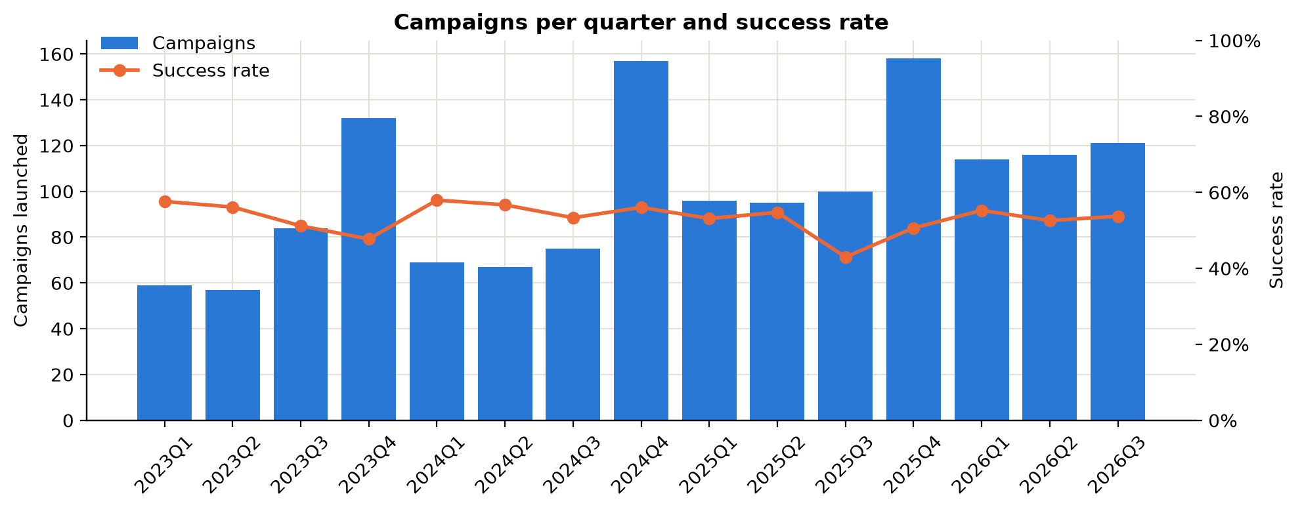
Figure 2. Campaign volume and success rate over time
What it shows: Number of campaigns launched per quarter (bars) and the share that met their objectives (line).
Insight: Volume grows every year and peaks in Q4, but the success rate does not improve with experience: it swings between 43% (2025Q3) and 58% (2024Q1). Nov-Dec campaigns succeed 52% of the time vs 53% for the rest of the year.
Business implication: More campaigns are not translating into better campaigns, which shows the manual process is not learning (problem PS-06). Peak season needs the strictest feasibility checks.

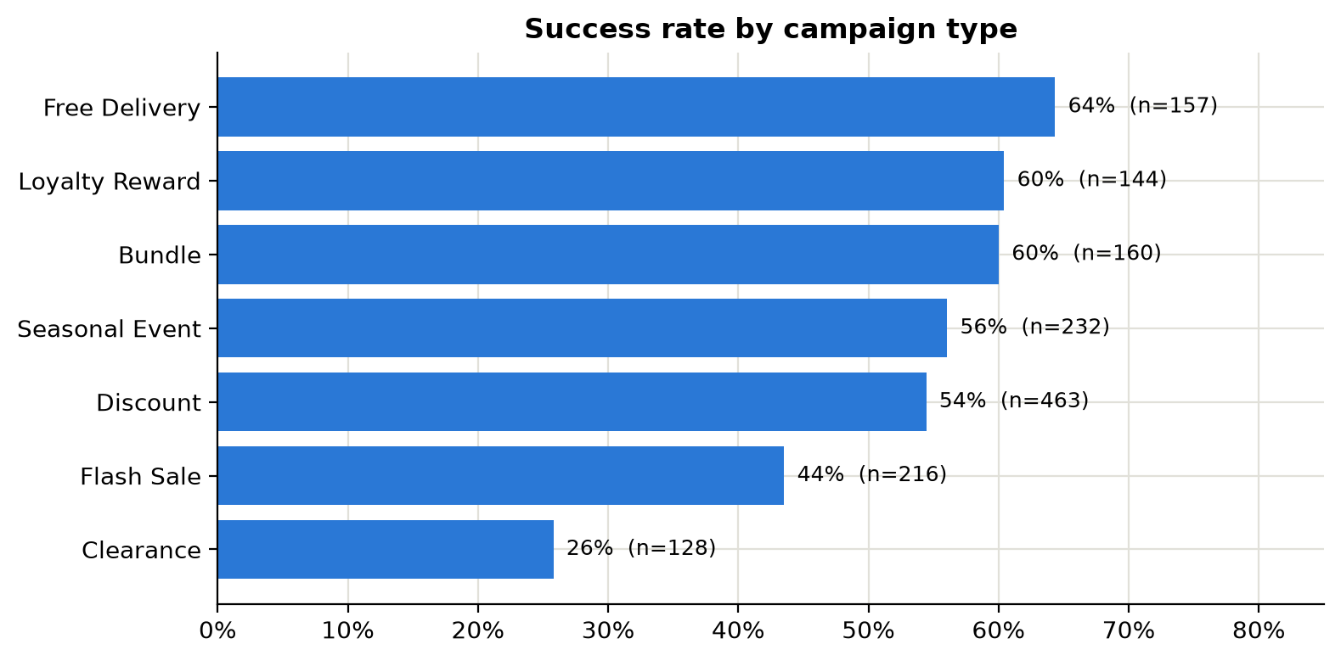
Figure 3. Success rate by campaign type
What it shows: Campaign count and success rate for each campaign type.
Insight: Free Delivery campaigns succeed most often (64%); Clearance campaigns least (26%, average discount 45%, average stockout 4.2%).
Business implication: High-discount, high-velocity types need tighter stock and capacity gates. This is why CIAP picks which models and rules to run by campaign type (BRD Section 10.2).

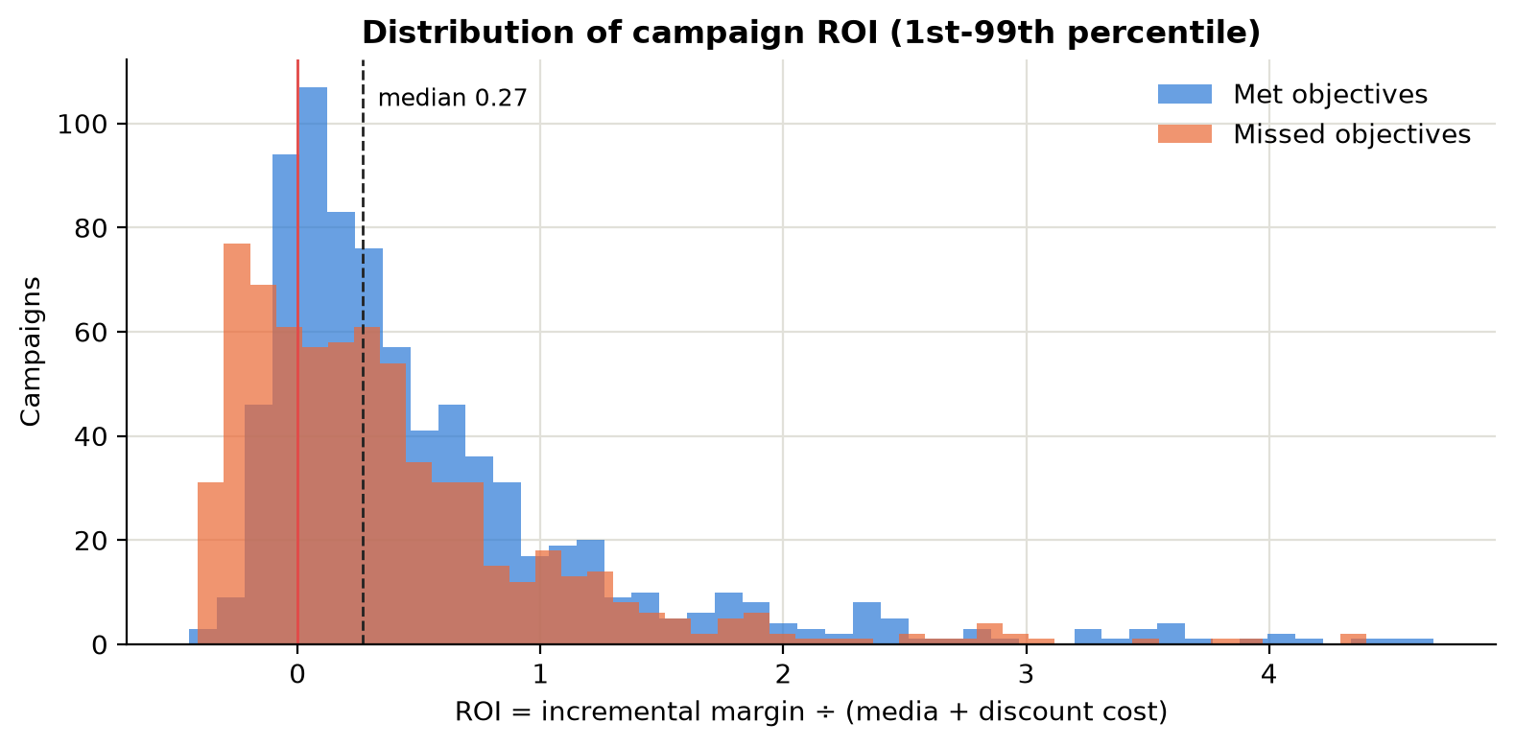
Figure 4. Distribution of campaign ROI
What it shows: Distribution (histogram) of ROI across all campaigns.
Insight: Median 0.27, mean 0.51, skewness 3.62. 26% of campaigns have a negative value.
Business implication: The distribution is skewed with a long tail, so the analysis uses medians and robust comparisons rather than the mean alone. The negative tail is the money CIAP's finance gate (BRL-012) aims to stop.

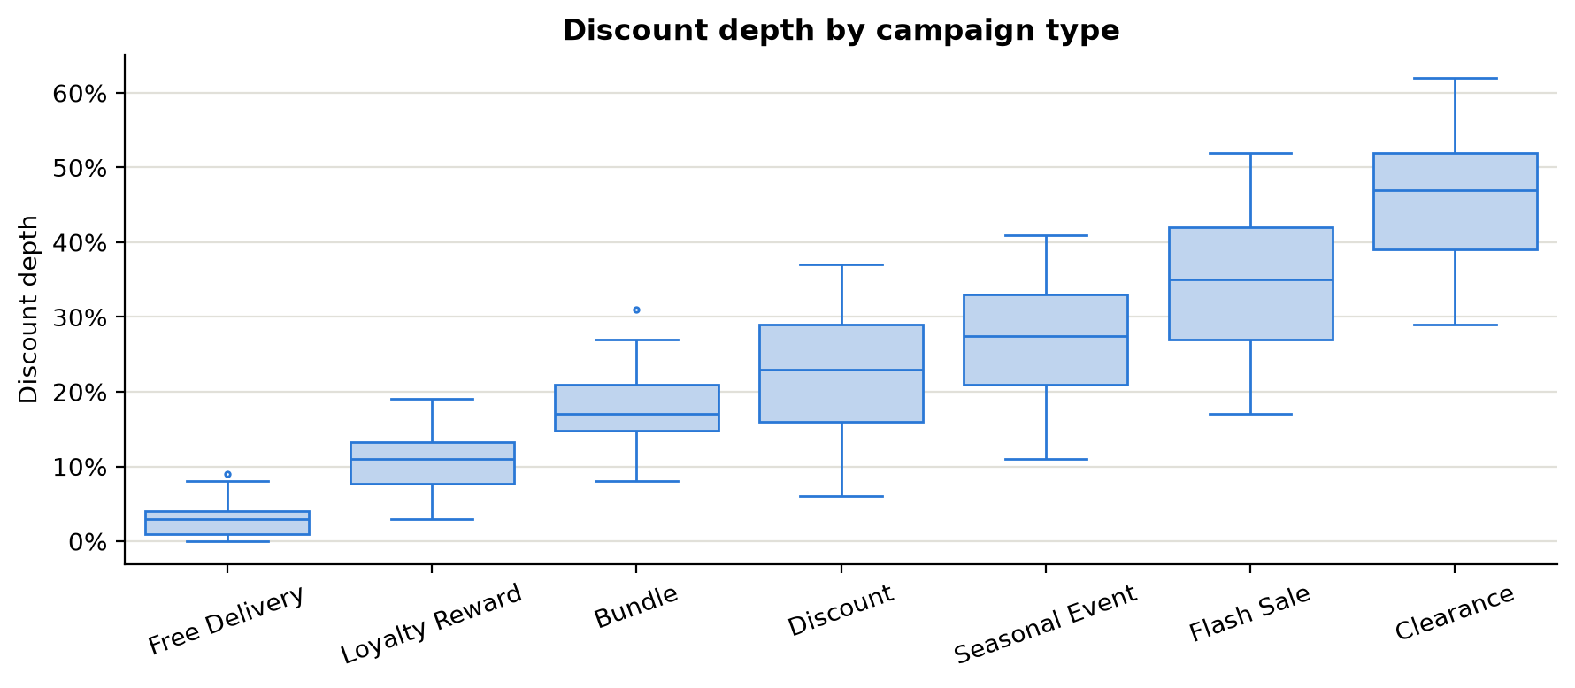
Figure 5. Discount depth by campaign type
What it shows: Spread of discount depth for each campaign type (box = middle 50%, line = median, whiskers = typical range).
Insight: Clearance and Flash Sale campaigns use the deepest discounts and have the widest spread. 27% of all campaigns went above the category discount ceiling that CIAP would escalate (BRL-015).
Business implication: Discount depth is set case by case with no common ceiling. Category ceilings with escalation give consistency without banning deep discounts.

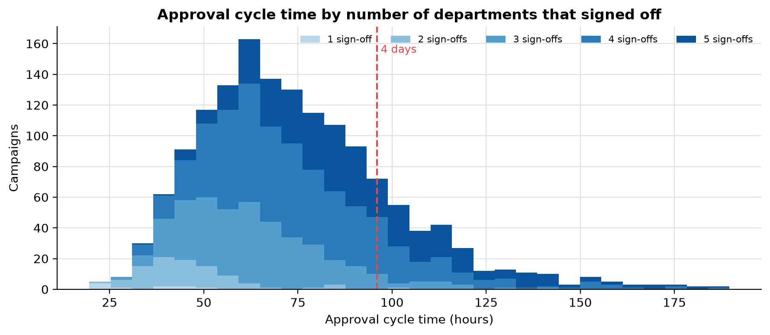
Figure 6. Approval cycle time
What it shows: Distribution of approval cycle time (hours from proposal to launch decision), coloured by how many departments signed off.
Insight: Median approval takes 71 h, and 18% of campaigns take more than 4 days. Each extra department adds time: median 33 h with 1 sign-off vs 87 h with 5.
Business implication: The manual process forces a trade-off: being thorough (all five checks) is slow, and being fast means skipping checks. CIAP removes the trade-off by running all five evaluations in parallel (FR-014).

6. Correlation analysis (Step 3)
Correlation measures how strongly two variables move together (−1 to +1). Pearson captures linear relationships. Spearman (rank-based) was also computed as a robustness check because several variables are skewed or have threshold effects. The two methods agree on the direction of every strong relationship. Correlation does not prove causation, so each relationship is interpreted with business logic and checked with the diagnostic charts in Section 7.
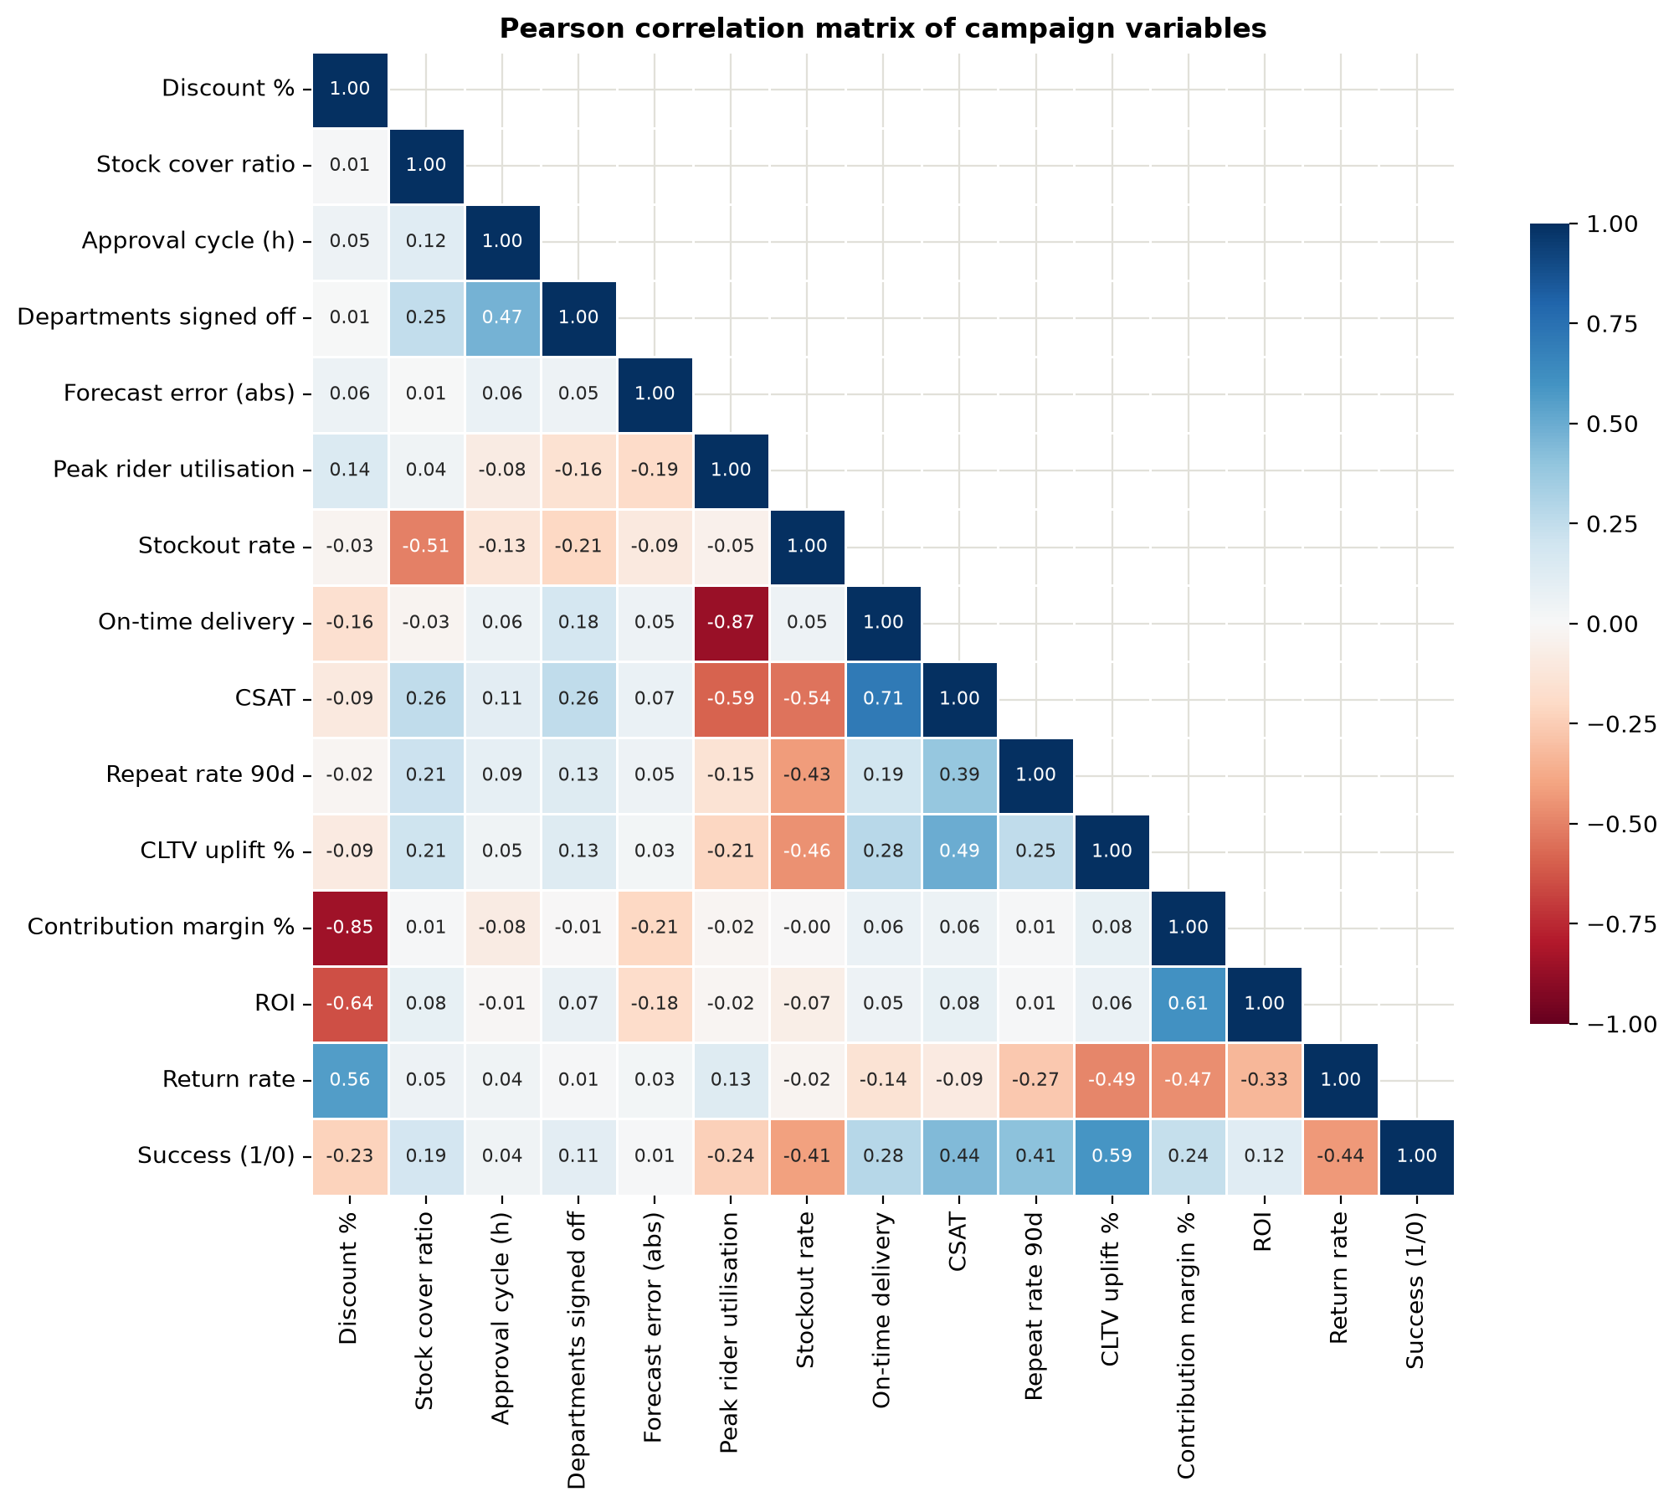
Figure 7. Correlation matrix
What it shows: Pearson correlation between 15 numeric campaign variables (+1 = move together, -1 = move opposite, 0 = no linear link).
Insight: Strongest relationships: Peak rider utilisation and On-time delivery (-0.87); Discount % and Contribution margin % (-0.85); On-time delivery and CSAT (+0.71); Discount % and ROI (-0.64); Contribution margin % and ROI (+0.61).
Business implication: Two chains stand out. Stock cover drives stockouts, which hurt CSAT, repeat purchase and CLTV. Rider utilisation drives late deliveries, which hurt CSAT. These are exactly the operational gates CIAP enforces before launch.

Spearman robustness check: Strongest relationships: Contribution margin % and ROI (+0.90); Discount % and Contribution margin % (-0.84); Peak rider utilisation and On-time delivery (-0.81); Discount % and ROI (-0.81); CLTV uplift % and Success (1/0) (+0.60).
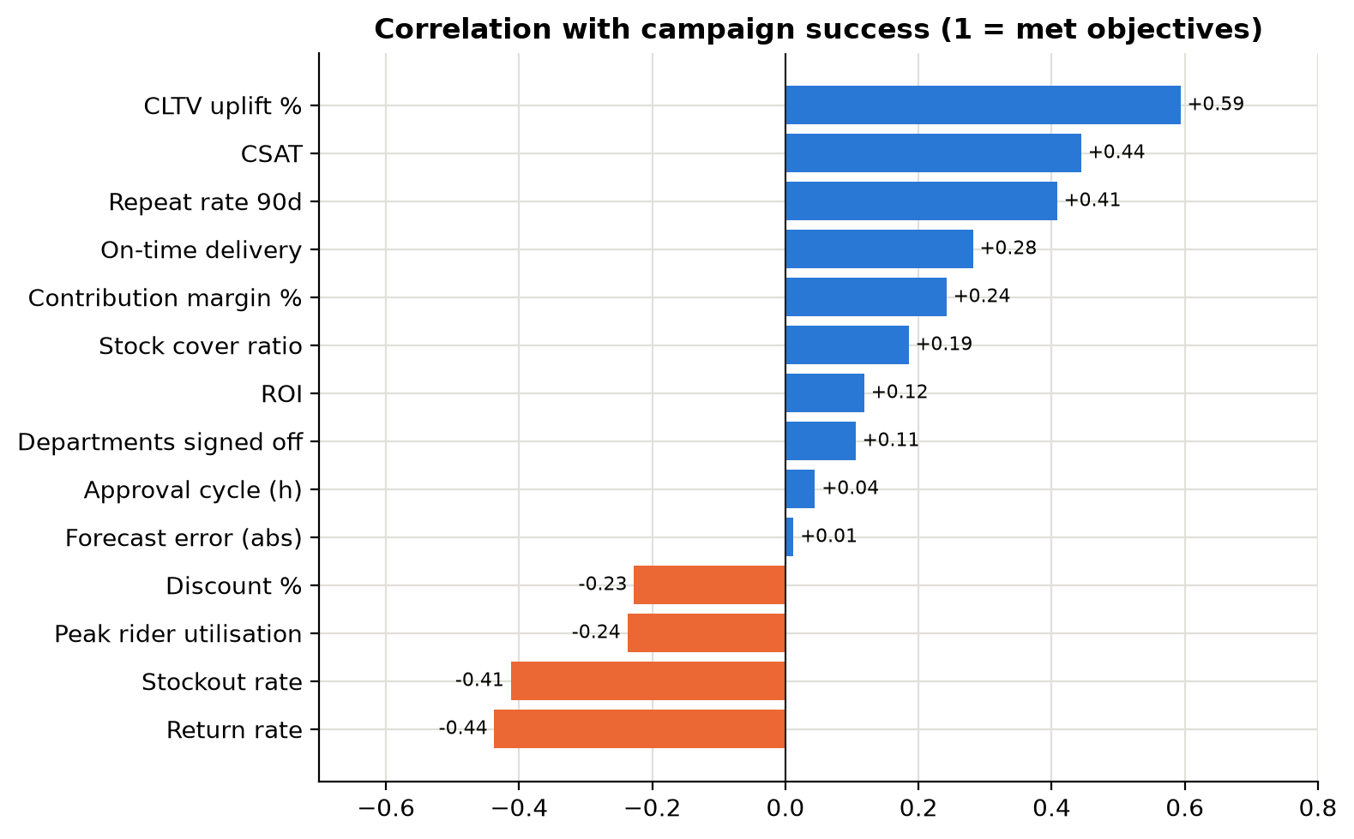
Figure 8. What correlates with success
What it shows: Correlation of each variable with campaign success (point-biserial correlation with the 1/0 success flag).
Insight: Most positive: CLTV uplift % (+0.59) and CSAT (+0.44). Most negative: Return rate (-0.44) and Stockout rate (-0.41).
Business implication: Outcome variables (CLTV, repeat rate, CSAT) naturally correlate with success. The decision levers available before launch, namely stock cover, discount depth and rider capacity, are the ones CIAP can act on.

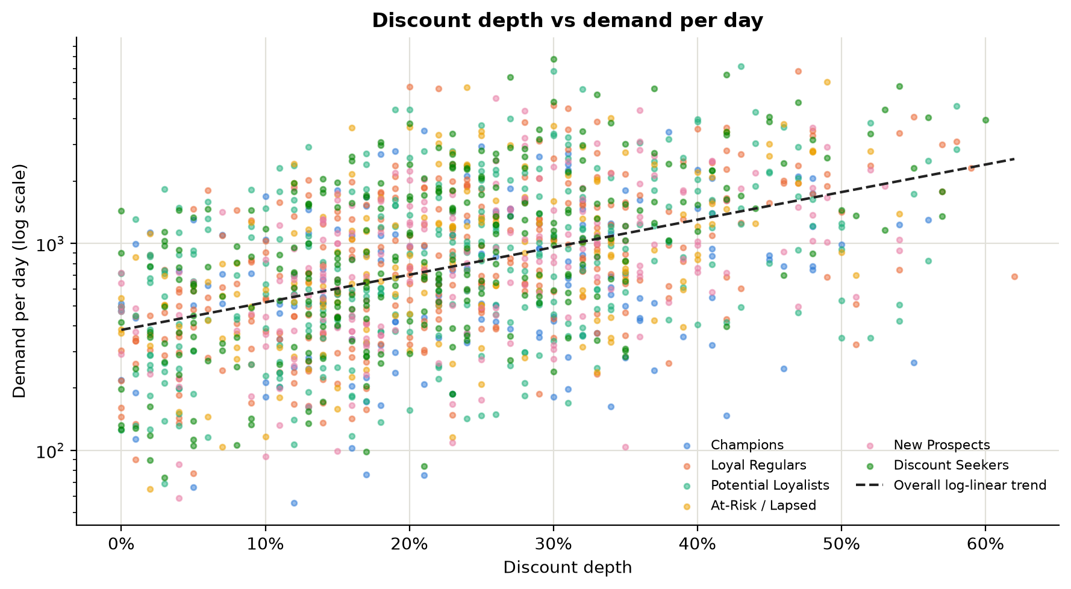
Figure 9. Discount depth vs demand
What it shows: Each dot is a campaign: discount depth against demand per day (log scale), coloured by target segment.
Insight: Deeper discounts lift demand (correlation with log demand +0.46). The response is strongest for Discount Seekers (+0.55) and weakest for Champions (+0.26).
Business implication: A discount is a demand multiplier, so every extra point of discount must be matched by stock and delivery capacity. That is why CIAP tests feasibility against the upper bound of the forecast, not the average.

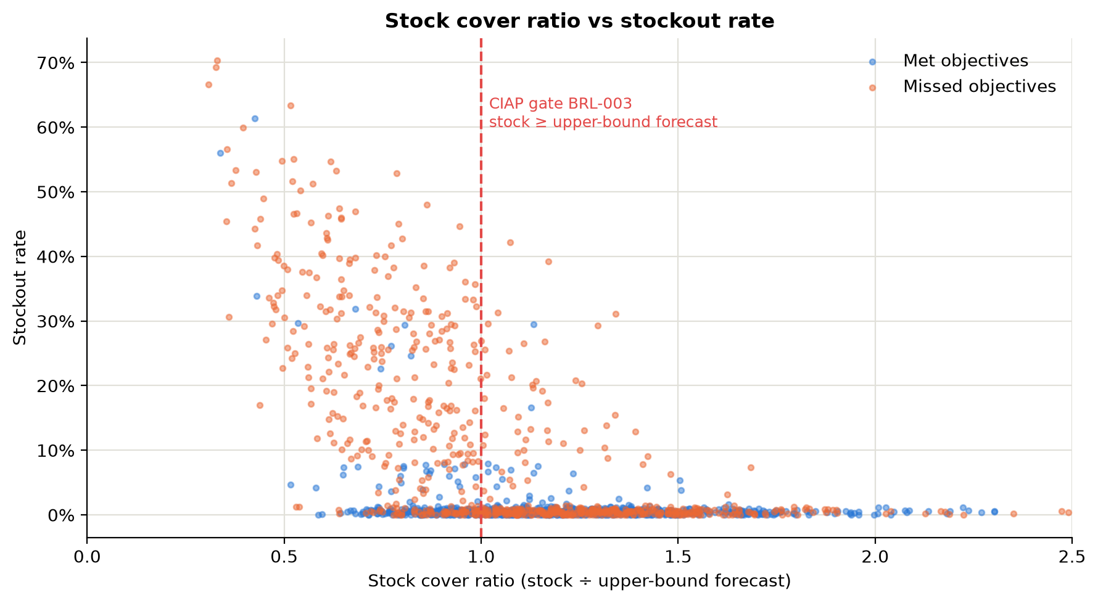
Figure 10. Stock cover vs stockouts
What it shows: Stock available at launch divided by the upper bound of the CIAP demand forecast (x-axis) against the share of campaign days out of stock (y-axis).
Insight: Clear threshold effect (Spearman -0.42). Below a cover ratio of 1.0 the average stockout rate is 13.4%; at 1.0 or above it is 1.4%. 37% of campaigns launched below 1.0.
Business implication: This validates rule BRL-003: requiring stock to cover the forecast upper bound removes most stockouts. The threshold sits at 1.0, as the BRD specifies.

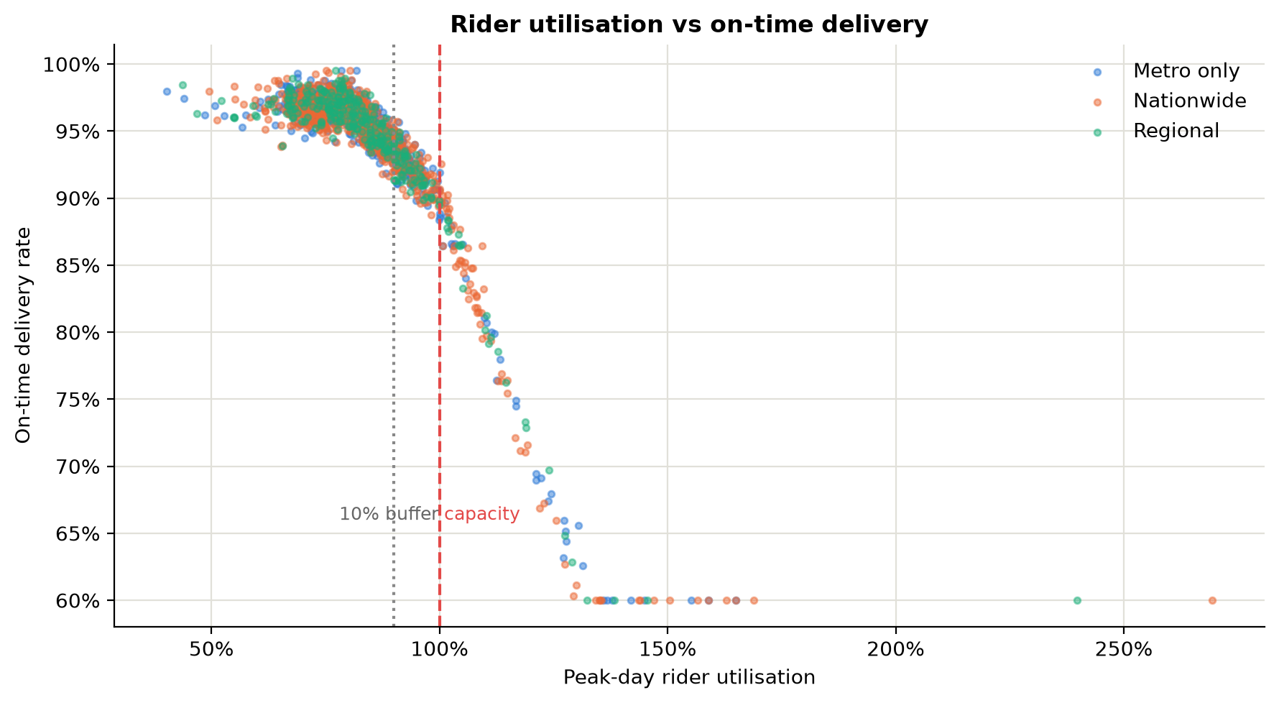
Figure 11. Rider capacity vs on-time delivery
What it shows: Peak-day rider utilisation (orders ÷ rider capacity) against on-time delivery rate.
Insight: Correlation -0.87. Campaigns that stayed under 90% utilisation delivered 96.2% on time; those above 100% only 76.2% (135 campaigns).
Business implication: Delivery performance holds until capacity is exhausted, then falls sharply. This supports BRL-009 (hard gate above 100%, condition inside a 10% buffer) and BRL-010.

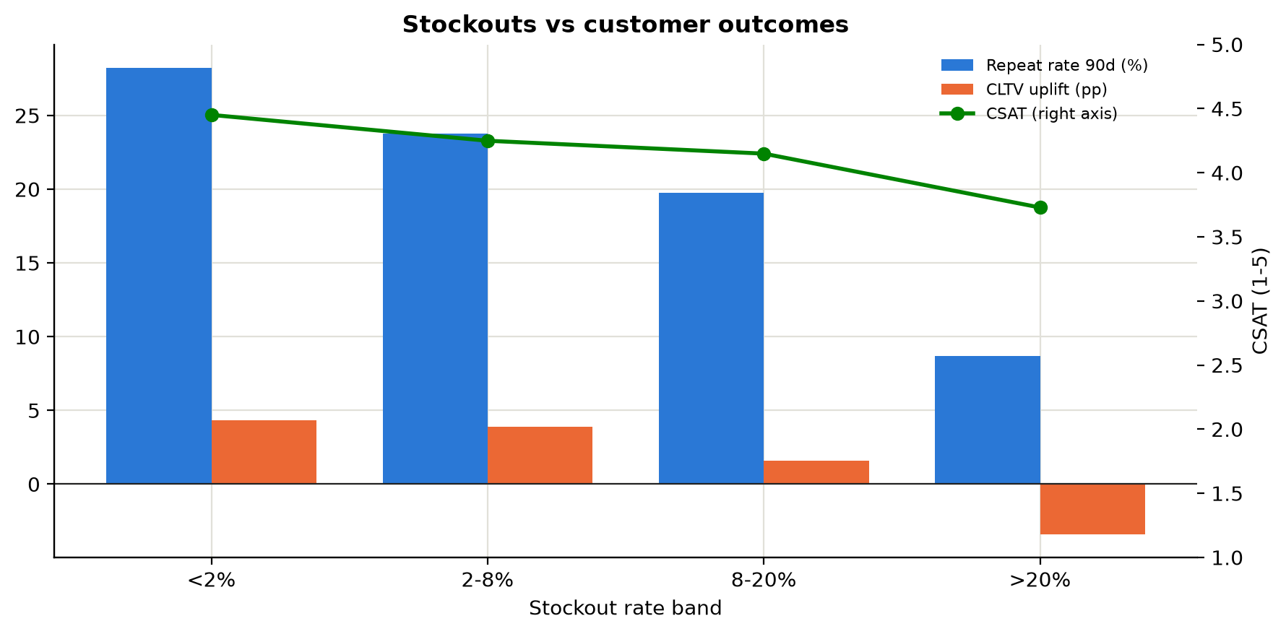
Figure 12. Stockouts vs customer outcomes
What it shows: Average CSAT, 90-day repeat rate and CLTV uplift for campaigns grouped by stockout rate.
Insight: As stockouts rise from <2% to >20%, CSAT falls from 4.45 to 3.73, repeat rate from 28% to 9% and CLTV uplift from +4.3% to -3.4%.
Business implication: A stockout costs twice: the sale today and customer value tomorrow (BRD Section 2). This puts a number on the CLTV argument for blocking infeasible campaigns.

7. Diagnostic analytics (Step 3)
Diagnostic analytics answers "why did it happen?". It breaks failures down by root cause, compares groups, and tests each hypothesis.
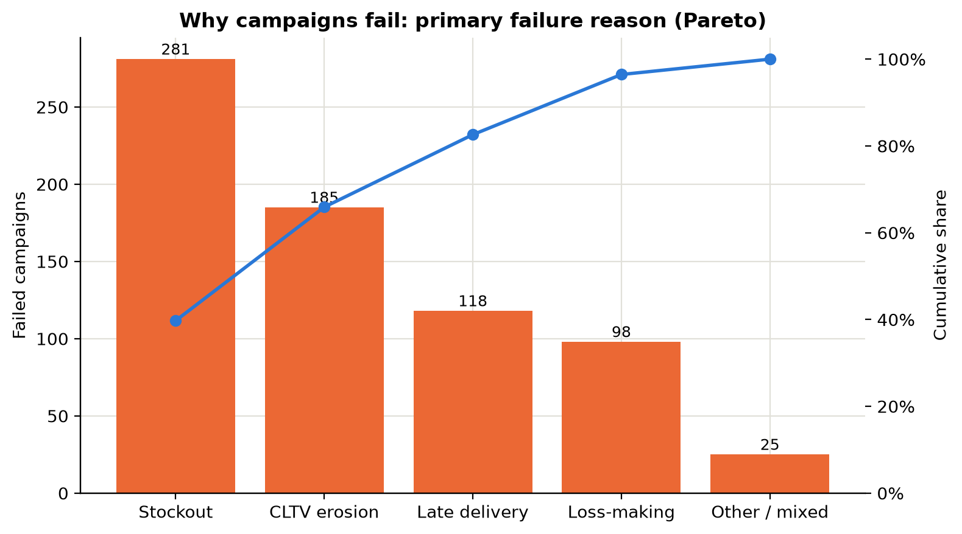
Figure 13. Failure root causes
What it shows: Pareto chart of the primary reason each failed campaign missed its objectives (bars) with the cumulative share (line).
Insight: 707 campaigns failed. Stockout is the biggest cause (40%), and the top two causes explain 66%. Loss-making campaigns lost $7.29M of margin in total.
Business implication: Most failures are operational (stock and delivery), not creative. They can be predicted before launch, which is the core claim of the CIAP strategy.

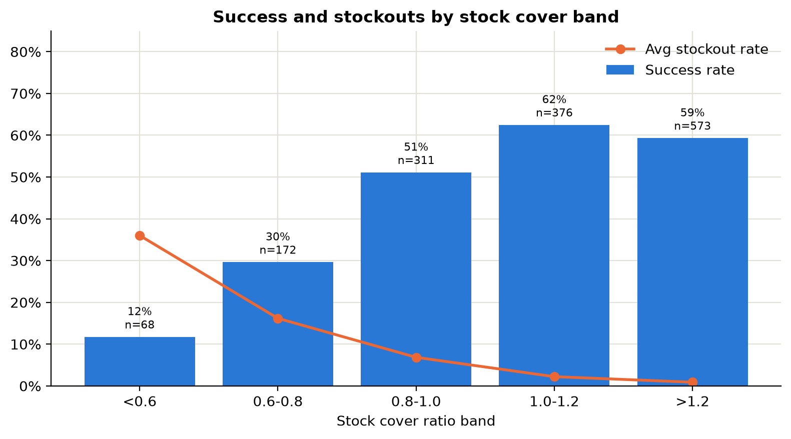
Figure 14. Success by stock cover
What it shows: Success rate and average stockout rate for campaigns grouped by stock cover ratio band.
Insight: Success rate climbs from 12% when stock covers under 60% of upper-bound demand to 62% at 1.0-1.2. Above 1.2 it does not improve further (59%).
Business implication: There is an optimum: enough stock to cover the upper bound, but no more. Extra cover only ties up working capital (BRL-005 / BRL-013).

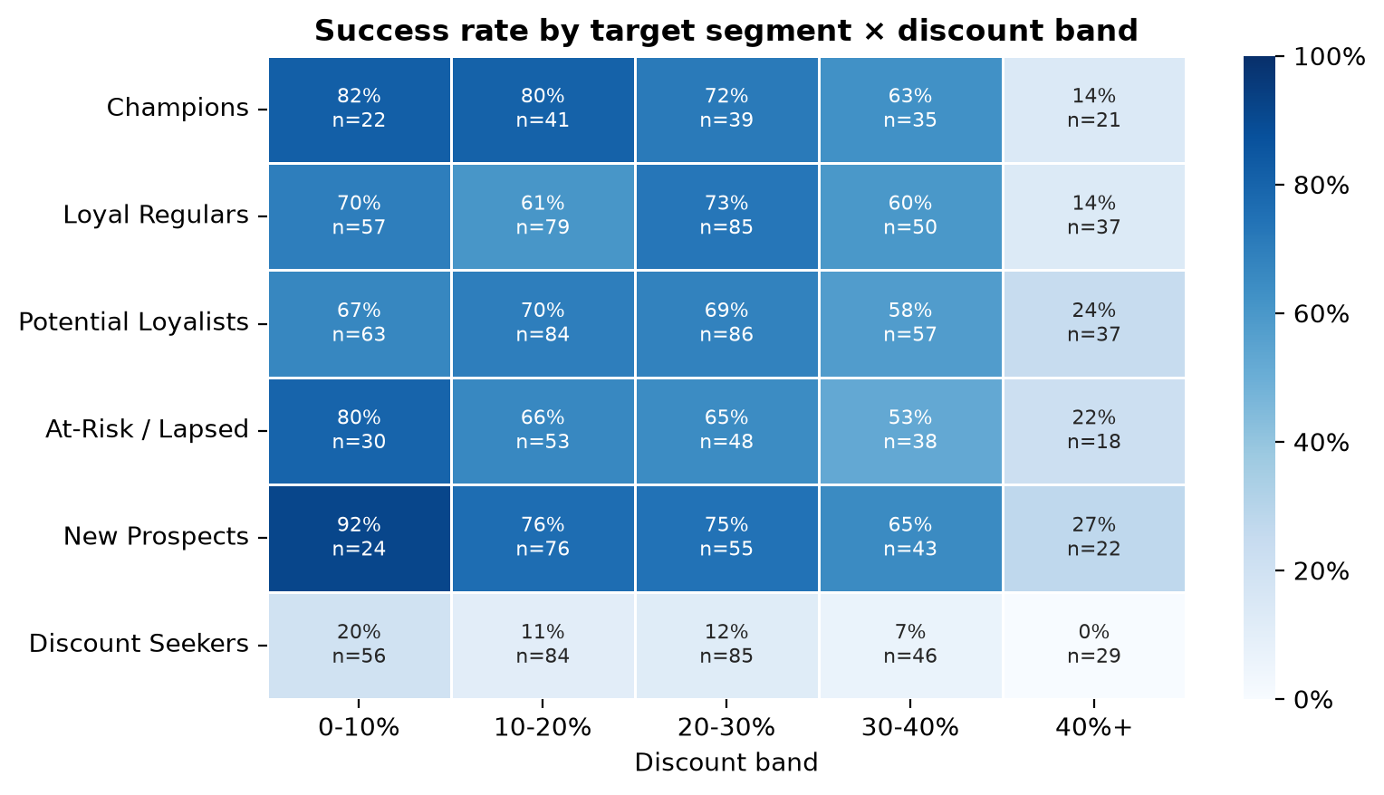
Figure 15. Segment × discount diagnostic
What it shows: Success rate for each combination of target segment (rows) and discount band (columns). Darker = more successful.
Insight: Discount Seekers fail in almost every discount band (overall 11% success, average CLTV uplift -4.2%). For other segments success drops sharply once discounts pass 40%.
Business implication: Targeting matters as much as the offer. Campaigns aimed at Discount Seekers buy short-term volume but erode long-term value (problem PS-05, rule BRL-014).

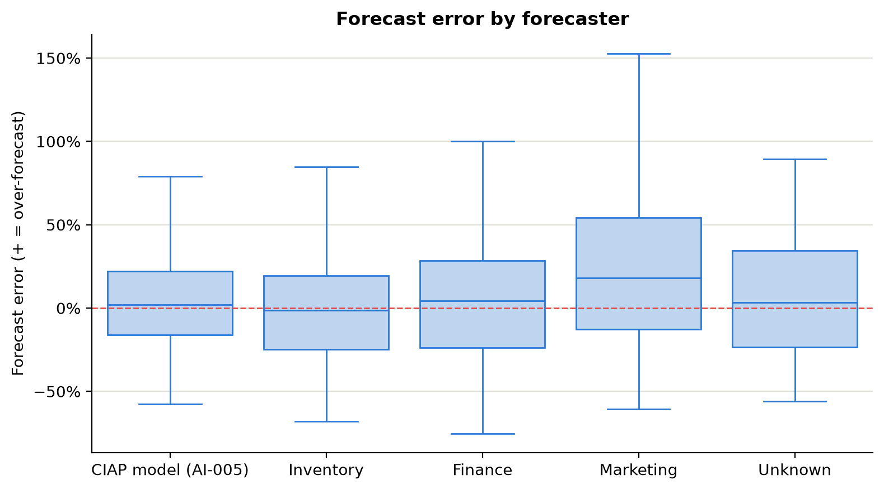
Figure 16. Forecast accuracy by team
What it shows: Forecast error = (forecast − actual demand) ÷ actual demand, by who made the forecast. Above zero = over-forecast.
Insight: Each department forecasts differently (problem PS-02). Marketing over-forecasts by a median 18% (typical error 30%). The back-tested CIAP model has a median bias of 2% and typical error of 19%.
Business implication: One shared, unbiased forecast with a prediction range replaces three conflicting ones (BRD Section 6, future state).

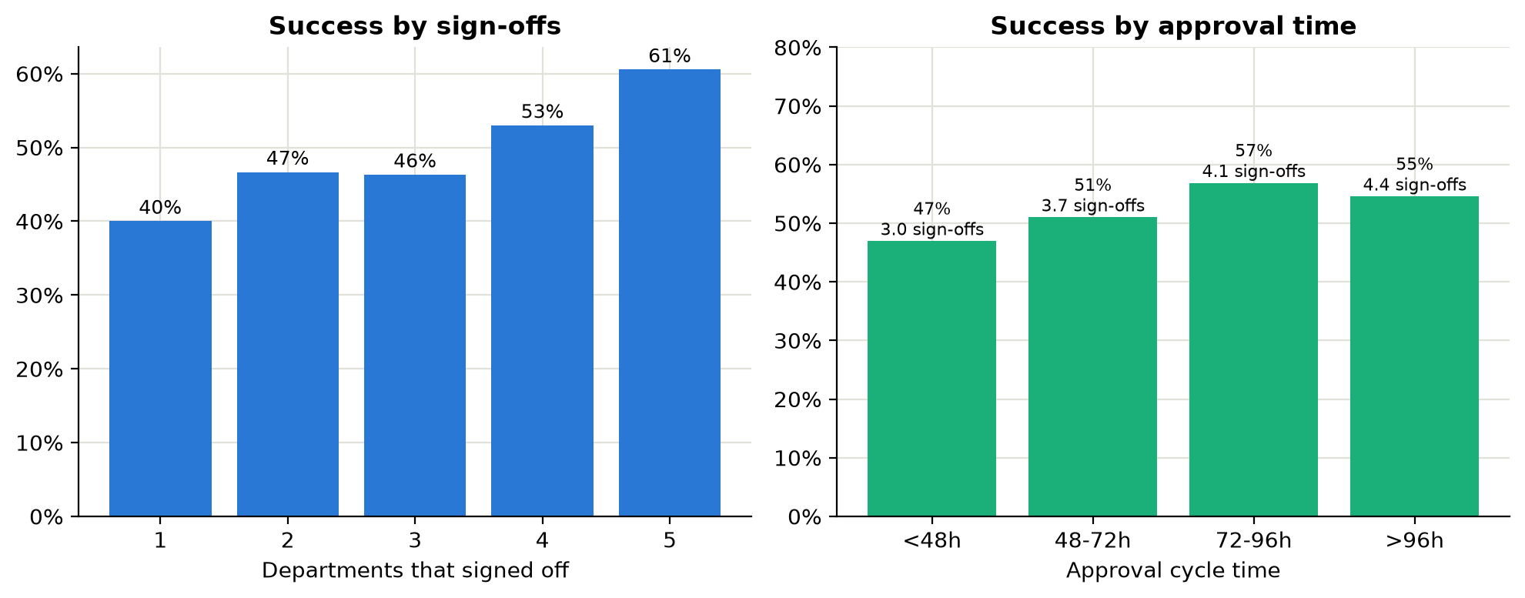
Figure 17. Sign-offs and approval time
What it shows: Left: success rate by how many of the five departments signed off. Right: success rate by approval cycle time, with the average number of sign-offs in each band.
Insight: Campaigns with all 5 sign-offs succeed 61% vs 46% with 3 or fewer. Skipping the Inventory check raises the average stockout rate from 2.8% to 13.8%. Fast approvals are not better approvals: campaigns decided in under 48 h succeed 47% (average 3.0 sign-offs) vs 57% at 72-96 h (4.1 sign-offs), because speed was bought by skipping checks.
Business implication: The manual process forces a choice between fast and thorough. Running all five evaluations in parallel on one data snapshot gives both (FR-014, BR-013).

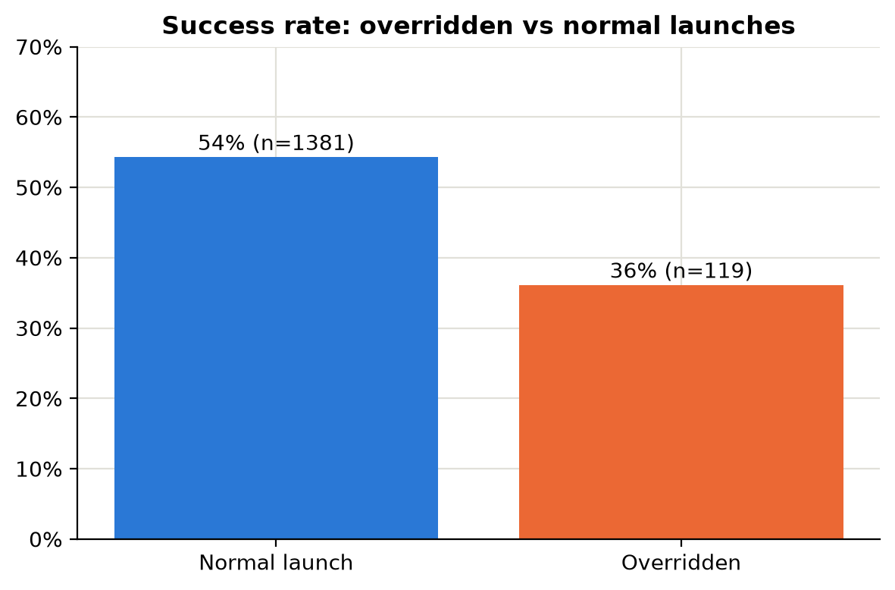
Figure 18. Overrides
What it shows: Campaigns launched despite a department objection (override) compared with normal launches.
Insight: 119 campaigns were overridden. They succeeded 36% of the time vs 54% for the rest. Today nobody records why they were overridden.
Business implication: Overrides should stay possible but be authorised, justified and tracked against outcome (FR-032/033, KPI-21).

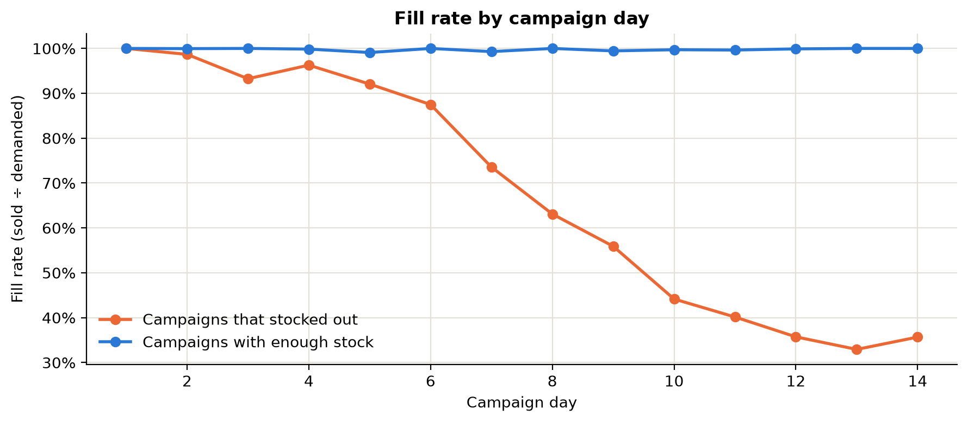
Figure 19. When stock runs out
What it shows: Day-by-day fill rate (units sold ÷ units demanded) for the 250 most recent campaigns, split by whether they stocked out.
Insight: Campaigns that stocked out run out early: half of them were empty by day 10, so most of the campaign ran with no stock while media spend continued.
Business implication: Demand is front-loaded (the BRD example puts 40% of volume in week 1), so the stock check must hold on the peak days, not just in total. CIAP checks SKU x location x day (DATA-003).

8. Customer-level diagnostics
CLTV is the BRD's north-star measure, so the customer table links each campaign's experience to what its customers did over the next 12 months.
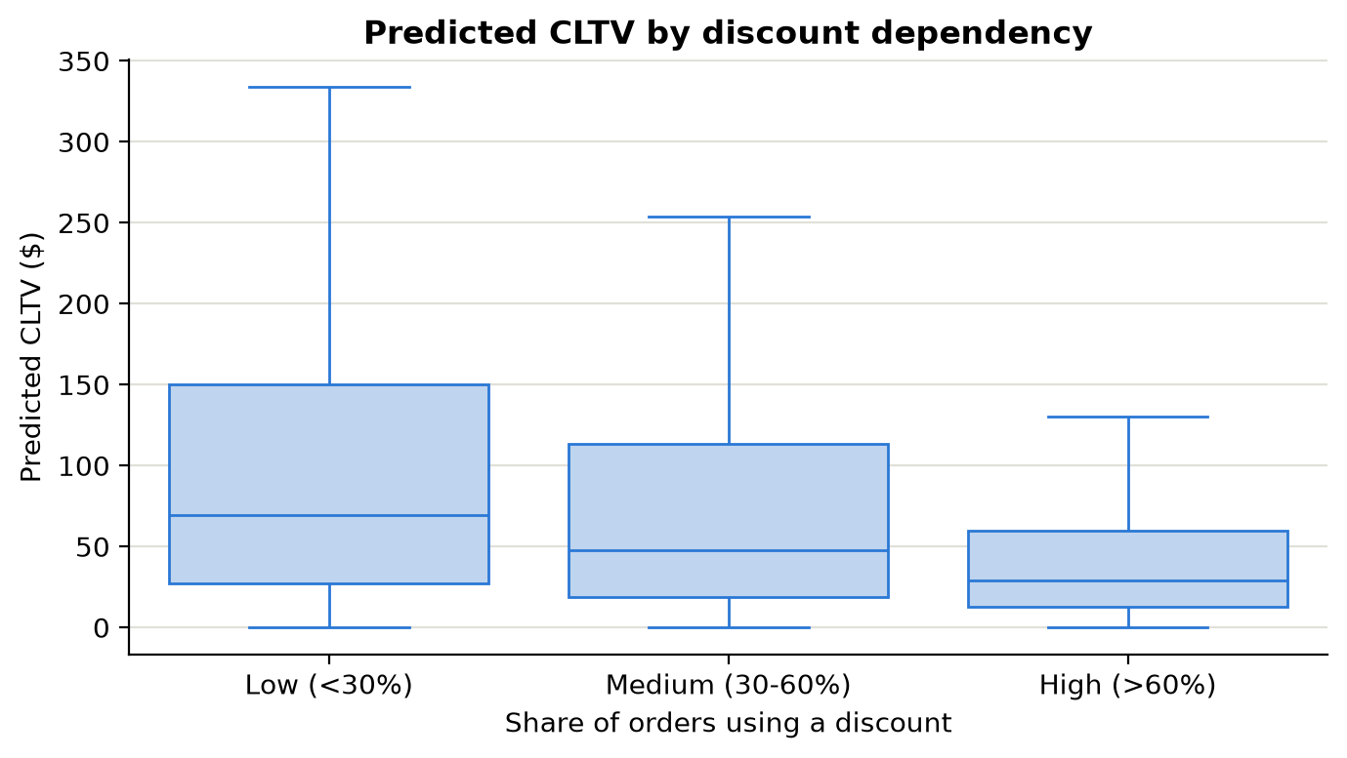
Figure 20. Discount dependency vs CLTV
What it shows: Predicted CLTV of 6,000 campaign-acquired customers, grouped by the share of their orders that used a discount.
Insight: Median CLTV is $69 for low-discount-dependency customers vs $29 for highly dependent ones (2.4x).
Business implication: Customers acquired through heavy discounts are worth much less. CLTV, not campaign revenue, should be the north-star measure (BRD guiding principle).

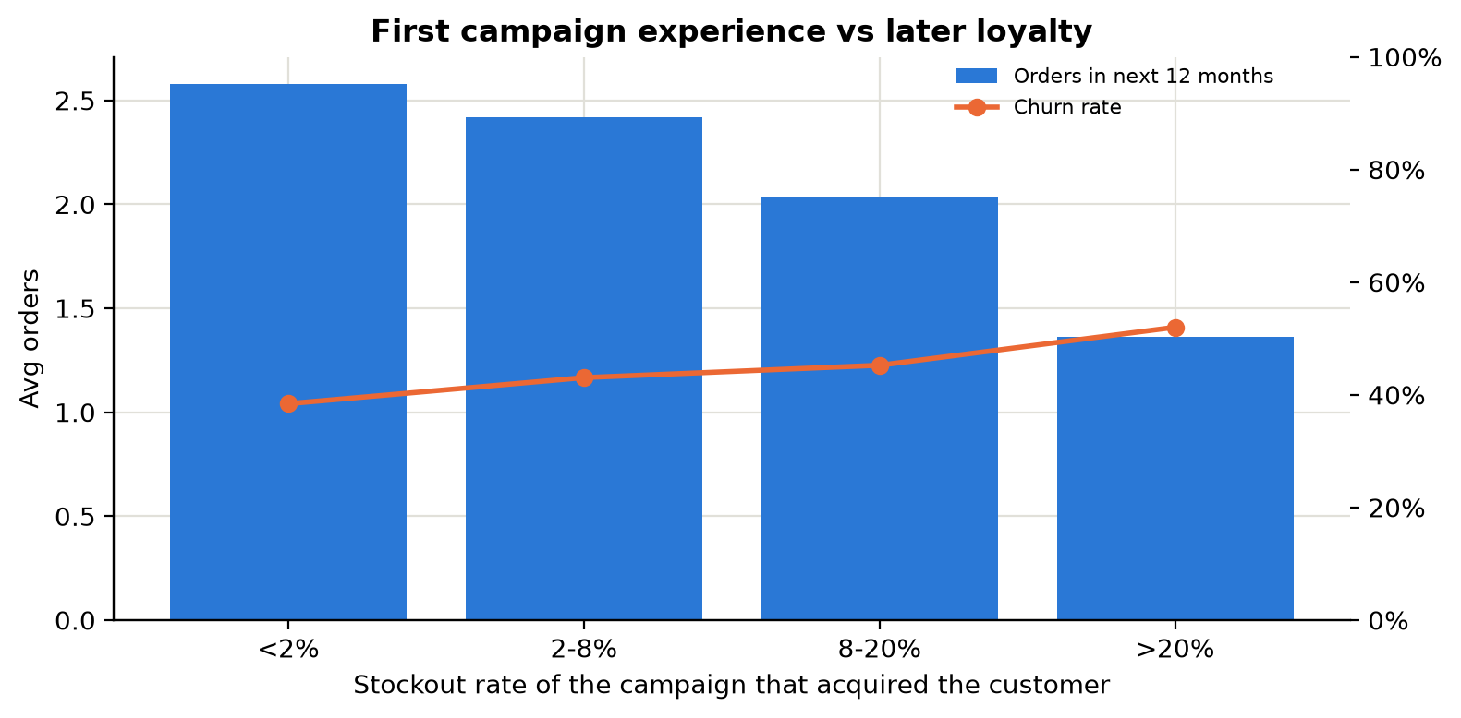
Figure 21. First experience vs loyalty
What it shows: Customers grouped by the stockout rate of the campaign that acquired them: average orders in the next 12 months and churn rate.
Insight: Customers whose first campaign had under 2% stockouts placed 2.6 orders a year; those from campaigns with over 20% stockouts placed 1.4, and churn rose from 38% to 52%.
Business implication: A bad first experience teaches new customers that XYZ promotions are unreliable. Operational feasibility is therefore a customer-value issue, not just an operations issue.

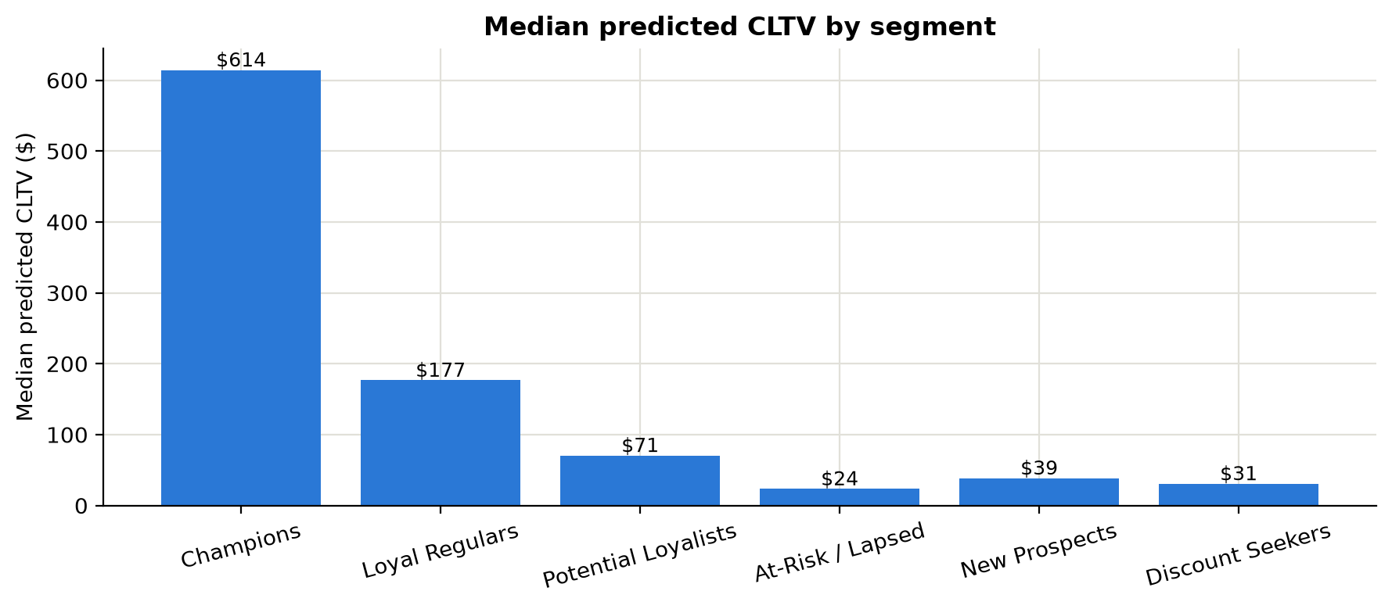
Figure 22. CLTV by segment
What it shows: Median predicted CLTV and average orders per customer by segment.
Insight: Champions are worth $614 each vs $31 for Discount Seekers, who also use discounts on 68% of orders.
Business implication: Budget should shift toward segments with high CLTV and genuine response (Potential Loyalists, At-Risk win-back) and away from discount-only buyers.

9. Validating the strategy: CIAP back-test
To test the strategy, every historical campaign was re-evaluated with the CIAP rules using only information available before launch (CIAP model forecast, stock, rider capacity, budget, price and cost). The verdicts were then compared with what actually happened. The same back-test is built with live formulas in the Excel workbook (sheet CIAP_Gate_Simulation), where the thresholds can be changed.
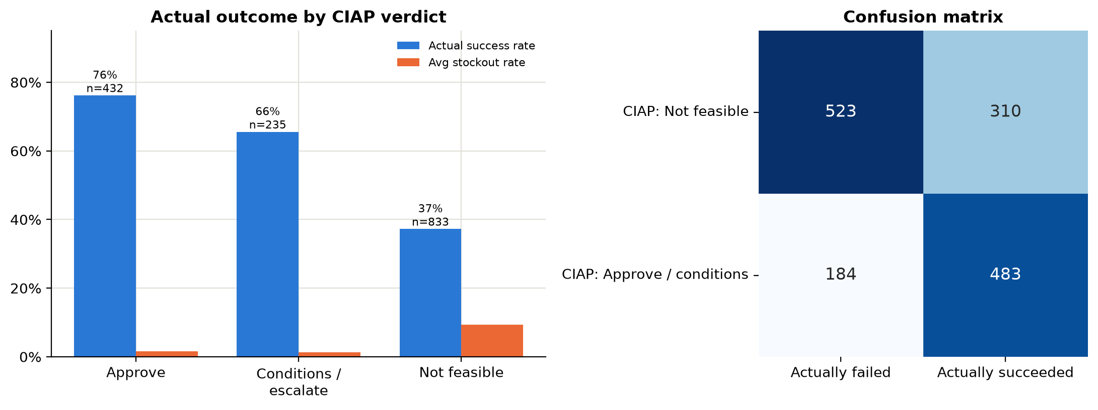
Figure 23. CIAP back-test
What it shows: Back-test: every historical campaign was replayed through the CIAP gates using only information available before launch, then compared with what actually happened.
Insight: Campaigns CIAP would approve succeeded 76% of the time; campaigns it would block succeeded only 37%. Of the campaigns that failed, CIAP would have caught 74% before launch (recall), and 63% of its blocks were correct (precision). Blocked campaigns included $12.01M of losses.
Business implication: This is the key validation of the strategy: the gates separate good from bad campaigns using pre-launch data only. Blocked campaigns are not simply rejected; CIAP proposes feasible alternatives (FR-020), so good ideas can still be recovered.

Table 10. Back-test results by verdict
CIAP verdict | Campaigns | Success rate | Avg stockout | Avg on-time | Total CM | Avg CLTV uplift (pp)
Approve | 432 | 76% | 1.5% | 96.2% | $80.53M | +4.9
Approve with conditions / escalate | 235 | 66% | 1.3% | 94.6% | $31.68M | +4.3
Not feasible | 833 | 37% | 9.3% | 92.4% | $105.85M | +1.9

Reading the confusion matrix: of 707 campaigns that failed, CIAP would have blocked 523 (recall 74%). Of the 833 campaigns it would block, 523 really failed (precision 63%). The 310 "false alarms" are campaigns that succeeded despite thin stock or capacity, often by luck. In CIAP they would not be rejected outright: the platform generates feasible alternatives (lower discount, unit cap, later start after replenishment, narrower region), so most of their value can be kept with less risk.

9.1 Hypothesis verdicts
Table 11. Hypothesis testing summary
# | Verdict | Evidence
H1 | Supported | Stockout rate 13.4% below cover 1.0 vs 1.4% above; success 12% (<0.6) to 62% (1.0-1.2)
H2 | Supported | On-time 96.2% at ≤90% utilisation vs 76.2% above 100%; on-time ↔ CSAT r = +0.71
H3 | Supported | Marketing median bias 18%; model 2%; typical error 30% vs 19%
H4 | Supported | Success 61% with 5 sign-offs vs 46% with ≤3; stockouts 13.8% without Inventory sign-off vs 2.8%; overrides succeed 36% vs 54%
H5 | Supported | Discount Seekers success 11%, CLTV uplift -4.2pp; high-dependency customers' CLTV 0.6x lower
H6 | Supported | Success 76% (approve) vs 37% (blocked); recall 74%, precision 63%

10. Business strategy and recommendations
The analysis supports the CIAP strategy and shows where to focus first. Recommendations are ordered by impact.
- Make stock cover a hard launch gate (BRL-003). Stockouts are the biggest failure cause and 37% of campaigns launched under-stocked. Require stock + confirmed inbound to cover the upper bound of forecast demand on peak days, not just in total.
- Use one forecast with a prediction range (AI-005). Replace three biased departmental forecasts with one model that all teams use. Test capacity against the upper bound so gates hold if the campaign outperforms.
- Gate delivery capacity with a buffer (BRL-009/010). Commit extra 3PL riders or narrow the region when peak utilisation would exceed 90%. On-time delivery collapses above 100%.
- Target for CLTV, not volume (BRL-014/015). Cap discounts by category, escalate anything above the ceiling, and move budget from Discount Seekers to Potential Loyalists and At-Risk win-back, where campaigns add long-term value.
- Evaluate in parallel and automate the routine. Run all five departmental checks at once on one data snapshot, so speed no longer requires skipping checks. Auto-approve only the low-risk tier, after a shadow-mode period proves agreement with human decisions.
- Turn "no" into "yes, if". When a campaign fails a gate, offer ranked feasible alternatives (unit cap, lower discount, staggered launch, start after replenishment) instead of a flat rejection.
- Make overrides accountable. Allow hard-gate overrides only by the CEO/CFO with a reason code and written justification, and report their outcomes against the system's prediction.
- Close the learning loop. Feed every campaign's actual results back into the models. The flat success-rate trend shows the current process does not learn.

10.1 Expected impact
If the gates had been in place and blocked campaigns had been redesigned to perform like approved ones, the success rate would move toward the 76% seen in approved campaigns, from 53% today. This is an upper estimate, because some redesigned campaigns would still fail. At minimum, the $12.01M of losses in blocked campaigns, and the customer value lost through stockouts, would be avoided. Baselines and targets for these KPIs should be agreed with XYZ in Phase 0 (BRD Section 13).
The companion CIAP prototype dashboard (the BRD-based web app) shows how these rules, approval tiers, alternatives and in-flight monitoring would work in practice. This report provides the evidence base for it.

11. Limitations and next steps
- Synthetic data. The data is simulated from assumptions in the BRD. The relationships found are therefore partly built in, and the exact numbers must be re-estimated on XYZ's real data in Phase 0.
- Correlation vs causation. Correlation shows association, not cause. Here the causal structure is known because we simulated it, but on real data a controlled test (holdout groups, FR-029) is needed.
- Back-test scope. The back-test is retrospective and does not model the alternatives CIAP would have proposed. A shadow-mode pilot is the proper validation.
- Success definition. Success is a single rule-based label. A weighted score or separate KPIs might suit some campaign objectives better.
- Next steps. Next steps: predictive models (classification of success, demand forecasting), prescriptive optimisation of discount and stock, and the group presentation.

Appendix A. Rationale for every technique
Table 12. Techniques and rationale
Technique | Stage | Why it was used on this dataset
Synthetic data with a causal model | Generation | No linked historical data exists; encoding BRD cause-and-effect makes the data realistic and the strategy testable
Injected data-quality issues | Generation | Mirrors real departmental exports and allows a meaningful cleaning exercise
De-duplication, label standardisation, type conversion, date parsing | Cleaning | Prevents double counting and split categories; numbers must be numeric to analyse
IQR outlier rule (3×IQR) | Cleaning | Distribution-free way to separate typing errors from genuine large campaigns
Group-median imputation | Cleaning | Robust to skew and preserves differences between groups
Exact recovery from stock movement | Cleaning | Uses an accounting identity instead of estimating
Feature engineering (ratios, bands, flags) | Transformation | Turns raw fields into business measures and rule tests (e.g. stock cover = gate BRL-003)
Summary statistics and skewness | Descriptive | Shows centre, spread and shape; skew tells us to prefer medians
Histograms and box plots | Descriptive | Show distribution and spread by group (ROI, discount depth, cycle time)
Time-series trend (quarterly) | Descriptive | Tests whether the process improves over time (PS-06)
Pearson and Spearman correlation matrix | Correlation | Pearson for linear links; Spearman for skewed and threshold relationships
Point-biserial correlation with success | Correlation | Ranks the drivers of a binary outcome
Scatter plots with threshold lines | Correlation | Reveal non-linear cliff edges (stock cover 1.0, utilisation 100%) that justify gate thresholds
Pareto analysis | Diagnostic | Shows which few causes explain most failures (focus)
Group comparison / binning | Diagnostic | Success by stock band, sign-offs, cycle time and overrides isolates each factor
Cross-tab heatmap (segment × discount) | Diagnostic | Finds interaction effects that one-way charts miss
Forecast error analysis (bias, median absolute error, WAPE) | Diagnostic | Quantifies the cost of departmental silos (PS-02)
Back-test and confusion matrix (precision / recall) | Validation | Measures how well pre-launch rules predict real failure: the core test of the strategy
Excel formulas (COUNTIFS, AVERAGEIFS, CORREL, IF gates) | Validation | Independent, transparent re-computation; thresholds as editable inputs for what-if
Interactive Streamlit dashboard | Communication | Lets the user filter and explore; explanations update with the data

Appendix B. Files submitted and how to run them
Live dashboard: https://ciap-campaign-analytics.streamlit.app (Streamlit Community Cloud; if it has gone to sleep, click the wake-up button and wait about 30 seconds).
Source code: https://github.com/jagjampiaaditya-byte/ciap-campaign-analytics
Table 13. Submitted files
File | Purpose
01_generate_synthetic_data.py | Creates the three raw CSVs in data/raw (seed 42)
02_clean_transform.py | Cleans and transforms → data/clean, outputs/cleaning_log.csv, outputs/data_quality_summary.csv
analysis.py | Shared analysis functions: every chart's data and explanation
app.py | Streamlit dashboard (8 tabs, sidebar filters): streamlit run app.py
03_eda_figures.py | Static report figures → outputs/figures
04_build_excel.py | Excel workbook with live formulas → outputs/CIAP_Calculations.xlsx
05_build_report.py | This report → outputs/CIAP_Analytics_Report.docx
requirements.txt / README.md | Library list and run instructions
LIVE_DASHBOARD.txt / Open Live Dashboard.url | Link to the deployed dashboard (double-click the .url file to open it)

Run order: pip install -r requirements.txt → python 01_generate_synthetic_data.py → python 02_clean_transform.py → streamlit run app.py (dashboard) → python 03_eda_figures.py → python 04_build_excel.py → python 05_build_report.py

