Phase-1 E2E Retest (Commands + Sequence + Results)
Below is a Phase-1 complete pack (fully local, no leakage) matching your current structure (02-Inputs, 01-Scripts, 03-Modules, 05-Outputs, config.json).

1) Simple text-based architecture diagram
Stakeholders (CSV/XLSX/TXT)
|
02-Inputs/ (local only)
|
Step1-AutoFix.ps1 ---> calls python auto_fixer.py (deterministic)
| |
|
autofix-audit/*.json (every change logged)
cleaned-data.csv (single cleaned artifact)
|
Step2-Validate.ps1 ---> basic validation (deterministic, fail-fast)
|
05-Outputs/Output_<timestamp>/
- cleaned-data.csv
- step1_autofix.log
- step2_validate.log
- autofix-audit/*.json

2) Clean module/folder structure
LocalAIAgent-Phase1/
├─ 01-Scripts/
│ ├─ RUN-ALL.ps1
│ ├─ Step1-AutoFix.ps1
│ ├─ Step2-Validate.ps1
│ └─ Common-Functions.ps1
├─ 02-Inputs/ # stakeholders drop files here
├─ 02-Schema/ # schema + rules (JSON/YAML)
├─ 03-Config/ # optional configs (if you split later)
├─ 03-Modules/ # python modules used by scripts
│ └─ auto_fixer.py # deterministic cleaning (example)
├─ 04-Source/ # optional future code
├─ 05-Outputs/
│ └─ Output_YYYYMMDD_HHMMSS/
│ ├─ cleaned-data.csv
│ ├─ step1_autofix.log
│ ├─ step2_validate.log
│ └─ autofix-audit/
│ └─ autofix-audit-*.json
├─ 06-Documentation/
├─ .venv311/
└─ config.json

Step 1 — Open PowerShell and go to the project root

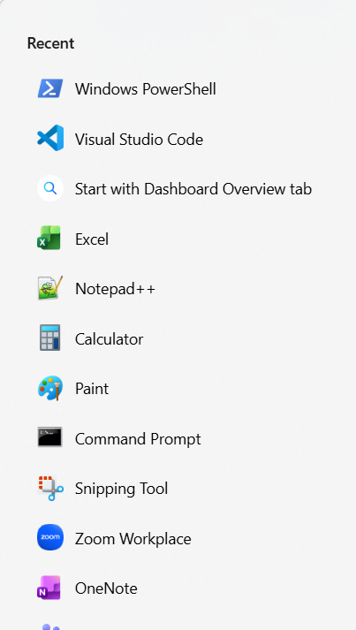
cd "C:\MyCode\cx-ai-local\LocalAIAgent-Phase1"
Expected result:
C:\MyCode\cx-ai-local\LocalAIAgent-Phase1

Step 2 — Activate the local Python environment
.\.venv311\Scripts\Activate.ps1

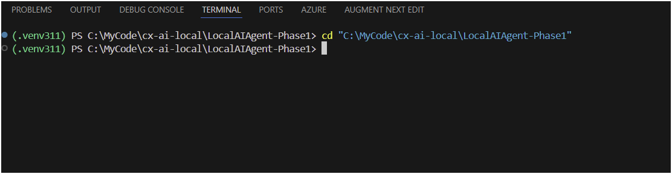
Expected result: prompt shows (.venv311)

Step 3 — Put new file(s) into input folder and confirm they exist
Copy/Drop your new CSV/XLSX into:
C:\MyCode\cx-ai-local\LocalAIAgent-Phase1\02-Inputs
Then check:
dir ".\02-Inputs"
Expected result: you see your file(s), e.g. myfile.csv
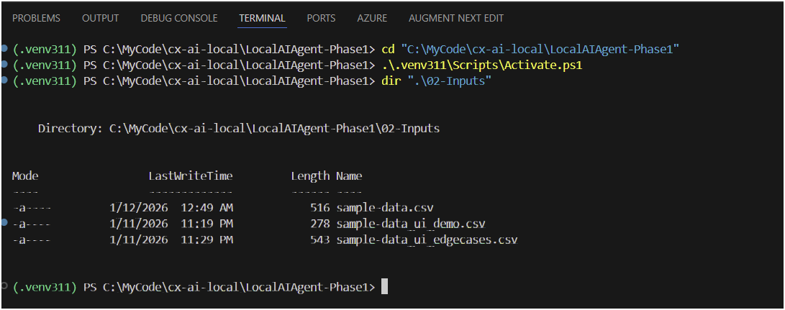

Option A (Recommended): One-command E2E run

Step 4A — Run the full pipeline (Step1 + Step2)
powershell -ExecutionPolicy Bypass -File ".\01-Scripts\RUN-ALL.ps1"

Expected result (console):
- Shows BASE_PATH
- Shows DATA_PATH (should be ...\02-Inputs)
- Creates a new run folder under 05-Outputs\Output_<timestamp>
- Runs Step1 then Step2
- Ends with completion message (or at least no errors)

Step 5A — Get the latest output folder
$latest = (Get-ChildItem ".\05-Outputs" -Directory |
Where-Object Name -like "Output_*" |
Sort-Object Name -Descending |
Select-Object -First 1).FullName
$latest
Expected result: prints a folder like
...\05-Outputs\Output_YYYYMMDD_HHMMSS

Step 6A — List outputs (must-have artifacts)
dir $latest

Expected result: you must see:
- cleaned-data.csv
- step1_autofix.log
- step2_validate.log
- autofix-audit (folder)

Step 7A — Confirm Step1 ran correctly
Get-Content "$latest\step1_autofix.log" -Tail 50

Expected result includes:
- Step1-AutoFix started
- DataPath: ...\02-Inputs
- Step1-AutoFix completed

Step 8A — Confirm Step2 passed validation
Get-Content "$latest\step2_validate.log" -Tail 120

Expected result includes:
- Found cleaned file: ...\cleaned-data.csv
- Basic validation passed
- Step2-Validate completed
✅ If Step2 passes, Phase-1 retest is successful.

Option B: Manual E2E run (explicit Step1 then Step2)
Use this if you want full control and guaranteed folder naming.

Step 4B — Create a new output folder for this run
$out = Join-Path ".\05-Outputs" ("Output_" + (Get-Date -Format "yyyyMMdd_HHmmss"))
New-Item -ItemType Directory -Path $out | Out-Null
$out
Expected result: prints the new output folder path.

Step 5B — Run Step1 AutoFix
powershell -ExecutionPolicy Bypass -File ".\01-Scripts\Step1-AutoFix.ps1" -OutputDir $out

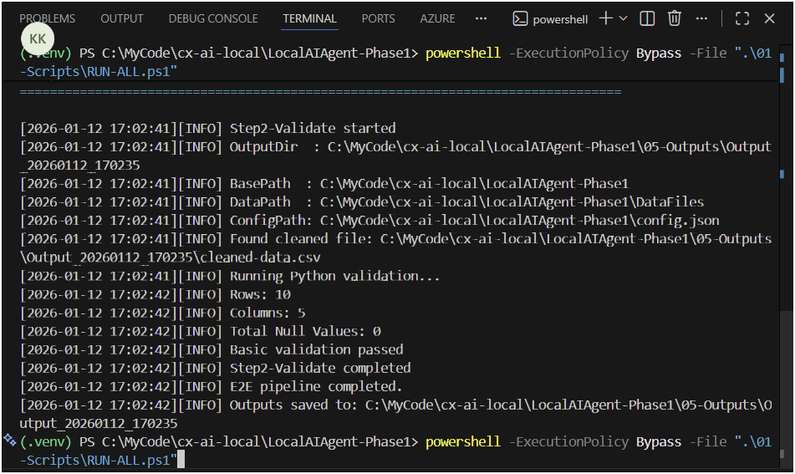

Expected result:
- JSON like "status": "success"
- cleaned-data.csv created
- autofix-audit\*.json created
- step1_autofix.log created
Verify:
dir $out
dir "$out\autofix-audit"

Step 6B — Run Step2 Validate
powershell -ExecutionPolicy Bypass -File ".\01-Scripts\Step2-Validate.ps1" -OutputDir $out

Expected result (console):
- DataPath : ...\02-Inputs
- Found cleaned file: ...\cleaned-data.csv
- Basic validation passed
- Step2-Validate completed
Verify log exists:
Test-Path "$out\step2_validate.log"
Expected: True
Read it:
Get-Content "$out\step2_validate.log" -Tail 120

Phase-1 “PASS” Criteria (final result)
A run is considered successful only if the output folder contains:
dir $latest
Must include:
- ✅ cleaned-data.csv
- ✅ step1_autofix.log
- ✅ step2_validate.log
- ✅ autofix-audit\autofix-audit-*.json

Where the end user finds results
All runs are stored here:
C:\MyCode\cx-ai-local\LocalAIAgent-Phase1\05-Outputs\Output_<timestamp>\

