**Scenario Two – Ecommerce**

Student Name: Jagjeet Singh

Student ID:200530603

1. **Sitemap for Ecommerce**

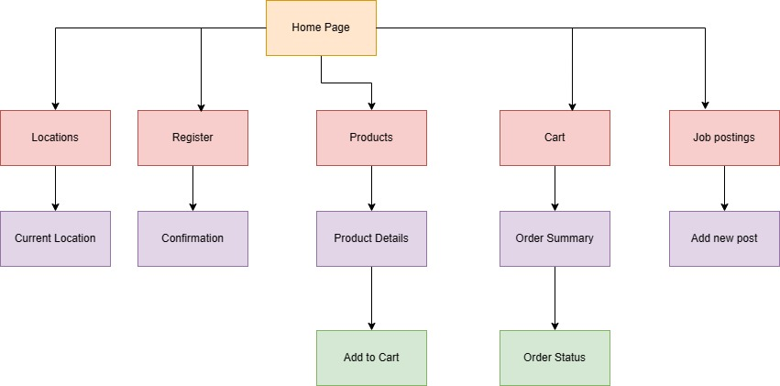

Fig. 1 Sitemap

Fig. 1 shows the sitemap of the e-commerce platform showing four levels of pages. At the top level there is home page. The user when will send the request in initial with the website name will be given index page as home page. From home page the user will be able to get into second level. The second level includes locations, register, products, cart and job postings. The user from second level can go to the third level. At the third level there are current location, registration confirmation screen, product details, order summary, and add new post. At the fourth level there is add to cart and order status.

1. **Wireframe for E-commerce website**

* **Home Page**

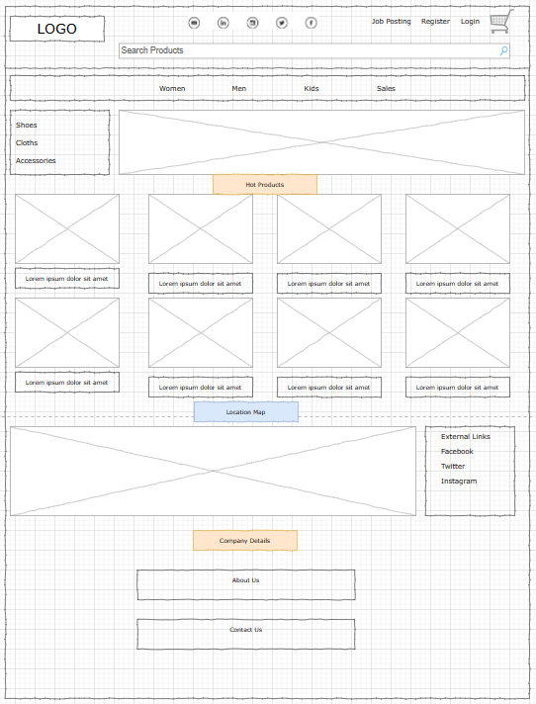

Fig. 2 Wireframe for Home Page

Fig. 2 shows the wireframe of home of E-commerce website. The interface provides the opening of website from which a user can selected a specific option to navigate in other webpages.

* **Register**

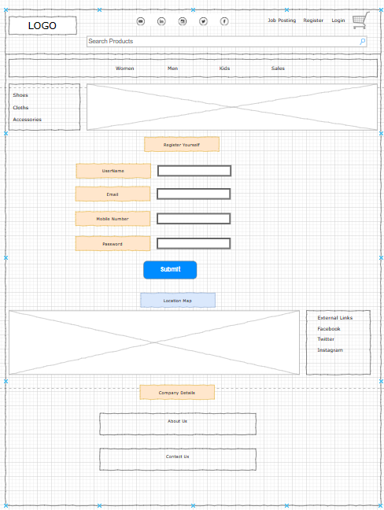

Fig. 3 registration of user

Fig. 3 shows the registration of user with the shopping platform. The users will be able to submit their details so that e-commerce platform can keep the users records in the centralized database.

* **Product Details**

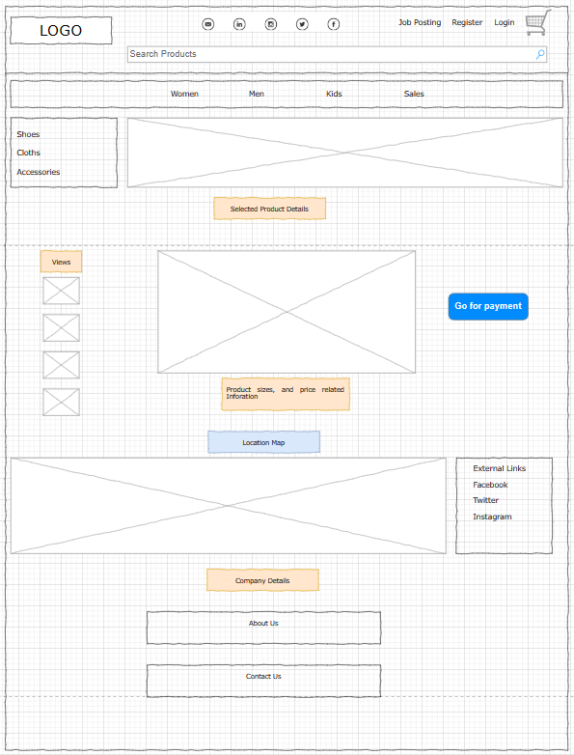

Fig. 4 Product details

Fig. 4 shows the product details of that product which user has selected for shopping.

* **Job posting**

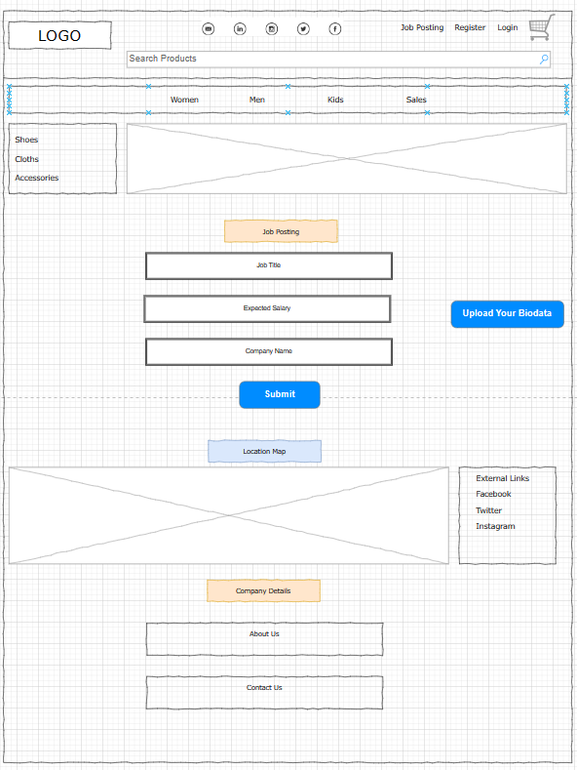

Fig. 5 Job posting

Fig. 5 shows the job posting for the users. The user can file all the job postings that are available at the e-commerce engine. The user in this case will be admin.

* **Order Status**

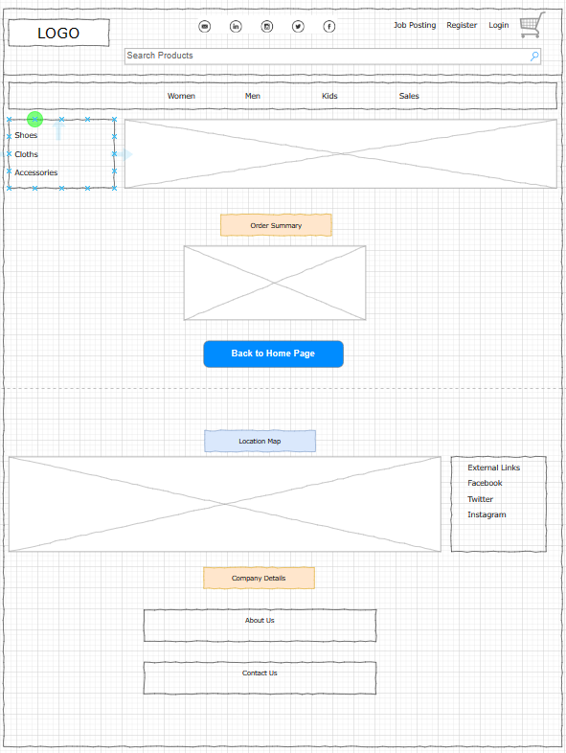

Fig. 6 order summary

Fig. 6 shows the order summary that user has placed. It will show all the products and their related details to the user.

1. **References**

https://www.usability.gov/how-to-and-tools/methods/wireframing.html#:~:text=A%20wireframe%20is%20a%20two,functionalities%20available%2C%20and%20intended%20behaviors.