Project 1 – Remote Control iRobot

Design process was over several labs during the course of the semester in which we built various parts of the final build. (Don’t have final build since was done in lab)

Skills and tools used – C++ , integrated circuits including wifi chips and motor controls, irobot

During the course of CPRE 288 we were tasked with the design of a remote-controlled iRobot. Over the course of the semester we built various parts of the code for controlling this robot. At the end of the year we combined all of the parts previously worked on in an attempt to create a fully functional robot controlled by a user through an interface. At the finish of the course we navigated through an obstacle course to find a point in which the robot was “safe”. This course included cliffs, an outline to stay within and several pillars that were to be avoided.

Project 2 – Teacher Social Hub

During this project we created Use case diagrams, researched non-functional requirements and new technologies. The design process started by researching technology to be used, then we began to study and develop a look for the website we were creating. After the initial sketch we began an iterative process of creating and polishing until we were finished.

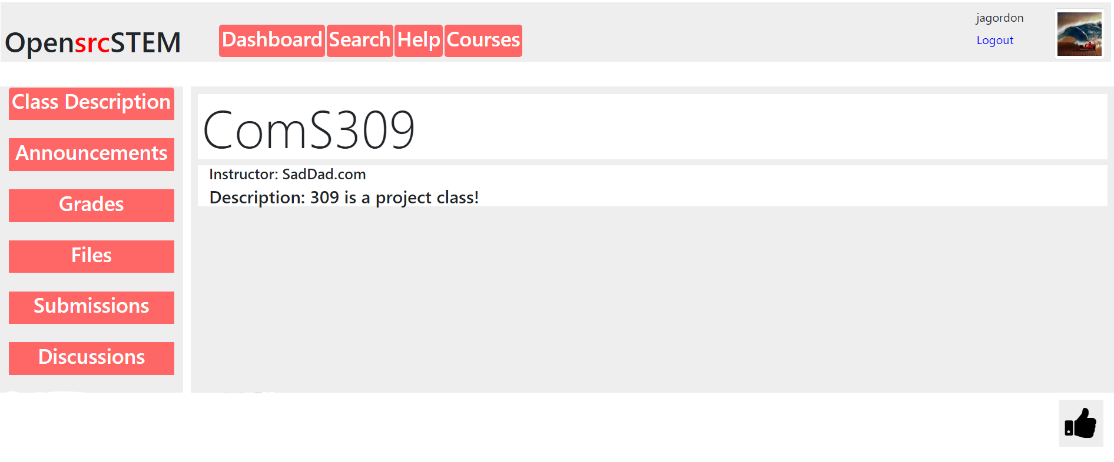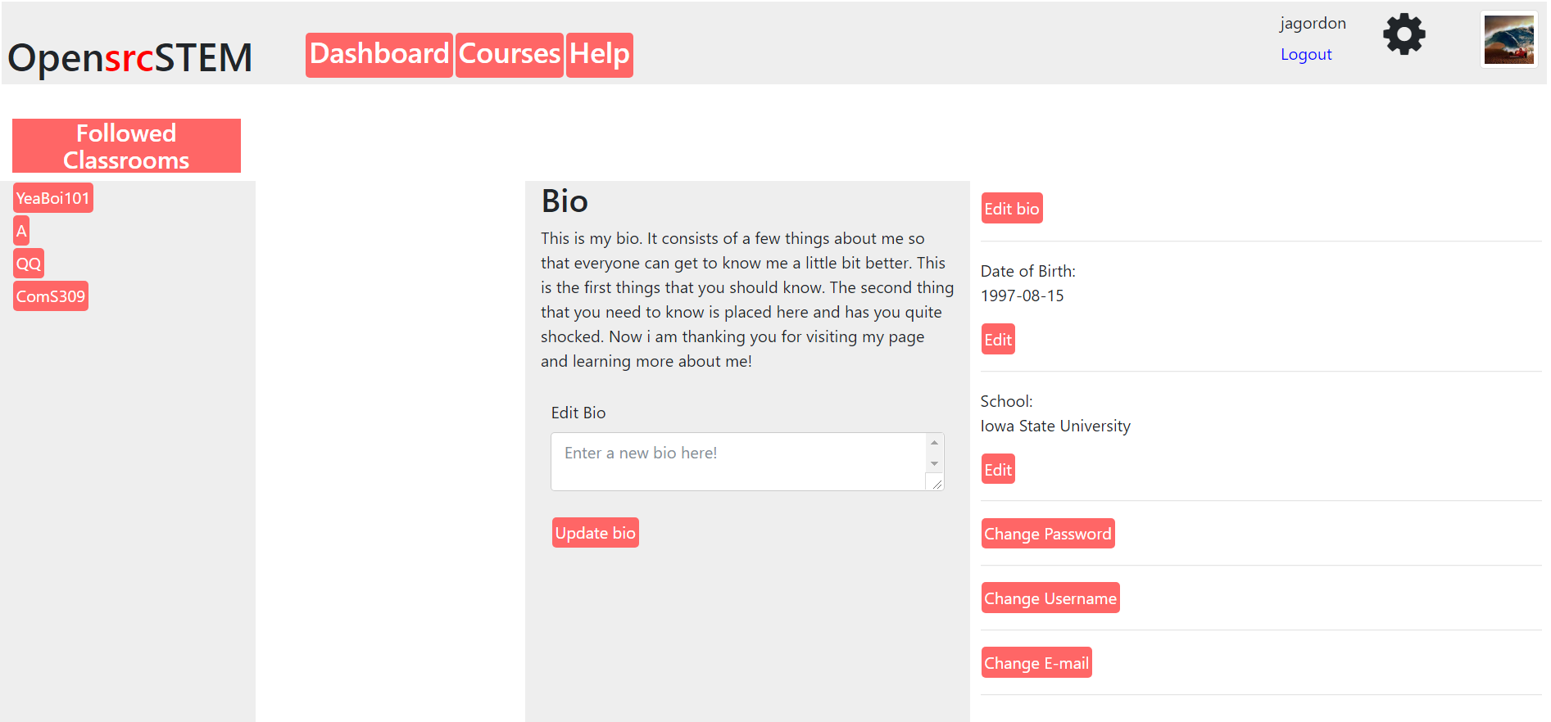

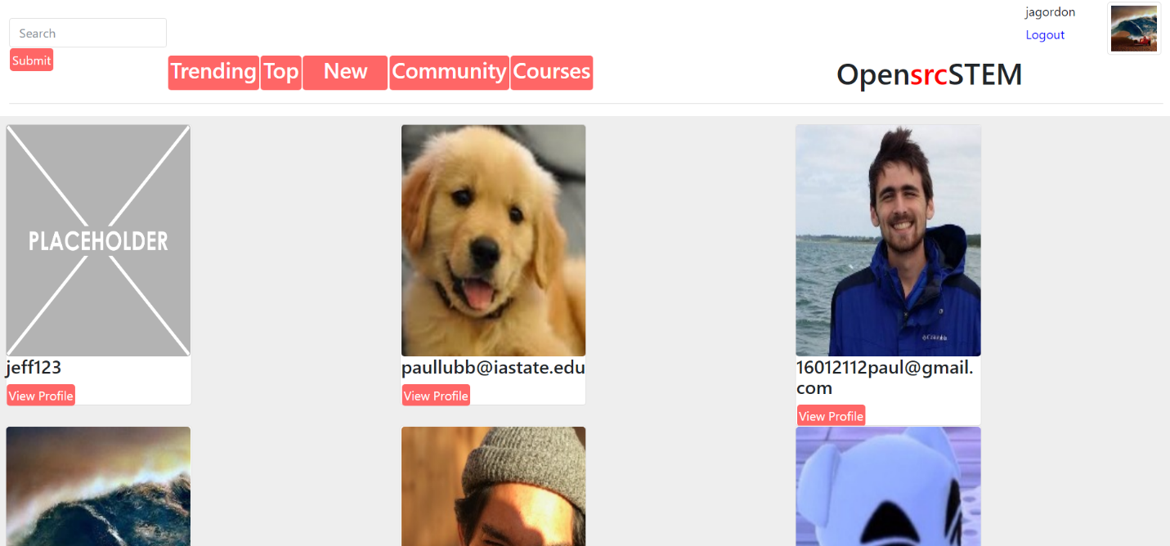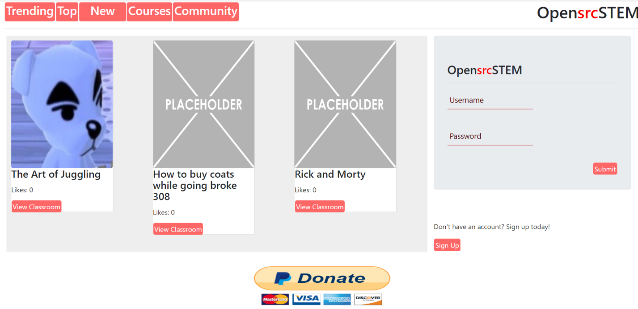

Skills and tools used – Javascript and MEAN stack development techniques

In Computer Science 309 we created an idea for a teachers social hub. This hub would be used for teachers to share course curriculum and give feedback to one another in different aspects. This webpage also included virtual classrooms and a way to follow other teachers or join their classes. We included email verification, profiles, and teacher and student roles for which classroom you were visiting.

Project 3 – Monopoly

During this project we created Use case diagrams, researched non-functional requirements and new technologies. While part of the group worked in backend Java the GUI was created with Java swing and was new to everyone. We started by assigning roles to people and tasks based on those roles. We kept up to date using trello as a tool to keep track of story items and what had to be done vs previous work.

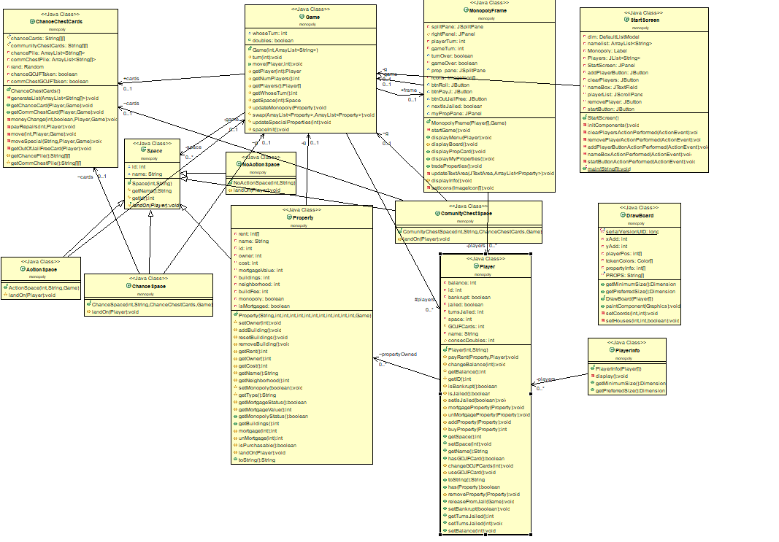

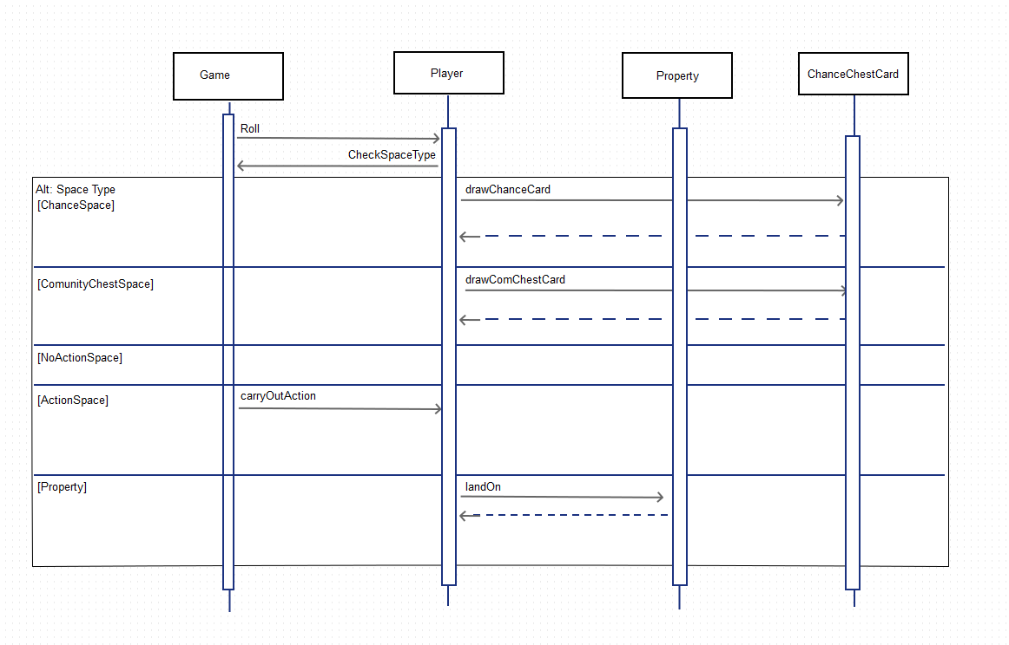

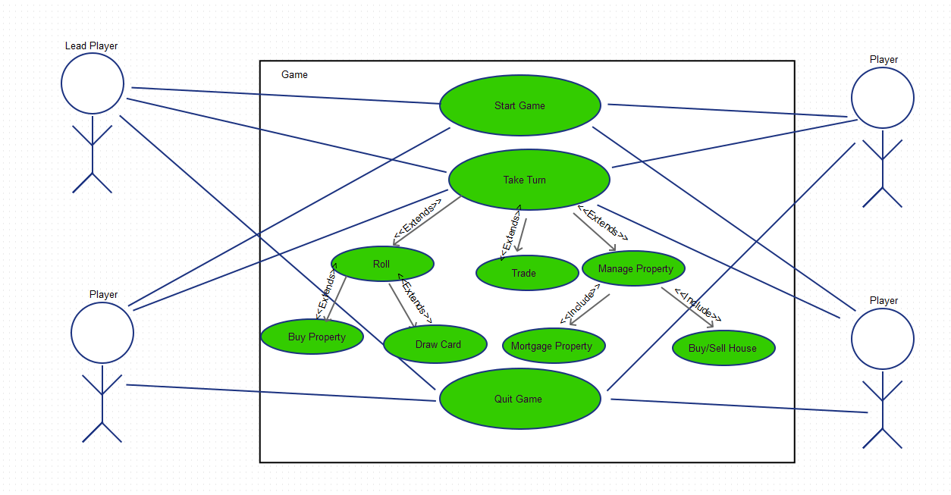

Skills and tools used – Java, java swing, netbeans

This project was developed in Computer Science 319. We were charged with creating one of two projects presented by our groups. We chose monopoly and used java to implement a local monopoly game. Using Java Swing for the GUI was new to us all since none of us worked with a GUI at this point before. We also used several different methods of communication including groupme and trello in order to hold everyone accountable. Working in a larger group helped to simulate an industry project setting where communication is key.