Experiment: 5

Student Name: Jagrath UID:24BDA70365
Branch: CSE Section/Group: AIT-KRG-GP2
Semester: 4th Date of Performance:27/02/2026
Subject Name: DBMS

- Aim of the practical: To understand and apply conditional logic in SQL by using the modulus operator (MOD / %) to analyze numerical data and classify employee salaries as odd or even, thereby improving data analysis and decision-making skills in SQL.

2. Tool Used:

● Database Management System:

○ PostgreSQL

● Database Administration Tool:

○ pgAdmin

- Objective:

To write and execute SQL queries that use the MOD (%) operator to check employee salaries and display odd and even salary values separately from an employee table.

- Practical / Experimental Steps

Step 1: Open Oracle SQL Developer or pgAdmin and connect to the database.

Step 2: Create the Employee table with required attributes.

Step 3: Insert multiple records into the Employee table.

Step 4: Write a SELECT query using CASE statement and MOD (%) operator to classify salaries as odd or even.

Step 5: Execute the query and observe the output.

Step 6: Verify the correctness of results.

- I / O Analysis

DATABASE DESIGN

Query to create Table employee :

CREATE TABLE Employee(

emp_id INT PRIMARY KEY,

name VARCHAR(50) NOT NULL,

Salary INT NOT NULL

);

DATA MANIPULATION

Insert Sample records in the table

INSERT INTO Employee (emp_id, name, Salary) VALUES
(1, 'Amit Sharma', 50000),
(2, 'Priya Verma', 45575),
(3, 'Rahul Mehta', 62000),
(4, 'Sneha Kapoor', 38745),
(5, 'Vikram Singh', 71000),
(6, 'Anjali Desai', 53211),
(7, 'Rohan Gupta', 48000),
(8, 'Neha Reddy', 39999),
(9, 'Karan Malhotra', 84500),
(10, 'Isha Nair', 36781),
(11, 'Arjun Patel', 90000),
(12, 'Meera Joshi', 42133),
(13, 'Siddharth Rao', 76000),
(14, 'Pooja Bansal', 58917),
(15, 'Manish Yadav', 64000);


C) Query to Display Even and Odd Salaries
SELECT emp_id,
name,
salary,
CASE
WHEN MOD(salary, 2) = 0 THEN 'Even Salary'
ELSE 'Odd Salary'
END AS salary_type
FROM Employee;

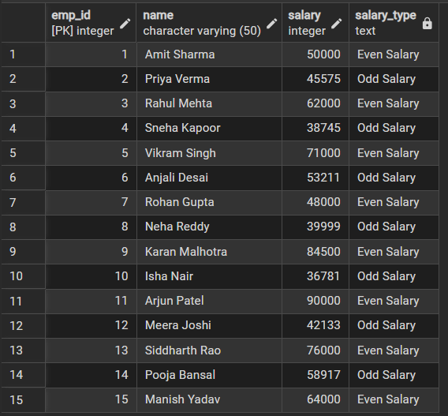

- Learning outcomes (What I have learnt):
• Understood how to create and manage tables in SQL.
• Learned how to insert multiple records into a database table.
• Gained practical knowledge of using the MOD (%) operator for numerical analysis.
• Learned to apply conditional logic using CASE statements in SQL queries.
• Developed the ability to classify and analyze data directly within SQL queries.
• Improved understanding of SQL-based decision-making and data filtering techniques.

