Experiment: 2

Student Name: Jagrath UID:24BDA70365
Branch: CSE Section/Group: AIT-KRG-GP2
Semester: 4th Date of Performance:21/01/26
Subject NameDBMS

- Aim of the practical: To understand and implement SQL SELECT queries using various clauses such as WHERE, ORDER BY, GROUP BY, and HAVING to retrieve and manipulate data efficiently from relational database tables.

2. Tool Used:

● Database Management System:

○ PostgreSQL

● Database Administration Tool:

○ pgAdmin

- Objective:

● To practice writing SQL SELECT statements.

● To apply filtering conditions using the WHERE clause.

● To sort query results using the ORDER BY clause.

● To group records using the GROUP BY clause.

● To filter grouped data using the HAVING clause.

● To analyze data using aggregate functions like COUNT(), SUM(), AVG(), MIN(), and MAX().

- Practical / Experimental Steps

Step 1: Open pgAdmin / SQL shell and connect to the PostgreSQL database.

Step 2: Create the Students table with appropriate columns and data types.

Step 3: Insert sample student records containing id, name, city, and marks.

Step 4: Use the COUNT() function with GROUP BY city to find the number of students in each city.

Step 5: Apply ORDER BY on the aggregated COUNT result to sort cities based on student count.

Step 6: Use the HAVING clause to filter cities having at least a specified number of students.

Step 7: Use the AVG() function with GROUP BY city to calculate the average marks of students in each city.

Step 8: Execute aggregation functions such as SUM(), MIN(), and MAX() to analyze student marks.

Step 9: Verify the output of each query to understand grouping and aggregation behavior in SQL.

- I / O Analysis

DATABASE DESIGN

Query to create Table Students:

CREATE TABLE Students (

id NUMERIC(10,0) PRIMARY KEY,

name VARCHAR(50),

city VARCHAR(30),

marks NUMERIC(10,0)

);

Insert same record into the table

INSERT INTO Students VALUES (1, 'Aman', 'Mohali', 85);

INSERT INTO Students VALUES (2, 'Rohit', 'Mohali', 78);

INSERT INTO Students VALUES (3, 'Neha', 'Mohali', 92);

INSERT INTO Students VALUES (4, 'Simran', 'Amritsar', 88);

INSERT INTO Students VALUES (5, 'Karan', 'Amritsar', 75);

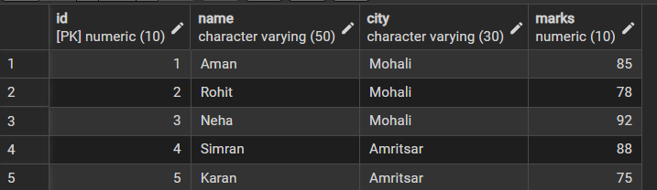

Group By Queries:

SELECT CITY ,COUNT(*) AS COUNT_STUDNETS

FROM STUDENTS

GROUP BY CITY

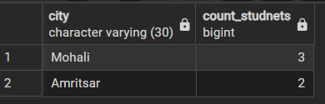

SELECT CITY ,COUNT(ID) AS COUNT_STUDNETS

FROM STUDENTS

GROUP BY CITY

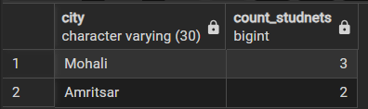

SELECT CITY ,COUNT(ID) AS COUNT_STUDNETS

FROM STUDENTS

GROUP BY CITY

ORDER BY COUNT_STUDNETS ASC

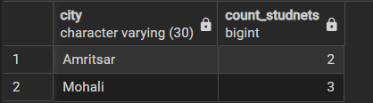

SELECT CITY ,COUNT(*) AS COUNT_STUDNETS

FROM STUDENTS

GROUP BY CITY

ORDER BY COUNT(*) ASC

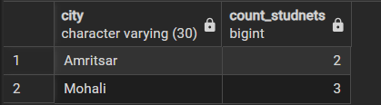

SELECT CITY ,COUNT(ID) AS COUNT_STUDNETS

FROM STUDENTS

GROUP BY CITY

HAVING COUNT(ID)>=3

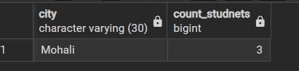

SELECT CITY ,AVG(MARKS)::NUMERIC(10,2) AS AVERAGE_MARKS

FROM STUDENTS

GROUP BY CITY

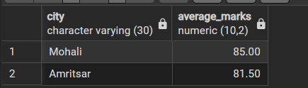

SELECT CITY ,SUM(MARKS)::NUMERIC(10,2) AS SUBMITION_MARKS

FROM STUDENTS

GROUP BY CITY

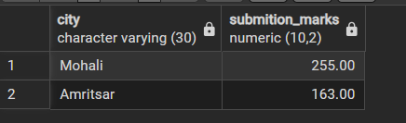

SELECT CITY ,MIN(MARKS)::NUMERIC(10,2) AS MINIMUM_MARKS

FROM STUDENTS

GROUP BY CITY

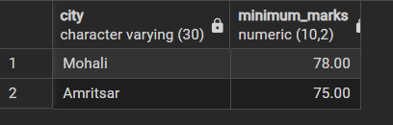

SELECT CITY ,MAX(MARKS)::NUMERIC(10,2) AS MAXIMUM_MARKS

FROM STUDENTS

GROUP BY CITY

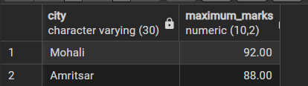

- Learning outcomes (What I have learnt):

- Understood the concept of database table creation using appropriate data types, primary keys, and constraints to maintain data integrity.
- Gained practical knowledge of SQL aggregate functions such as COUNT, SUM, AVG, MIN, and MAX along with the use of GROUP BY and HAVING clauses.
- Developed the ability to analyze and summarize data by grouping records and sorting results using ORDER BY.
- Acquired hands-on experience in executing data manipulation operations including INSERT, UPDATE, DELETE, and SELECT queries.
- Gained practical exposure to role-based access control and database security by creating roles, granting permissions, and revoking privileges in PostgreSQL.

