PROOV
Provenance-Verified Emissions Monitoring using Cross-Modal Sensor Fingerprinting and Tamper-Evident Logging
Hardware Schematic Verification Summary | BACSE324 — Embedded Systems Architecture | VIT Vellore

1. Purpose of This Document
This document records the final, verified hardware architecture for the PROOV two-node prototype and summarizes the iterative design-review process used to reach it. The schematic went through multiple AI-assisted generation rounds; each round was independently checked against the project's architecture specification, and several rounds surfaced real wiring or electrical-safety errors that were corrected before the design was accepted. This log is included as evidence of a rigorous verification process, suitable for the course report, the GitHub repository, and any prior-art / patent documentation.

2. Final Verified Architecture — Summary
The accepted design implements the three-layer trust chain on two independent power domains:
- Heater supply (5V, always-on, unswitched) — powers the MQ gas sensor's heater element continuously, with no relay or GPIO control in its path.
- Relay/equipment supply (5V, GPIO4-switched) — powers the relay, the external test equipment (fan/motor/lamp), and the INA219 current sensor, which sits in series in the equipment's return leg.
- ESP32 logic domain (3.3V) — powers the ESP32, DS3231 RTC, SD card module, and the INA219/DS3231 I2C signal lines, with pull-up resistors referenced to 3.3V only.
This separation is what makes Layer 1 (physical plausibility) meaningful: the gas reading and the equipment's power draw are two independent physical signals, measured on two independent circuits, that are only compared in software.

2.1 GPIO Pin Assignments (Final)
GPIO | Function | Bus / Type | Notes
GPIO21 | I2C SDA | I2C (shared) | INA219 (0x40) and DS3231 (0x68)
GPIO22 | I2C SCL | I2C (shared) | INA219 (0x40) and DS3231 (0x68)
GPIO23 | SPI MOSI | SPI | SD card module
GPIO19 | SPI MISO | SPI | SD card module
GPIO18 | SPI SCK | SPI | SD card module
GPIO5 | SPI CS | SPI | Idles high via pull-up; safe strapping-pin use
GPIO34 | Analog input (ADC1_CH6) | Analog, input-only | MQ gas sensor AO
GPIO4 | Digital output | GPIO | Relay control (switches external equipment only)
GPIO0, GPIO2, and GPIO12 are deliberately excluded from the design — these are ESP32 boot-strapping pins, and external hardware holding them in the wrong state at power-on can cause boot failure or unintended flash-mode entry.

2.2 Power Domain Reference
Domain | Voltage | Powers | Switching
Heater supply | 5V | MQ sensor heater element | None — always on
Relay / equipment supply | 5V | Relay module, external equipment, INA219 (sense path) | GPIO4 via relay
ESP32 logic rail | 3.3V | ESP32, DS3231, SD card, I2C pull-ups, INA219/DS3231 logic supply | N/A — continuous

3. Design Review Log
The table below summarizes the issues identified and corrected across the review process. Each was caught before being accepted into the final design.
Round | Issue Identified | Risk | Resolution
1 | INA219 wired across the MQ heater instead of the external equipment | Defeats Layer 1 — no independent second signal to correlate against | Rewired INA219 in series with external equipment only
2 | Relay wiring reused GPIO pins inconsistently between diagram and table | Ambiguous build reference | Standardized on one wiring topology across all outputs
3 | Pin reassignment introduced GPIO12 (SD MISO) and GPIO2 (relay) | ESP32 boot-strapping pins — risk of boot failure / brick | Reverted to safe pin set: 21, 22, 23, 19, 18, 5, 34, 4
4 | Relay line shown driving the MQ heater directly | Breaks heater/equipment isolation, re-couples Layer 1 signals | Decoupled heater onto its own always-on, unswitched 5V supply
5 | I2C pull-up resistors referenced to 5V; relay spec implied GPIO sourcing full coil current | 5V on ESP32 GPIOs risks pin damage (not 5V-tolerant); GPIO cannot source 70mA | Pull-ups corrected to 3.3V; relay module confirmed to use onboard transistor driver
6 | Final self-audited version cross-checked against full specification | N/A — verification pass | All checks passed; design accepted as buildable

4. Final Verification Checklist
The accepted design was checked against the following criteria before approval:
✓ INA219 is in series with the external equipment, not the MQ heater
✓ MQ heater runs on an independent, always-on 5V supply with no relay/GPIO in its path
✓ GPIO0, GPIO2, and GPIO12 are not used anywhere in the design
✓ All eight required GPIOs (21, 22, 23, 19, 18, 5, 34, 4) are assigned uniquely, with no conflicts
✓ I2C pull-up resistors reference the 3.3V rail only
✓ Relay coil current is sourced from the 5V rail via the module's onboard transistor driver, not directly from GPIO4
✓ Layer 1 logic correlates MQ gas reading with INA219 equipment power draw
✓ Layer 2 logic samples the MQ heater's resistance curve independently of the INA219
✓ Layer 3 logic hashes (previous_hash + timestamp + gas_value + INA219_power + fingerprint_result) and verifies against the SD card's stored chain

5. Final Circuit Diagram
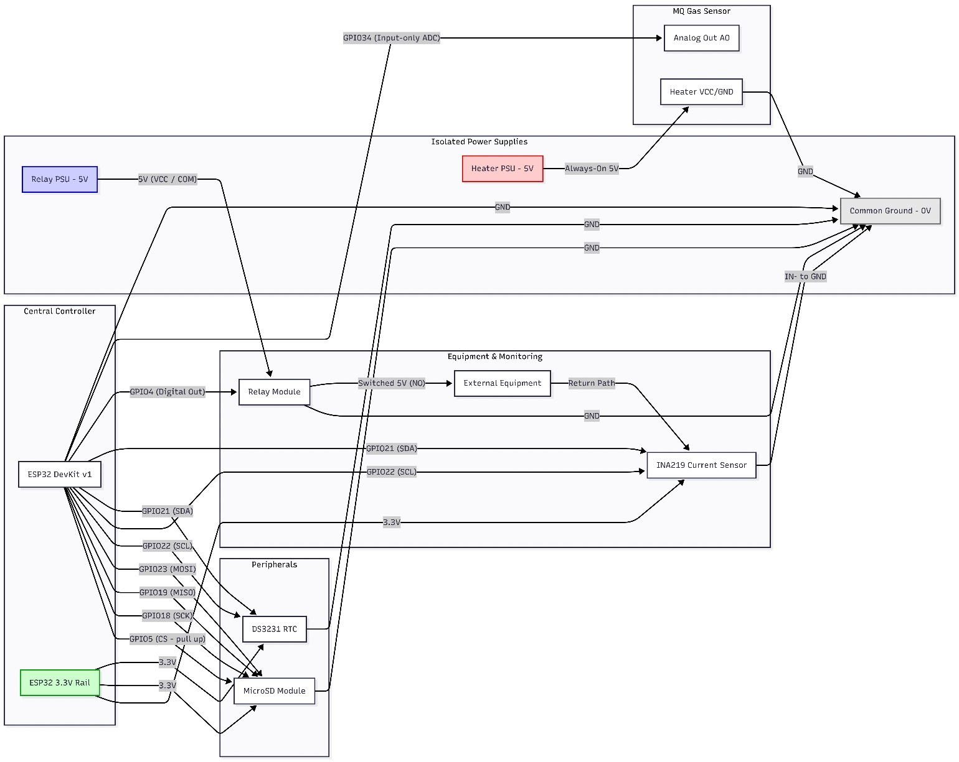

6. Conclusion
The PROOV two-node hardware architecture has been verified across six rounds of AI-assisted schematic generation and manual review. Every identified wiring hazard — miswired current-sense placement, unsafe GPIO strapping-pin use, cross-coupled heater/relay control, and an out-of-tolerance I2C voltage domain — was caught and corrected prior to acceptance. The final design isolates the two physical signals that Layer 1 depends on (gas concentration and equipment power draw), keeps the ESP32's logic pins within their safe operating domain, and avoids all boot-critical strapping pins.
This design is considered ready for breadboard assembly. Recommended next steps: begin the MQ sensor 24–48 hour burn-in period immediately, proceed with breadboard assembly per Section 2, and produce a formal KiCad schematic (with an electrical-rules check) for the final course submission and GitHub repository, using this document as the verified reference design.

