- You can use google to answer these questions

1. A SELECT working perfectly starts to be slow in a production environtment. Do you know the causes? Wich actions can solve the situation?
2. What is DISTINCT used for with MySQL?
3. In a day, how many times do the hands of a clock overlap?
4. Wich regular expresion can match $cadena1 and $cadena2 but without matching $cadena3?

$cadena1 = daniel11@volcan1cinternet.com

$cadena2 = pepito22@volcanicinternet.com

$cadena3 = pepito3333333333@volcanicinternet.com

1. Using jQuery, show in the console all the values of the text type inputs from form with using #main-form id
2. Please use php to show the actual date and time with this format:

YYYY-MM-DD HH:MM:SS

1. How do you calculate the number of days between two dates in php?
2. Write a code to print a table using HTML/CSS and without <table> tags. Do you validate your code?
3. How can I monitor my website’s status? Give some tools and the experience that you have with them.
4. If you have this result on pagespeed, what action are you going to do to fix them for mobile?

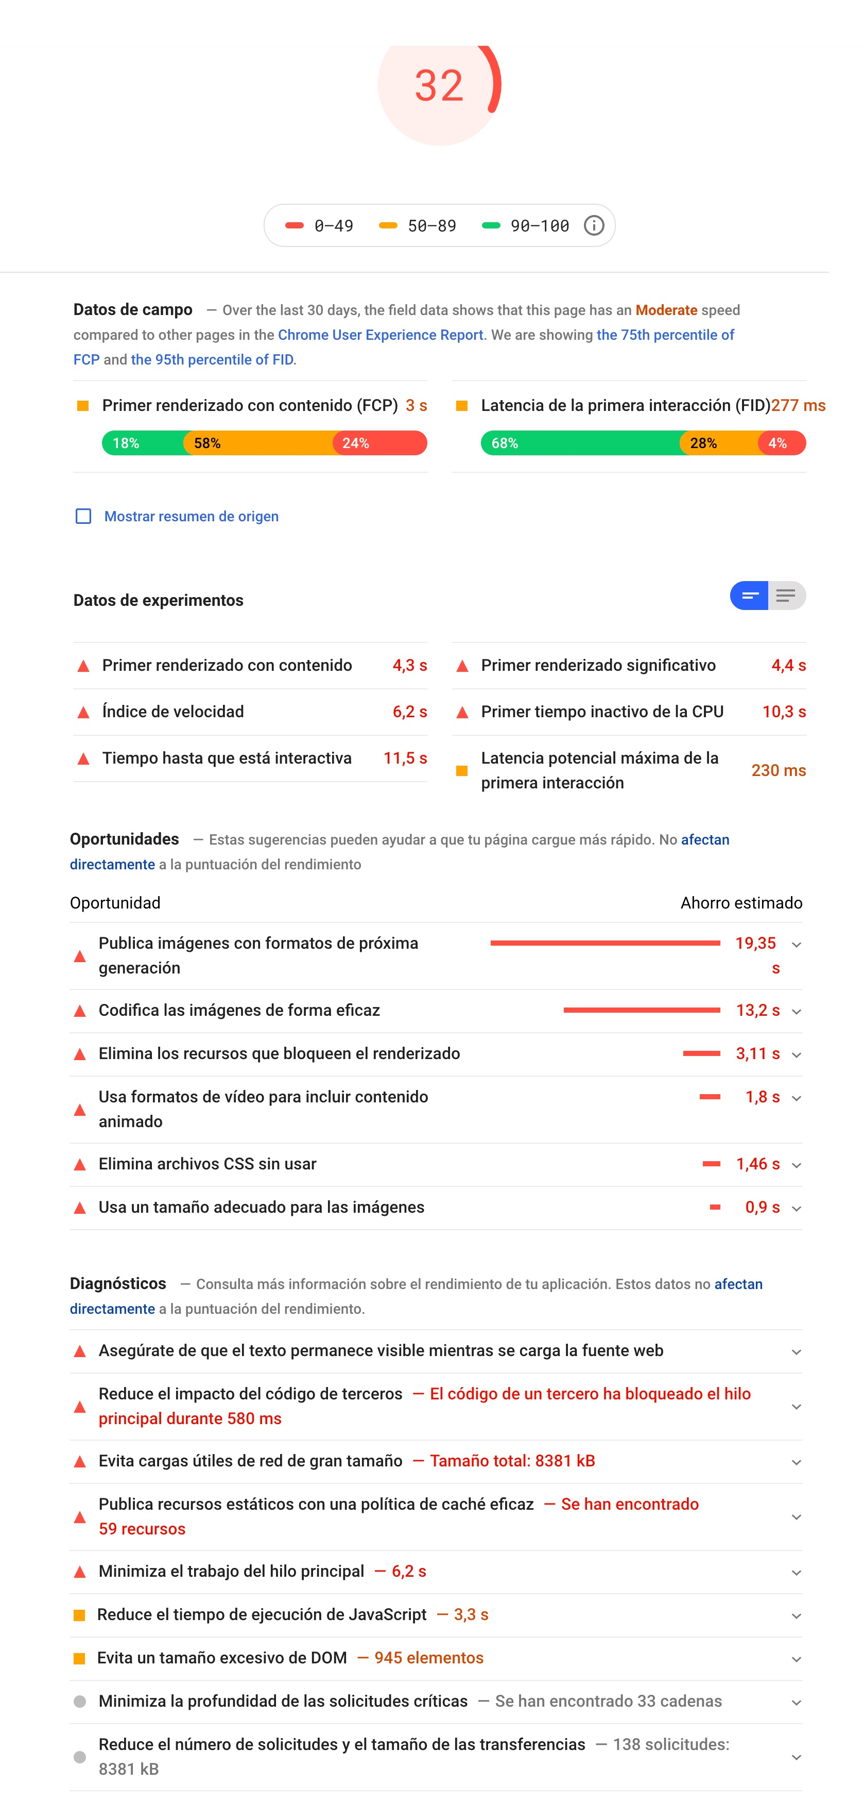

1. Go to <https://www.volcanicinternet.com> and describe 4 ways to improve the site. You can write about UX/UI but also code and performance.
2. How can we submit form without a submit button?
3. How can we register the variables into a session?
4. If a web service returns a JSON, how you would extract the data?
5. Add a css file in the frontend using WordPress functions
6. Write a WordPress Query to get the last 25 posts with red color. The post type name is car and you have a meta field called color.
7. What are WordPress hooks?
8. How many WordPress posts can I create?
9. What is WordPress multisite?
10. Volcanic has developed a website with WordPress with more than 100 pages and 1000 blog post in 1 language. The website has 200 visits per day. After 2 months running in live environment the client ask us to add two 2 languages to the site. What steps do you make in order to developer the feature?
11. You just installed a new plugin that crashed your Wordpress site. You can’t login to Wordpress dashboard. What can you do to fix the problem?
12. Where are stored WordPress plugins options?
13. You have this scenario. You have to develop different landing pages about game reviews. Each landing need to have these fields:

- Game name

- Game review

- Image gallery

- Video preview

- Game company name

- User reviews

- Game multi player?

- Website links where to buy it

How would you create the data structure of the project in WordPress? any website administrator have to be able to update the content from wp-admin.

1. How would you set up a website with WP and ACF with the following features:
   * The customer just wants to fill the content of each page and not worry about the design
   * The customer wants to be able to choose for each page he creates the sections he wants to put and the order they will have.
2. Given the following php code to create a two-level WP menu, how would you mount the styles using a pre-processor like SASS or LESS to make the second level unfold when hovering over the first level when you're on the desktop (from 1200px). You should also make the menu on mobile and up to 768px hidden from view (let's leave it for another occasion to display from a burger menu icon). You can make a codepen or similar to show how you would do it.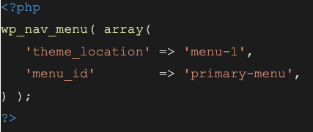

The premises are that you can only use the given classes and that you need to use as few lines of code as possible.

Bonus: Do you think you could use some mixin to improve the code and make it less repetitive?

1. What is the result of this function? Take 3,141592 for value, 2 for decimals and 10 for scale.

function _escaleValue( $value, $decimals = 0, $scale = 0 ){

($scale > 0)? $scale = 1000 : $scale = 0;

$scaleVal = $value * $scale;

if( $decimals == 0 ) return round( $scaleVal ); else return @number_format( $scaleVal, $decimals, '.', '') ;

}